MEMORANDUM
To: Managing Partner
From: Hope T Mutema
Subject: Investigating How Global Availability, Viewing Hours, Genre, and Release Season Impact Movie Ratings, A Multiple Linear Regression Analysis.
Table 1: Categorical Summary
 | Freq. | Percent
Available Globally
Yes | 4,249 | 29%
No | 10,384 | 71%
Total | 14,633 | 100%
Season
Fall | 3,959 | 27%
Spring | 3,628 | 25%
Summer | 3,495 | 24%
Winter | 3,551 | 24%
Total | 14,633 | 100%
Genre
Comedy | 3,935 | 33.7%
Drama | 4,975 | 34.0%
Animation | 1,979 | 13.5%
Other Genres | 3,744 | 25.6%
Total | 14,633 | 100%
Rating Number is an interval ratio movie rating. For Genre, there is comedy, drama and animation which are coded as dummy variables, with Reference group, other genres not explicitly defined above. Hours Viewed is the total number of hours viewed, recoded in millions for easier interpretation. Season, Season of release, derived from release date, Winter (Dec–Feb), Spring (Mar–May), Summer (Jun–Aug), Fall (Sep–Nov) and the reference group as Winter. Global Availability, binary which is either available globally or not.
By analyzing how genre, viewing hours, global availability and release season relate to ratings, this memo provides actionable insights that can benefit viewers, content creators, and Netflix’s programming strategy. This issue affects both industry stakeholders and audiences by shaping the future direction of streaming content. Comedy movies consistently receive lower ratings, while global availability, popularity, and seasonality show no significant impact on audience scores. The model explains little of the variation, suggesting factors like cast, marketing, and viewer context play a larger role. Based on the summary statistics, most of the movies are not available globally and approximately equal proportion of movies are distributed each season. The comedy and drama genre has the most movies released compared to Animation and other genres. Hypothesis: Movies with higher viewing hours, released during certain seasons, or in popular genres (Comedy, Drama, Animation) tend to have higher average ratings on Netflix. This analysis uses an alpha level of 0.05 and a dataset of 14,633 observations to explore these relationships.
Regression Model Specification
Movie Rating = 6.654 − 0.016(Available Globally: Yes) − 0.063(Comedy) + 0.011(Drama) − 0.012(Animation) + 0.0003(Hours Viewed, mil) − 0.016(Fall) + 0.001(Spring) − 0.024(Summer) + $ϵ$
Table 2: Quantitative Summary
 | Freq | Min | Max | Med. | Mean | SD | Skewness
Movie Ratings | 14,633 | 1.40 | 10.00 | 6.60 | 6.62 | 1.26 | -0.28
Hours Viewed (Million) | 14,633 | 0.10 | 812.10 | 2.90 | 10.98 | 32.36 | 11.04

Table 3: Regression Results Netflix Movie Ratings
 | Coeff. Β | Std. Err. | p-value
Intercept | 6.654 | 0.026 | ***
Available Globally (Yes) | -0.016 | 0.023
Genre (Comedy) | -0.063 | 0.022 | ***
Genre (Drama) | 0.011 | 0.023
Genre (Animation) | -0.012 | 0.031
Hours Viewed | 0.0003 | 0.0003
Season (Fall) | -0.016 | 0.029
Season (Spring) | 0.001 | 0.030
Season (Summer) | -0.024 | 0.030
Significance *** 0.001 ** 0.01 * 0.05 (). 0.1
R² | 0.001
Adj. R² | 0.0002
Regression Analysis: Coefficient Interpretation: Intercept (6.654), The baseline expected average rating is about 6.65 for movies not globally available, not Comedy, Drama, or Animation, with zero hours viewed and released in Winter; this result is statistically significant (p<0.05). Available Globally (Yes) (-0.016), movies available globally are predicted to have an average rating 0.016 points lower than those not globally available all else equal, not statistically significant (p>0.05). Genre (comedy) (-0.063), comedy movies have, on average, ratings that are 0.063 points lower than movies in other genres holding other things equal, and this is statistically significant (p<0.05). Genre (drama) (0.011), Drama movies have 0.011 points higher average ratings than other genres all else equal, not significant (p>0.05). Genre (animation) (-0.012), animation movies have slightly lower in ratings by 0.012 points, but again all else equal, this is not statistically significant (p>0.05). Hours Viewed in millions (0.0003), each additional million hours viewed is associated with an increase of 0.0003 in the rating all else equal, but this coefficient is not significant (p>0.05). Release Season Fall (-0.016), movies released in Fall are rated 0.016 points lower than Winter releases (reference group) holding other independent variables constant, but this is not significant (p >0.05). Release Season Spring (0.001), Spring releases are rated 0.001 points higher than Winter, not significant (p>0.05). Release Season Summer (-0.024), summer releases are 0.024 points lower than Winter all else equal, also not significant (p>0.05). Model Significance: R-squared (0.001), The model explains only about 0.1% of the variance in movie ratings. This means almost all differences in ratings are due to other factors not included in the model, suggesting very weak explanatory power. F Statistic (1.414), the F-test is not significant, which indicates the model does not predict ratings better than using the mean alone. The regression model isn't statistically useful. Checking for Multicollinearity - All the variance of inflation (VIF) were below 5 meaning no serious multicollinearity problem exits.
OLS Assumption check - The regression diagnostic plots indicate that the OLS assumptions are generally met, with residuals showing linearity, constant variance, and approximate normality. No influential outliers or violations were detected in the residual, leverage plot. The OLS diagnostic plots show that model assumptions linearity, homoscedasticity, and normality are generally satisfied, and no influential outliers were found. Overall, the model fits the basic requirements for regression analysis. Power Analysis: The power analysis for my multiple regression model gave an f² statistic of 0.001 and a power of 0.88, confirming high statistical power for my analysis with the chosen predictors and sample size. Significance: Most coefficients in the regression are not statistically or substantively meaningful, and only Comedy shows a small, significant, negative effect. The adjusted R-squared is near zero, so the model does not explain variation in movie ratings.
Dependent Variable Relationship with Independent Variables
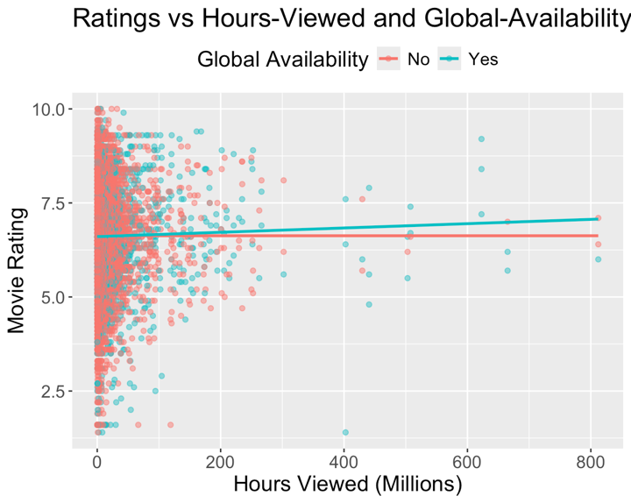
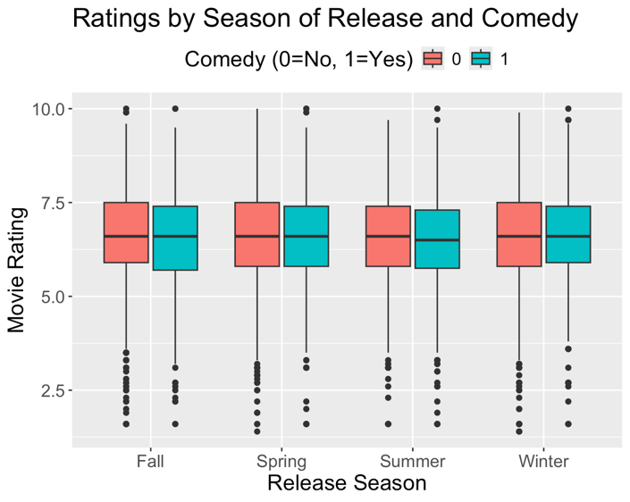
Weakness of the Study: One major weakness in this study is the limited set of variables included, as important factors such as cast, marketing, viewer demographics, and audience engagement were not analyzed, which likely explains the low explanatory power. Future analysis could address this gap by expanding the dataset to incorporate more detailed movie attributes and external influences, leading to stronger and more meaningful results.
Conclusion & Interpretation: Except for the negative effect for Comedy movies, none of the variables in the regression model are significant predictors of movie ratings at standard significance levels. Even for Comedy, while the effect is statistically significant, the practical impact a decrease by 0.063 on a rating scale often spanning several 10 points is not substantively significant. The combination of a very low R-squared and insignificant F test suggests that movie ratings are primarily influenced by factors not captured in this model such as cast, storyline, marketing, or deeper cultural preferences.

Regression Diagnostic Plots
