MEMORANDUM
To: Managing Partner
From: Hope T Mutema
Subject: Exploring How Movie’s Global Availability Relates to Movie Ratings: A Regression Analysis
This memo presents an analysis of the statistical relationship between a movie's audience ratings and its global availability status on Netflix. Global availability on Netflix is significantly linked to higher average movie ratings but explains just 0.13% of rating differences showing that other factors like genre, marketing, cast, and cultural context matter for audience reception. This memo is most relevant for Netflix content strategists, marketing teams, product managers, global acquisition managers, data analysts, and executive decision makers involved in audience research, and international distribution of movies.
Hypothesis: Movies that are available globally have a statistically significant, higher average rating than movies that are not available globally. Choose Alpha level $α$ of 0.05 for this analysis, by looking at the size of the dataset 18,332.
Regression Model Specification: $\hat{Movie rating }=6.450+0.128 (Available Global (Yes))$
Findings: Movies available globally have ratings just 0.128 points higher than those not available globally, but global availability explains only 0.13% of rating variance, showing that it is useful to assess other predictor variables of movie ratings. Data Set: The regression analysis utilizes the Netflix dataset. The analysis employs Simple Ordinary Least Square Regression; the two variables used in the model are defined are Movie Ratings (IV). This is the numerical rating score assigned to the movie which is continuous on the range 1 to 10. Global Availability (DV) this variable indicates whether a movie is available globally, measured as a dichotomous (binary) category Yes or No. This analysis uses an average movie rating (as RatingNum) as the outcome and global availability (Yes/No) as the predictor that of whether the movie is available on global market.
Table 1: Quantitative Summary
 | Freq | Min | Max | Med. | Mean | SD | Skewness
Movie Ratings | 18,328 | 6.48 | 10.00 | 6.60 | 0.00 | 1.55 | -1.46

Table 2: Categorical Summary
 | Freq. | Percent
Available Globally
Yes | 4,534 | 25%
No | 13,794 | 75%
Total | 18,328 | 100%
Missing Values: There were only 4 missing values hence removing them would not make much of a difference in the data set and will not affect the analysis and potential generalization of the population.
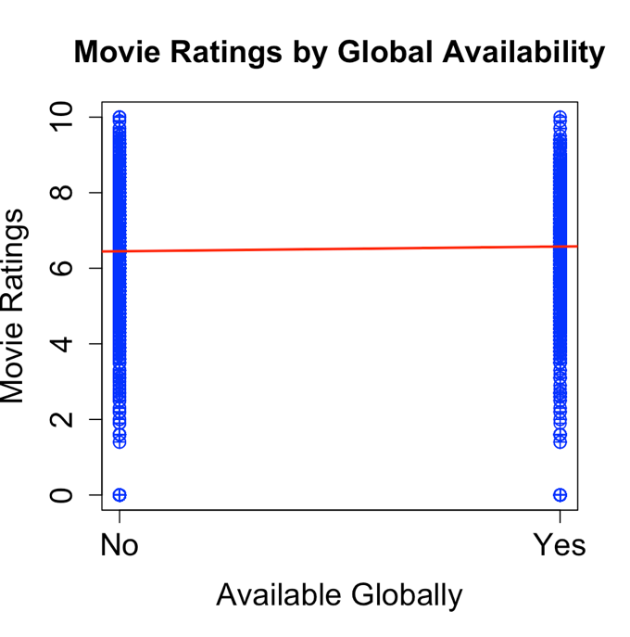
Regression Analysis: The model showed that movies available globally have an average rating 0.128 points higher than non-globally available movies, and this coefficient is highly statistically significant. However, the model shows week applicability of the findings since the Global Availability explains only 0.1266% of the variance in Movie Ratings. The overall model is statistically significant F = 23.23, with a very small p value suggesting the predictor is reliably, but its effect size is negligible shown by a small $R^{2}$ value. The Intercept value 6.45 shows that when movie is not available globally on average the rating will be 6.45. Scatter plot with fitted regression line: Shows that the independent variable is binary with the average ratings being the showed on the two binary points no and yes. The slope is relatively flat showing that there isn’t much of a difference being explained by whether the movie is available globally or not which supports the small coefficient of determination found.
OLS Assumption Check: All OLS assumptions were checked using diagnostic plots. The Q-Q plot suggests some influential outliers, which could make p-values and coefficients less reliable. Since the independent variable is binary, residuals cluster on two lines, likely violating the homoscedasticity assumption making standard errors and significance tests less precise.
Conclusion: Global availability has a statistically significant but practically small effect on movie ratings, explaining just 0.13% of variance. The team should focus on finding other, more influential predictors of rating success instead of relying on global availability alone hence the need for multiple linear regression and look on other variables such as genre in the data set.
Challenges and Tips Learned: Statistical significance alone doesn’t mean the model is useful if predictive power is weak. Global availability isn’t a strong strategy for raising ratings; focus should shift to finding better predictors with multiple regression.

Regression Results
Regression Results
 | Dependent Variable
 | Rating Number
Available Globally (Yes) | 0.128 | p<0.05
Intercept | 6.450 | p<0.05
Observations | 18, 328
$R^{2}$ | 0.001
F | 23.225 | p<0.05

Regression Diagnostic Plots
