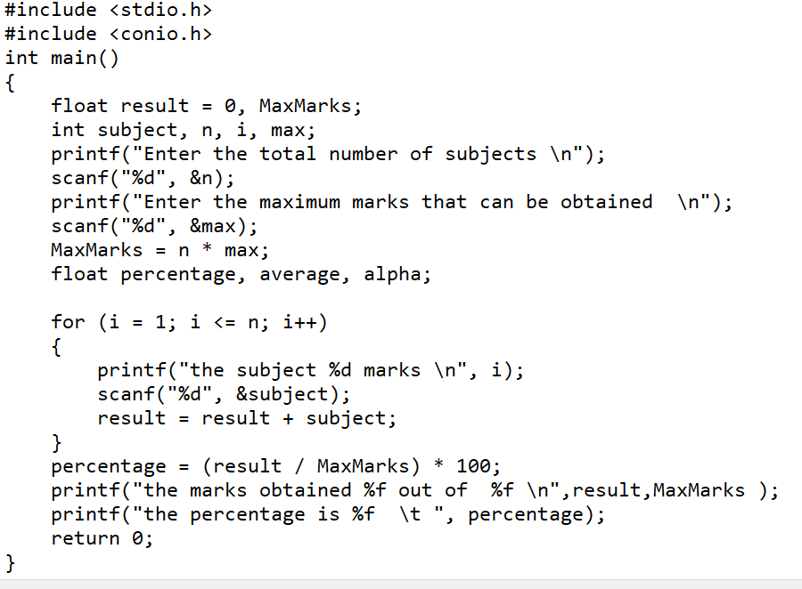Program 1 :WAP that accepts the marks of 5 subjects and finds the sum and percentage marks obtained by the student.

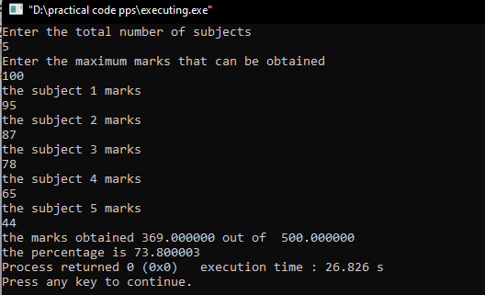Output:

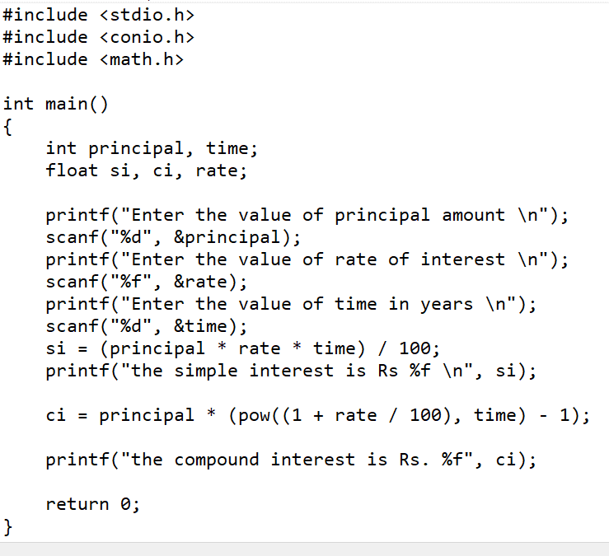Program 2: WAP that calculates the Simple Interest and Compound Interest. The Principal, Amount, Rate of Interest and Time are entered through the keyboard.

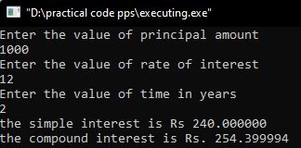

Output:

Program 3: WAP that swaps values of two variables using a third variable.

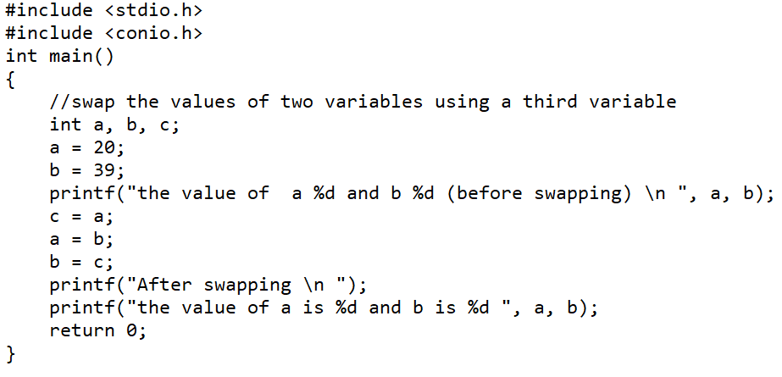

Output:

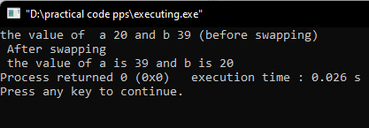

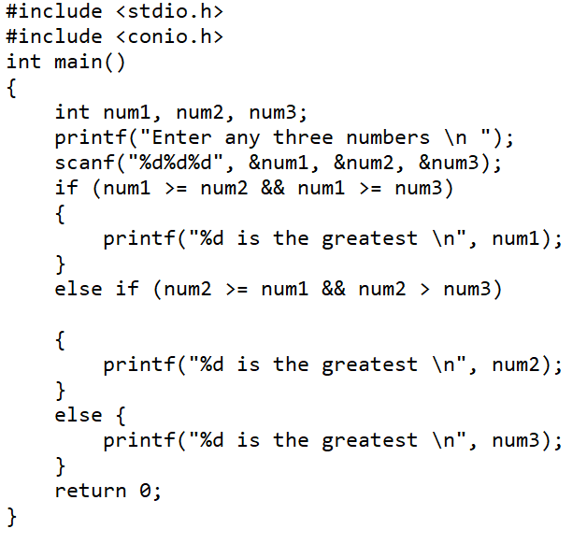Program 4 : WAP to find the greatest of three numbers

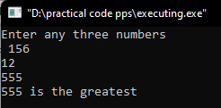 Output:

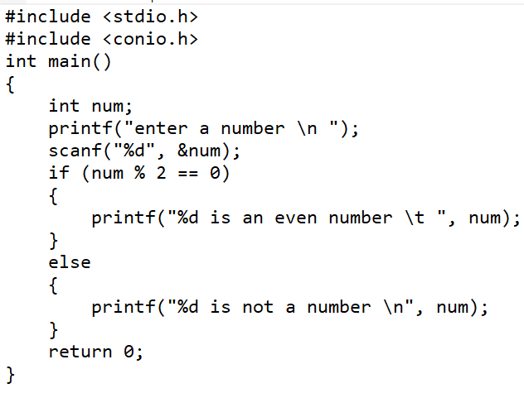Program 5 : WAP that finds whether a given number is even or odd.

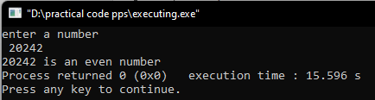Output:

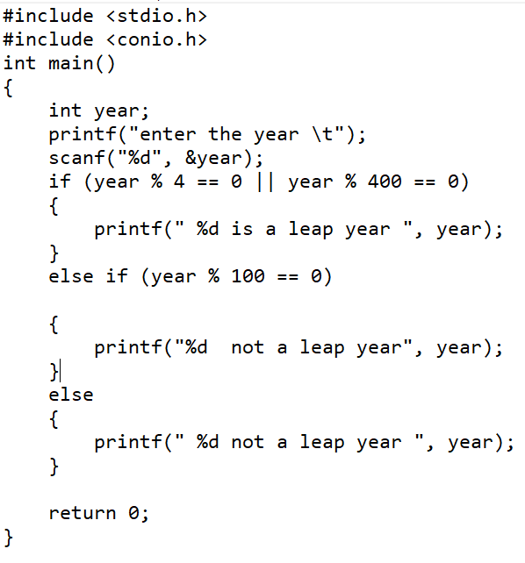Program 6: WAP that tells whether a given year is a leap year or not.



Output:

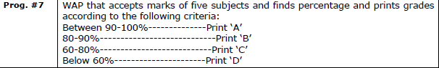

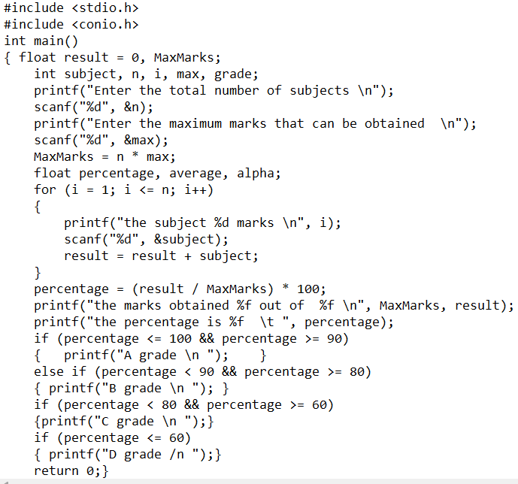

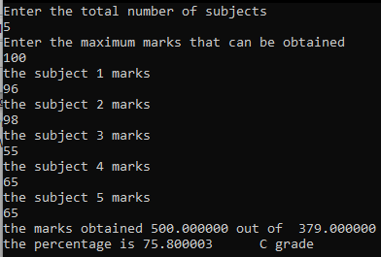

output:

Program 8:

|  |
| --- |
| WAP that takes two operands and one operator from the user to design a simple calculator with four basic operations (+,-,*,and /) and prints the result by using Switch statement. |

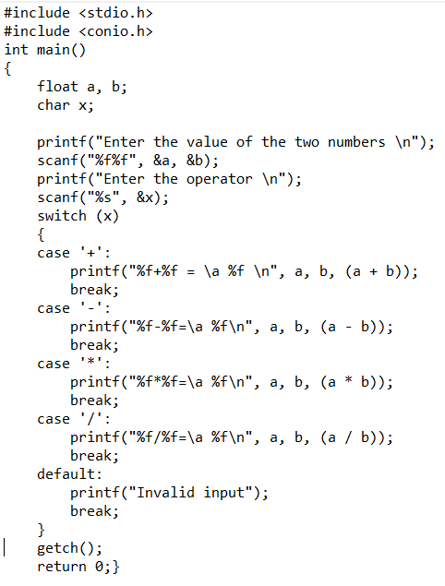

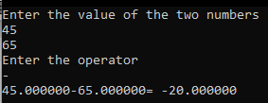

Output :

Program 9: WAP to print the sum of all numbers up to a given number.

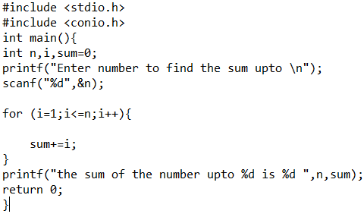

Output :

Program10: WAP to find the factorial of a given number.

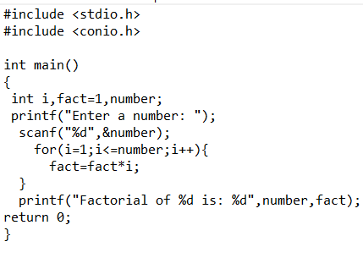

Output:

Program 11: WAP to print sum of even and odd numbers from 1 to N numbers.

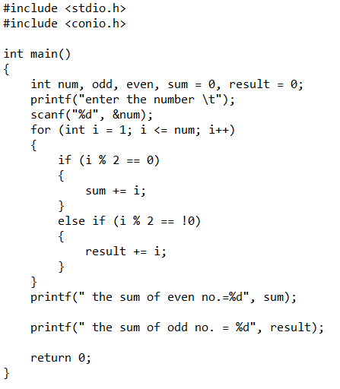

Output :

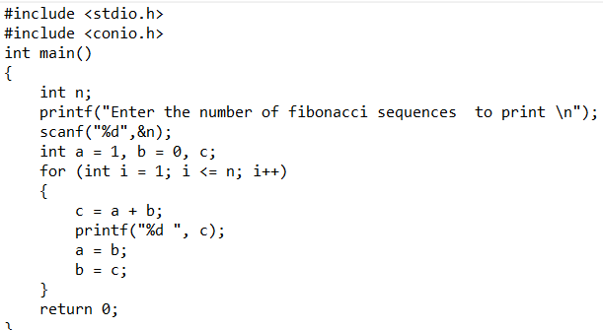Program 12 : WAP to print the Fibonacci series.

Output :



Program 13: WAP to find the reverse of a number and check for palindrome.

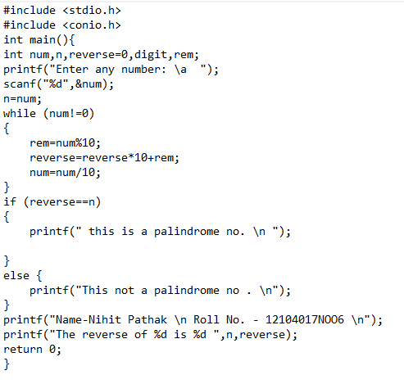

Output :

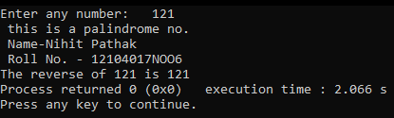

Program 14: WAP to print Armstrong numbers from 100 to 999.

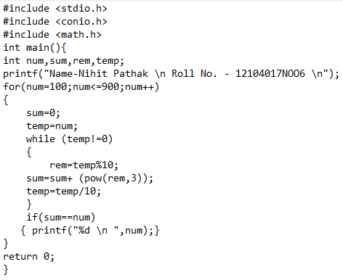

Output :

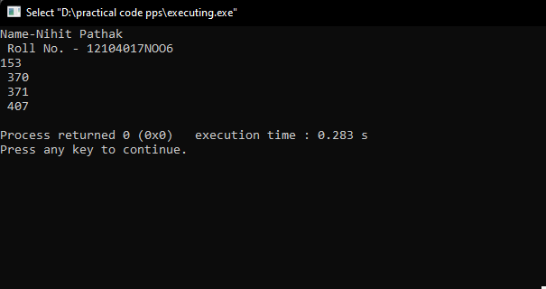

Program 15: WAP to convert binary number into decimal number.

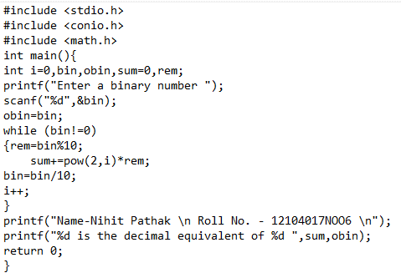

Output:

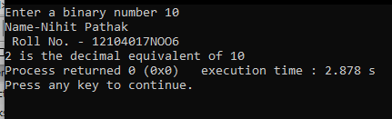

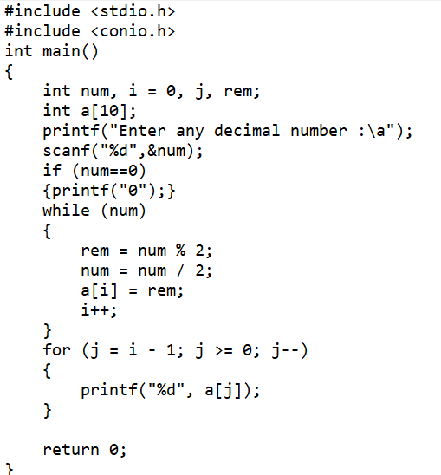Program 16: WAP to convert decimal number into binary number.

Output :

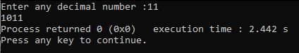

Program 18 : WAP to generate multiplication table of a given integer number.

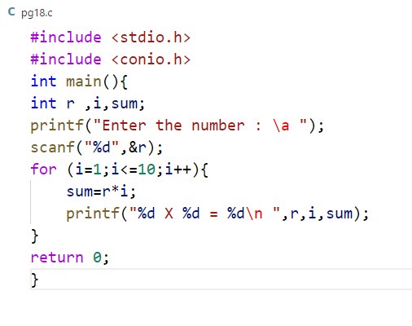

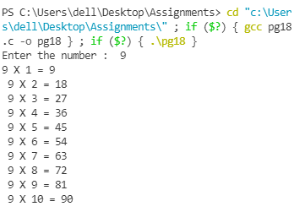Output:

Program 19: WAP to find GCD and LCM of two given numbers.

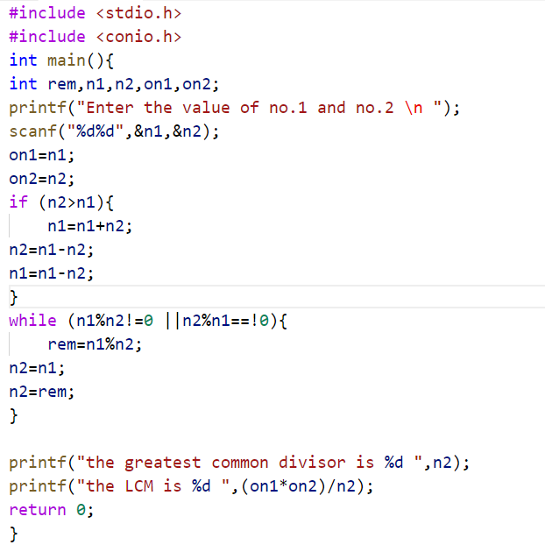

Output :

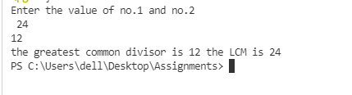

Program 20: WAP to display factors of a given number.

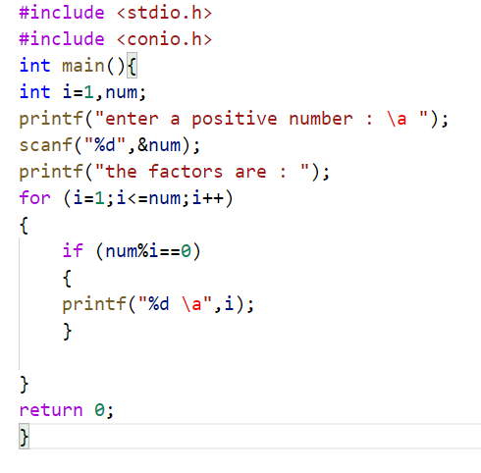

Output :

