Title: Scale-Aligned Comparison of Sum-Score and Latent-Variable Growth Models: Parameter Recovery under Correlated Uniqueness

1 Introduction
2 Background
3 Scale Alignment

4 Simulation Design
4.1 Data-Generating Model
The 2-LGCM was used as a data-generating model to define growth trajectory of latent construct at the population level. The growth trajectory is modeled as linear and the number of waves (T) and number of indicators (J) per wave are additionally manipulated as design conditions described as well. As a visual overview of the data-generating model, see the path diagram in Figure 1 of which example design with the T = 5 and J = 5. The simulated data were then analyzed using both the 1-LGCM with sum scores and the 2-LGCM with latent variables to compare the precision and accuracy of growth parameter estimates.
Regarding the fixed population parameter settings, the means of the growth intercept ($κ_{I}$) and slope ($κ_{s}$) were fixed at 1 and .125, respectively, to examine the statistical power for detecting a non-zero intercept and slope. The growth factor covariance matrix was fixed at $ϕ_{II}$= 1 (intercept variance), $ϕ_{SS}$ = .2025 (slope variance), and $ϕ_{IS}$ = .18 (intercept–slope covariance), yielding an intercept–slope correlation of approximately .4, which can be considered a small-to-moderate relationship. The disturbance variance of the latent constructs was specified via a slightly decreasing sequence of [$ψ_{1}, ψ_{2}, ψ_{3}, ψ_{4}, ψ_{5}$] = [1.203, .96, .902, .865, .828] for the T = 5 condition (with only the first three values used for T = 3), such that more than 60% of the proportion of variance in the latent construct was explained by the growth parameters at each time point.
To remove confounding effects from the size of scale, I used effects-coding identification (ECI) for the 2-LGCM to align it with that for sum-score 1-LGCM. Population parameters of the data-generating model and the analysis model parameters are presented in Table 1 with analytically derivation via the affine transformation from equation ( X ).
The item intercept was fixed at $τ_{it}=.1$ and the unstandardized factor loading at $λ_{it}=.2$. The value of $λ_{it}=.2$ was chosen so that, in the reference design with five indicators per wave (J = 5), the ECI constraint that the within-wave loadings sum to one ($\sum_{i}{λ_{it}}=1$) is automatically satisfied at the population level, making the generating and ECI-fitted variance–covariance matrices of the growth factors numerically identical (see Table 1). For J = 3 conditions, where $\sum_{i}{λ_{it}}=.6$, the ECI-rescaled parameters take different values, as also shown in Table 1. This study assumes complete data without any missingness.

4.2 Simulation Conditions
Correlated uniqueness ($ρ$). The CU structure for each indicator was modeled as a lag-1 CU pattern, in which only the residuals of adjacent time points were correlated at $ρ$, while all longer-lag residual correlations were fixed to zero. Two levels were used in the data-generating model: $ρ=0$ (no CU) and $ρ=.15$ (small-to-moderate CU). For each level of generated data, the analysis model either specified the CU component or did not. Crossing these two factors yields four CU specifications: no CU not modeled, CU correctly modeled, CU ignored, and CU overfitted.
Measurement quality. To manipulate measurement quality, the residual variance of each indicator was calibrated to yield two levels of standardized factor loadings: poor ($R^{2}=.16$, target standardized loading = .4) and good ($R^{2}=.45$, target standardized loading = .671). Given the unstandardized loading and the latent construct variance determined by the growth parameters and disturbance variances, the residual variance was set such that the indicator reliability matched the target $R^{2}$ at each wave.
Number of time points (T). To assess whether the comparison generalizes across different numbers of waves, the number of measurement occasions was set to T = 3 and T = 5. T = 3 represents the minimum number of time points required for the LGCM. In practice, researchers are often unable to collect more than the minimum of three waves, and at this length the CU parameters in the analysis model cannot be freely estimated because of under-identification. For this reason, only two of the four CU specifications were applied at T = 3: no CU not modeled, and CU ignored (CU present in the generating model but not specified in the analysis model). At T = 5, all four CU specifications were included.
Number of indicators per time point (J). The number of indicators measured at each time point was set to either J = 3, a small but realistic number of indicators, or J = 5, included to examine whether more indicators have any buffering effect on the recovery of growth parameters.
Sample size (N). Sample sizes were set to 200, 500, and 800, spanning small to commonly adequate sizes in latent growth models.
In total, the design consisted of 144 simulation conditions, partitioned into two design blocks defined by the number of waves. At T = 5, the full crossing yielded 96 = 3 (N) $×$ 2 (J) $×$ 2 (measurement quality) $×$ 4 (CU specification) $×$ 2 (models) conditions. At T = 3, the reduced crossing yielded 48 = 3 (N) $×$ 2 (J) $×$ 2 (measurement quality) $×$ 2 (CU specification) $×$ 2 (models) conditions. For each condition, 2,000 replications were generated.
4.3 Outcome Measures
Parameter estimation accuracy was evaluated with relative bias (RB) and relative root mean square error (R.RMSE). RB was computed as the average relative difference between the estimate and the population value across replications. Estimates with RB within [−.10, .10] were considered relatively accurate (Muthén & Muthén, 2002). R.RMSE, which reflects both precision and bias scaled by the absolute true value, was computed as . Additionally, coverage was the proportion of replications in which the nominal 95% confidence interval contained the true value. Statistical power was defined as the rejection rate for the growth parameters, computed within each condition as the proportion of admissible replications. Finally, I compared the proportion of admissible solutions across the four CU specifications, defined as replications that converged without negative variance estimates or standardized correlations exceeding 1 in absolute value.

Table 1. Population growth parameters in the data-generating and EC fitted metrics.
Parameter |  | Generating model | EC transformation rule | EC-fitted  J = 5 | EC-fitted  J = 3
Effects-coding re-scaling constants
Scaling factor, a |  | $$a=∑λ_{i}$$ | Sum of all J item loadings at a wave | 1 | .6
Location shift, c |  | $$c=∑τ_{i}$$ | Sum of all J item intercepts at a wave | .5 | .3
Mean of growth intercept and slope
Intercept, $κ_{I}$ |  | 1 | $${aκ}_{I}+c$$ | 1.5 | .9
Slope, $κ_{s}$ |  | .125 | $${aκ}_{s}$$ | .125 | .075
Variance/covariance of growth intercept and slope
$$Φ$$ | $ϕ_{II}$ $ϕ_{IS}$  $ϕ_{IS}$ $ϕ_{SS}$ | 1 .18  .18 .2025 | $$a^{2}Φ$$ | 1 .18  .18 .2025 | .36 .065  .065 .073
Note. Generating loadings and intercepts are invariant across the T waves (strict longitudinal measurement invariance). The scaling factor $a=∑λ_{i}$ and location shift $c=∑τ_{i}$ map the generating growth factors to the EC-fitted metric via an affine transformation.

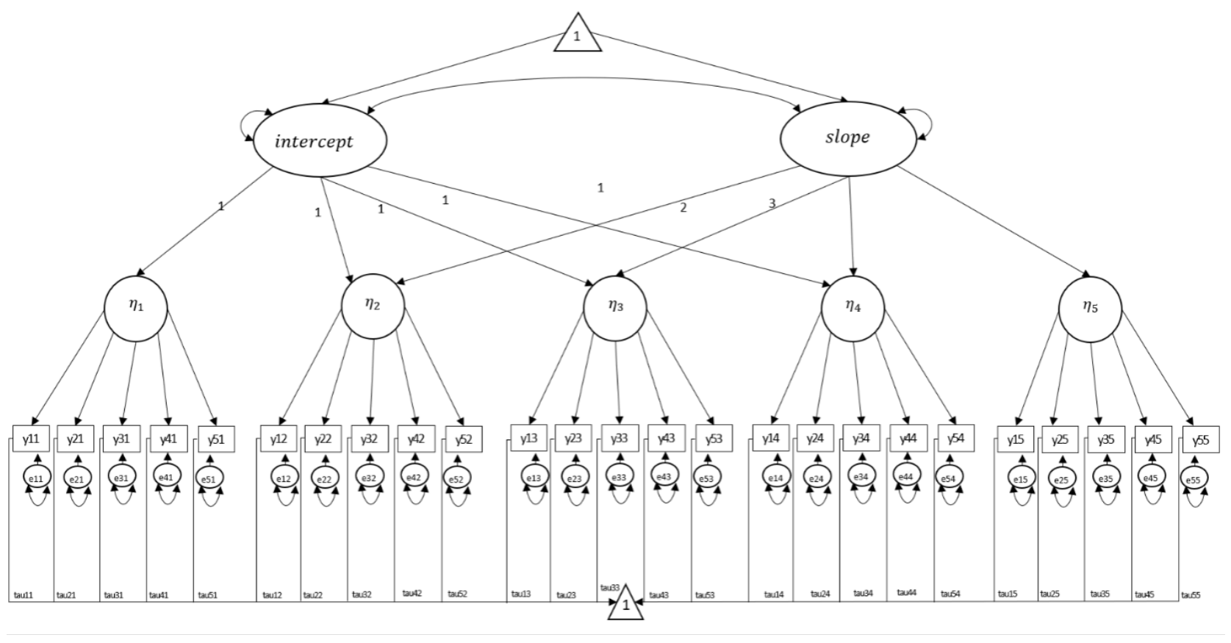
Figure 1. Path diagram of the data-generating second-order latent growth curve model (2-LGCM) for the T = 5, J = 5 design. Figure and mathematical expressions are adapted from Grimm et al. (2016) and Yang et al. (2021).

