Mitchell's Homemade Ice Cream
Cloud-Based Manager (MitchCloud)
Kent State University
Paul Birkholtz

Table of Contents:

Page: Section Name:
3 Project Intro
4-8 Use cases Diagrams and Descriptions
5-11 Sequence Diagrams
12-13 Design Models
14-15 Vision and Specifications
16-30 Source Code

Author: Paul Birkholtz
Date: December 2, 2017

Description:
A system that unifies, simplifies, and streamlines the shopping and checking out process. The system can be used as a centralized base system for user data, including sales and inventory. This system can serve all system users including ice cream shop clerks, customers, managers, sale analysts, etc. This new system, can support existing and future expansions.

Sponsored by:
Mitchell's Homemade Ice Cream, Kent State Computer Science Department

Project Successes:

Project Unexpected Events:
- For some reason some string functions weren’t working such as converting strings to ints or floats.
- The .length() function for arrays wouldn’t work for me forcing me to put constants into for loops, something I couldn’t figure out how to fix.

Project Lessons Learned:
- I didn’t realize how out of practice I was with C++, I’ve been doing a lot of work in Python and VB.NET lately so going back was more difficult than I expected at first. Lesson learned, always practice!
- I learned that the GCC compiler isn’t perfect and had an error with string functions, fixed it with an online patch giving me back the string conversion functions. Sometimes it isn’t my fault!
- I’d like to learn why my .length() will not work.
- I learned the difference between a domain model, class diagram and package diagram.

Project Performance:
Everything works to my specifications except expand-ability, I wish I could improve on this more. There are no noticeable hangs and all systems seem to be working to expectations.

Use Cases:
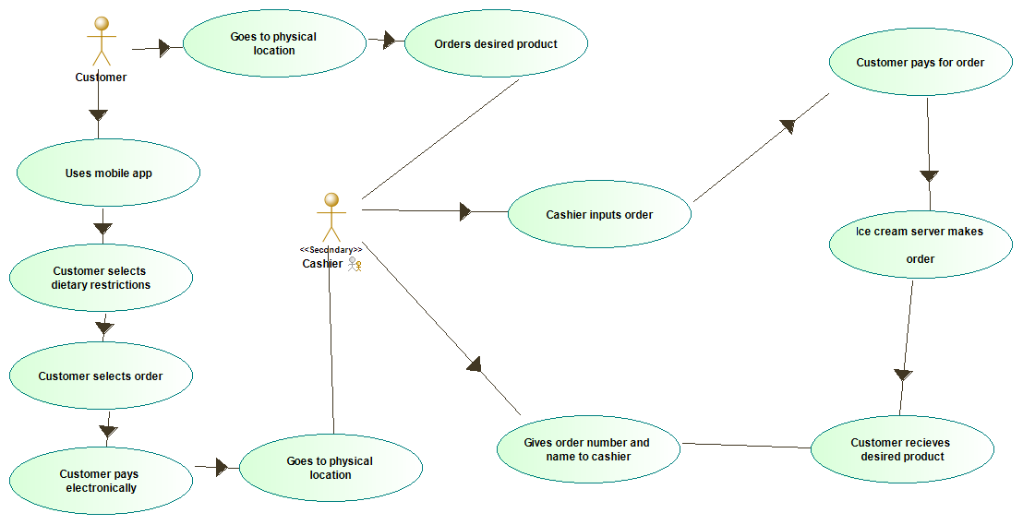
Figure 1: Use Case: Customer Purchase
--------------------------------------------------
CHARACTERISTIC INFORMATION
Goal in Context: To allow customers to easily purchase customized product
Scope: POS system.
Level: Primary task
Preconditions: User has applicable device and user is near a store
Success End Condition: Satisfied customer and successful payment
Failed End Condition: Customer doesn't order product or cannot pay
Primary Actor: Customer
Trigger: The need to order ice cream product
----------------------------------------
MAIN SUCCESS SCENARIO
1. Customer begins purchase by choosing a physical or digital POS
2. Customer selects dietary restrictions and order customizations
3. Customer waits for and recieves order at a physical location or by delivery (if available)
----------------------
RELATED INFORMATION (optional)
Priority: Top priority.
Performance Target: Customer Satisfied
Frequency: As often as supplies last
Subordinate Use Cases: Backend updates other stakeholders
Channel to primary actor: Backend system, internet, POS device
Secondary Actors: Ice Cream Servers
Channel to Secondary Actors: Backend system, internet, Cashier UI
----------------------------
SCHEDULE
Due Date: Version 1.0 release

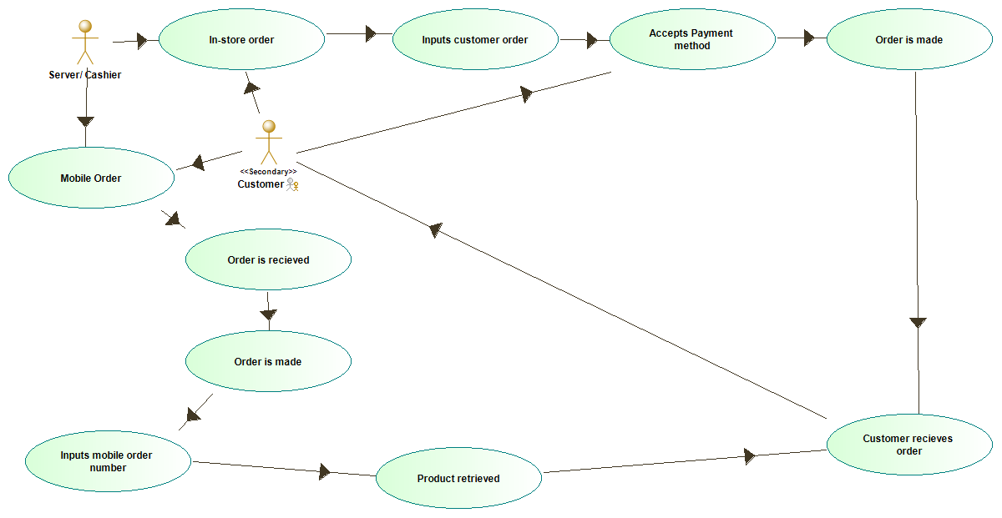

Figure 2: Use Case: Ice Cream Servers system interaction during purchase
--------------------------------------------------
CHARACTERISTIC INFORMATION
Goal in Context: To allow Ice Cream Servers to easily sell customized product
Scope: employee system interaction
Level: Primary task
Preconditions: User is an employee and has a customer
Success End Condition: Completed system interaction
Failed End Condition: Customer doesn't recieve product
Primary Actor: Ice Cream Server
Trigger: Customer places an order
----------------------------------------
MAIN SUCCESS SCENARIO
1. Customer orders
2. Server processes order
3. Server accepts payment method if needed
4. Server serves requested product
----------------------
RELATED INFORMATION (optional)
Priority: Top priority.
Performance Target: Completed system interaction
Frequency: As often as supplies last
Subordinate Use Cases: Backend updates other stakeholders
Channel to primary actor: Backend system, internet, Cashier UI
Secondary Actors: Customer
Channel to Secondary Actors: Backend system, internet, POS device
----------------------------
SCHEDULE
Due Date: Version 1.0 release
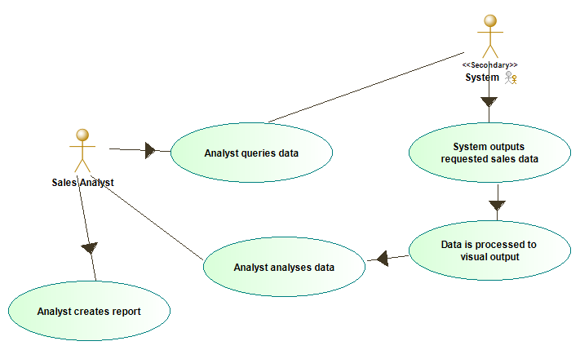

Figure 3: Use Case: Sales analysts interacting with sales data
--------------------------------------------------
CHARACTERISTIC INFORMATION
Goal in Context: To allow Sales analysts to easily formulate and visualize patterns in sales data
Scope: Sales analyst system interaction
Level: Primary task
Preconditions: User is an employee and has access to sales data
Success End Condition: Visualized and analized information
Failed End Condition: Data contains no pattern or is unreachable
Primary Actor: Sales analyst
Trigger: Sales analyst querries data
----------------------------------------
MAIN SUCCESS SCENARIO
1. analyst queries data
2. Data visualizes
3. Analyst processes and analyses data into a report
----------------------
RELATED INFORMATION (optional)
Priority: Top priority
Performance Target: Completed system interaction
Frequency: Daily
Subordinate Use Cases: Backend updates other stakeholders
Channel to primary actor: Backend system, internet, data readout
Secondary Actors: NONE
Channel to Secondary Actors: N/A
----------------------------
SCHEDULE
Due Date: Version 1.0 release

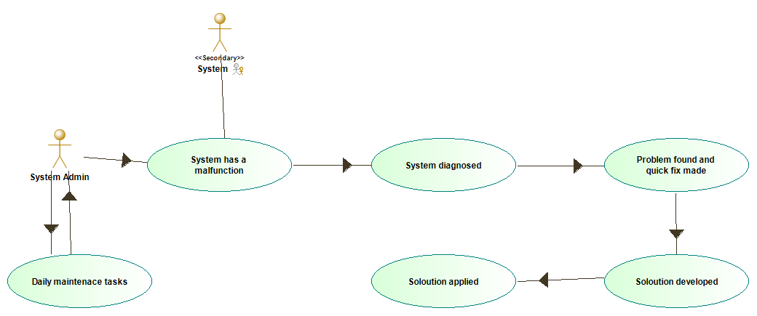
Figure 4: Use Case: System administrator keeping the system up and running
--------------------------------------------------
CHARACTERISTIC INFORMATION
Goal in Context: To allow System administrators to easily perform mainanence and fixes to the overall system
Scope: System administrator system interaction
Level: Primary task
Preconditions: User is an employee and has access to all backend systems
Success End Condition: Backend systems remain operational
Failed End Condition: System goes down
Primary Actor: System administrator
Trigger: System failure occurence or optimization required
----------------------------------------
MAIN SUCCESS SCENARIO
1. System admin is notified of system failure
2. admin analyses and finds fault
3. admin applies fix or patch
----------------------
RELATED INFORMATION (optional)
Priority: Top priority
Performance Target: Completed system interaction
Frequency: Daily or per occurence
Subordinate Use Cases: N/A
Channel to primary actor: Backend system, System admin UI
Secondary Actors: NONE
Channel to Secondary Actors: N/A
----------------------------
SCHEDULE
Due Date: Version 1.0 release

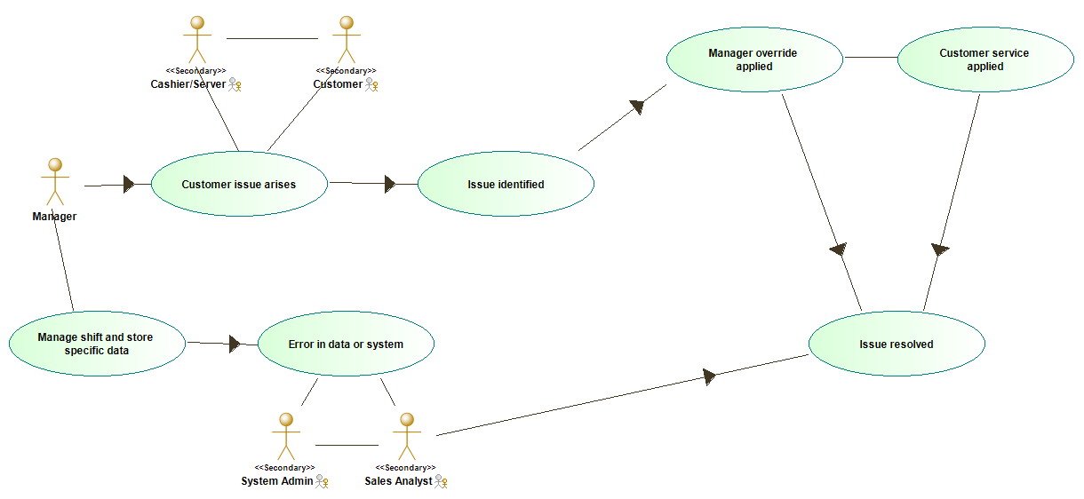
Figure 5: Use Case: Manager maintaining a location on a store by store basis
--------------------------------------------------
CHARACTERISTIC INFORMATION
Goal in Context: To allow Managers to easily maintain a brick and morter store and it's issues
Scope: Manager store interaction
Level: Primary task
Preconditions: Manager is at a store location and the store is open
Success End Condition: All issues resolved
Failed End Condition: Store loses a customer or system
Primary Actor: Manager
Trigger: Employee or store has an issue
----------------------------------------
MAIN SUCCESS SCENARIO
1. Server has an issue that cannot be resolved
2. Manager attends to issue
3. Issue is resolved technically or through customer service
----------------------
RELATED INFORMATION (optional)
Priority: Top priority
Performance Target: All issues resolved
Frequency: Daily or per occurence
Subordinate Use Cases: Ice cream server sale transaction
Channel to primary actor: Ice cream server or customer to manager
Secondary Actors: Ice cream server, Customer
Channel to Secondary Actors: customer to server or system to server
----------------------------
SCHEDULE
Due Date: Version 1.0 release

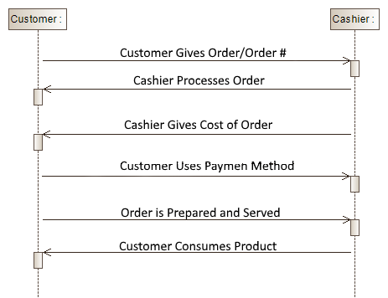
Sequence Diagrams:
Figure 6: Sequence Case 1
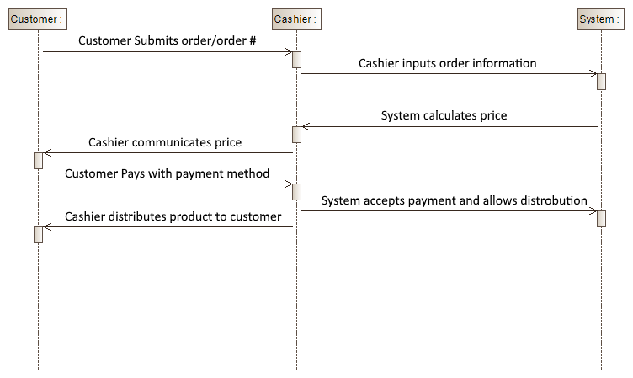
Figure 7: Sequence Case 2

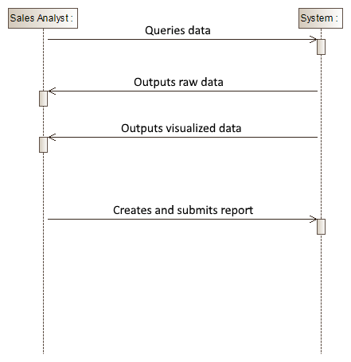
Figure 8: Sequence Case 3
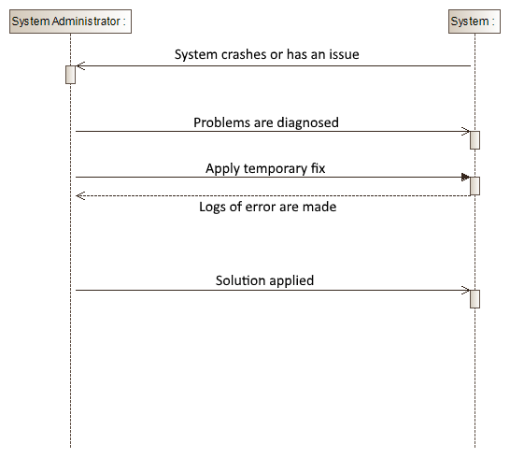
Figure 9: Sequence Case 4

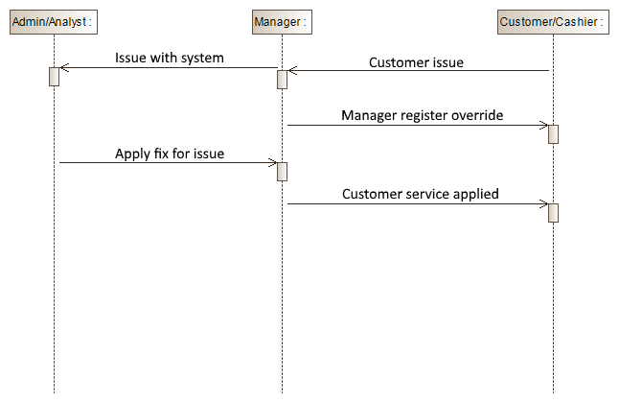
Figure 10: Sequence Case 5

Design Models:
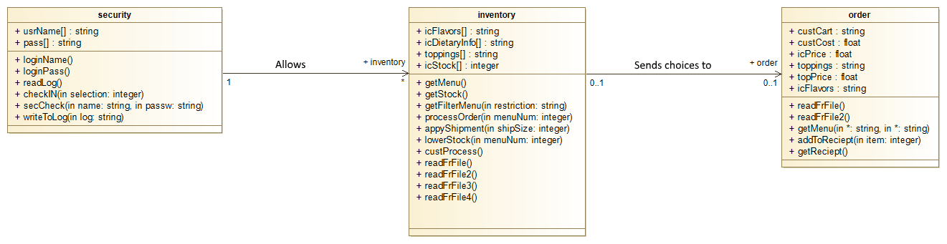
Class Diagram
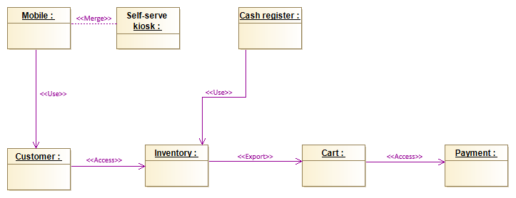
Package Diagram

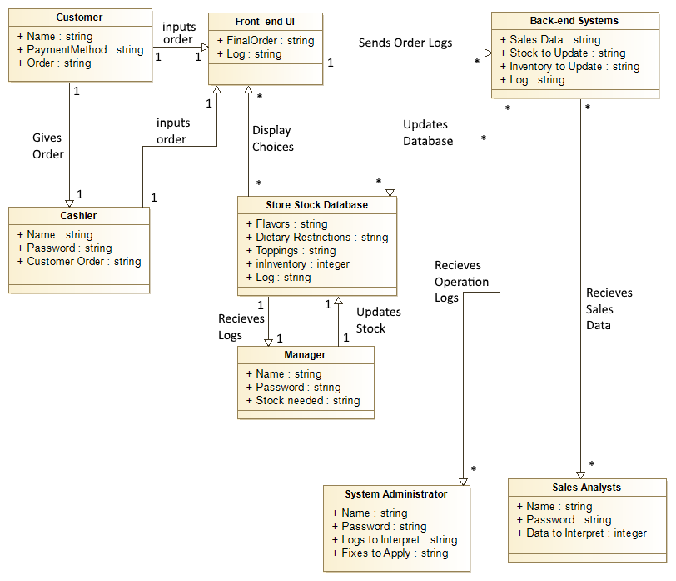
Domain Model

Vision:
Mitchell's Homemade Ice Cream Cloud-Based Manager (MitchCloud)
An infrastructure cloud based system that will run as a service and help unify, simplify, and streamline the shopping and checking out process, it would also be using a centralized data based system for user data, including sales and inventory.

Stake-Holders:
managers- The people who work middle management above ice cream servers and possibly also store owners. Needing access to things like transaction logs, financial, inventory, sales and ordering information.

system administrators- a person who manages the operation of a computer systems, such as a message boards and back-end software.

sale analysts- sales analyst is tasked with a variety of efforts relating to increasing overall sales. This primarily involves analyzing past sales data and market trends, and then using those analyses to produce sales forecasts and strategies.

ice cream servers- The front line workers who directly interact with the customer and the front end of the app. They do not need access to any of the data layers of the app, only how to work the user UI.

customers- The main users of the front end UI and the ones who matter most in the applications functionality. They do not need access to any of the data layers of the app, only how to work the user UI.

Features:
Having the full array of menu items available at Mitchell's Homemade Ice Cream along with specialties and filtering options.

Product information and other related information

Customization of ordering of products provided at any point in the process

Accepts 3 payment forms, cash credit and phone pay

Can detect payment errors and offer alternatives

Keeps logs of all interactions for analysis

POS and kiosk specifically can be used offline

Tracks goods and products required and ordered by Mitchell's Homemade Ice Cream

Ability to change rules on pricing and specials

Real time transactions with third party systems using inventory management, a data access layer, a database sync framework, chatting manager, tax calculator, delivery operation manager, HTTP Request Handler, and payment authorization service.

Business Rules:
-All users must be authenticated to access the system.

-Company employees are restricted to thier access points in the system.

-Only system admins and managers can make changes to the system manually.

-System logging must always be active for all interactions.

-Cash, credit, and phone pay are the only acceptable payment methods.

-System rules can only be changed for fixed seasonal discounts, card holders’ discounts, membership discounts and only a manager can edit and add new rules at any point during off hours.

Supplementary Specification:
Usability
Has interfaces for multiple use cases front and back end with real-time transactions with third party systems.

Reliability
The system has multiple points where people interact with the system and has many forms of data
collection and logging, keeping the system up and running and catching errors is made easy.

Availability
Multiple available hardware/software platforms, access over the internet including Kiosks which can be used even
offline.

Supportability
Connection with databases, logging tools and real-time transactions with 3rd party systems.

Design Constraints
All systems must serve their purpose for the appropriate user while segragating other systems and thier data
from users who should not have access to them.

IMPLIMENTATION CODE:

#include <iostream>
#include <fstream>
#include <string>
#include <sstream>
#include <iomanip>
#include <ctime>
#include<limits>

using namespace std;

class inventory{
public:
inventory();
~inventory();

void getMenu();
void getStock();
void getFilterMenu(string restriction);
int processOrder(int menuNum);
void appyShipment(int shipSize);
void lowerStock(int menuNum);
void custProcess();
void writeToFile();

private:
string icFlavors[24];
string icDietaryInfo[24];
string toppings[20];
int icStock[24];

void readFrFile();
void readFrFile2();
void readFrFile3();
void readFrFile4();
};

#include "inventory.h"

class salesAnalysis
{
public:
salesAnalysis();
~salesAnalysis();

float getSales();
float getBreakEvenProfit();
float getOverhead();

void addOverhead(float cost);
void addSales(float profit);

void writeToFile();

protected:

private:
float totalSales, overhead, breakinEven;

void setBreakEven();
void readFrFile();
};

#include "salesAnalysis.h"

class order{
public:
order();
~order();

void getMenu(string*, string*);
void addToReciept(int item);
void getReciept();
float getCustCost();

private:
string custCart;
float custCost= 0.00;

const float icPrice= 6.20;
const float topPrice= 0.35;
string icFlavors[24];
string toppings[20];

void readFrFile();
void readFrFile2();
};

#include "order.h"

class security{
public:
security();
~security();

string loginName();
string loginPass();
void writeToLog(string log);
void readLog();
int checkIN(int selection);
int secCheck(string name, string passw);

private:
string usrName[4]= {"ICE", "FLOYD", "METALLICA","ZEPPELIN"};
string pass[4]= {"CUBE", "THINICE", "UNDERICE","ICEANDSNOW"};
};

#include "inventory.h"

inventory::inventory(){
readFrFile();
readFrFile2();
readFrFile3();
readFrFile4();
}

inventory::~inventory(){
//dtor
}

void inventory::getMenu(){
cout<< "\nICE CREAMS:"<< setw(65)<< right<< "DIETARY RESTRICTIONS:";
for(int i= 0; i< 24; i++){
cout<< "\n"<< i+1<< ". "<< icFlavors[i]<< setw(60 - icFlavors[i].length())<< right<< icDietaryInfo[i];
}
cout<< "\n\nTOPPINGS:";
for(int j= 0; j< 14; j++){
cout<< "\n"<< j+30<< ". "<< toppings[j];
}
}

void inventory::getStock(){
cout<< "\nICE CREAM STOCK BY PERCENT:";
for(int i= 0; i< 24; i++){
cout<< "\n"<< i<< ". "<< icFlavors[i]<< setw(60 - icFlavors[i].length())<< right<< icStock[i];
}
}

int inventory::processOrder(int orderNum){
int sentOrder= orderNum;
return sentOrder;
}

void inventory::lowerStock(int menuNum){
icStock[menuNum]-= 2;
}

void inventory::appyShipment(int shipSize){
for(int i= 0; i< 24; i++){
icStock[i] += shipSize;
}
getStock();
}

void inventory::getFilterMenu(string restriction){
cout<< "\nFILTERRED ICE CREAMS:" << setw(55)<< right<< "DIETARY RESTRICTIONS:";
if(restriction== "all"){
for(int i= 0; i< 24; i++){
if(icDietaryInfo[i] != "-None"){
cout<< "\n"<< i<< ". "<< icFlavors[i]<< setw(60 - icFlavors[i].length())<< right<< icDietaryInfo[i];
}
}
}else{
for(int i= 0; i< 24; i++){
if(icDietaryInfo[i] == ("-" + restriction)){
cout<< "\n"<< i<< ". "<< icFlavors[i]<< setw(60 - icFlavors[i].length())<< right<< icDietaryInfo[i];
}
}
}
cout<< "\n\n";
};

//////////////////////////////////////////////////////////////////////////////////////////////////////////////////////

void inventory::readFrFile(){
ifstream infile1;
string tempStr;
string token;

const char s= ',';
int i= 0;

infile1.open("data/Flavors.txt");
infile1 >> tempStr;

istringstream strs(tempStr);

while(getline(strs, token, s)){
icFlavors[i]= token;
i++;
}
infile1.close();
}

void inventory::readFrFile2(){
ifstream infile2;
string tempStr;
string token;
const char s= ',';
int i= 0;
infile2.open("data/Dietary.txt");
infile2 >> tempStr;

istringstream strs1(tempStr);

i= 0;
while(getline(strs1, token, s)){
icDietaryInfo[i]= token;
i++;
}
infile2.close();
}
void inventory::readFrFile3(){
ifstream infile3;
string tempStr;
string token;
const char s= ',';
int i= 0;
infile3.open("data/Toppings.txt");
infile3 >> tempStr;

istringstream strs3(tempStr);

i= 0;
while(getline(strs3, token, s)){
toppings[i]= token;
i++;
}
infile3.close();
}
////////////////////////////////////////////////
void inventory::readFrFile4(){
ifstream infile4;
string tempStr;
string token;
const char s= ',';
int i= 0;
infile4.open("data/Stock.txt");
infile4 >> tempStr;

istringstream strs4(tempStr);

i= 0;
while(getline(strs4, token, s)){
icStock[i]= stoi(token);
i++;
}
infile4.close();
}
////////////////////////////////////////////////
void inventory::writeToFile(){
ofstream outfile;
outfile.open("data/Stock.txt");
for(int i= 0; i< 24; i++){
outfile<< icStock[i]<< ",";
if(i== 23){
outfile<< icStock[i];
}
}
outfile.close();
};

#include "salesAnalysis.h"

salesAnalysis::salesAnalysis(){
readFrFile();
}

salesAnalysis::~salesAnalysis(){
//dtor
}

float salesAnalysis::getSales(){
return totalSales;
}

float salesAnalysis::getBreakEvenProfit(){
return (totalSales - overhead);
}

float salesAnalysis::getOverhead(){
return overhead;
}

void salesAnalysis::addOverhead(float cost){
overhead+= cost;
}

void salesAnalysis::addSales(float profit){
totalSales+= profit;
}

void salesAnalysis::setBreakEven(){
breakinEven= totalSales - overhead;
}

void salesAnalysis::readFrFile(){
ifstream infile1;
string tempStr;
string token;

const char s= ',';
int i= 0;

infile1.open("data/Sales.txt");
infile1 >> tempStr;

istringstream strs(tempStr);

while(getline(strs, token, s)){
if(i== 0){
totalSales= stof(token);
}else if(i== 1){
overhead= stof(token);
}else{
breakinEven= stof(token);
break;
}
i++;
}
infile1.close();
}

void salesAnalysis::writeToFile(){
ofstream outfile;
outfile.open("data/Sales.txt");

outfile<< totalSales<< ",";
outfile<< overhead<< ",";
outfile<< breakinEven;
outfile.close();
};

#include "order.h"

order::order(){
readFrFile();
readFrFile2();
}

order::~order(){
//dtor
}

void order::readFrFile(){
ifstream infile1;
string tempStr;
string token;
const char s= ',';
int i= 0;

infile1.open("data/Flavors.txt");
infile1 >> tempStr;

istringstream strs(tempStr);

while(getline(strs, token, s)){
icFlavors[i]= token;
i++;
}
infile1.close();
}

void order::readFrFile2(){
ifstream infile2;
string tempStr;
string token;
const char s= ',';
int i= 0;
infile2.open("data/Toppings.txt");
infile2 >> tempStr;

istringstream strs2(tempStr);

i= 0;
while(getline(strs2, token, s)){
toppings[i]= token;
i++;
}
infile2.close();
}

void order::addToReciept(int item){
if(item < 25){
custCart+= icFlavors[item] + "\n";
custCost+= icPrice;
}else{
custCart+= toppings[item-30] + "\n";
custCost+= topPrice;
}
}

void order::getReciept(){
cout<< "Ice Cream = $6.20 Toppings = $0.35\n";
cout<< custCart;
cout<< "\nTOTAL: $";
cout<< custCost;
cout<< "\n";
}

float order::getCustCost(){
return custCost;
}

#include "security.h"

security::security()
{
//ctor
}

security::~security()
{
//dtor
}

string security::loginName(){
string tempUname;

cout<< "Please enter User name: ";
cin>> tempUname;
return tempUname;
}

string security::loginPass(){
string tempPass;

cout<< "Please enter a Password: ";
cin>> tempPass;
return tempPass;
}

int security::secCheck(string name, string passw){
// Cashier, Customer
if((name == usrName[0] && passw== pass[0]) || (name == usrName[1] && passw== pass[1])){
return 1;
}else{
// Manager
if(name == usrName[2] && passw== pass[2]){
return 2;
}
// Sales
if(name == usrName[3] && passw== pass[3]){
return 3;
}
}
}

void security::writeToLog(string log){
ofstream outfile;
outfile.open("data/SysLog.txt", ios_base::app);

time_t now = time(0);
tm *ltm = localtime(&now);

outfile<< ltm->tm_hour<< ":"<< ltm->tm_min<< ":"<< ltm->tm_sec<< "_"<< ltm->tm_mday<< "/"<< ltm->tm_mon<< "/"<< 1900 + ltm->tm_year<< "___";
outfile<< log<< "\n";
outfile.close();
};

void security::readLog(){
ifstream infile;
string tempStr;

infile.open("data/SysLog.txt");
while (!infile.eof()) {
infile >> tempStr;
cout<< tempStr<< "\n";
}
infile.close();
};

int security::checkIN(int selection){
if((!(cin>> selection)) || selection < 0){
while(!(cin >> selection)) {
cout << "Incorrect input. Hit ENTER to try again.\n";
cin.clear();
cin.ignore(numeric_limits<streamsize>::max(), '\n');
}
while(selection < 0){
cout << "The number you entered is negative. Please enter a positive number to continue.\n";
cin.clear();
cin.ignore(numeric_limits<streamsize>::max(), '\n');
}
}
return selection;
};

// MAIN
#include "security.h"

int main(){
security sys;
string tempPass, tempUname;
int selection, sizeOfShip, secCheck;

tempUname= sys.loginName();
tempPass= sys.loginPass();
secCheck= sys.secCheck(tempUname, tempPass);

if(secCheck>= 1){
if(secCheck== 1){
cout<< "\nWelcome ELEVATED USER! \nLoading updates...\nWelcome to Mitchel's Homemade Ice Cream!\n";
}else{
cout<< "\nWelcome USER! \nLoading updates...\nWelcome to Mitchel's Homemade Ice Cream!\n";
}
inventory inven;
order cart;
salesAnalysis numDat;
sys.writeToLog("LOGGED_IN:" + tempUname);

while(true){
if(secCheck>= 2){
cout<< "1= View menu 2= I have dietary restrictions 3= View cart 4= Exit 5= Elevated options(admin only)\n";
selection= sys.checkIN(selection);
}else{
cout<< "1= View menu 2= I have dietary restrictions 3= View cart 4= Exit\n";
selection= sys.checkIN(selection);
if(selection> 4){
cout<< "Sorry, that is not an option!\n";
continue;
}
}
/////////////////////////////////////////////////////////////
if(selection== 1){
inven.getMenu();
cout<< "\nEnter choice or 0 to go back:\n";
while(true){
selection= sys.checkIN(selection);;
if(selection== 0){
break;
}else{
cart.addToReciept(inven.processOrder(selection));
inven.lowerStock(selection);
if(selection>= 30){
numDat.addSales(6.20);
}else{
numDat.addSales(0.35);
}
sys.writeToLog("Item:" + to_string(selection) + "_ordered");
cout<< "Would you like more? Or toppings? Press 0 to go back:\n";
}
}
}
/////////////////////////////////////////////////////////////
if(selection== 2){
cout<< "Please enter your restriction:\n"<< "1= Vegan 2=Egg Free 3=All 4= Back\n";
selection= sys.checkIN(selection);
if(selection== 1){
inven.getFilterMenu("Vegan");
cout<< "\nEnter choice or 0 to go back:\n";
while(true){
selection= sys.checkIN(selection);
if(selection== 0){
break;
}else{
cart.addToReciept(inven.processOrder(selection));
inven.lowerStock(selection);
if(selection>= 30){
numDat.addSales(6.20);
}else{
numDat.addSales(0.35);
}
sys.writeToLog("Item:" + to_string(selection) + "_ordered");
cout<< "Would you like more? Or toppings? Press 0 to go back:\n";
}
}
}
if(selection== 2){
inven.getFilterMenu("Egg_Free");
cout<< "\nEnter choice or 0 to go back:\n";
while(true){
selection= sys.checkIN(selection);
if(selection== 0){
break;
}else{
cart.addToReciept(inven.processOrder(selection));
inven.lowerStock(selection);
if(selection>= 30){
numDat.addSales(6.20);
}else{
numDat.addSales(0.35);
}
sys.writeToLog("Item:" + to_string(selection) + "_ordered");
cout<< "Would you like more? Or toppings? Press 0 to go back:\n";
}
}
}
if(selection== 3){
inven.getFilterMenu("all");
cout<< "\nEnter choice or 0 to go back:\n";
while(true){
selection= sys.checkIN(selection);
if(selection== 0){
break;
}else{
cart.addToReciept(inven.processOrder(selection));
inven.lowerStock(selection);
if(selection>= 30){
numDat.addSales(6.20);
}else{
numDat.addSales(0.35);
}
sys.writeToLog("Item:" + to_string(selection) + "_ordered");
cout<< "Would you like more? Or toppings? Press 0 to go back:\n";
}
}
}
if(selection!= 1 && selection!= 2 && selection!= 3){
continue;
}
}

if(selection== 3){
cart.getReciept();
sys.writeToLog("Receipt_requested");
continue;
}
/////////////////////////////////////////////////////////////
if(selection== 4){
break;
}
/////////////////////////////////////////////////////////////
if(selection== 5){
while(secCheck== 2){
cout<< "\n1= show stock 2= Order Stock 3=View System Logs 4= Back\n";
selection= sys.checkIN(selection);
if(selection== 1){
inven.getStock();
sys.writeToLog("Total_Stock_requested");
}
if(selection== 2){
cout<< "\nWhat was the size of the shipment in ounces?\n";
sizeOfShip= sys.checkIN(selection);
inven.appyShipment(sizeOfShip);
numDat.addOverhead(sizeOfShip * 2.60);
sys.writeToLog("Shipment_of=" + to_string(sizeOfShip));
}
if(selection== 3){
sys.readLog();
sys.writeToLog("Logs_Viewed");
}
if(selection> 3){
break;
}
}
while(secCheck== 3){
cout<< "\n1= Show Sales 2= Show Overhead 3=View Net Profit 4= Back\n";
selection= sys.checkIN(selection);
if(selection== 1){
sys.writeToLog("Sales_Numbers_Analysis_Viewed");
cout<< "\nTotal profits: "<< numDat.getSales()<< "\n";
}
if(selection== 2){
sys.writeToLog("Overhead_Analysis_Viewed");
cout<< "\nTotal business overhead: "<< numDat.getOverhead()<< "\n";
}
if(selection== 3){
sys.writeToLog("Net_Profits_Analysis_Viewed");
cout<< "\nNet Profits: "<< numDat.getBreakEvenProfit()<< "\n";
}
if(selection== 4){
break;
}
}
}
numDat.writeToFile();
inven.writeToFile();
}
}else{
cout<< "\nI'm sorry your user name or password is incorrect please try again or contact customer support.\n";
sys.writeToLog("incorrect_manager_login_USERNAME=" + tempUname + "_PASSWORD=" + tempPass);
}
sys.writeToLog("SYS_EXIT");
return 0;
}

