WORKER:-

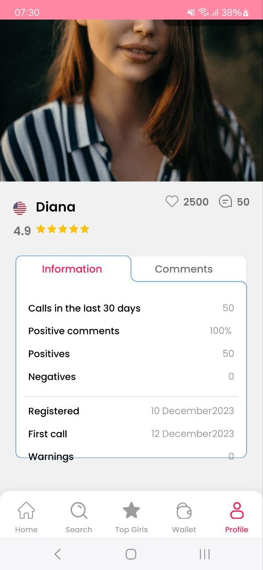
-Here "Warnings" comes out of the profile box.
-Here I hit "more" and it doesn't open to see more

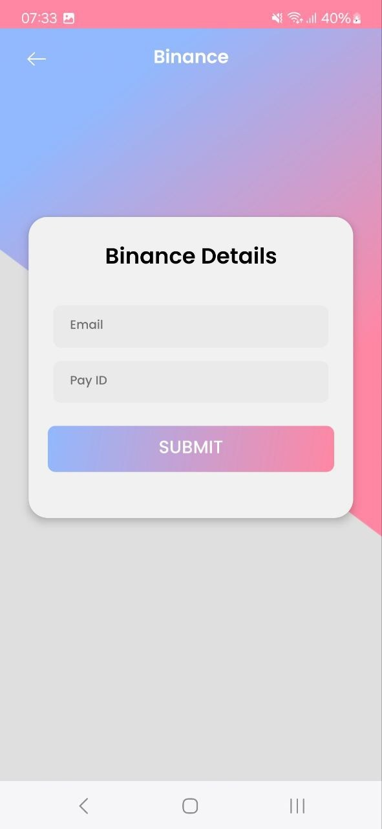
-Here I saved some random data and instead of exiting to enter the data again, the data I entered and the option to edit should appear.

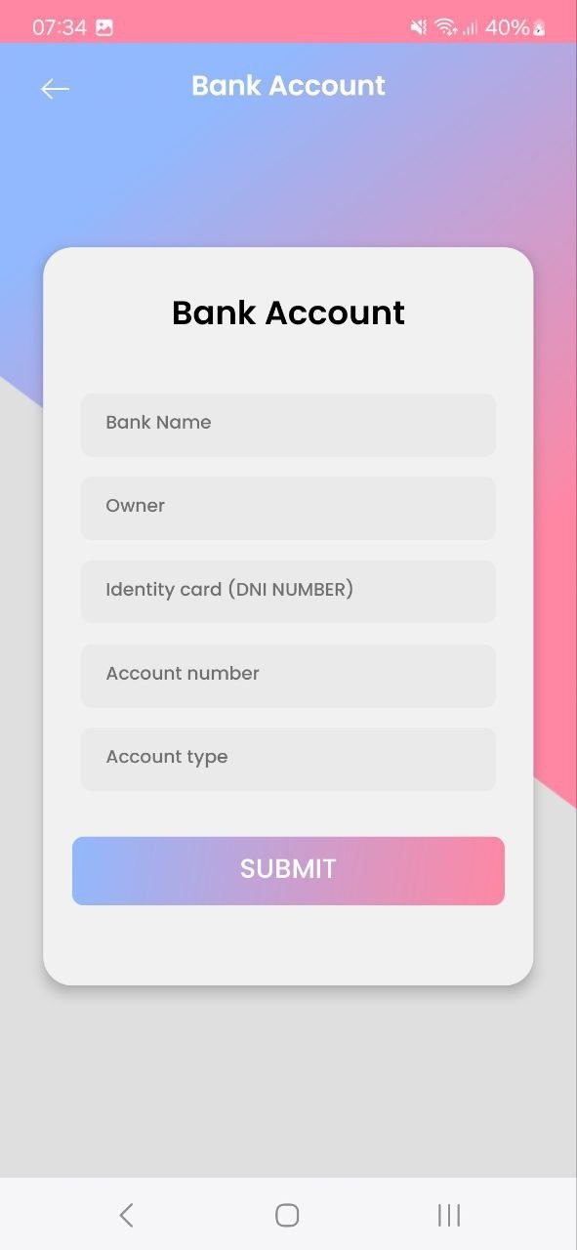Same Here
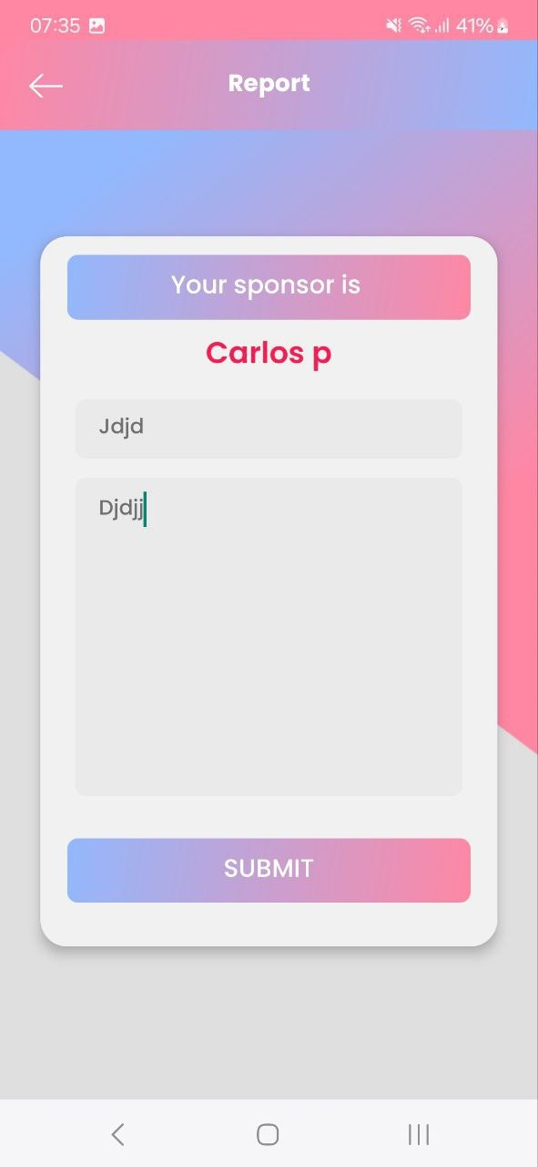
The option to upload evidence of why you report to your sponsor is missing here.
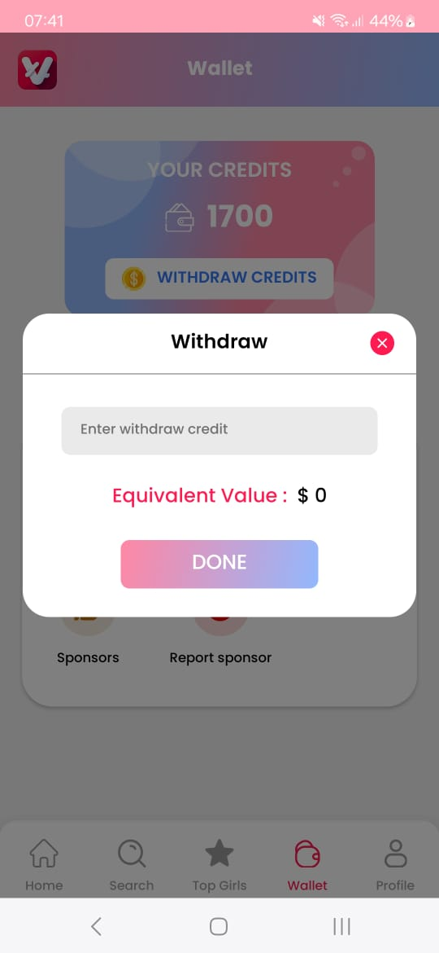
And when withdrawing credits, options like these should appear when you click "

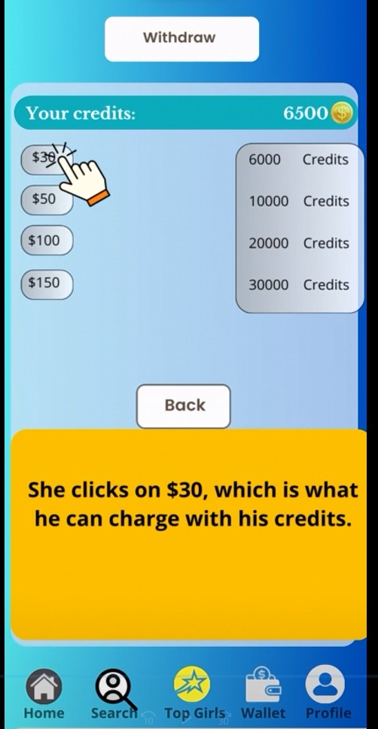This is how it should come out:

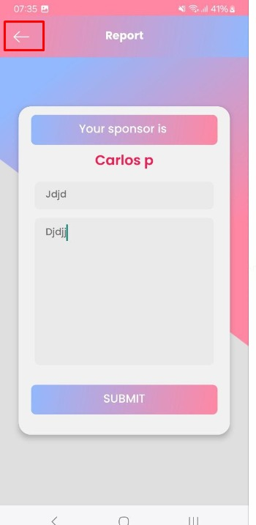When I hit that arrow. It took me out of the app.

USER:-

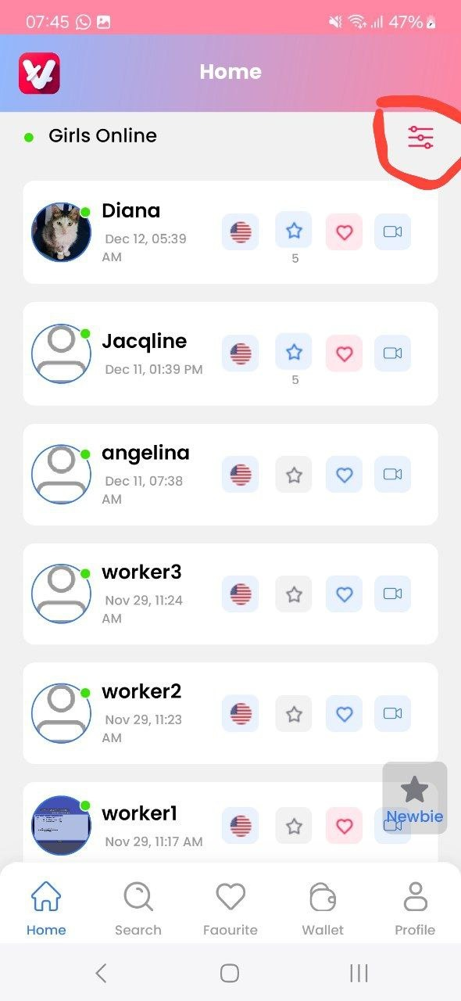
Here by clicking where it is marked. It should appear to filter by country the one that is connected. It doesn't do anything when you click it.

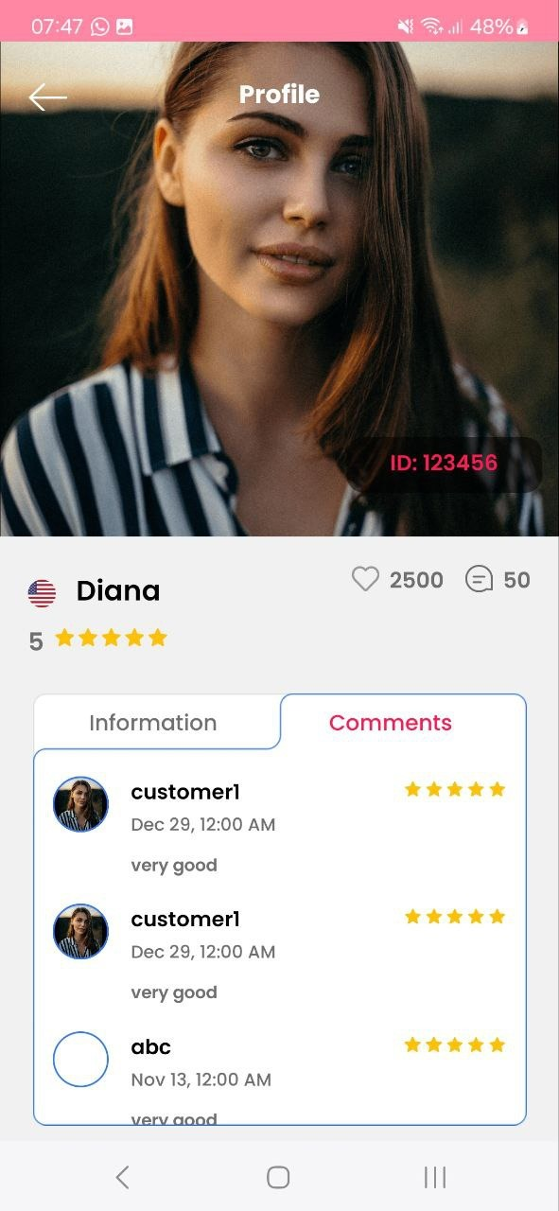

These are missing here that I will show you with the one in the model.

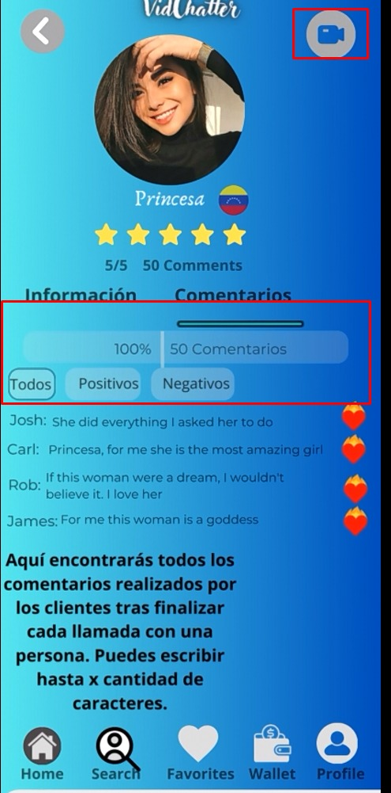

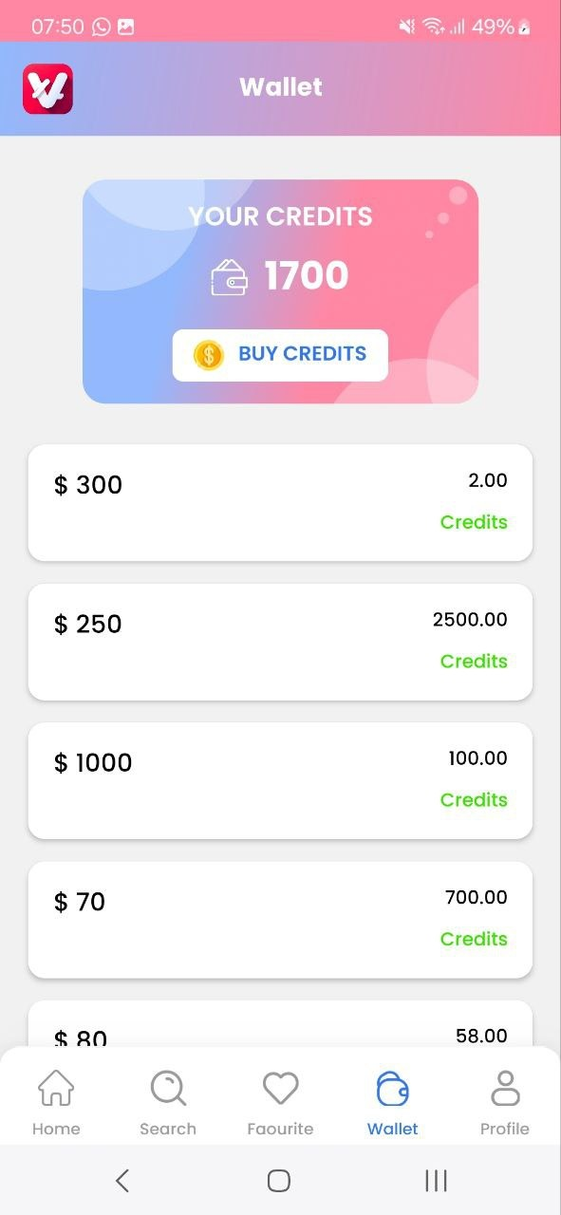

And here it should be:

$5,500 credits
$10 1000 credits
$15 1500 credits
$20 2000 credits
$50 5000 credits
$100 10000 credits
$100 being the maximum allowed.
and when I clicked reload on the options that the app has. It sends me to binance. ._. when there it is with the cryptomus api.

Note:
I have not yet tried the option when it will make a video call. It would be later, right?

I will create the privacy policies, terms of service, and frequently asked questions and answers that will be implemented in the app to send them to you and integrate them there.

