HOPE OCHOLI
FINANCIAL REGULATIONS REPORT
GoogleDrive: https://drive.google.com/drive/folders/1SkNg2mdfkML27yW3E0gHiX3pER4nDJ84?usp=drive_link
Collab: https://colab.research.google.com/drive/1ph-srD_SSh0IHcCb2dU959q5xbE8aj9T

QUESTION 1: CRD IV and Solvency II.
Basel I to Basel III and Solvency II
The evolution of the international bank capital regulation system could be considered a series of progressively advanced responses to the shortcomings of the previous systems. In 1974, after the bankruptcy of Bankhaus Herstatt, the Basel Committee on Banking Supervision (BCBS) was created as a supervisory working party (Badev et al., 2025). The Basel Accord of 1988 introduced a minimum capital requirement of 8% of risk-weighted assets for internationally active banks, using broad regulatory risk buckets.
However, to level the competitive international field, Basel I had limitations such that it did not consider qualitative differences between exposures and between obligors of different credit standings, also being structurally insensitive to the presence of regulatory arbitrage opportunities resulting from securitization (Jones, 2000).
In 2004, Basel II once again identified three pillars, which were the minimum regulatory capital requirements (Pillar 1), supervisory review (Pillar 2), and market discipline (Pillar 3). Pillar 1 introduced new risk-sensitive capital requirements with the Standardized, Foundation IRB, and Advanced IRB approaches; the latter enabling banks to estimate their own probability of default (PD), loss given default (LGD), and exposure at default (EAD), which were the three Basel II deficiencies identified during the global financial crisis.
In 2009, Basel 2.5 required stressed VaR and an incremental risk charge on the trading book. Nevertheless, the finalized Basel III package of December 2017, often referred to by practitioners as ‘Basel IV,' further constrained the capital relief available from internal models by introducing an output floor of 72.5% of standardized RWAs.
Solvency II (Directive 2009/138/EC), which applies to European insurers from January 2016, performs a parallel role in insurance regulation. The directive combines quantitative capital rules, governance requirements, supervisory review, and calibrates solvency around a 99.5% one-year value-at-risk risk standard. Considering that Basel and Solvency II are both post-crisis prudential architectures, but Solvency II is tailored to the balance-sheet and liability structures of insurers rather than banks.

ICAAP, CRD IV, and CRR:
Pillar 2 demands an Internal Capital Adequacy Assessment Process (ICAAP), which is an internal version of the external minimum regulatory requirements. Banks use ICAAP to assess whether their capital is adequate for their specific risk profile, including risks not fully captured under Pillar 1, such as concentration risk, banking book interest rate risk, pension risk, and strategic risk (Resti, 2018). ICAAP is also a risk management instrument and a supervisory communication instrument; the Supervisory Review and Evaluation Process is a step that allows the supervisors to evaluate the ICAAP and apply the bank-specific Pillar 2 Requirements and Guidance as well as minimum regulatory requirements.
The current CRD IV (Directive 2013/36/EU) implemented since January 2014 and has changed the compliance environment in four ways. First, the total capital ratios in the buffer period were much higher than in the pre-crisis period, and there were caps on dividends and variable remuneration if the buffer was breached. Second, the bonus cap limits the variable remuneration of material risk takers to 100 percent or 200 percent with the approval of shareholders for the first time in the global financial markets. Third, the risk and remuneration committees of large institutions were more closely governed, and the number of executive directorships of small institutions was capped. And fourth, the Pillar 3 public disclosures of risk, leverage, liquidity, and remuneration were also strengthened (European Parliament, 2013).

The binding EU rulebook, which is the Capital Requirements Regulation (CRR, Regulation 575/2013), has provided a one-stop shop; no more external shopping for a better regulatory regime and gold plating as in the past. The CRR III will increase the capital requirements for institutions using their own models, and the output floor will be set between 2025 and 2030 (European Parliament, 2024). Collectively, these changes broadened the prudential model of EU bank regulation from a minimal ratio focus to one that included capital, governance, disclosure, and compensation discipline.

EBA, ECB, and Central Banks:

The European Banking Authority, which was set up under Regulation (EU) 1093/2010, backs up supervisory convergence by means of standardized disclosure templates, stress testing, binding technical standards, and guidelines. The market discipline and supervisory credibility tests are stress tests conducted every two years (Resti, 2018). The Single Supervisory Mechanism, with the European Central Bank as the head office, supervises 113 significant institutions through joint supervisory teams that review the Supervisory Review and Evaluation Process (SREP) and conduct model check reviews. National central banks' counter-cyclical policy of creating the CCyB, the O-SII moniker, and a systemic risk buffer remains, showing that a QLA is required by the LCR (Smaga, 2024). The net interest margin has been limited by the short-term wholesale funding available under the NSFR and has prompted a rethink of funding structures and business models in institutions that had relied heavily on short-term wholesale markets.

Banker Remuneration: Critical Perspectives

Bebchuk et al. (2010) offer one of the most critical pre-crisis critiques of banker remuneration. Using compensation data from Bear Stearns and Lehman Brothers, they demonstrate that senior executives were able to take big bonuses during the boom while assuming minimal risk after their companies fell. Their central point is that compensation arrangements rewarded short-term gains while delaying losses, resulting in a convex incentive to take excessive risks. Their recommended solution is to tie remuneration to a broader basket of the firm's securities, including debt-like instruments, so that executives bear losses sustained by both creditors and shareholders.

Limitations of CRD IV and Bebchuk vs Bhagat

EBA guidance is not precise and can be exploited (EBA/GL/2021/04) in the defined periods before the full consequences of actions are realized, where ratio caps ameliorate but do not solve the critical alignment issue. To align the interests of the executive with the entire group of creditors rather than the common shareholders, Bebchuk & Spamann (2009) viewed remuneration as a portfolio of outstanding securities in a firm, such as subordinated debt and preferred stock. Bhagat & Romano (2010) are more modest because they argue for mandatory long-term restricted equity (vesting in a short interval), post-vesting restrictions, and hedges that would enable an executive to sell an equity stake. The Bebchuk-Spamann approach is more elegant but difficult to implement; however, the Bhagat-Romano approach is simpler but less targeted at the convexity problem. This type of argument is followed by Srivastav & Hagendorff (2015) in their analysis of inside debt, defined benefit pension liabilities and deferred compensation as creditor claims on the firm by senior employees and connected to outside debt. They extend the inside debt idea by Edmans & Liu (2010) to conclude that as the ratio of inside debt grows, the bank risk, tail risk, and the likelihood of the bank engaging in a transaction that is not in the interest of shareholders and creditors grows. Moreover, there is a better way to control bank risk-taking than using ordinary pay caps and obsolete methods of equity alignment, which suffers from the convexity problem (Bebchuk & Spamann, 2009)
Combining stricter capital requirements with enhanced governance, transparency, and incentive-alignment mechanisms, CRD IV, CRR, and Solvency II represent the post-crisis trend in Europe toward more overbearing prudential regulation.

QUESTION 2: Securitization and Credit Derivatives.

Definition and Process of Securitization

These illiquid assets (such as mortgages, car loans, credit card debts, corporate loans, etc.) are converted by securitization into tranched tradeable securities, which are sold to investors in capital markets. The originator sells the assets to a bankruptcy-remote Special Purpose Vehicle (SPV), which removes the asset pool from the originator's financial risk. The SPV issues asset-backed securities with varying degrees of seniority (senior, mezzanine, and equity tranches) and is rated by credit rating agencies and sold to investors with varying risk-taking profiles. A servicer receives payment and forwards it to the SPV; credit enhancements such as overcollateralization and reserve accounts are employed to back the preferred ratings on the senior tranches (Hull, 2023, Ch. 8). In the United States, agency mortgage-backed securities are issued or guaranteed by Ginnie Mae and the government-sponsored firms Fannie Mae and Freddie Mac. Sequential-pay CMOs, PAC bonds, and IO/PO strip structures reduce repayment risk and enable investors to choose the tranches that match their liabilities (Hull, 2023).

Securitization Growth, CDS, and Regulatory Arbitrage:

Securitization growth saw the originate-to-hold model yielding to the originate-to-distribute model, where the bank originates loans hoping they can be securitized and gets a fee at the time of loan origination as opposed to net interest margin over the life of the loan. Where the originators retained the loans, the full burden of underwriting errors was borne, but securitization at the point of origin created extreme problems of adverse selection and moral hazard due to asymmetry of information between the originator and the investor. Empirically, Keys et al. (2010) show that securitized mortgages on the boundary of standard screening criteria were far more prone to default than non-securitized mortgages and that there was lower underwriting quality in the originate-to-distribute model.

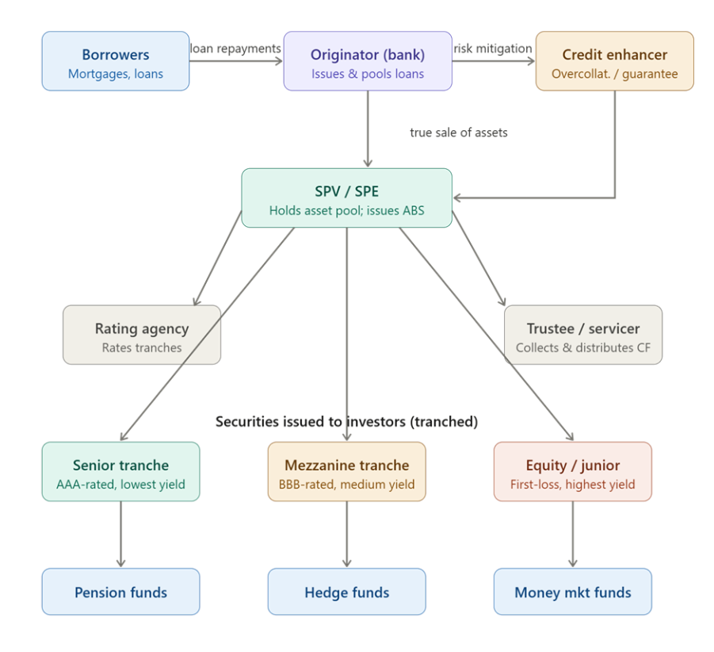
Figure 1: Securitization Growth, CDS, and Regulatory Arbitrage Flowchart
Credit Default Swaps (CDS) were not solely used as a hedging tool, although in the mid-1990s, JP Morgan used them to transfer concentrated credit exposures with no negative tax and accounting implications. At the turn of the century, CDSs were used to create synthetic credit exposures that did not result in a loan transaction and thus accumulated even greater credit risk than the underlying loan markets could manage. The development of CDS index products and their application as reference portfolios by synthetic CDOs culminated this process (Coval et al., 2009). A CDS is a bilateral derivative contract in which the protection buyer pays a periodic premium to the protection seller in exchange for reimbursement if a certain credit event occurs with respect to a reference firm.
The contingent payment is normally the difference between par and recovery value, which is usually decided through an ISDA auction process. A regulatory issue has been whether naked positions (synthetic short positions with no underlying interest) can occur (International Monetary Fund, 2008).

CDS Mechanism Flowchart [Figure 2]
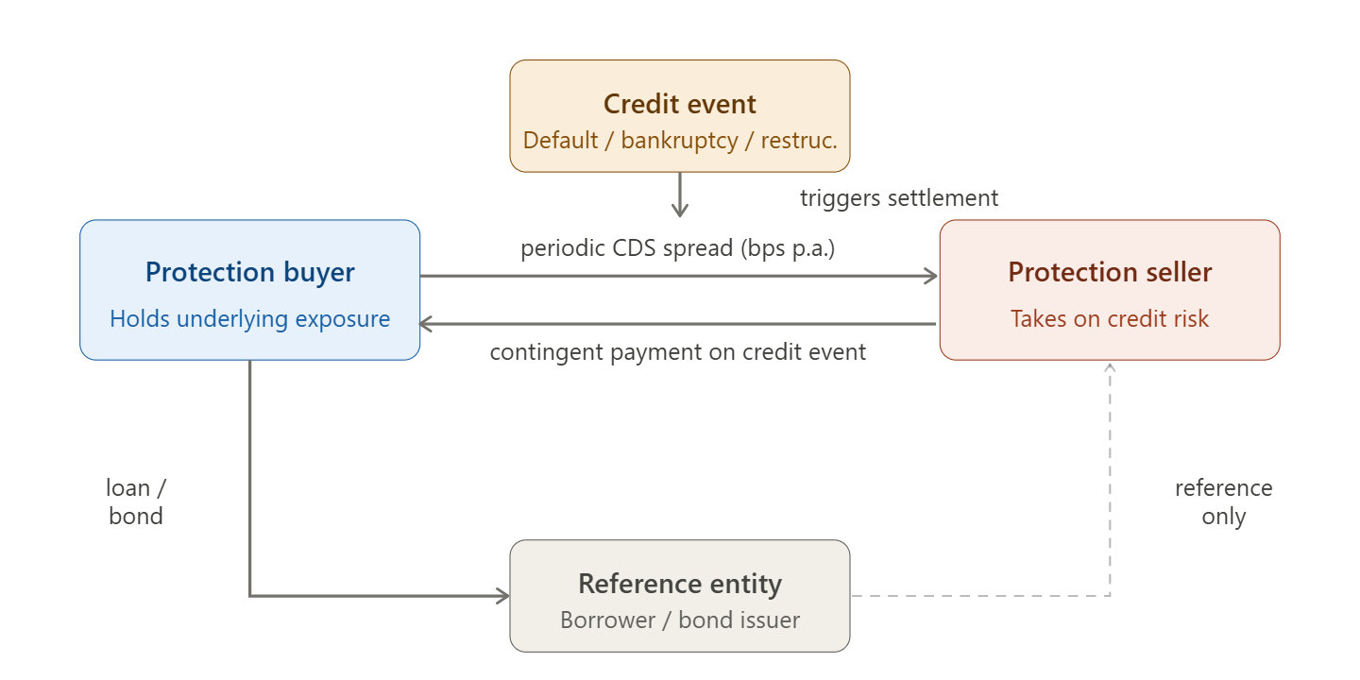
Figure 2: CDS Mechanism Flowchart

Private-label securitization not backed by GSE credit support was enabled by the development of an illusion of credit enhancement with derivatives and the Gaussian copula model of joint default probabilities, now the standard model of CDO pricing in the industry. It had been calibrated very inaccurately to benign period data in systemic stress and produced ratings that were many orders of magnitude too high (Salmon, 2012). Basel I demanded that banks whose ABS were rated AAA bear a 20 per cent risk weight, as opposed to the 100 per cent on underlying mortgages, creating a framework of institutional incentives in which the creation of loans was now the primary goal. Off the balance sheet, short-term ABS portfolios were accumulated in vast numbers through Structured Investment Vehicles and conduits that were funded with short-term Asset-Backed Commercial Paper (ABCP). As investor confidence evaporated in the summer of 2007, the ABCP markets froze, and the sponsoring banks had no choice but to place these vehicles on the balance sheet which triggered twin liquidity and capital crises (International Monetary Fund, 2008).

Partnoy & Skeel (2006, p. 38) express a prophetic three-fold condemnation by disclosure. The bilateral nature of CDS markets, where centralization of reports and positions could not occur, allowed the pooling of systemic risk, which could not be observed by regulators and was later subject to reporting at a subsequent date under Dodd-Frank and EMIR. On credit ratings, issuing investment-grade ratings by issuer-paid agencies with structural conflicts of interest with tranches of CDOs based on models that issuers could manipulate provided a false sense of safety to investors who relied on ratings as an alternative to analysis. On safe harbors in bankruptcy, the provisions granting CDS counterparties the right to unwind and preserve their positions without regard to the automatic stay that other creditors receive the disciplinary role of bankruptcy under compromise and remain unresolved under the current law. However, this is a classic example of regulatory arbitrage and capital standards treated highly rated securitized claims as safer than the underlying exposures, even when the risk had not been eliminated but only rearranged.

Structured Finance, CDOs, and CDO-Squared:

The IMF Global Financial Stability Report describes structured finance as instruments having their credit risk determined based on the structure of the cash flows, rather than the underlying pool of assets, and tranching allows securities to be rated at a higher level than the underlying collateral (International Monetary Fund, 2008). The boom before the crisis was a hunt after yield in a world of excessive global liquidity; systematic underpricing of correlation the originator; originator, and the CDS market, which allowed synthetic recreation of cash market exposures, in the form of CDOs of different seniority on cash flows of the underlying pool. Mezzanine tranches are the second and subsequent losers; senior tranches are the AAA-rated tranches, insured by all the junior tranches; the equity tranche, typically 3-5 percent of the capital structure, is the first loser.

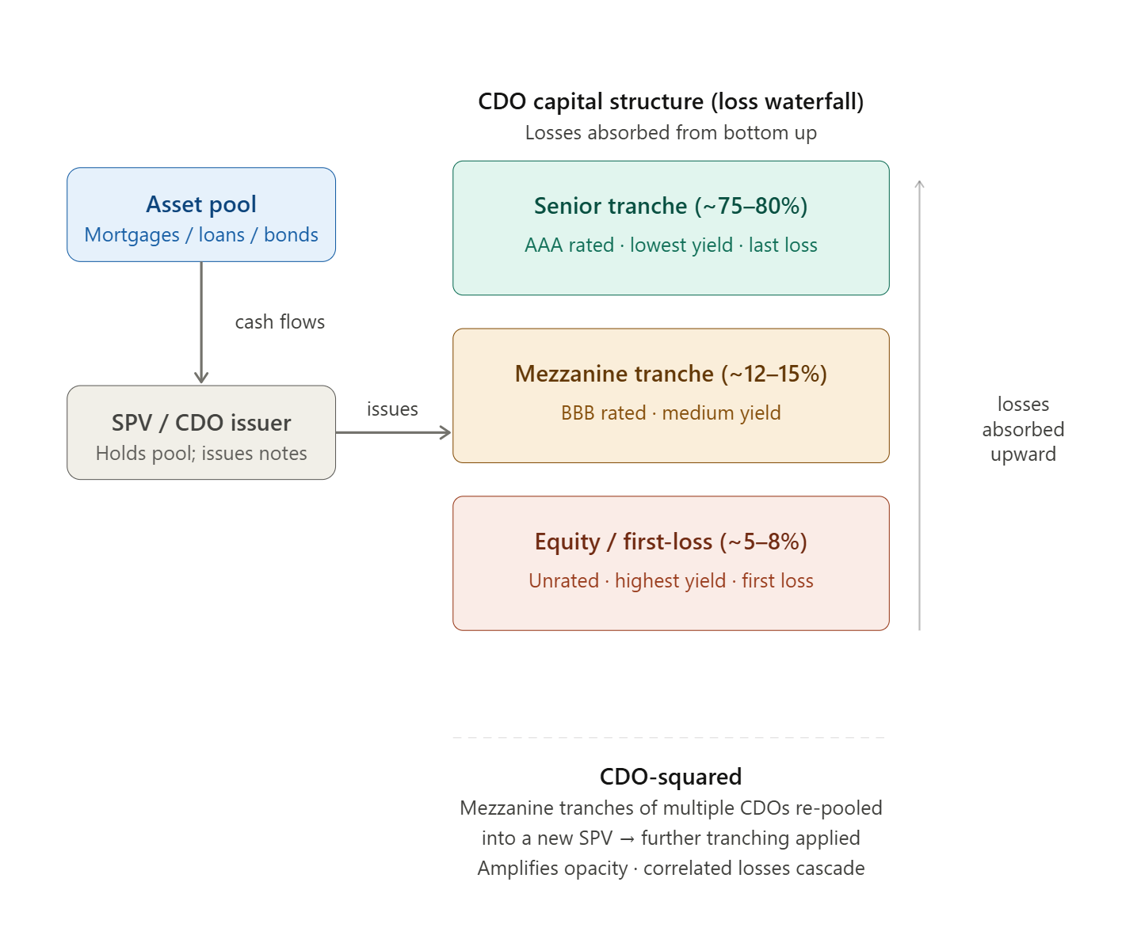
Figure 3: A CDO-Squared Structure
A CDO-squared is a CDO whose reference portfolio consists of tranches of other CDOs, making it even more complex and even more dependent on model assumptions about correlation and tail risk. Rating agencies calculated systematic risk using Gaussian copula models to estimate grade assets by regulation demanded investment grade assets. Structural problems are most resistant to correction: they are dependent on assumptions of correlation that are impossible to observe and volatile by nature, and regulation uses ratings as a proxy to measure risk. The crisis has led to reforms that have treated the symptoms of risk retention and STS labeling, but the epistemological issue regarding the complex structured finance instruments that are difficult to value even by those involved in the market has no incentives but incentives, but also epistemic fragility: the most senior tranches appeared safe only because markets, models, and regulation consistently underestimated correlation and systemic risk.

QUESTION 3
The Four Horsemen, CFMA and ISDA:

Partnoy (2002) argues that the four horsemen of U.S. derivatives regulation are the Federal Reserve, the SEC, the CFTC, and the OCC, a disjointed and overlapping regulatory system whose jurisdictional boundaries were determined by historical accident. The Commodity Futures Modernization Act of 2000 mainly exempted qualifying OTC derivatives between eligible contract participants from meaningful CFTC monitoring and left a market rapidly growing in terms of notional amounts, to hundreds of trillions of dollars, outside the effective reach of public regulation. Partnoy (2002) describes this as the victory of the law of the individual over the law of the state. The law of the systemically important market was the ISDA Master Agreement documentation, whose institutional interests were those of dealer banks and not systemic risk. ISDA has played on both sides, and its documentation standardization (ISDA Master Agreement, Credit Support Annex, and definitional booklets) lowers transaction costs while providing a measure of legal certainty about the enforceability of netting and was a precondition to BIS acceptance that bilateral netting was to be included in regulatory capital requirements. Its darker side is that it is an institutional form of dealer bank resistance to compulsory clearing and reporting and other forms of public regulation. The post-crisis reforms have limited the de facto regulatory powers of ISDA by forcing them to clear and report; however, it is worth noting that instruments too complicated to be regulated at the micro-level by legislators have been codified into contracts (Partnoy, 2002). As a result, ISDA decreased private transaction costs while also contributing to the establishment of a market structure that resisted increased state control.

CCPs, Dodd-Frank, EMIR, and Duffie:

Cecchetti et al. (2009) provide the economic rationale in support of compulsory CCP clearing: bilateral OTC markets create negative externalities that no individual market participant has much incentive to internalize. A CCP acts as an intermediary between buyer and seller through novation, allowing positions to be netted multilaterally between clearing members, such that all positions requiring collateralization have their gross notional value greatly lowered. This improves transparency and reduces gross bilateral exposures, although it also concentrates risk in a systemically important node. As a result, robust default waterfalls and credible resolution frameworks are essential. The G20 Pittsburgh commitment that standardized OTC derivatives be cleared by CCPs but, where practicable, electronically traded and reported to trade repositories is operationalized by Dodd-Frank VII (2010) and EMIR (Regulation (EU) 648/2012). Dodd-Frank required standardized interest rate and credit default swaps to be cleared, swap execution facilities to be traded, real-time reporting to swap data repositories, and uncleared swaps to be more highly marginated. EMIR has a category-based requirement to clear financial and non-financial counterparties above the ESMA limits; a bilateral risk reduction framework in which prompt confirmation, reconciliation of portfolios, daily market-to-market, and bilateral margin are introduced proportionally to smaller non-financial counterparties; EMIR 3.0 (2024) addressed the active account issues during the post-Brexit period.
Duffie (2016) lists five remaining vulnerabilities. First, the concentration of clearing in a small number of CCPs raises the possibility of a "too important to fail" scenario. Second, low data quality and fragmentation across trade repositories impede real-time systemic risk monitoring. Third, more usage of compression services is required to lower gross notional exposures. Fourth, exemptions in FX derivatives protect regulatory arbitrage opportunities. Fifth, migrating derivatives activity by less regulated non-bank firms does not eliminate risk but rather relocates it. Existing problems in quality and aggregation of information across trade repositories limit real-time observation of systemic risk on a repository-by-repository basis and require legal entity identifiers. Further portfolio compression facilities are required on gross notional exposures. The Dodd-Frank exemption generated regulatory arbitrage in an FX derivatives market of global concern. Transferring OTC derivatives to less-regulated non-banks does not mitigate the risk of shadow banking.

Margining, EMIR Architecture, MiFID II and ESMA:

Hull (2023) explains that the futures margining system aims at containing the credit exposure to just a day's price movement by imposing an initial margin at the time of the contract initiation and a daily mark-to-market variation margin, settling all gains and losses in cash. Maintenance margin requirements force an immediate restoration of margin accounts after adverse price movements that lead to the closeout of positions before losses post-collision from posted collateral surpass them. The application of similar margining logic after the crisis to OTC derivatives by the mandate on variation and initial margin for both cleared or uncleared instruments is the most direct transposition of the futures model of managing risk to the OTC market (Hull, 2012). EMIR's three pillars are transparency, mandatory clearing, and risk mitigation for non-cleared derivatives. The transparency pillar involves reporting derivatives contracts to registered trade repositories within the applicable reporting timelines. The so-called mandatory clearing pillar obligates the clearing of standardized types of OTC derivatives that meet ESMA's criteria through authorized CCPs. The risk mitigation pillar calls for timely confirmation and the harmonization of portfolios and bilateral margin requirements under the BCBS-IOSCO framework. In bilateral clearing, credit risk is placed in the hands of individual agreed arrangements as to collateral in the event of a default, and available nettings only within each bilateral relationship. CCP clearing novates the CP into every transaction, which allows multilateral netting across all clearing members, ensures full position visibility, and provides real-time risk surveillance. CCP risk management works on a default waterfall, initial margin, a defaulting member's default fund contribution, CCP skin-in-the-game capital, default fund contributions mutualistically from surviving members, and assessment rights as a last resort, calibrated to the Cover 2 standard of surviving the simultaneous default of the two largest clearing members.

[Figure 4: Bilateral vs. CCP Clearing Diagram].
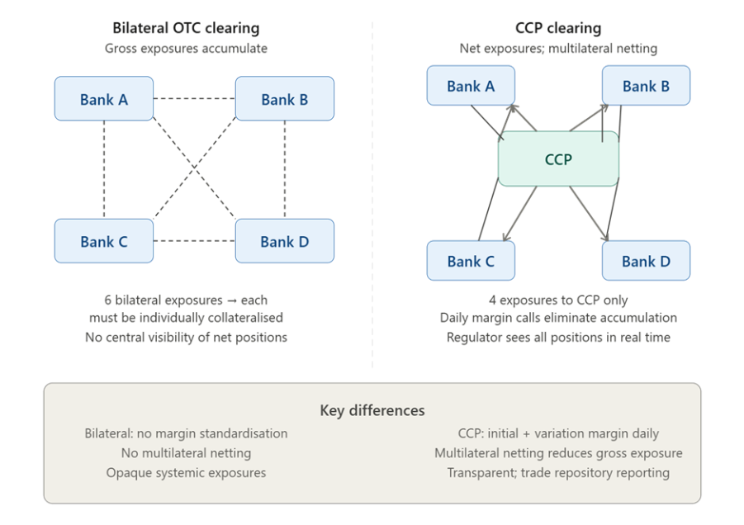
Figure 4: Bilateral vs. CCP Clearing Diagram

EMIR placed significant operational demands on financial counterparties through clearing arrangements with CCP to settle daily variation margin, amongst other measures, phased bilateral initial margin requirements, and investment in data infrastructure and legal entity identifier (LEI) maintenance. The updated EMIR reporting technical standards from April 2024 increased the reporting field changes and harmonized formats with CFTC standards at extra industry-wide systems investment (ESMA, 2022). MiFID I (Directive reporting and harmonized conduct standards and the level of transparency of equity markets, as well as passporting) was inadequate for the needs of the MTF sector, the transparency of non-equity markets, markets, and investor protection in the context of complex products. MiFID II (Directive 2014/65/EU) and MiFIR (Regulation (EU) 600/2014) from January 2018 extend the scope of transparency and cover bonds, structured finance products, harmonized derivatives, and derivatives; , create the OTF category; improve investor protection via product governance, inducements restrictions, restrictions, and suitability requirements; set commodity derivative position limits and restructure the broker-research marketplace (ESMA, 2018). ESMA, which was established by Regulation (EU) 1095/2010, develops binding regulatory technical standards. Binding regulatory technical standards constitute the EU law that directly supervises trade repositories and systemically important third-country CCPs under EMIR 2.2; and promotes convergence across national competent authorities through Q&A documents and binding mediation, which appears to be an increasingly important function following Brexit. The post-reform architecture discourages regulatory arbitrage in commercial banking by having uniform margin standards, eliminating opportunities to take under-collateralized derivative exposures, as it gives full supervisory visibility through mandatory reporting and makes the economic attractiveness of non-cleared structures less attractive than their centrally cleared counterparts.
In that respect, post-crisis OTC derivatives regulation did not eliminate systemic risk but rather made it more apparent, collateralized, and difficult to hide inside bilateral market structures.

QUESTION 4: Artificial Intelligence Act in the EU & Credit Scoring

Regulatory Architecture and Implementation Burden:

The Artificial Intelligence Act (Regulation (EU) 2024/1689), which went into effect on August 1, 2024, established the first complete horizontal, risk-based framework for regulating AI systems. Because AI systems used to assess creditworthiness or produce credit ratings are categorized as high-risk under Annex III(5)(b), the Act will most certainly redefine model governance, documentation, monitoring, explainability, and vendor strategy in European banking. Article 10 requires that training, validation and testing datasets be relevant, representative and error-free, a solid challenge considering the types of bias that lead to historical lending decisions under previously discriminatory practices. Article 11 requires technical documentation to a far higher level than the standards in the current industry. Articles 13, 14, and 86 exert significant practical demand for better interpretable model structures. Explainability is financially and legally beneficial due to transparency duties, human oversight needs, and impacted persons' rights to receive meaningful information about high-risk actions. This has been seriously argued to systematically favor a logistic regression approach and scorecards approach to the detriment of gradient boosting or neural network architectures that empirically outperform, at potential cost of predictive accuracy, and paradoxically to fairness outcomes for underserved borrowers (Milkau, 2024). The Digital Omnibus initiative (2025) is aimed at matching up the provisions of the AI Act with GDPR, MiCA, and DORA to minimize the overlap of regulations, but the substantive obligations for high-risk systems of credit scoring are unfortunately not reduced by this measure. Annex III AI systems have the main compliance deadline of August 2026 for conformity assessment, technical documentation, and registration in the EU AI database (European Commission, 2025).

Comparative Analysis Thesis: Comparative Petrification: A Thesis:

The EU's omnibus rights-based approach is a contrast to governance models in the U.S. and China. In the U.S. the major rules are the Equal Credit Opportunity Act and Regulation B, which stipulate the use of adverse action notices with a breakdown of the major reasons for credit denial. The CFPB's circular issued in 2023 reaffirmed that the CFPB's requirements on specificity in Regulation B are also relevant to decisions made on the basis of AI-created models in the context of credit; that was an important clarification but nowhere near enough with respect to requirements on persons to develop AI models ex ante (work in the future) and to maintain ongoing monitoring. State-level initiatives such as, for example, California's AB 331 and Colorado's SB 169 do add algorithmic impact assessment requirements; however, in the absence of federal horizontal AI legislation, the state of affairs in the U.S. remains fragmented, enforcement-oriented, and reactive rather than lifecycle-governing (Buttaboni & Floridi, 2026). China's framework echoes its state-centric model of governance: its credit reporting system and private data platforms at the People's Bank of China co-exist in a data governance environment where controlling state access is first and foremost for the government and not a restriction. The provisions on algorithm recommendations are incorporated in the 2022 Provisions on Algorithm Recommendations are aimed at transparency in accordance with the goals of supervision in the individual states, and the boundary between commercial credit governance and broader state data-governance objectives is more porous than in the EU model. The EU's stress on individual explainability rights, data minimization, and ex ante governance have has normative foundations that are structurally incommensurable with China's model as well as categorically different in their enforcement orientation from the US. The petrification thesis, which has been put forward by Barocas & Selbst (2016) and, in the viewpoint of the AI Act, by Hacker & Eber (2025), contends that strong ex ante compliance requirements may have a paradoxical effect of entrenching social inequality with respect to credit allocations by incentivizing the choice of conservative features and models that reproduce historical constructions of creditworthiness. The risk of petrification is greatest when supervisors interpret compliance conservatively, institutions are concerned about enforcement uncertainty, and legacy data already contains exclusionary patterns. In contrast, the Act's fairness potential is greatest when Article 10 is substantively enforced, representative data are taken seriously, and enterprises are expected to evaluate distributional effects rather than simply document methods.
The classification as high-risk factors creates burdensome validation and human oversight requirements that create significant compliance expenses and legal risk for institutions that play with novel data and algorithms for credit scoring. Commercial rationality results in privileges for feature sets that have evidence-based histories of brute force and traditional income documentation, even when other data, or more complicated models, may result in assessments that are more equitable for underserved populations. If information from credit bureaus underestimates the creditworthiness of young applicants, immigrants, or workers of the informal economy, compliance-oriented conservatism could perpetuate their inequality. The thesis accords with an optimistic counter-reading: whereas Article 10's emphasis on the need for representative and unbiased training data could impress itself on institutions with the mandate to take care to avoid and compensate for systematic discrimination rather than enabling it, it could compel institutions to impress themselves with the duty to pay attention to disparate impact within the process of credit scoring through the non-discrimination requirements of the AI Act and the GDPR's requirement for the treatment of sensitive data.
Kisten & Khosa (2024) suggests the actual implementation of the governance requirements could result in more systematic distributional model assessment and thus more equitable credit allocation. Resolution will be subject to supervisory interpretation: a tight interpretation of provision 9, requiring retrospective benchmarking based on historical data; materialization of the risk of petrification; or a broad interpretation of the provision in terms of credit evaluation.

Strategic Competitiveness and Normative Fowler to Essay Normative.

The strategic implications of the AI Act for European credit markets are being debated. At one extreme is a compliance-driven stagnation scenario, in which the load of conformity testing, documentation, and oversight stifles model innovation. On the other hand, in a high-trust innovation scenario, regulatory legitimacy becomes a competitive advantage. In that scenario, large incumbents absorb the fixed compliance costs, while smaller fintech challengers face disproportionate barriers to entry. The conformity assessment process is operationally onerous, and its fixed costs have strong economies of scale, making it economically prohibitive for smaller institutions to develop and maintain multiple credit scoring models (Hacker & Eber, 2025). The optimistic scenario of high-trust innovation assumes that obedience to mandatory documentation, explainability, and oversight requirements could produce regulatory credibility that is a true competitive advantage; high-credibility institutions for which customer claims can be explained under robust and explainable credit models have less litigation risk, less government intervention risk, and possibly greater customer trust, where customers have the right under Article 86 to explanation. EU AI Act compliance may also be an export winner as other jurisdictions are working on their own AI governance frameworks. In a dual-speed market, large incumbents will absorb compliance costs and use it as a competitive advantage, while smaller institutions with a competitive advantage from model innovation and faster iteration speed will face high adjustment costs. This puts pressure on credit decisioning, limiting innovation for underserved populations. The application of the AI Act to credit scoring is a real governance success in setting up the first comprehensive and legally enforceable regime to one of the most consequential uses of AI in financial markets. The life-changing consequences of credit decisions are well-documented, the evidence of the historical prevalence of discriminatory credit allocation is substantial, and the complexity of the credit models that AI has created creates information asymmetries that cannot be resolved without institutional intervention. The governance advantage over the competitiveness handicap case is conditional on the quality of implementation: when compliance requirements are viewed as mere narrow documentation exercises rather than fundamental risk management, when member states' supervisory capacities are weak, or when the framework cannot keep up with the development of AI, a competitiveness handicap is more likely. On the other hand, if the AI Act creates the world's default standard for trustworthy and explainable AI-helped credit decisioning processes, the externalities involved in reputational and regulatory terms could be a genuine and lasting addition. The best fit to the available evidence is medium-term costs of competitiveness with smaller institutions, especially disadvantaged ones, with longer-term governance dividends dependent upon the supervisory architecture acquiring the capacity and consistency to drive the requirements of the Act in a substantive, rather than just a formative, way.
Overall, the most likely medium-term outcome is a dual-speed market: large incumbents will absorb compliance expenses more readily, while smaller lenders and fintech rivals will face increased pressure. Nonetheless, if monitoring is substantive rather than formalistic, the long-term effect is more likely to be a governance advantage than a pure competitiveness disadvantage.

References
Badev, A., Baztán Gutiérrez, L., Da, S., Lopes, R., Duellmann, K., Endo, Y., Foos, D., Rosello, L., Palligkinis, S., Oliveira, R., Tanaka, N., Vaghefi, F., & Vieten, T. (2025). Basel Committee on Banking Supervision Working Paper 45 Lessons on Supervisory Effectiveness -a Literature Review.
Barocas, S., & Selbst, A. D. (2016). Big data's disparate impact. Calif. L. Rev., 104, 671.
Bebchuk, L. A., & Spamann, H. (2009). Regulating bankers' pay. Geo. lJ, 98, 247.
Bebchuk, L. A., Cohen, A., & Spamann, H. (2010). The wages of failure: Executive compensation at Bear Stearns and Lehman 2000-2008. Yale J. on Reg., 27, 257.
Bhagat, S., & Romano, R. (2010). Reforming executive compensation: Simplicity, transparency and committing to the long-term. ECFR, 7, 273.
Buttaboni, C., & Floridi, L. (2026). A regulatory taxonomy of AI opacity in the EU: Rethinking transparency, traceability, interpretability, and explainability. AI and Ethics, 6(1). https://doi.org/10.1007/s43681-025-00940-0
Cecchetti, S. G., Gyntelberg, J., & Hollanders, M. (2009, September 1). Central counterparties for over-the-counter derivatives. SSRN Electronic Journal. https://papers.ssrn.com/sol3/papers.cfm?abstract_id=1472960
Coval, J., Jurek, J., & Stafford, E. (2009). The economics of structured finance. Journal of Economic Perspectives, 23(1), 3–25. https://doi.org/10.1257/jep.23.1.3
Duffie, D. (2018). Financial regulatory reform after the crisis: An assessment. Management Science, 64(10), 4835–4857. https://doi.org/10.1287/mnsc.2017.2768
Edmans, A., & Liu, Q. (2010). Inside debt. Review of Finance, 15(1), 75–102. https://doi.org/10.1093/rof/rfq008
ESMA. (2018). Guidelines on mifid II product governance requirements. https://www.esma.europa.eu/sites/default/files/library/esma35-43-620_guidelines_on_mifid_ii_product_governance_requirements_0.pdf
ESMA. (2022). Guidelines for reporting under EMIR. https://www.esma.europa.eu/sites/default/files/library/esma74-362-2281_final_report_guidelines_emir_refit.pdf
European Commission. (2025). Digital package. Europa.eu. https://digital-strategy.ec.europa.eu/en/faqs/digital-package
European Parliament. (2013). EUR-Lex - 02013L0036-20250117 - EN - eur-lex. Europa.eu. https://eur-lex.europa.eu/eli/dir/2013/36/2025-01-17/eng
European Parliament. (2024). Regulation - EU - 2024/1623 - EN - eur-lex. Europa.eu. https://eur-lex.europa.eu/legal-content/EN/TXT/?uri=OJ:L_202401623
Hacker, P., & Eber, M. (2025). The future of credit underwriting and insurance under the EU AI act: Implications for europe and beyond. Harvard Data Science Review, 7(3). https://doi.org/10.1162/99608f92.171157d2
Hull, J. (2012). CCPs: their risks, and how they can be reduced. The Journal of Derivatives, 20(1), 26–29. https://doi.org/10.3905/jod.2012.20.1.026
Hull, J. (2023). Risk management and financial institutions. Google Books. https://books.google.ie/books?hl=en&lr=&id=WO6hEAAAQBAJ&oi=fnd&pg=PR24&dq=Hull
International Monetary Fund. (2008). Structured finance: What is it and how did it get so large? (Box 2.1). In Global financial stability report: Containing systemic risks and restoring financial soundness (pp. 56–57)
Jones, D. (2000). Emerging problems with the basel capital accord: Regulatory capital arbitrage and related issues. Journal of Banking & Finance, 24(1-2), 35–58. https://doi.org/10.1016/s0378-4266(99)00052-7
Keys, B. J., Mukherjee, T., Seru, A., & Vig, V. (2010). Did securitization lead to lax screening? Evidence from subprime loans*. Quarterly Journal of Economics, 125(1), 307–362. https://doi.org/10.1162/qjec.2010.125.1.307
Kisten, M., & Khosa, M. (2024). Enhancing fairness in credit assessment: Mitigation strategies and implementation. IEEE Access, 12, 177277–177284. https://doi.org/10.1109/access.2024.3505836
Milkau, U. (2024). Expected risks of “artificial intelligence.” In Risk beyond repeated games (pp. 165–196). Springer Gabler. https://doi.org/10.1007/978-3-658-44202-6_7
Partnoy, F. (2002). ISDA, NASD, CFMA, and SDNY: The four horsemen of derivatives regulation? Brookings-Wharton Papers on Financial Services, 2002(1), 213–252. https://doi.org/10.1353/pfs.2002.0018
Resti, A. (2018). Review of the 2017 SREP results banking union scrutiny IN-DEPTH ANALYSIS requested by the ECON committee. https://www.europarl.europa.eu/RegData/etudes/IDAN/2018/614506/IPOL_IDA(2018)614506_EN.pdf
Salmon, F. (2012). The formula that killed wall street. Significance, 9(1), 16–20. https://doi.org/10.1111/j.1740-9713.2012.00538.x
Smaga, P. (2024). Potential impact of introducing a neutral positive countercyclical capital buffer in EU countries. Central Bank Review, 24(4), 100180. https://doi.org/10.1016/j.cbrev.2024.100180
Srivastav, A., & Hagendorff, J. (2015). Corporate governance and bank risk-taking. Corporate Governance: An International Review, 24(3), 334–345. https://doi.org/10.1111/corg.12133

