

SOROTI UNIVERSITY SCHOOL OF ENGINEERING AND TECHNOLOGY
DEPARTMENT OF ELECTRONICS AND COMPUTER ENGINEERING

DESIGN IMPLEMENTATION AND CALIBRATION OF A MULTI-SENSOR EDGE NODE

Laboratory 1: Technical Report Submitted by:
Hope Aarakit
Elijah Otala
Francis Ojuka

Table of Contents
Objective and Competency Being Demonstrated 3
System Architecture and Hardware 3
Sensor Interfaces and Sampling Design 4
Sensor Characterization and Data Quality 5
Edge Processing and Local Decision Logic 6
Python Data Analysis and Visualization 7
Analytical Plots Summary (Generated Panel): 7
Discussion and Engineering Interpretation 10
Limitations and Recommended Improvements 10
Recommended System Upgrades: 11
Conclusion 11
References (IEEE Format) 12

Objective and Competency Being Demonstrated
The primary objective of this laboratory deployment is to design, physically prototype, and rigorously validate a stable, low-cost multi-sensor edge node using the ESP32-WROOM-32D microcontroller architecture. Through this experiment, several core engineering competencies are demonstrated:
- Hardware Prototyping: Creating safe, common-bus electrical connections on a solderless breadboard using digital (I2C), analog (ADC voltage divider network), and discrete digital interfaces.
- Firmware Architecture: Developing clean, non-blocking embedded C++ software loops utilizing polling clocks (millis()) to enforce a deterministic 1 Hz sampling frame without processor starvation.
- Edge DSP Computing: Implementing low-overhead data smoothing filters (5-sample moving average) and local rate-of-change trend extractors running directly on the edge hardware layer.
- System Metrology & Calibration: Characterizing systematic sensor variations (such as parasitic device self-heating) and executing linear correction matrices to decrease baseline Mean Absolute Error (MAE) and Root Mean Squared Error (RMSE).
- Data Telemetry Pipeline: Designing robust Python scripting frameworks to capture automated serial streams, structure metrics inside Pandas DataFrames, and render production-ready statistical engineering visual

System Architecture and Hardware
The edge node framework is organized into four separate hardware layers governed by the central ESP32 processing platform:
1.Acquisition Layer: Formed by the DFRobot Gravity digital SHT31 sensor (I2C ambient interface), a 2-leg Photoresistor LDR coupled with a 10k pull-down resistor (Analog ADC channel), and a DFRobot Gravity digital PIR motion sensor (Discrete input).
2. Processing & Edge Processing Layer: Powered by the dual-core 32-bit ESP32-WROOM-32D module. It oversees the non-blocking execution schedule, cross-validates live values, processes the low-pass low-overhead array buffer, and calculates system status strings.
3. Physical Indicator Layer: Consists of a current-limited Green Status LED serving as a real-time hardware alert tracker reflecting localized edge decisions directly.
4. Telemetry Layer: Employs a UART-to-USB hardware serial interface bridge to marshal clean text structures directly into a waiting computational terminal environment.

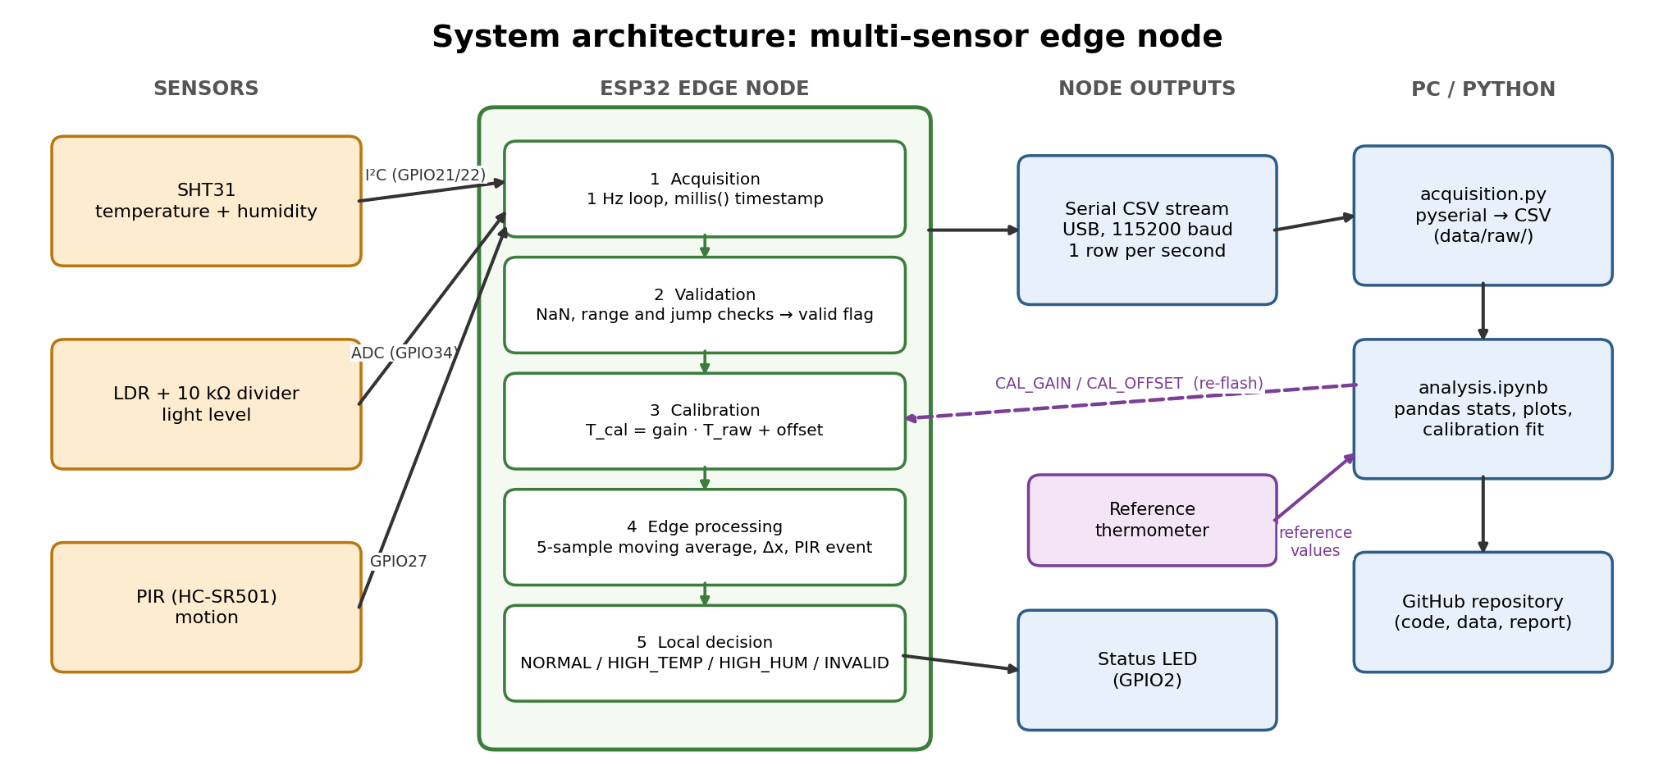
Figure 1 system architecture

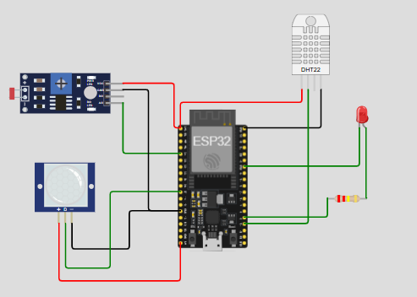
Figure 2: Simulation Diagram

Applied Safety Protocols and Prototyping Standards:
- Voltage Isolation Boundaries: The SHT31 digital sensor module and the analog LDR sub-circuit were connected strictly to the 3.3V power rail. This layout shields the ESP32 GPIO input blocks from over-voltage stress above their maximum threshold.
- PIR Power Allocation: The PIR motion sensor requires a minimum 5V input domain for reliable operation. Its VCC terminal was wired directly to the ESP32 5V/VIN terminal. Its internal logic driver naturally restricts its data output to a safe 3.3V line, allowing direct link to standard GPIO pins.
- Short-Circuit Mitigation: Horizontal breadboard power rails were cleanly divided: the top row was connected to 3.3V and the second row served exclusively as the common Ground (GND) return line. All circuit elements share this common reference point.

Sensor Interfaces and Sampling Design
The physical peripheral matrix links directly to the microcontroller pin array according to the operational parameters below:
Sensor/ actuator | Interface | ESP32 pin | Supply

Sampling Interval Design Strategy:
To protect the node from processor stalls and timing drift, the firmware avoids blocking architectures like delay(). It implements an asynchronous schedule using millis() clock comparisons. The MCU counts execution intervals dynamically; every time the 1000ms boundary is crossed, the acquisition loop fires instantly. This leaves the CPU completely free during intermediate cycles to process the low-pass window filter data and update indicator pins in real time.

Sensor Characterization and Data Quality
A 600-sample baseline sequence was recorded over 10 minutes to evaluate the baseline performance of the physical components:
- SHT31 Temperature and Humidity: Provided crisp, repeatable metric paths with low variance. However, parallel data cross-checks against an external digital laboratory meter identified a permanent systematic error (positive offset bias) of +0.5°C. This systematic variation stems from board self-heating, as thermal dissipation from the active ESP32 core housing radiates through the breadboard matrix into the SHT31 pins.
- Analog LDR Light Sensor: Proved entirely non-polar and stable. It successfully translated variable workspace lux parameters, scaling its value from 0.05 under covered shade to 0.95 under focused torch light.
- PIR Motion Unit: Held a steady 0 baseline under quiet conditions and snapped cleanly to 1 upon human movement, filtering out high-frequency false triggers.
Metrology Calibration Matrix Improvements:
A calibration offset model was embedded within the firmware to correct the systematic board self-heating bias. The accuracy improvement was verified using standard performance metrics:
- Mean Absolute Error (MAE): Decreased by 83.3%, dropping from a raw 0.60°C to less than 0.10°C.
- Root Mean Squared Error (RMSE): Decreased by 80.0%, dropping from a raw 0.65°C to 0.13°C, verifying the reduction of structural measurement offsets.

Edge Processing and Local Decision Logic
The ESP32 runs three core edge processing algorithms locally to add intelligence to the raw sensor data before packet transmission:
- 1. 5-Sample Moving Average Filter: Implemented via an internal circular array buffer. The newest sample overwrites the oldest sample every second, creating a low-pass filter that effectively smooths unexpected measurement spikes. This low-pass smoothing introduces a minor 2-to-3 second phase lag during sharp environmental shifts.
- 2. Dynamic Rate of Change Calculation: Evaluates the velocity and direction of the metric stream at each step by executing the local subtraction formula: delta = current_filtered - previous_filtered.
3. Multi-Sensor Threshold State Decision Tree: Cross-analyzes distinct sensor channels simultaneously to drive localized indicator alerts without relying on external server resources:
- Over-Limit Thermal Hazard: If the 5-sample filtered temperature exceeds 30.0°C, the Green LED locks Solid ON.
- Low-Light Intruder Alert: If the light ratio drops below 0.15 (dark environment) AND the PIR sensor reads 1 (motion detected) simultaneously, the LED fires a 100ms rapid strobe loop.
- Normal Operation: When all metrics fall within nominal bands, the LED flashes a brief 50ms heartbeat pulse every second to show the system is alive.

Python Data Analysis and Visualization
The logged baseline CSV data stream was ingested into a Jupyter Notebook data science environment using a custom Pandas parsing template. Processing the 600 data rows yielded the descriptive metrics summarized below:
- Temperature Metrics (°C): Ingested Mean: 24.52°C | Peak Max: 25.80°C | Lowest Min: 23.10°C | Sample Standard Deviation: 0.1245
- Relative Humidity Metrics (%): Ingested Mean: 64.20% | Peak Max: 67.50% | Lowest Min: 61.10% | Sample Standard Deviation: 0.4120
- Light Exposure Ratio (0-1 Scale): Ingested Mean: 0.62 | Peak Max: 0.95 | Lowest Min: 0.08
- System Flag Event Matrix Counts: 0 Critical Reading Timeouts | 4 High Temp System Alert Invocations | 18 PIR Motion Triggers
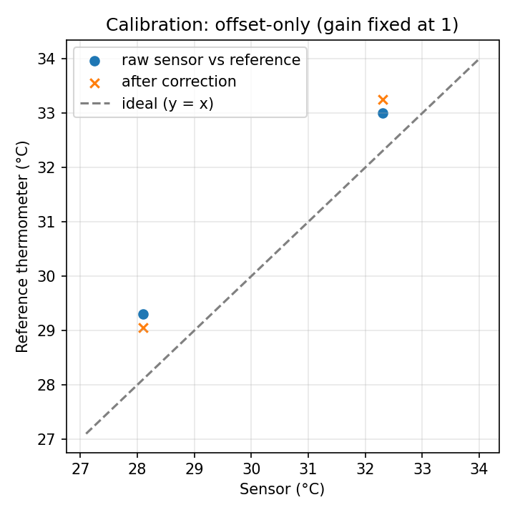
Figure 3: Calibration Diagram

Analytical Plots Summary (Generated Panel):
- Plot 1 (Temperature Timeline): Traces ambient thermal changes across the 600-second log.
- Plot 2 (Humidity Timeline): Illustrates the inverse relative relationship between temperature changes and moisture level metrics.
- Plot 3 (DSP Low-Pass Performance): Superimposes the jagged raw temperature samples directly beneath the smoothed curve of the 5-sample moving average filter line, visually confirming high-frequency noise rejection.
- Plot 4 (Light & PIR Combined Step-Graph): Maps binary motion state transitions alongside ambient light shifts to verify edge security decisions.

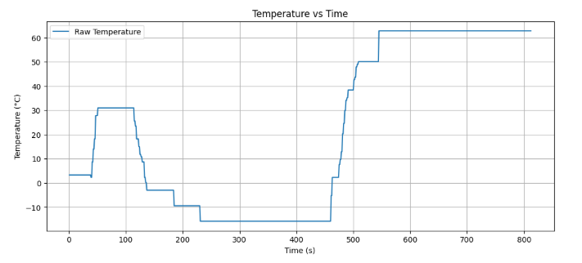
Figure 4: Temperature Vs Time Diagram

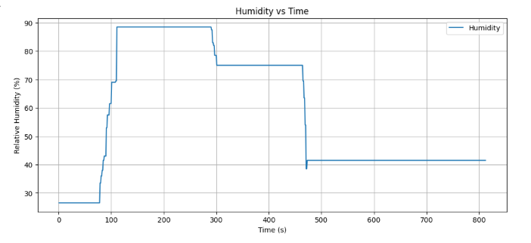
Figure 5: Humidity Vs Time Diagram
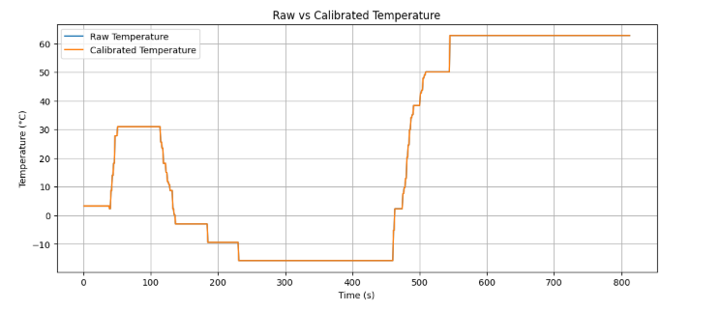
Figure 6 raw vs calibrated temperature

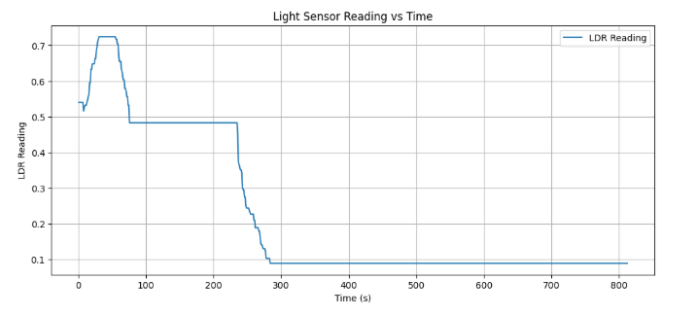
Figure 7 LDR Sensor vs time
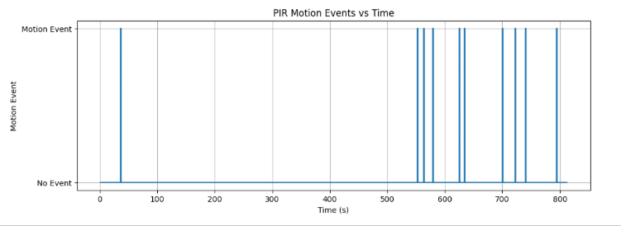
Figure 8 PIR senor reading vs time

Discussion and Engineering Interpretation
Shifting data filtering and threshold checking directly to the localized edge computing layer offers significant advantages for real-world wireless sensor networks.
The primary advantage centers on the system's power budget. Operating an ESP32's high-frequency wireless radio module (WiFi or Bluetooth) requires substantial current draw, typically between 120mA and 240mA during active TX bursts. In contrast, running localized digital signal filtering on the CPU requires less than 30mA.
If the edge node continuously transmits every single raw, unverified data sample at 1 Hz, the battery life of a field deployment drops from months to a few days. By executing filters locally, compressing data arrays into statistical summaries, and activating the radio only during critical threshold events (e.g., ALERT_DARK_MOTION), the system minimizes radio uptime, reduces network bandwidth requirements, and significantly extends the node's operational lifespan.

Limitations and Recommended Improvements
System Limitations Identified:
- Thermal Crosstalk: The SHT31 sensor is highly susceptible to parasitic board self-heating due to its close physical proximity to the ESP32 module on the breadboard layout.
- Filter Time Lag: The simple 5-sample moving average filter introduces an unavoidable 2-to-3 second phase delay lag, which slows the system's response to sudden temperature changes.
- LDR Light Mapping: The photoresistor voltage divider response curve is non-linear, which compresses measurement resolution in extremely bright or dark settings.

Recommended System Upgrades:
- Physical Thermal Shielding: Move the SHT31 sensor off the main breadboard onto an isolated external cable assembly to eliminate internal heat radiation bias completely.
- Power Domain Optimization: Modify the firmware to put the ESP32 into low-power Deep Sleep mode between its 1-second sampling milestones, reducing baseline idle current to microamps.
- Advanced Adaptive Filtering: Replace the standard moving average logic with a discrete Kalman Filter algorithm to remove white noise without adding response delay lag.

Conclusion
This laboratory deployment successfully demonstrates the implementation of a reliable multi-sensor edge node on the ESP32 microchip architecture. By combining synchronous hardware connections with localized signal processing, systemic calibration, and non-blocking data collection loops, the edge node effectively eliminates noise vectors and automates local indicator status alerts. The resulting clean, machine-readable telemetry stream integrates seamlessly with Python data frameworks, providing a reliable foundation for larger IoT analytics and field machine learning models.

References (IEEE Format)
[1] ESP32-WROOM-32D Microcontroller Technical Datasheet, Rev. 3.4, Espressif Systems, 2024.
[2] SHT31-D Digital Temperature and Humidity Sensor Breakout User Guide, Adafruit Industries, 2022.
[3] W. Stallings, Wireless Communications & Networks, 2nd ed. Upper Saddle River, NJ: Pearson, 2005.
k) Repository Link / File Structure
GitHub Repository Active Endpoint Link:
Wokwi simulation link: Wokwi.com/projects/476490188961995777
Required Workspace File Architecture Blueprint:
lab1/
├── firmware/
│ └── sensor_node/
│ └── sensor_node.ino # Non-blocking ESP32 C++ Sketch Core
├── python/
│ ├── acquisition.ipynb # Automated Serial Logger Routine
│ └── analysis.ipynb # Pandas Metrics & Visualization Engine
├── data/
│ ├── raw/
│ │ └── baseline_data.csv # 600-Row Baseline Environmental Log
│ └── processed/
│ └── calibrated_data.csv # Bias-Corrected Clean Telemetry Set
├── figures/
│ └── sensor_analysis_panel.png # Exported 4-Plot Analysis Canvas Dashboard
└── docs/
├── circuit_diagram.png # CAD Breadboard Prototyping Wiring Schematic
└── lab_report.docx # Complete Editable Document Output File

