Evidence-Graph Judge: A Rule–Evidence Graph Framework for Unified Role Control and Performance Assessment in Pharmacy OSCEs
CUHK Phamacy | 7 October 2026

What we would like to establish
We have developed an AI OSCE platform from the School’s four cases, role instructions, marking forms and faculty comments. We would first like to establish whether it meets the School’s requirements for OSCE practice. The starting point is how the School has evaluated its human-delivered OSCEs, and whether those measures can also evaluate AI stations. [1]
We then propose a separate comparison within the same AI platform. Approach A uses conventional role prompting and assessment after the consultation. Approach B adds Evidence-Graph Judge (EGJ), which connects role permissions and assessment through an executable rule graph and a record of what actually happened. This comparison tests whether EGJ improves role consistency and assessment accuracy.

Questions for the School
1 How has the School judged previous OSCEs to be successful? Which measures and acceptable limits matter most, and which can transfer to AI practice?
2 Which supplied materials or existing results can provide a comparable benchmark? Without comparable human performance data, meeting School requirements would not establish superiority over human OSCEs.
3 Is the intended use formative practice, assessment support, or both? Which decisions should always remain subject to faculty review?
4 Could six to eight students participate in parallel for about 90 minutes, with one or two faculty members helping to confirm criteria and review anonymised records afterwards?

The comparison and the proposed contribution
Approach A follows MedSimAI’s structured role prompts and post-consultation, item-level assessment with transcript quotations. Its disclosure constraints are retained. Both approaches use the same cases, rubric, model settings, speech services and approved pharmacy knowledge; a shared knowledge graph is our pharmacy adaptation, not a component attributed to MedSimAI. [2, 3]
GSR already executes graph-based rubrics, and LogiDebrief checks temporal requirements. EGJ connects these ideas to live role decisions: an authorised prompt actually delivered changes both later permissions and marking consequences. The LLM matches language to rules; code executes the confirmed rules. Uncertain evidence still requires review. [4, 5]
Sources and original papers: [1] ASPE 2017; [2] MedSimAI 2026; [3] AIPatient 2026; [4] GSR 2026; [5] LogiDebrief 2025

The common platform and EGJ additions
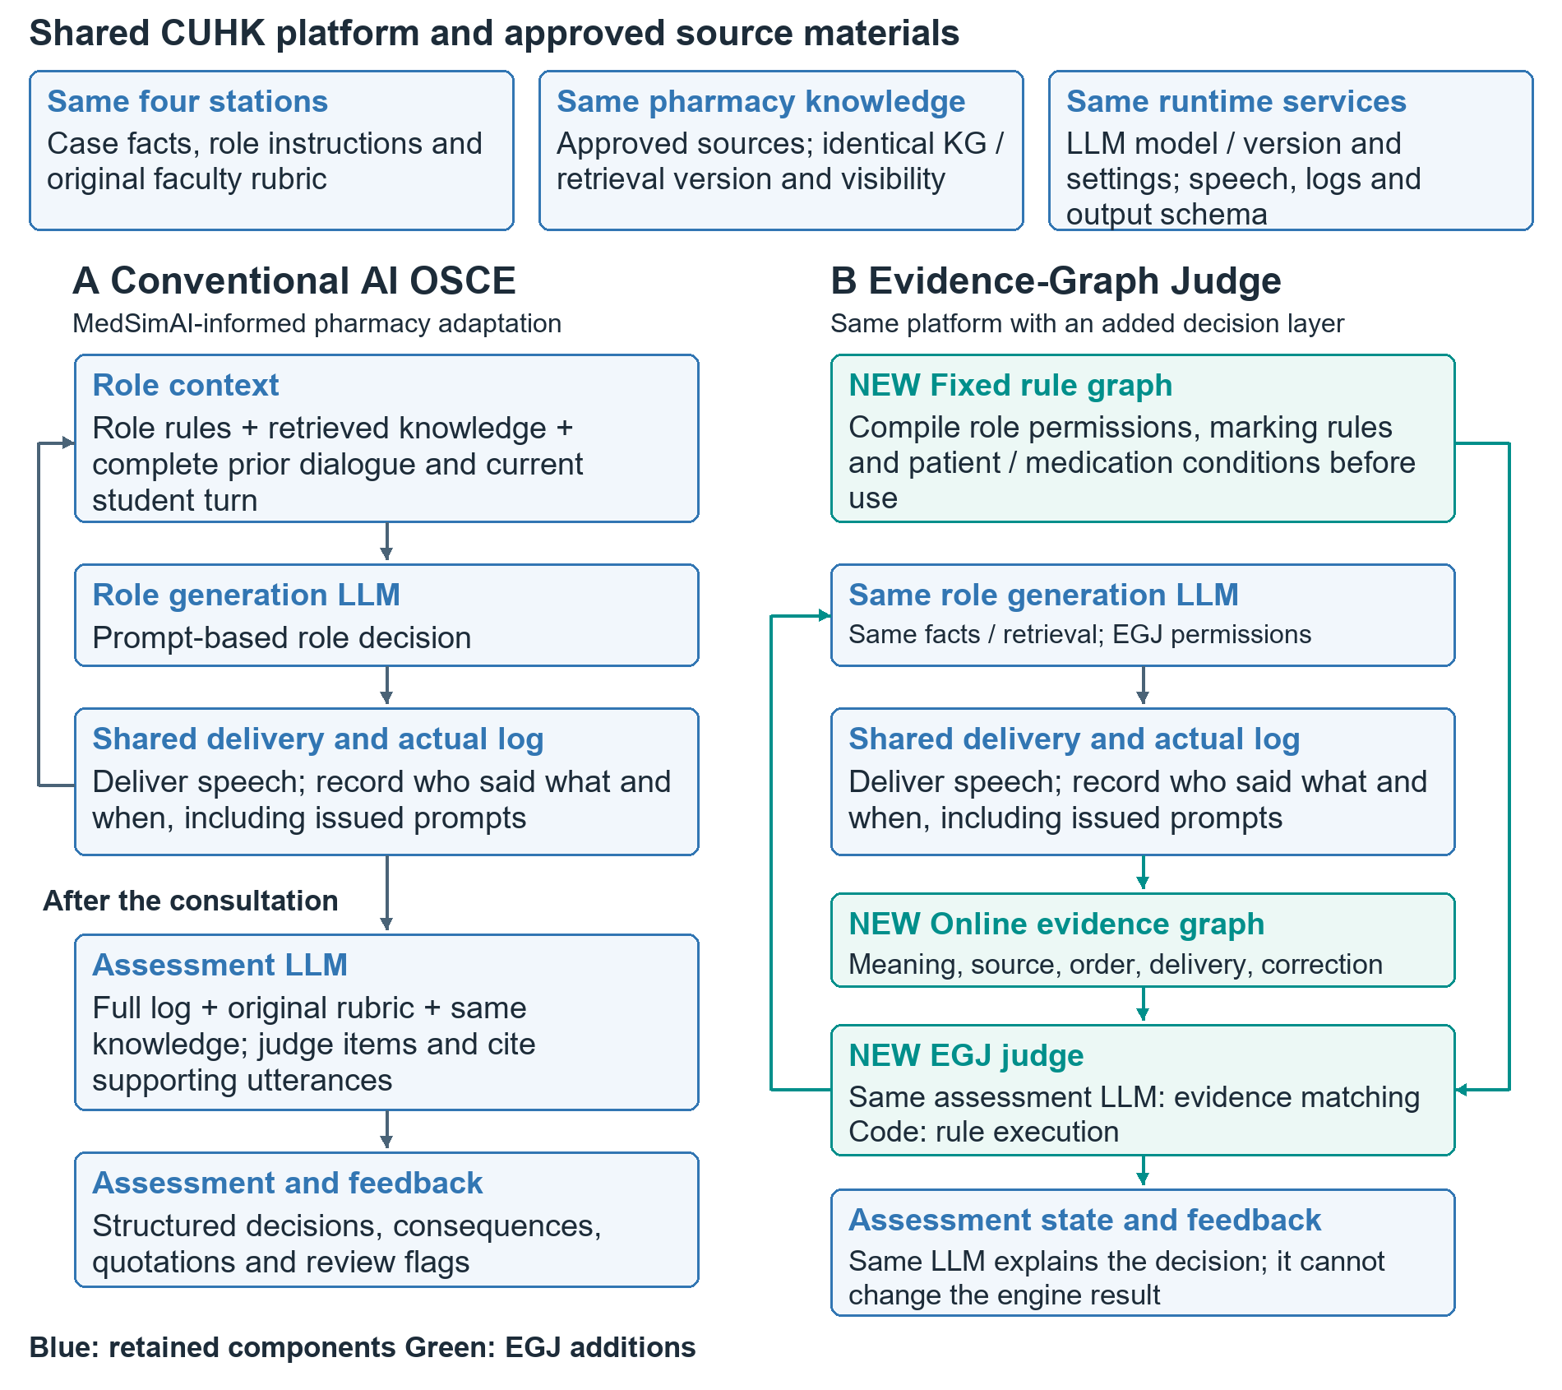
Figure 1. Blue components are shared; green components are added by EGJ. Only delivered AI actions update later permissions and marking consequences. In paired technical tests, both methods receive the same dialogue and source information.

The example and the two outcomes
In the CUHK onychomycosis station, the student misses the itraconazole–atorvastatin interaction, receives an authorised prompt, then answers correctly. EGJ credits the answer and retains the rubric’s C+ maximum; a prompt drafted but never issued cannot impose that cap. Approach A may also decide correctly: the experiment measures whether EGJ is more reliable.
Role consistency = replies satisfying all applicable requirements ÷ reviewed replies. Five categories: completeness, case facts, permissions, source/timing and authorised prompts. Assessment accuracy = decisions agreeing exactly with faculty on status and all applicable consequences, corrections and review flags ÷ reviewed decisions. Faculty judges independently of AI output; missing output counts as failure.

Data collection and the 90-minute student activity
Each of six or eight students completes all four different cases: two with A and two with B. Balance method order as far as possible; students use ordinary task sheets, without answer scripts. This gives 24 or 32 live consultations, a feasibility study rather than a powered superiority trial. Repeated sessions from one student remain linked in analysis. [6, 7]
Case | A live sessions  6 / 8 students | B live sessions  6 / 8 students | Separate technical  test questions
Onychomycosis | 3 / 4 | 3 / 4 | 30
Diuretics | 3 / 4 | 3 / 4 | 30
Methotrexate | 3 / 4 | 3 / 4 | 30
Migraine | 3 / 4 | 3 / 4 | 30
Total | 12 / 16 | 12 / 16 | 120 per outcome

What does one test question mean
Think of giving two systems the same exam question. For a role test, freeze a dialogue before the AI reply; both systems generate that reply. For assessment, both evaluate the same completed dialogue. In the prompted interaction example on page 2, the question is whether to credit the answer and retain the C+ cap. Two outputs form one paired test—not two independent samples.
The 30 questions are distinct situations within an existing case, not 30 students or new diseases. Each outcome has a separate set of 4 × 30 = 120 paired questions, producing 240 outputs. Faculty reference decisions are fixed first. Reruns, paraphrases and related excerpts cannot be counted as independent questions.

Who does what and how long it takes
Six to eight students start together: 10-minute briefing + 54 minutes per student (40 consultation, 8 reading, 3 transitions, 3 questionnaire) + 10–20 minutes buffer = 74–84 minutes; reserve 90 minutes. Use separate devices/headsets and rehearse concurrent capacity. Students rate usability, role consistency and relevance before feedback. One or two faculty members use existing requirements to review anonymised records afterwards; that review is outside the 90 minutes.
Sample and statistical methods: [6] Eldridge et al. 2016; [7] Lakens 2022; [8] Fagerland et al. 2013

Appendix A. Faculty Role-Compliance Review Form
Complete one form for each live consultation. For the identical-input comparison, complete a separate form for each anonymised response. The research team supplies the full preceding context and audio timestamps, with the method names hidden. Select one judgement in each of the five categories and record a quotation or timestamp and a brief reason for every category. Additional issues can be entered in the same field.
Record ID | Station | Faculty or student ID | Date
____________ | ____________ | ____________ | ____________

Review scope and recording location
☐ Whole consultation
☐ First response after the fixed preceding context
Start/end or response timestamp:__________________

Requirement | Faculty judgement | Quotation or timestamp and specific reason
1 Response completeness  Once the conditions requiring an answer are met, the role provides the prescribed content. Omitting permitted but optional content is not a failure to answer. | ☐ Compliant  ☐ Non-compliant  ☐ Not applicable  ☐ Cannot determine | Quote/time: ___________  Evidence/issue: ___________
2 Case-fact consistency  The AI role's identity, history, medication and established facts remain consistent with the station materials and earlier dialogue. Fixed facts are not added or changed without support. | ☐ Compliant  ☐ Non-compliant  ☐ Not applicable  ☐ Cannot determine | Quote/time: ___________  Evidence/issue: ___________
3 Disclosure permissions  The AI role discloses only information permitted at that point, without revealing the expected answer prematurely or making an assessed judgement on the student's behalf. | ☐ Compliant  ☐ Non-compliant  ☐ Not applicable  ☐ Cannot determine | Quote/time: ___________  Evidence/issue: ___________
4 Source and timing  The AI role uses only information available at that point. The source of repetitions, prompts and student recommendations is clear; later information is not used prematurely. | ☐ Compliant  ☐ Non-compliant  ☐ Not applicable  ☐ Cannot determine | Quote/time: ___________  Evidence/issue: ___________
5 Authorised prompts  Any authorised prompt actually delivered complies with the station's conditions, wording, frequency and timing. Ordinary clarification is not mistaken for an authorised prompt. | ☐ Compliant  ☐ Non-compliant  ☐ Not applicable  ☐ Cannot determine | Quote/time: ___________  Evidence/issue: ___________

For 'Not applicable', identify the condition that was not triggered. For 'Cannot determine', specify the missing evidence. Give a brief reason for 'Compliant' too, such as 'The patient identity remained unchanged throughout'. Assess the AI role's behaviour; an incorrect student recommendation is not itself a case-fact error by the AI role.
Overall finding | Details or points to check
☐ All applicable items meet requirements  ☐ At least one item does not meet requirements  ☐ Verification pending | __________________

Research-team coding: all applicable items comply = 1; any non-compliant item = 0. If one or more judgements remain unresolved and no explicit failure has been identified, verification remains pending. No valid response = system failure, coded 0. Calculate the metric as described in Section 7; faculty need not enter percentages.

Appendix B1. Faculty Assessment: Onychomycosis
Complete independently before viewing the AI decision. For each item, select the completion status and enter the consequence, quote and reason. Select the error status (no error/unresolved/corrected) and whether review is required. For 'Not applicable', explain the untriggered condition; other inapplicable fields may be left blank. If speech is unclear, record the missing evidence rather than selecting 'No error'. Use the dropdowns in Word or write the responses on a printed copy.
Record ID | Station | Faculty or student ID | Date
____________ | Onychomycosis | ____________ | ____________

Core requirement and original rule | Faculty judgement and consequence | Dialogue evidence and reason
1 Patient conditions  Recognises that itraconazole is unsuitable in this case because of heart failure or ventricular dysfunction.  Original rule: identified only after an authorised prompt, maximum C+; still not identified after the prompt, automatic FAIL. | ☐ Meets  ☐ Partly meets  ☐ Does not meet  ☐ Not applicable  ☐ Cannot determine  Consequence: ____________  Error: Select  Review: Select | Quote/time: ___________  Reason: ___________  Omission/correction: ___________
2 Drug interaction  Recognises that itraconazole increases atorvastatin exposure and toxicity risk, and recommends appropriate action for this case.  Original rule: identified only after an authorised prompt, maximum C+; still not identified after the prompt, automatic FAIL. | ☐ Meets  ☐ Partly meets  ☐ Does not meet  ☐ Not applicable  ☐ Cannot determine  Consequence: ____________  Error: Select  Review: Select | Quote/time: ___________  Reason: ___________  Omission/correction: ___________
3 Alternative treatment  Proposes the station-approved terbinafine regimen, without presenting a treatment unsuitable for this patient as an appropriate alternative.  Original rule: terbinafine not proposed, maximum B− under the original rubric. | ☐ Meets  ☐ Partly meets  ☐ Does not meet  ☐ Not applicable  ☐ Cannot determine  Consequence: ____________  Error: Select  Review: Select | Quote/time: ___________  Reason: ___________  Omission/correction: ___________
4 Dose and duration  For this patient's circumstances: terbinafine 125 mg orally once daily for 12 weeks.  Original rule: incorrect dose or duration, automatic FAIL under the original rubric. | ☐ Meets  ☐ Partly meets  ☐ Does not meet  ☐ Not applicable  ☐ Cannot determine  Consequence: ____________  Error: Select  Review: Select | Quote/time: ___________  Reason: ___________  Omission/correction: ___________

Use the full original rubric separately for identity checks, the time limit, professionalism and the follow-up question on carbamide. These four items do not constitute the overall station grade.
Key station-level consequences and reasons | Selected core items; not a full-rubric total
☐ None ☐ Grade cap ☐ Grade reduction  ☐ Automatic FAIL ☐ Review required  Value and reason: __________________ | ☐ Full faculty rubric also completed  ☐ Core-item form only  Original-rubric grade, if available: ______

Faculty's original onychomycosis rubric YT's comments, pages 13–15

Appendix B2. Faculty Assessment: Migraine
Complete independently before viewing the AI decision. For each item, select the completion status and enter the consequence, quote and reason. Select the error status (no error/unresolved/corrected) and whether review is required. For 'Not applicable', explain the untriggered condition; other inapplicable fields may be left blank. If speech is unclear, record the missing evidence rather than selecting 'No error'. Use the dropdowns in Word or write the responses on a printed copy.
Record ID | Station | Faculty or student ID | Date
____________ | Migraine | ____________ | ____________

Core requirement and original rule | Faculty judgement and consequence | Dialogue evidence and reason
1 Allergy check  As required by the original rubric, asks about or verifies allergies when recommending an alternative medicine. If no alternative is recommended, this condition has not been triggered.  Original rule: confirm before the activity whether the check must precede the first recommendation and what grade consequence applies. Do not import the patient-station failure rule. | ☐ Meets  ☐ Partly meets  ☐ Does not meet  ☐ Not applicable  ☐ Cannot determine  Consequence: ____________  Error: Select  Review: Select | Quote/time: ___________  Reason: ___________  Omission/correction: ___________
2 Cafergot suitability  Recognises that Cafergot/ergotamine is contraindicated or unsuitable given this patient's cardiovascular and other relevant conditions.  Original rule: identified after an authorised prompt, maximum C+; still not identified after the prompt, automatic FAIL. | ☐ Meets  ☐ Partly meets  ☐ Does not meet  ☐ Not applicable  ☐ Cannot determine  Consequence: ____________  Error: Select  Review: Select | Quote/time: ___________  Reason: ___________  Omission/correction: ___________
3 Accepted alternative  Proposes an acute-treatment alternative accepted by Professor YT Zhang, including lasmiditan or a CGRP option confirmed in the materials. Acceptance is not restricted to one medicine.  Original rule: CGRP identified only after a prompt, maximum B−; no suitable alternative after the prompt, automatic FAIL under the original rubric. Prompt consequences for other accepted alternatives remain to be confirmed. | ☐ Meets  ☐ Partly meets  ☐ Does not meet  ☐ Not applicable  ☐ Cannot determine  Consequence: ____________  Error: Select  Review: Select | Quote/time: ___________  Reason: ___________  Omission/correction: ___________
4 Selected regimen  Gives the correct dose, route and regimen for the selected approved medicine. If rimegepant is chosen: a single oral dose of 75 mg as needed, maximum 75 mg in 24 hours.  Original rule: incorrect information is subject to the original failure rules. Check other regimens against their faculty-approved references. | ☐ Meets  ☐ Partly meets  ☐ Does not meet  ☐ Not applicable  ☐ Cannot determine  Consequence: ____________  Error: Select  Review: Select | Quote/time: ___________  Reason: ___________  Omission/correction: ___________

Also check the follow-up question on magnesium, doctor identity and contact details, the time limit and professionalism. Under the original rubric, not answering the follow-up question caps the grade at B.
Key station-level consequences and reasons | Selected core items; not a full-rubric total
☐ None ☐ Grade cap ☐ Grade reduction  ☐ Automatic FAIL ☐ Review required  Value and reason: __________________ | ☐ Full faculty rubric also completed  ☐ Core-item form only  Original-rubric grade, if available: ______

Faculty's original migraine rubric YT's comments, pages 13–15

Appendix B3. Faculty Assessment: Diuretics
Complete independently before viewing the AI decision. For each item, select the completion status and enter the consequence, quote and reason. Select the error status (no error/unresolved/corrected) and whether review is required. For 'Not applicable', explain the untriggered condition; other inapplicable fields may be left blank. If speech is unclear, record the missing evidence rather than selecting 'No error'. Use the dropdowns in Word or write the responses on a printed copy.
Record ID | Station | Faculty or student ID | Date
____________ | Diuretics | ____________ | ____________

Core requirement and original rule | Faculty judgement and consequence | Dialogue evidence and reason
1 Allergy check  Asks about or verifies medication allergies before the consultation ends. This need not be the first question.  Original rule: no allergy check during the consultation, automatic FAIL under the original rubric. Record a technically truncated session as interrupted; do not apply this rule mechanically. | ☐ Meets  ☐ Partly meets  ☐ Does not meet  ☐ Not applicable  ☐ Cannot determine  Consequence: ____________  Error: Select  Review: Select | Quote/time: ___________  Reason: ___________  Omission/correction: ___________
2 Rosuvastatin regimen  Correctly explains rosuvastatin 20 mg once daily to the patient.  Original rule: apply the original rubric. Do not assign another medicine's as-needed regimen to rosuvastatin. | ☐ Meets  ☐ Partly meets  ☐ Does not meet  ☐ Not applicable  ☐ Cannot determine  Consequence: ____________  Error: Select  Review: Select | Quote/time: ___________  Reason: ___________  Omission/correction: ___________
3 Frusemide regimen  For fluid retention or oedema: frusemide 20 mg during the daytime as needed, maximum 20 mg per day, without increasing the dose independently.  Original rule: only some required conditions explained, 'Partly meets'; apply the original rubric. | ☐ Meets  ☐ Partly meets  ☐ Does not meet  ☐ Not applicable  ☐ Cannot determine  Consequence: ____________  Error: Select  Review: Select | Quote/time: ___________  Reason: ___________  Omission/correction: ___________
4 Urgent symptoms and seeking care  Explains at least two of four urgent symptoms and the need to seek care: severe breathlessness, chest pain, fainting/confusion, or rapidly worsening swelling (YT 3.6).  Original rule: a complete correct answer after a prompt incurs no grade reduction; an answer that remains incomplete incurs a half-grade reduction. Naming fewer than two symptoms is not equivalent to knowing no heart-failure symptoms. | ☐ Meets  ☐ Partly meets  ☐ Does not meet  ☐ Not applicable  ☐ Cannot determine  Consequence: ____________  Error: Select  Review: Select | Quote/time: ___________  Reason: ___________  Omission/correction: ___________

The original rubric also covers identity, teach-back, medication safety, missed doses and other items. This four-item form does not replace those items or the overall performance assessment.
Key station-level consequences and reasons | Selected core items; not a full-rubric total
☐ None ☐ Grade cap ☐ Grade reduction  ☐ Automatic FAIL ☐ Review required  Value and reason: __________________ | ☐ Full faculty rubric also completed  ☐ Core-item form only  Original-rubric grade, if available: ______

Faculty's original diuretics rubric YT's comments, pages 13–15

Appendix B4. Faculty Assessment: MTX
Complete independently before viewing the AI decision. For each item, select the completion status and enter the consequence, quote and reason. Select the error status (no error/unresolved/corrected) and whether review is required. For 'Not applicable', explain the untriggered condition; other inapplicable fields may be left blank. If speech is unclear, record the missing evidence rather than selecting 'No error'. Use the dropdowns in Word or write the responses on a printed copy.
Record ID | Station | Faculty or student ID | Date
____________ | MTX | ____________ | ____________

Core requirement and original rule | Faculty judgement and consequence | Dialogue evidence and reason
1 Weekly frequency  Explicitly states that methotrexate is taken once weekly. If 'daily' is later corrected to 'weekly', retain the original error and record the correction.  Original rule: failure to emphasise once-weekly dosing, automatic FAIL under the original rubric. The final grade after a self-correction follows the faculty-confirmed policy. | ☐ Meets  ☐ Partly meets  ☐ Does not meet  ☐ Not applicable  ☐ Cannot determine  Consequence: ____________  Error: Select  Review: Select | Quote/time: ___________  Reason: ___________  Omission/correction: ___________
2 Missed-dose advice  For YT's Monday-dose example: if remembered Tuesday–Thursday, take the missed dose and resume Monday; if remembered Friday–Sunday, either take it and change the weekly dosing day or wait until the next scheduled dose. The boundaries of these windows require final faculty approval.  Original rule: incomplete explanation of the missed-dose windows, half-grade reduction. Record double-dose advice separately under Item 4. | ☐ Meets  ☐ Partly meets  ☐ Does not meet  ☐ Not applicable  ☐ Cannot determine  Consequence: ____________  Error: Select  Review: Select | Quote/time: ___________  Reason: ___________  Omission/correction: ___________
3 Folic acid regimen  Explains that folic acid reduces MTX toxicity and is taken once weekly on a different day from MTX. Distinguishes omission from an actual recommendation to take both on the same day.  Original rule: actual same-day advice, one-grade reduction. Omission alone is not automatically equivalent to same-day advice; apply faculty policy. | ☐ Meets  ☐ Partly meets  ☐ Does not meet  ☐ Not applicable  ☐ Cannot determine  Consequence: ____________  Error: Select  Review: Select | Quote/time: ___________  Reason: ___________  Omission/correction: ___________
4 No double-dose advice  Does not advise taking a double MTX dose to make up a missed dose. Not spontaneously saying 'do not double the dose' is not itself double-dose advice.  Original rule: actual double-dose advice, automatic FAIL under the original rubric. If subsequently corrected, retain the history and review it under faculty policy. | ☐ Meets  ☐ Partly meets  ☐ Does not meet  ☐ Not applicable  ☐ Cannot determine  Consequence: ____________  Error: Select  Review: Select | Quote/time: ___________  Reason: ___________  Omission/correction: ___________

The original rubric also covers identity, allergies, monitoring, red-flag symptoms, teach-back and other items. These four items are used only for the prespecified comparison of core decisions.
Key station-level consequences and reasons | Selected core items; not a full-rubric total
☐ None ☐ Grade cap ☐ Grade reduction  ☐ Automatic FAIL ☐ Review required  Value and reason: __________________ | ☐ Full faculty rubric also completed  ☐ Core-item form only  Original-rubric grade, if available: ______

Faculty's original MTX rubric YT's comments, pages 13–15

Appendix C. Student Experience Questionnaire
Complete after both stations and before viewing feedback. The research team records the station order; students are not told the method names. For each statement, select one response for the first station and one for the second. Respond based on the experience; completion takes about two minutes.
Anonymous student ID | Session batch | Date
______________ | ______________ | ______________

First-station case | Second-station case | Year of study
______________ | ______________ | ______________

1 Strongly disagree; 2 Disagree; 3 Neutral; 4 Agree; 5 Strongly agree; X Cannot determine. For a low rating or a problem, describe what happened or quote the dialogue in the right-hand column. If there was no problem, write 'None'.
Statement | First station | Second station | Issue or explanation
1 I could complete the consultation task without technical problems interrupting the interaction. | ☐ 1 ☐ 2 ☐ 3  ☐ 4 ☐ 5 ☐ X | ☐ 1 ☐ 2 ☐ 3  ☐ 4 ☐ 5 ☐ X | Station: ____________  What happened/quote: __________
2 The other party maintained a clear doctor or patient identity. | ☐ 1 ☐ 2 ☐ 3  ☐ 4 ☐ 5 ☐ X | ☐ 1 ☐ 2 ☐ 3  ☐ 4 ☐ 5 ☐ X | Station: ____________  What happened/quote: __________
3 The information provided remained consistent, without obvious contradictions. | ☐ 1 ☐ 2 ☐ 3  ☐ 4 ☐ 5 ☐ X | ☐ 1 ☐ 2 ☐ 3  ☐ 4 ☐ 5 ☐ X | Station: ____________  What happened/quote: __________
4 The responses and follow-up questions were relevant to the consultation and allowed the discussion to continue. | ☐ 1 ☐ 2 ☐ 3  ☐ 4 ☐ 5 ☐ X | ☐ 1 ☐ 2 ☐ 3  ☐ 4 ☐ 5 ☐ X | Station: ____________  What happened/quote: __________
5 I consider this type of consultation suitable for practising similar cases. | ☐ 1 ☐ 2 ☐ 3  ☐ 4 ☐ 5 ☐ X | ☐ 1 ☐ 2 ☐ 3  ☐ 4 ☐ 5 ☐ X | Station: ____________  What happened/quote: __________

One improvement or additional comment
__________________

This questionnaire does not ask about the accuracy of grades that students have not yet seen and does not affect course grades. The items were written for this study; two students outside the formal sample should check their clarity before the activity. Report results item by item, without claiming a validated scale.[17]

Appendix D. Faculty Judgement of Educational Use
Complete after reviewing the assigned consultation and assessment records. Judge educational use separately from the EGJ-versus-conventional accuracy comparison. Give a reason for each item. Record any unresolved School standards below; no new formal examination scale is required.
Record ID | Station | Faculty or student ID | Date
____________ | ____________ | ____________ | ____________

Question | Faculty judgement | Evidence and improvements needed
1 Can consultations in all four stations be completed as originally intended? | ☐ Acceptable  ☐ Changes needed  ☐ Not currently suitable  ☐ Insufficient evidence | Evidence: _______________  Reason/improvement: ___________
2 Are the AI doctor or patient roles suitable for formative practice? | ☐ Acceptable  ☐ Changes needed  ☐ Not currently suitable  ☐ Insufficient evidence | Evidence: _______________  Reason/improvement: ___________
3 Can system assessments support feedback under faculty supervision? | ☐ Acceptable  ☐ Changes needed  ☐ Not currently suitable  ☐ Insufficient evidence | Evidence: _______________  Reason/improvement: ___________
4 Have critical safety issues or system interference been handled appropriately? | ☐ Acceptable  ☐ Changes needed  ☐ Not currently suitable  ☐ Insufficient evidence | Evidence: _______________  Reason/improvement: ___________
5 Is the proposed scope of use appropriate against the faculty's requirements for human OSCEs? | ☐ Acceptable  ☐ Changes needed  ☐ Not currently suitable  ☐ Insufficient evidence | Evidence: _______________  Reason/improvement: ___________

Existing faculty quality standards applicable to this study | Specific thresholds or unacceptable situations
__________________ | __________________

Recommended uses and decisions requiring human verification
__________________

Report the comments and issue counts directly; do not convert one assessor's five judgements into an 'expert pass percentage'. Whether the system meets requirements depends on the agreed School standards, complete data and intended use. This form records educational judgement and its rationale.

