TECHNICAL CONSULTING REPORT
Client Name: BlueMesa Utilities
Report ID: BMU-ERA-2017-024
Report Date: 2017-10-15
Client Contact: R. Bell
Author: C. Tran
Site: Substation East
Asset: Switchboard SB-2

Introduction
This report documents a electrical reliability audit conducted for BlueMesa Utilities at Substation East during 2017. The engagement was initiated after a sequence of repeat defects and growing maintenance backlog signaled increased reliability risk. The client requested an evidence-led assessment with practical recommendations that could be executed within routine shutdown constraints.
The study is written for operations management, maintenance planners, and integrity engineers. It consolidates field observations, historical maintenance trends, and fit-for-purpose risk ranking so that decisions on intervention timing, resource allocation, and assurance controls can be made with clear traceability.
Scope
Scope covered the nominated asset boundary around Switchboard SB-2, including adjacent interfaces that materially influence reliability performance. Activities included document review, condition walkdowns, selected checks against design intent, and stakeholder interviews across operations and maintenance shifts.
The assessment deliberately excluded full detail design and procurement packaging. However, it included enough technical depth to define immediate corrective actions, medium-term mitigation options, and an implementation sequence that can be integrated into existing planning cycles.
Background
Between 2014 and 2016, work order data indicated increasing corrective intervention frequency against the assessed equipment class. Temporary repairs and repeat call-outs were more common where close-out evidence was incomplete or acceptance criteria were interpreted inconsistently.
Asset criticality workshops previously identified this area as contributing disproportionately to production interruptions. Given the current cost pressure and constrained outage windows, the client sought a targeted approach that could stabilize performance without requiring immediate major capital replacement.
Method/Work Done
The team applied a four-stage method: evidence collection, condition grading, risk ranking, and stakeholder validation. Evidence collection combined maintenance history, calibration/test records, and field observations captured against a standardized checklist.
Condition grading used a weighted framework incorporating severity, recurrence, and detectability. Findings were reviewed in a multidisciplinary workshop to test assumptions, validate practicality, and assign accountable owners for each action item.
Results
The investigation identified a pattern of moderate-to-high risk issues concentrated in interfaces between routine maintenance and verification workflows. While several defects were technical in nature, the stronger predictor of recurrence was inconsistency in post-work validation evidence.
Performance trend analysis over twelve months indicated that assets with explicit acceptance criteria and documented verification closed with lower repeat failure rates. The included chart and supporting table summarise monthly defect counts and mean time between failures for the assessed period.
Results Data Trend Chart
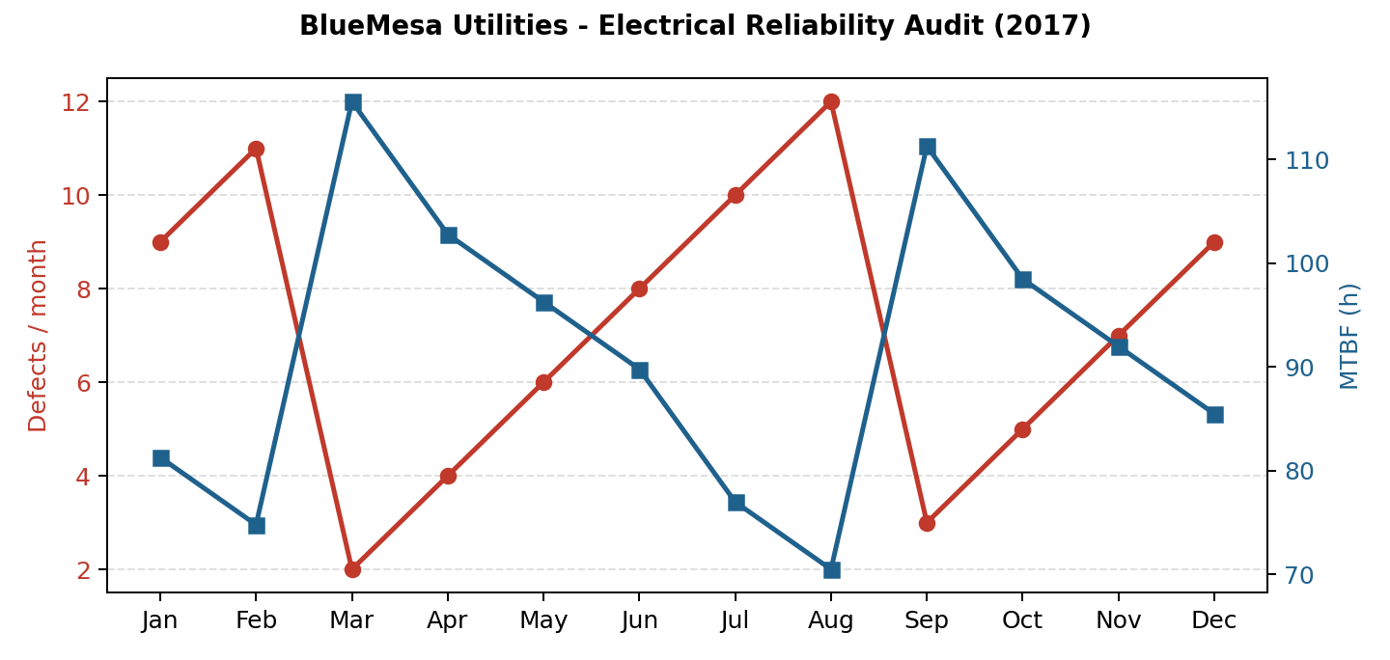
Month | Defects | MTBF (h)
Jan | 9 | 81.3
Feb | 11 | 74.8
Mar | 2 | 115.6
Apr | 4 | 102.8
May | 6 | 96.3
Jun | 8 | 89.8
Jul | 10 | 77.0
Aug | 12 | 70.5
Sep | 3 | 111.3
Oct | 5 | 98.5
Nov | 7 | 92.0
Dec | 9 | 85.5
Discussion
The results suggest that standalone repairs are unlikely to deliver durable improvement unless paired with process controls. In particular, inadequate handover detail between field execution and reliability assurance allows latent defects to persist and re-emerge under load.
A balanced strategy is therefore recommended: immediate defect elimination for highest-risk items, combined with stronger verification standards, clear acceptance criteria, and periodic governance reviews to ensure corrective intent is sustained in practice.
Conclusion
Overall condition for Switchboard SB-2 is serviceable but vulnerable to escalating reliability risk if current execution variability continues. The asset can remain in operation provided prioritized interventions are completed and assurance controls are strengthened.
The assessment confirms there is no single root cause; rather, risk is generated by the interaction of asset degradation, planning constraints, and inconsistent verification discipline. A staged improvement program over two quarters is expected to materially reduce reactive demand.
Recommendations
1) Complete high-priority corrective actions within 30 days and capture objective close-out evidence. 2) Standardize maintenance work packs with explicit acceptance criteria and mandatory verification checkpoints.
3) Establish monthly reliability review using defect aging, recurrence, and verification quality KPIs. 4) Perform a six-month reassessment to confirm risk reduction and identify residual gaps requiring further intervention.

