Dmytro Grebeniev, SD3

Task 1

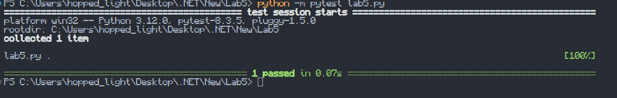

Task 2

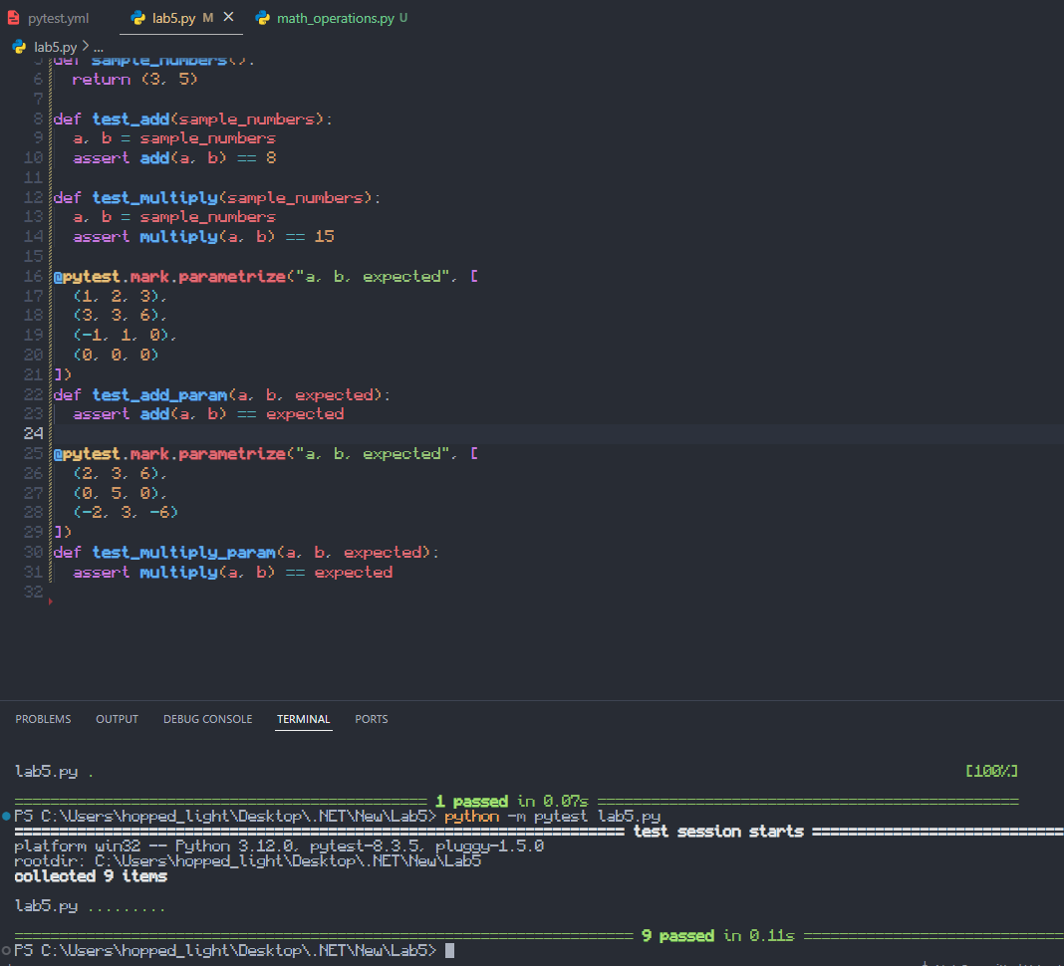

Task 3



