

**Team**

Konrad Hartwig ([konrad.hartwig@online.de](mailto:konrad.hartwig@online.de))

Implementer (Test-SP)

Marc Jacob ([the.mmj.yt@gmail.com](mailto:the.mmj.yt@gmail.com))

Implementer (Backend)

Luca Schimweg ([l.schimweg@gmail.com](mailto:l.schimweg@gmail.com))

Implementer (Frontend), Project Management

x

**Spent times (252h)**

Konrad: 50h

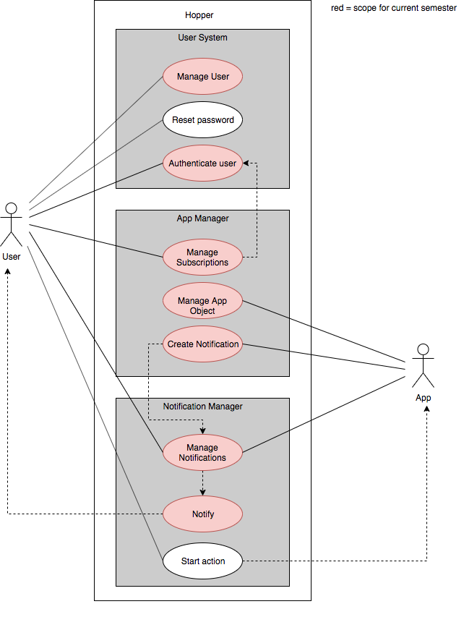Marc: 94h

Luca: 108h

Overall use case diagram