III. Functional Requirements
This feature manages the asset lifecycle from creating an asset record and storing it in the selected building inventory to assigning it to one or multiple rooms. The system must keep each asset identifiable, prevent invalid duplicate assignments, and maintain the asset location and condition history.

2. Assets Management

2.1 Asset Creation and Inventory

2.1.1 Asset Management Screen
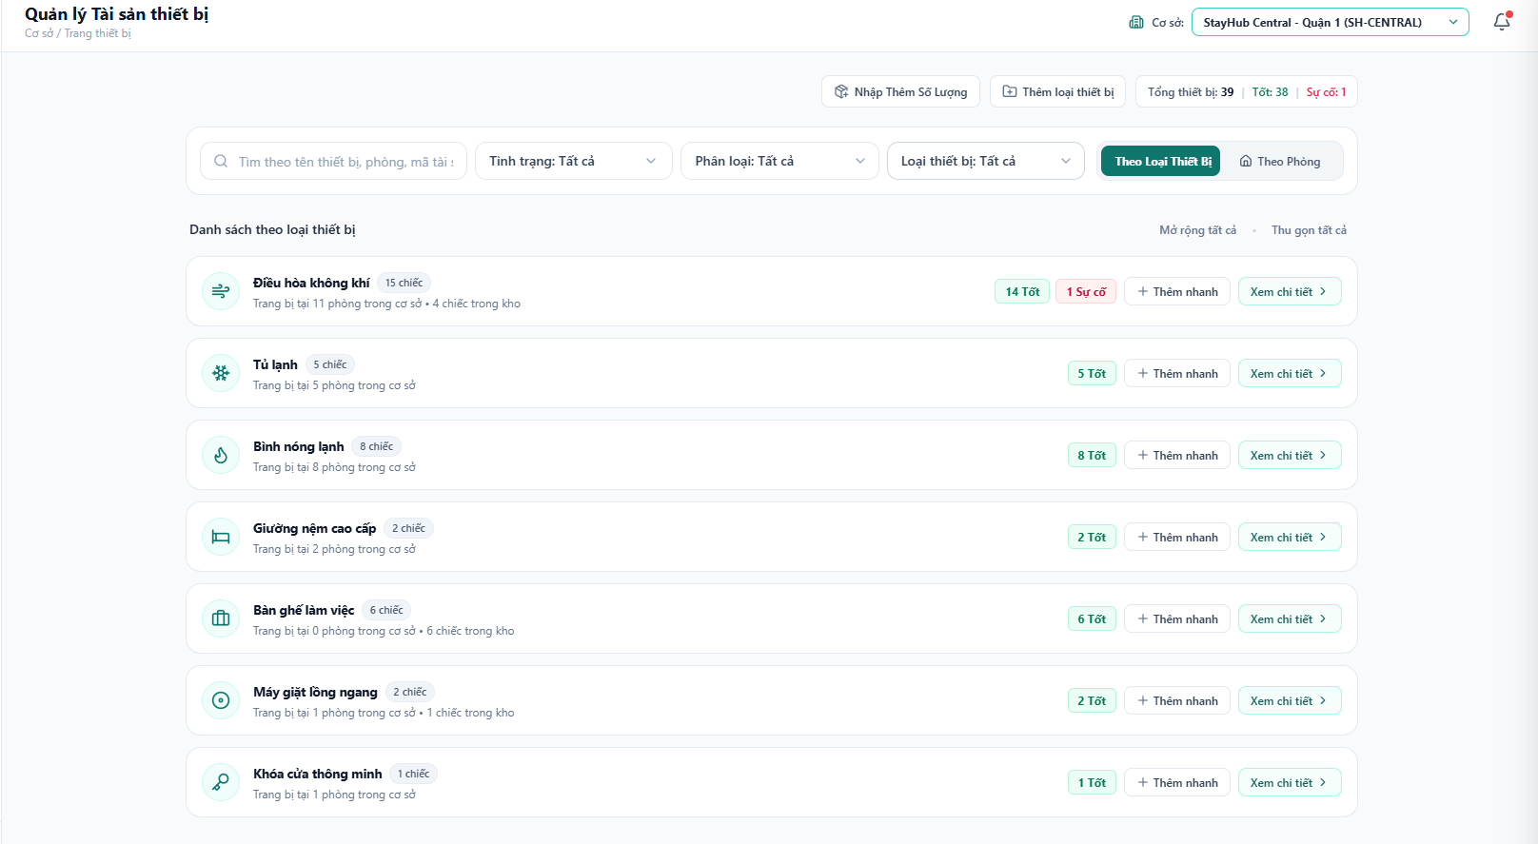
Figure 1. Asset Management Screen
This screen manages the asset inventory for the selected building. The user can create a new asset type, add more quantity to an existing model, search and filter inventory, switch between type-based and room-based views, assign assets quickly, and open the detailed asset record. Each asset type row summarizes total quantity, current condition, assigned rooms, and stock remaining in the building inventory.
Field Description
Field Name | Description
Page header | Shows the Asset Management title, current building context, total asset summary, and authorized actions.
Create Asset | Opens the Create Asset form for creating a new asset type and one or more asset records.
Restock Quantity | Opens the Restock form for adding more units to an existing asset model.
Search field | Searches by asset name, room, asset code, model, or serial information.
Condition filter | Filters assets by condition, such as Good, Damaged, Under Repair, or Inactive.
Asset class filter | Filters by Fixed Asset, Equipment or Supplies, and Consumable.
Asset type filter | Filters by a specific asset type, such as Air Conditioner, Refrigerator, Bed, or Smart Lock.
View mode | Switches between assets grouped by type and assets grouped by room.
Asset type card | Summarizes the number of assets, stock count, assigned-room count, condition badges, and quick assignment action.
Room asset list | Shows assets currently assigned to each room and exposes detail, recovery, and condition actions.

2.1.2 Create Asset Screen
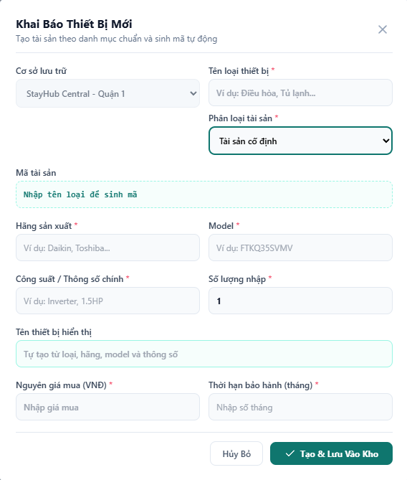
Figure 2. Create Asset Screen
This form creates a new asset model and stores the requested quantity in the selected building inventory. The asset code is generated by the system and must not be manually edited.
Field Description
Field Name | Description
Building context | Read-only display of the building selected on the top bar. The user does not select another building in this form.
Asset type name | Required. Selects an existing type or enters a new type name.
Asset class | Required. Classifies the asset as Fixed Asset, Equipment or Supplies, or Consumable.
Asset code | Read-only preview of the generated identifier based on the asset type and building context.
Brand | Required manufacturer or brand name.
Model | Required model or product reference.
Main specification | Required capacity or main specification, such as Inverter 1.5HP.
Initial quantity | Required number of units to create in the inventory.
Display name | Read-only generated name composed from the asset type, brand, specification, and model.
Purchase price | Required original purchase price in VND.
Warranty period | Required warranty duration in months.
Create and Save to Inventory | Validates the form, generates unique asset codes for every unit, and saves the units to inventory.

2.1.3 Restock Quantity Screen
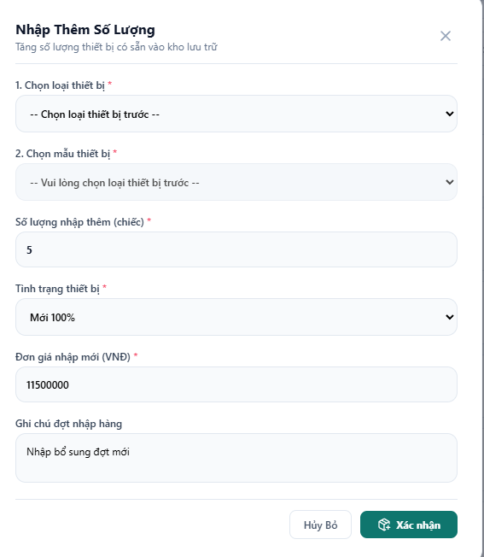
Figure 3. Restock Quantity Screen
This screen adds additional units to an existing asset model without creating a duplicate model. The user first filters by asset class, then selects an asset type and a specific model.
Field Description
Field Name | Description
Asset class | Required first filter. Limits the available asset types to the selected class.
Asset type | Required. Lists asset types that already have inventory records in the selected class.
Asset model | Required. Selects the existing model that will receive additional units.
Additional quantity | Required positive quantity to add to inventory.
Asset condition | Required condition for the new units, such as New 100%, Good, or Used.
New purchase price | Required unit purchase price for the restock batch.
Restock note | Optional note describing the procurement batch.
Confirm | Creates unique asset records for the added quantity and stores them as available inventory.

2.2 Asset Assignment

2.2.1 Assign Asset to Room Screen
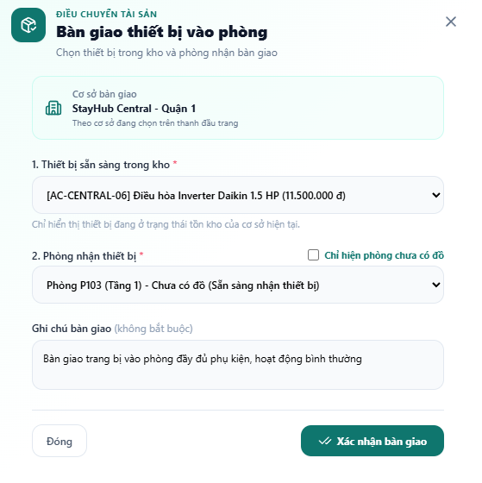
Figure 4. Assign Asset to Room Screen
This screen assigns one available asset to a selected room in the current building. The user chooses the asset model, selects a room, records the handover note, and confirms the assignment.
Field Description
Field Name | Description
Building context | Read-only selected building used to limit available inventory and destination rooms.
Available asset | Required. Lists assets currently in stock and available for assignment.
Destination room | Required. Lists rooms in the selected building. A quick filter can show only rooms that do not already have the selected fixed asset type.
Assignment note | Optional note describing the handover condition or included accessories.
Confirm assignment | Validates availability and duplicate rules, then changes the asset location from inventory to the selected room.

2.2.2 Quick Bulk Assignment Screen
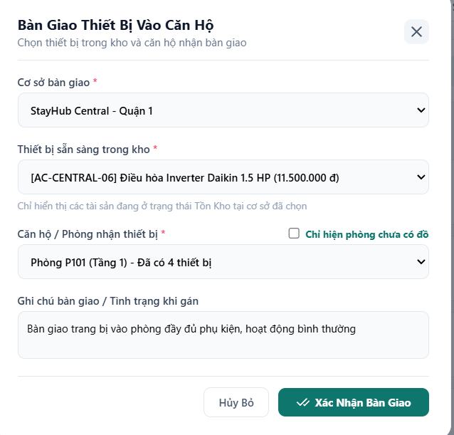
Figure 5. Quick Bulk Assignment Screen
This screen supports assigning the same asset type to multiple rooms in one operation. The system displays eligible rooms as selectable items and excludes rooms that already contain the same fixed asset type.
Field Description
Field Name | Description
Asset type | Read-only type selected from the asset type card that initiated the quick assignment.
Eligible room list | Displays rooms in the current building that can receive the selected asset type.
Room selection | Allows the user to select one or more destination rooms.
Assignment note | Optional note applied to the generated assignment records.
Confirm bulk assignment | Assigns available units to all selected rooms or returns a clear error when stock is insufficient.

2.3 Asset Lifecycle and Tracking

2.3.1 Asset Detail and Location Actions
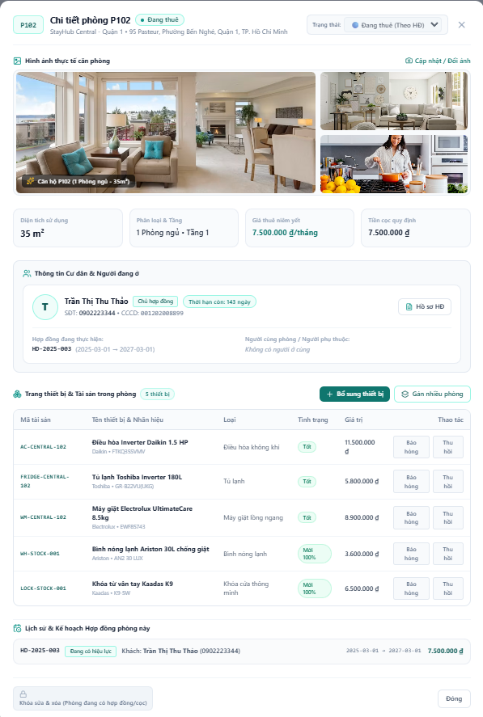
Figure 6. Asset Detail and Location Actions
The asset detail drawer shows the full record and assignment history for one asset. From this view, an authorized user can update condition, transfer an assigned asset to another room, or recover it to inventory.
Field Description
Field Name | Description
Asset identity | Shows asset code, display name, type, brand, model, specifications, purchase price, warranty, and current condition.
Current location | Shows the current building and room, or the inventory location when the asset is unassigned.
Assignment history | Shows assignment, transfer, and recovery events with room, date, user, and notes.
Update condition | Changes the current condition and records the update in the audit history.
Transfer room | Moves an assigned asset to another eligible room and records a transfer event.
Recover to inventory | Removes the asset from its room, returns it to inventory, and records a recovery event.

2.3.2 Asset Processing Rules
- Every created unit receives a unique asset code. The code is generated by the system and cannot be edited manually.
- A fixed asset type cannot be assigned twice to the same room. Equipment types configured to allow multiples may be assigned more than once.
- Only assets in available inventory can be assigned to a room.
- A bulk assignment must not partially create duplicate assignments; each result must be reported clearly when stock is insufficient.
- Every assignment, transfer, recovery, condition update, and restock operation must be recorded in asset history and audit logs.
- Staff users can perform only the asset actions allowed by their role; creating asset models and restocking are restricted from Staff.

