

Technical Safety Concept Lane Assistance

**Document Version: [Version]**

**Template Version 1.0, Released on 2017-06-21**



# Document history

|  |  |  |  |
| --- | --- | --- | --- |
| Date | Version | Editor | Description |
| 3/5/2018 | 1.0 |  | Initial Draft |
| 3/6/2018 | 1.1 |  | Add WDC-02 |
|  |  |  |  |
|  |  |  |  |
|  |  |  |  |

# 

# Table of Contents

Document history

Table of Contents

Purpose of the Technical Safety Concept

Inputs to the Technical Safety Concept

Functional Safety Requirements

Refined System Architecture from Functional Safety Concept

Functional overview of architecture elements

Technical Safety Concept

Technical Safety Requirements

Refinement of the System Architecture

Allocation of Technical Safety Requirements to Architecture Elements

Warning and Degradation Concept

# Purpose of the Technical Safety Concept

The technical safety concept translates high-level functional safety requirements into technical safety requirements that dictate specific performance parameters and concrete constraints for the system.

# Inputs to the Technical Safety Concept

## Functional Safety Requirements

|  |  |  |  |  |
| --- | --- | --- | --- | --- |
| **ID** | **Functional Safety Requirement** | **ASIL** | **Fault Tolerant Time Interval** | **Safe State** |
| Functional  Safety  Requirement  01-01 | The electronic power steering ECU shall ensure that the lane departure oscillating torque amplitude is below Max_Torque_Amplitude. | C | 50 ms | The LDW system will completely stop applying haptic feedback. Warning will display on dashboard informing driver of the fault. |
| Functional  Safety  Requirement  01-02 | The electronic power steering ECU shall ensure that the lane departure oscillating torque frequency is below Max_Torque_Frequency. | C | 50 ms | The LDW system will completely stop applying haptic feedback. Warning will display on dashboard informing driver of the fault. |
| Functional  Safety  Requirement  02-01 | The electronic power steering ECU shall ensure that the lane keeping assistance torque is applied for only Max_Duration. | B | 500 ms | The LDW system will completely stop affecting the car steering. Warning will display on dashboard informing driver that lane keeping has stopped. |

## Refined System Architecture from Functional Safety Concept

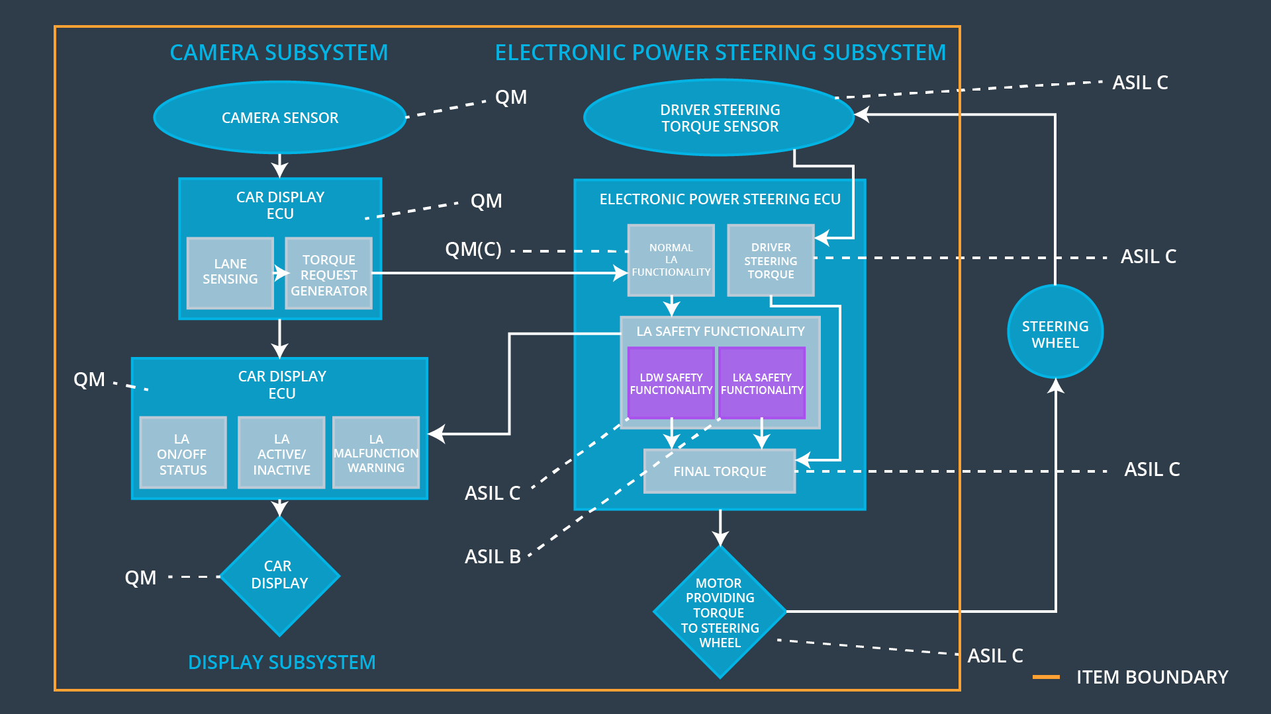

### 

### Functional overview of architecture elements

|  |  |
| --- | --- |
| **Element** | **Description** |
| Camera Sensor | The camera sensor reads in images from the road. |
| Camera Sensor ECU - Lane Sensing | Camera Sensor ECU Lane Sensing element interprets road images to determine position, orientation, and curvature of lane lines. |
| Camera Sensor ECU - Torque request generator | The Camera Sensor ECU Torque Request Generator uses lane pose information to determine necessary torque for lane keeping. |
| Car Display | The Car Display shows the driver the current status of LDW and LK functions, including current operation and warnings. |
| Car Display ECU - Lane Assistance On/Off Status | The Car Display ECU LA On/Off Status element determines whether each LA function has been turned on or off. |
| Car Display ECU - Lane Assistant Active/Inactive | The Car Display ECU LA Active/Inactive element determines whether the lane assist is active or inactive for display on the dashboard. |
| Car Display ECU - Lane Assistance malfunction warning | The Car Display ECU LA Malfunction Warning element receives LDW_Error_Status messages and provides appropriate warnings on the dashboard. |
| Driver Steering Torque Sensor | The Driver Steering Torque Sensor measures the amount of torque applied by the driver, which must be amplified by the EPS ECU to produce a torque. The LA functions are minor contributors to torque compared to the amplification of driver steering torque. |
| Electronic Power Steering (EPS) ECU - Driver Steering Torque | The Electronic Power Steering (EPS) ECU Driver Steering Torque element determines appropriate amplification of torque applied by the driver. |
| EPS ECU - Normal Lane Assistance Functionality | The EPS ECU Normal Lane Assistance Functionality element is responsible for the primary (non-safety) functions of LA. |
| EPS ECU - Lane Departure Warning Safety Functionality | The LDW Safety element is responsible for safety- related functions of LDW: limiting amplitude and frequency of haptic feedback. |
| EPS ECU - Lane Keeping Assistant Safety Functionality | The LK Safety element is responsible for safety- related functions of LK: limiting duration of usage. |
| EPS ECU - Final Torque | The Final Torque element combines torque contributions from driver amplification and LA elements. |
| Motor | The Motor provides torque for the steering wheel. |

# Technical Safety Concept

## Technical Safety Requirements

**Lane Departure Warning (LDW) Requirements:**

Functional Safety Requirement 01-01 with its associated system elements

(derived in the functional safety concept)

|  |  |  |  |  |
| --- | --- | --- | --- | --- |
| **ID** | **Functional Safety Requirement** | **Electronic Power Steering ECU** | **Camera ECU** | **Car Display ECU** |
| Functional  Safety  Requirement  01-01 | The lane keeping item shall ensure that the lane departure oscillating torque amplitude is below Max_Torque_Amplitude | X |  |  |

Technical Safety Requirements related to Functional Safety Requirement 01-01 are:

|  |  |  |  |  |  |
| --- | --- | --- | --- | --- | --- |
| **ID** | **Technical Safety Requirement** | **ASIL** | **Fault Tolerant Time Interval** | **Architecture Allocation** | **Safe State** |
| Technical  Safety  Requirement  01 | The LDW safety component shall ensure that the amplitude of the LDW_Torque_Request sent to the final electronic power steering torque component is below Max_Torque_Amplitude. | C | 50 ms | LDW safety | The LDW safety component will set the LDW torque amplitude request to 0, preventing further haptic. Warning will display on dashboard informing driver of the fault. |
| Technical  Safety  Requirement  02 | As soon as the LDW function deactivates the LDW feature, the 'LDW Safety' software block shall send a signal to the car display ECU to turn on a warning light. | C | 50 ms | LDW safety | The LDW safety component will set the LDW torque amplitude request to 0, preventing further haptic. Warning will display on dashboard informing driver of the fault. |
| Technical  Safety  Requirement  03 | As soon as a failure is detected by the LDW function, it shall deactivate the LDW feature and the 'LDW_Torque_Request' shall be set to zero. | C | 50 ms | LDW safety | The LDW safety component will set the LDW torque amplitude request to 0, preventing further haptic. Warning will display on dashboard informing driver of the fault. |
| Technical  Safety  Requirement  04 | The validity and integrity of the data transmission for 'LDW_Torque_Request' signal shall be ensured. | C | 50 ms | Data transmission integrity check | The LDW safety component will set the LDW torque amplitude request to 0, preventing further haptic. Warning will display on dashboard informing driver of the fault. |
| Technical  Safety  Requirement  05 | Memory test shall be conducted at start up of the EPS ECU to check for any faults in memory. | A | Ignition cycle | Safety startup | The LDW safety component will set the LDW torque amplitude request to 0, preventing further haptic. Warning will display on dashboard informing driver of the fault. |

Functional Safety Requirement 01-2 with its associated system elements

(derived in the functional safety concept)

|  |  |  |  |  |
| --- | --- | --- | --- | --- |
| **ID** | **Functional Safety Requirement** | **Electronic Power Steering ECU** | **Camera ECU** | **Car Display ECU** |
| Functional  Safety  Requirement  01-02 | The lane keeping item shall ensure that the lane departure oscillating torque frequency is below Max_Torque_Frequency | X |  |  |

Technical Safety Requirements related to Functional Safety Requirement 01-02 are:

|  |  |  |  |  |  |
| --- | --- | --- | --- | --- | --- |
| **ID** | **Technical Safety Requirement** | **ASIL** | **Fault Tolerant Time Interval** | **Architecture Allocation** | **Safe State** |
| Technical  Safety  Requirement  01 | The LDW safety component shall ensure that the frequency of the LDW_Torque_Request sent to the final electronic power steering torque component is below Max_Torque_Frequency. | C | 50 ms | LDW Safety | The LDW safety component will set the LDW torque frequency request to 0, preventing further haptic. Warning will display on dashboard informing driver of the fault. |
| Technical  Safety  Requirement  02 | As soon as the LDW function deactivates the LDW feature, the 'LDW Safety' software block shall send a signal to the car display ECU to turn on a warning light. | C | 50 ms | LDW Safety | The LDW safety component will set the LDW torque frequency request to 0, preventing further haptic. Warning will display on dashboard informing driver of the fault. |
| Technical  Safety  Requirement  03 | As soon as a failure is detected by the LDW function, it shall deactivate the LDW feature and the 'LDW_Torque_Request' shall be set to zero. | C | 50 ms | LDW Safety | The LDW safety component will set the LDW torque frequency request to 0, preventing further haptic. Warning will display on dashboard informing driver of the fault. |
| Technical  Safety  Requirement  04 | The validity and integrity of the data transmission for 'LDW_Torque_Request' signal shall be ensured. | C | 50 ms | Data Transmission Integrity Check | The LDW safety component will set the LDW torque frequency request to 0, preventing further haptic. Warning will display on dashboard informing driver of the fault. |
| Technical  Safety  Requirement  05 | Memory test shall be conducted at start up of the EPS ECU to check for any faults in memory. | A | Ignition cycle | Safety Startup | The LDW safety component will set the LDW torque frequency request to 0, preventing further haptic. Warning will display on dashboard informing driver of the fault. |

**Lane Keeping Assistance (LKA) Requirements:**

Functional Safety Requirement 02-1 with its associated system elements

(derived in the functional safety concept)

|  |  |  |  |  |
| --- | --- | --- | --- | --- |
| **ID** | **Functional Safety Requirement** | **Electronic Power Steering ECU** | **Camera ECU** | **Car Display ECU** |
| Functional  Safety  Requirement  02-01 | The lane keeping item shall ensure that the lane keeping assistance torque is applied for only Max_Duration | X |  |  |

Technical Safety Requirements related to Functional Safety Requirement 02-01 are:

|  |  |  |  |  |  |
| --- | --- | --- | --- | --- | --- |
| **ID** | **Technical Safety Requirement** | **ASIL** | **Fault Tolerant Time Interval** | **Allocation to Architecture** | **Safe State** |
| Technical  Safety  Requirement  01 | The LKA safety component shall ensure that the duration of LK usage is below Max_Duration. | B | 500 ms | LKA Safety | The LKA system will completely stop affecting the car steering. Warning will display on dashboard informing driver that lane keeping assistance has stopped. |
| Technical  Safety  Requirement  02 | As soon as the LKA function deactivates the LKA feature, the 'LKA Safety' software block shall send a signal to the car display ECU to turn on a warning light. | B | 500 ms | LKA Safety | The LKA system will completely stop affecting the car steering. Warning will display on dashboard informing driver that lane keeping has stopped. |
| Technical  Safety  Requirement  03 | As soon as a failure is detected by the LKA function, it shall deactivate the LKA feature and the 'LKA_Torque_Request' shall be set to zero. | B | 500 ms | LKA Safety | The LKA system will completely stop affecting the car steering. Warning will display on dashboard informing driver that lane keeping has stopped. |
| Technical  Safety  Requirement  04 | The validity and integrity of the data transmission for 'LKA_Torque_Request' signal shall be ensured. | B | 500 ms | Data Transmission Integrity Check | The LKA system will completely stop affecting the car steering. Warning will display on dashboard informing driver that lane keeping has stopped. |
| Technical  Safety  Requirement  05 | Memory test shall be conducted at start up of the EPS ECU to check for any faults in memory. | A | Ignition Cycle | Safety Startup | The LKA system will completely stop affecting the car steering. Warning will display on dashboard informing driver that lane keeping has stopped. |

## Refinement of the System Architecture

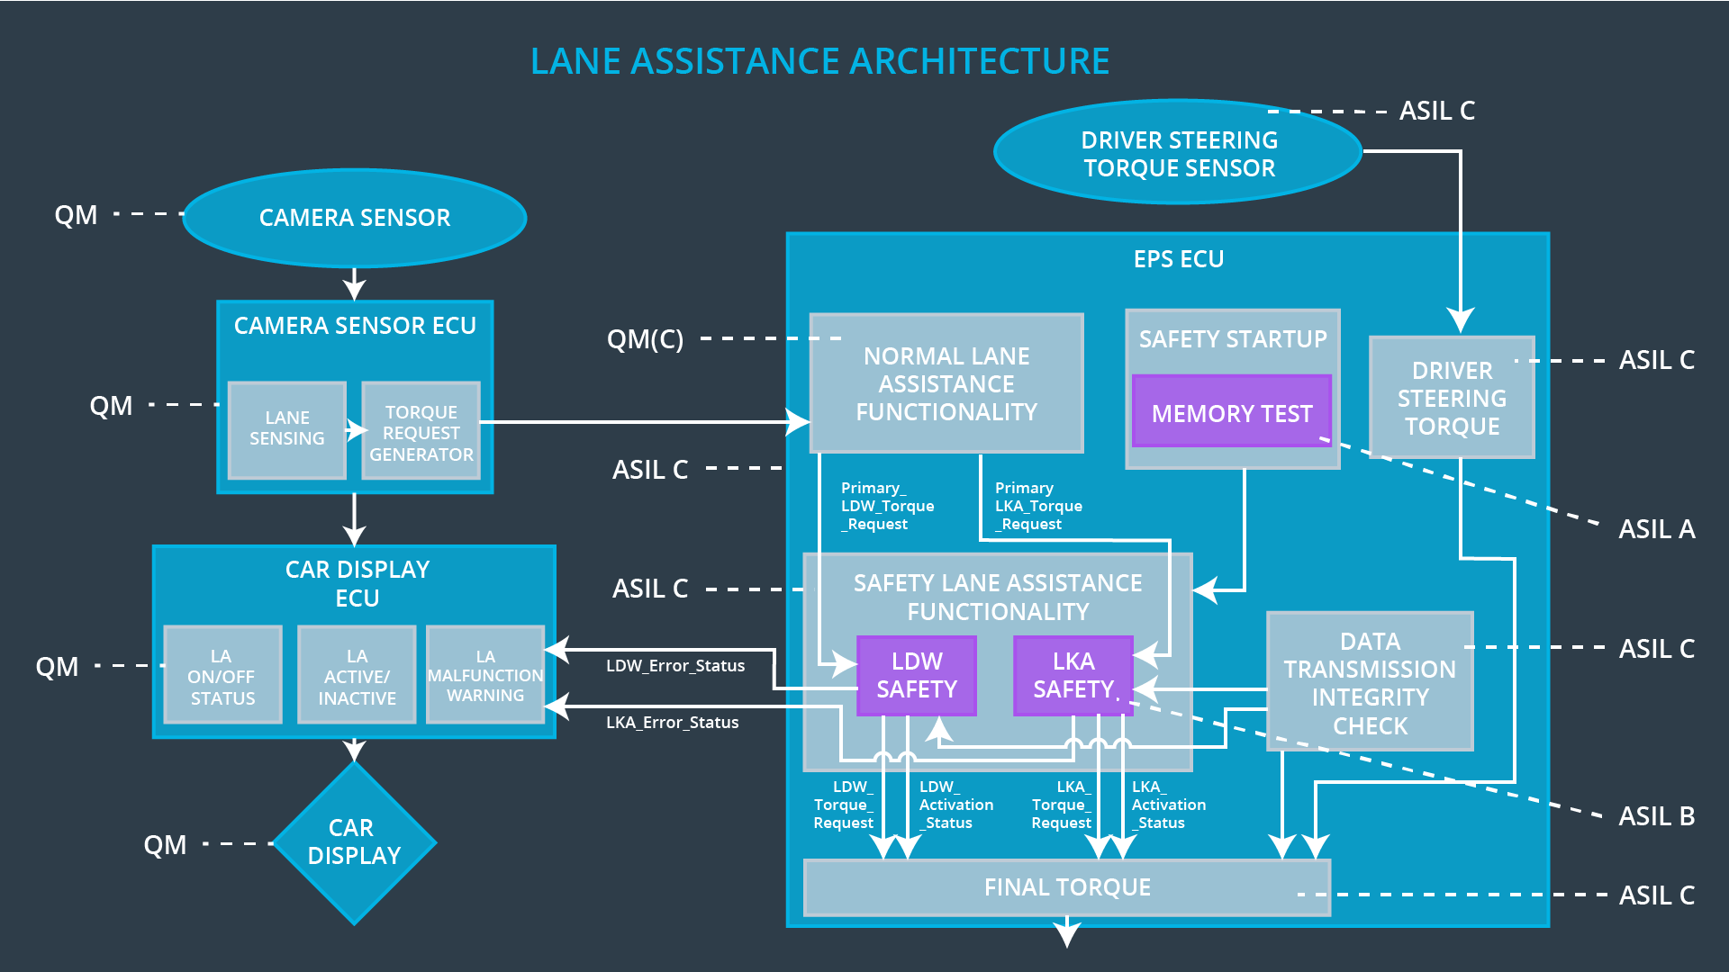

## Allocation of Technical Safety Requirements to Architecture Elements

All technical safety requirements are allocated to the electronic power steering ECU.

## Warning and Degradation Concept

|  |  |  |  |  |
| --- | --- | --- | --- | --- |
| **ID** | **Degradation Mode** | **Trigger for Degradation Mode** | **Safe State invoked?** | **Driver Warning** |
| WDC-01-01 | Turn off functionality. | The lane departure warning function applies an oscillating torque with very high torque amplitude (above limit). | Yes | Warning indicator on dashboard |
| WDC-01-02 | Turn off functionality. | The lane departure warning function applies an oscillating torque with very high torque frequency (above limit). | Yes | Warning indicator on dashboard |
| WDC-02-01 | Turn off functionality. | The lane keeping assistance function is not limited in time duration which leads to misuse as an autonomous driving function. | Yes | Warning indicator on dashboard |