**Note**

1. Main Menu

= > Photo=> view => Menu update by user

* Text => News

1. Slide

* Create form post image and title and ordering
* Link => insert
* Form:

1. Change feature to thumbnail in home not slide
2. Store Date in form when Post news
3. Create New bottom for new post article
4. Delete form under feature

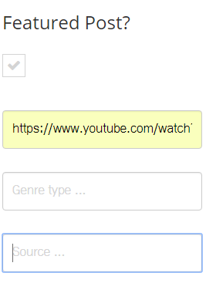

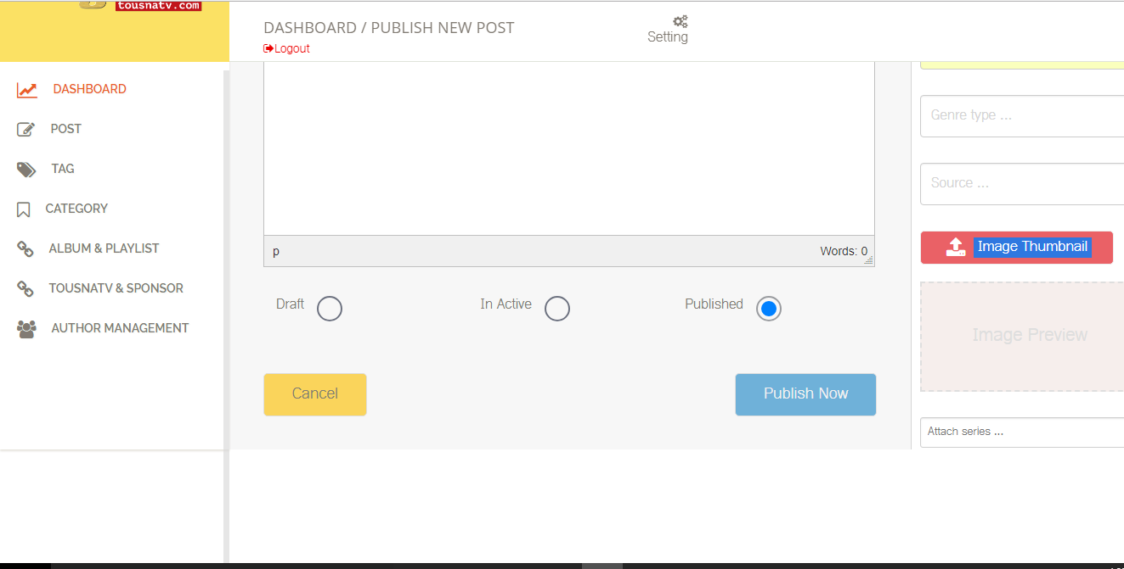

1. **Detail news**

