**EKSTRAKULIKULER**

**“FILM LENS DAN THEATER”**



PEMERINTAH KABUPATEN BOGOR

DINAS PENDIDIKAN

SMA NEGERI 2 CIBINONG

Jln. Karadenan No.5 Cibinong, Bogor 16913

Telp/Fax. (0251) 8654347

TAHUN 2020

1. **SEJARAH SINGKAT**

Ekstrakurikuler film dan teater merupakan suatu ekskul yang bergerak di bidang videografi, fotografi, dan pementasan teater di SMAN 2 Cibinong. Ekskul ini sering juga disebut 04.00PM, nama 04.00PM dibuat untuk menjadi rumah produksi film, foto sekaligus nama komunitas teater.

Nama 04.00PM sendiri berasal dari jam ekskul ini berkumpul untuk membahas tentang materi atau praktek yang berhubungan dengan videografi, fotografi, atau teater. Pada awal ekskul ini berdiri, ekskul ini hanya ekskul teater, lalu pada saat masa jabatan angkatan 23 mulai mencoba hal dan inovasi baru maka dari itu dikembangkan menjadi ekskul film, foto dan teater dan Filter seringkali ikut berpartisipasi dalam acara sekolah untuk mendokumentasikan kegiatan-kegiatan yang ada di sekolah.

Seiring bergulirnya waktu, Saat jabatan berada di angkatan 24, Filter sering kali memenangkan lomba, mulai dari lomba film pendek Bina Insani Cup hingga lomba Video Klip Asian Games. Pada masa jabatan angkatan 25 ekskul Filter juga sering memenangkan lomba seperti lomba film pendek SMAN 3 Bogor, lomba video klip UNHAN dan masih banyak lagi. Pada masa jabatan angkatan 26, ekskul Filter akhirnya mementaskan kembali teater berjudul “ the Last Stone “pada pentas seni SMAN 2 Cibinong yaitu “Smavo in action 5.0”

1. **STRUKTUR ORGANISASI**

|  |  |  |  |  |  |  |  |  |  |  |  |  |  |  |  |  |  |  |  |  |  |  |  |  |  |  |  |  |  |  |  |  |  |  |  |  |  |  |  |  |  |  |  |  |  |  |  |  |  |  |  |  |  |  |  |  |  |  |  |  |  |  |  |  |  |  |  |  |  |  |  |  |  |  |  |  |  |  |  |  |  |  |  |  |  |  |  |  |  |  |  |  |  |  |  |  |  |  |  |  |  |  |  |
| --- | --- | --- | --- | --- | --- | --- | --- | --- | --- | --- | --- | --- | --- | --- | --- | --- | --- | --- | --- | --- | --- | --- | --- | --- | --- | --- | --- | --- | --- | --- | --- | --- | --- | --- | --- | --- | --- | --- | --- | --- | --- | --- | --- | --- | --- | --- | --- | --- | --- | --- | --- | --- | --- | --- | --- | --- | --- | --- | --- | --- | --- | --- | --- | --- | --- | --- | --- | --- | --- | --- | --- | --- | --- | --- | --- | --- | --- | --- | --- | --- | --- | --- | --- | --- | --- | --- | --- | --- | --- | --- | --- | --- | --- | --- | --- | --- | --- | --- | --- | --- | --- | --- | --- |
|  | |  | |  | |  | |  | |  | | **KEPALA SEKOLAH** | | | | | | | | | | | |  | | |  | | |  | | | | |  | | |  | | | | |  | | |  | | |  | | | | |  | | | | |  | | | | |  | | | |  | | | |  | | | |  | | | |  | | | |  | | | |  | | | |  | | | |  | | | |  | | | |
|  | |  | |  | |  | |  | |  | | Dr. H. Bambang Supriyadi, M.Pd | | | | | | | | | | | |  | | |  | | |  | | | | |  | | |  | | | | |  | | |  | | |  | | | | |  | | | | |  | | | | |  | | | |  | | | |  | | | |  | | | |  | | | |  | | | |  | | | |  | | | |  | | | |  | | | |
|  | |  | |  | |  | |  | |  | |  | | |  | | |  | | | | |  | | |  | | |  | | |  | | | |  | | | | |  | | | |  | | |  | | | |  | | | |  | | | | |  | | | |  | | | |  | | | |  | | | |  | | | |  | | | |  | | | |  | | | |  | | | |  | | | |  | | | | | | | | |
|  | |  | |  | |  | |  | |  | | **PEMBINA MPK/OSIS** | | | | | | | | | | | |  | | |  | | |  | | | | |  | | |  | | | | |  | | |  | | |  | | | | |  | | | | |  | | | | |  | | | |  | | | |  | | | |  | | | |  | | | |  | | | |  | | | |  | | | |  | | | |  | | | |
|  | |  | |  | |  | |  | |  | | Sari ismono,S.Pd., M.Pd  Dijah Noeringtyas, M.Pd. | | | | | | | | | | | |  | | |  | | |  | | | | |  | | |  | | | | |  | | |  | | |  | | | | |  | | | | |  | | | | |  | | | |  | | | |  | | | |  | | | |  | | | |  | | | |  | | | |  | | | |  | | | |  | | | |
|  | |  | |  | |  | |  | |  | |  | | |  | | |  | | | | |  | | |  | | |  | | |  | | | |  | | | | |  | | | |  | | |  | | | |  | | | |  | | | | |  | | | |  | | | |  | | | |  | | | |  | | | |  | | | |  | | | |  | | | |  | | | |  | | | |  | | | | | | | | |
|  | |  | |  | |  | |  | |  | | **PEMBINA EKSKUL** | | | | | | | | | | | |  | | |  | | |  | | | | |  | | |  | | | | |  | | |  | | |  | | | | |  | | | | |  | | | | |  | | | |  | | | |  | | | |  | | | |  | | | |  | | | |  | | | |  | | | |  | | | |  | | | |
|  | |  | |  | |  | |  | |  | | Teguh Satya Pratama, S.Pd | | | | | | | | | | | |  | | |  | | |  | | | | |  | | |  | | | | |  | | |  | | |  | | | | |  | | | | |  | | | | |  | | | |  | | | |  | | | |  | | | |  | | | |  | | | |  | | | |  | | | |  | | | |  | | | |
|  | |  | |  | |  | |  | |  | |  | | |  | | |  | | | | |  | | |  | | |  | | |  | | | |  | | | | |  | | | |  | | |  | | | |  | | | |  | | | | |  | | | |  | | | |  | | | |  | | | |  | | | |  | | | |  | | | |  | | | |  | | | |  | | | |  | | | | | | | | |
|  | | **WAKIL** | | | | | | | |  | | **KETUA** | | | | | | | | | | | |  | | |  | | |  | | | | |  | | |  | | | | |  | | |  | | |  | | | | |  | | | | |  | | | | |  | | | |  | | | |  | | | |  | | | |  | | | |  | | | |  | | | |  | | | |  | | | |  | | | |
|  | | Farrell M. Zhafran | | | | | | | |  | | Abrar Bhanurasmi Z | | | | | | | | | | | |  | | |  | | |  | | | | |  | | |  | | | | |  | | |  | | |  | | | | |  | | | | |  | | | | |  | | | |  | | | |  | | | |  | | | |  | | | |  | | | |  | | | |  | | | |  | | | |  | | | |
|  | |  | |  | |  | |  | |  | |  | | | |  | |  | | | | |  | | |  | | |  | | |  | | | |  | | | | |  | | | |  | | |  | | | |  | | | |  | | | | |  | | | |  | | | |  | | | |  | | | |  | | | |  | | | |  | | | |  | | | |  | | | |  | | | |  | | | | | | | | |
|  | |  | |  | |  | |  | |  | |  | | | |  | |  | | | | |  | | |  | | |  | | |  | | | |  | | | | |  | | | |  | | |  | | | |  | | | |  | | | | |  | | | |  | | | |  | | | |  | | | |  | | | |  | | | |  | | | |  | | | |  | | | |  | | | |  | | | | | | | | |
|  |  | |  | | **SEKRETARIS** | | | | | | | | |  | | |  | | | **BENDAHARA** | | | | | | | | | | | | | |  | | | | | |  | | | | | | | | | | |  | | | | | |  | | | | |  | | | |  | | | |  | | | |  | | | |  | | | |  | | | |  | | | |  | | | |  | | | |  | | | |  | | |  | |  | |
|  |  | |  | | Luthfiana Azizah | | | | | | | | |  | | |  | | | Nisrina Atsil Y. | | | | | | | | | | | | | |  | | | | |  | | | | | | | | | | | | | |  | | | | |  | | | | |  | | | |  | | | |  | | | |  | | | |  | | | |  | | | |  | | | |  | | | |  | | | |  | | | |  | | |  | |  | |
|  |  | |  | |  | |  | |  | |  | |  | | | |  | |  | |  |  | | |  | | |  | | |  | |  | | | |  | | | | |  | |  | | |  | | |  | | | | |  | | | | |

1. **FOTO ANGGOTA**

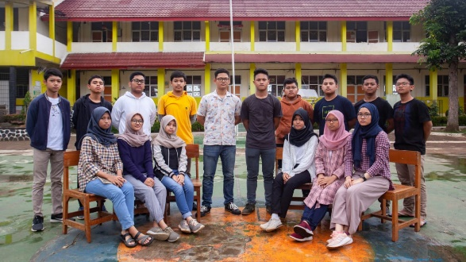

1. 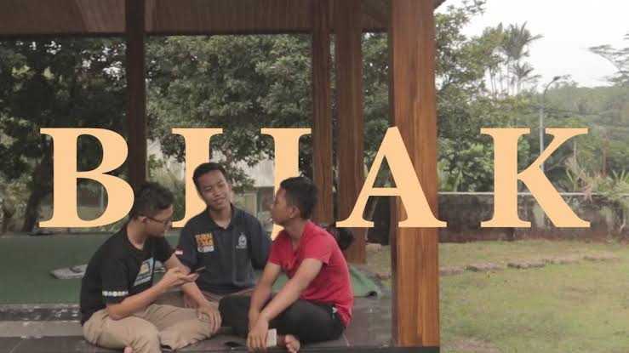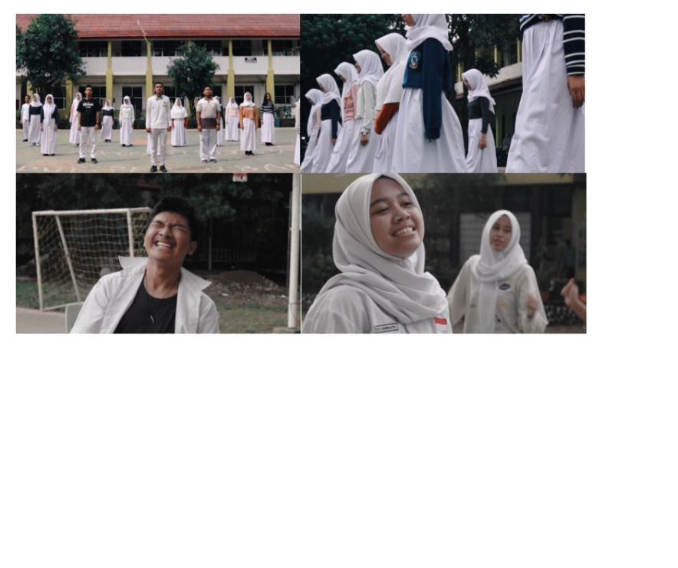**FOTO KEGIATAN EKSKUL**

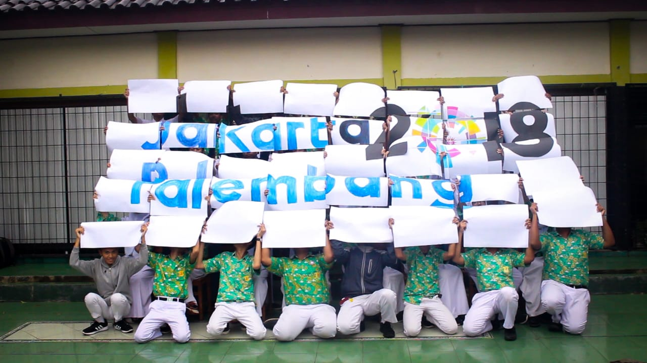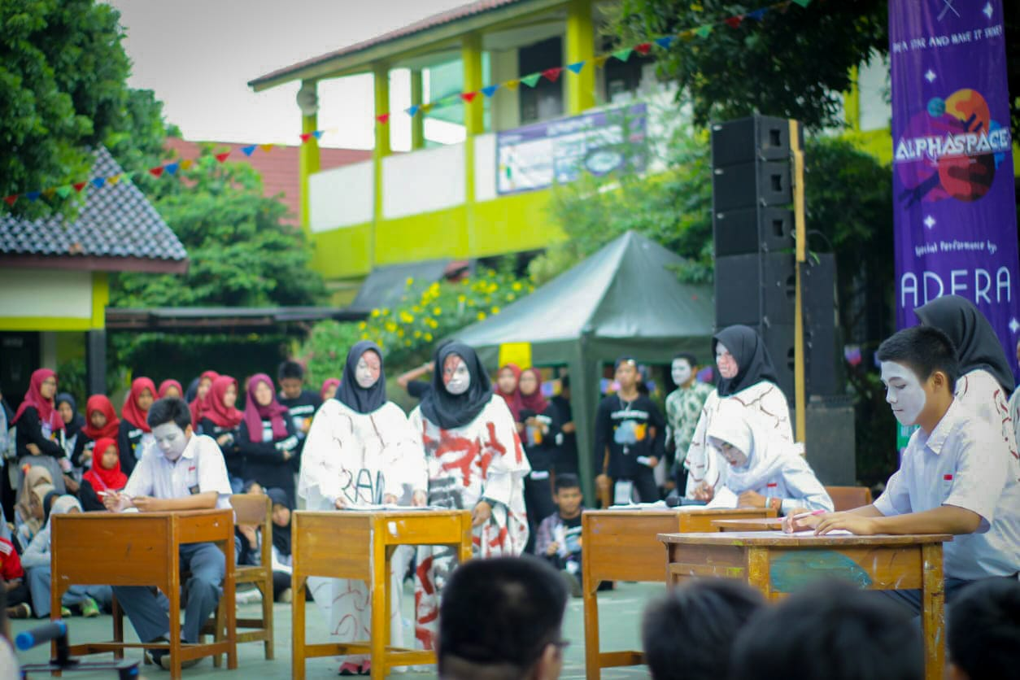

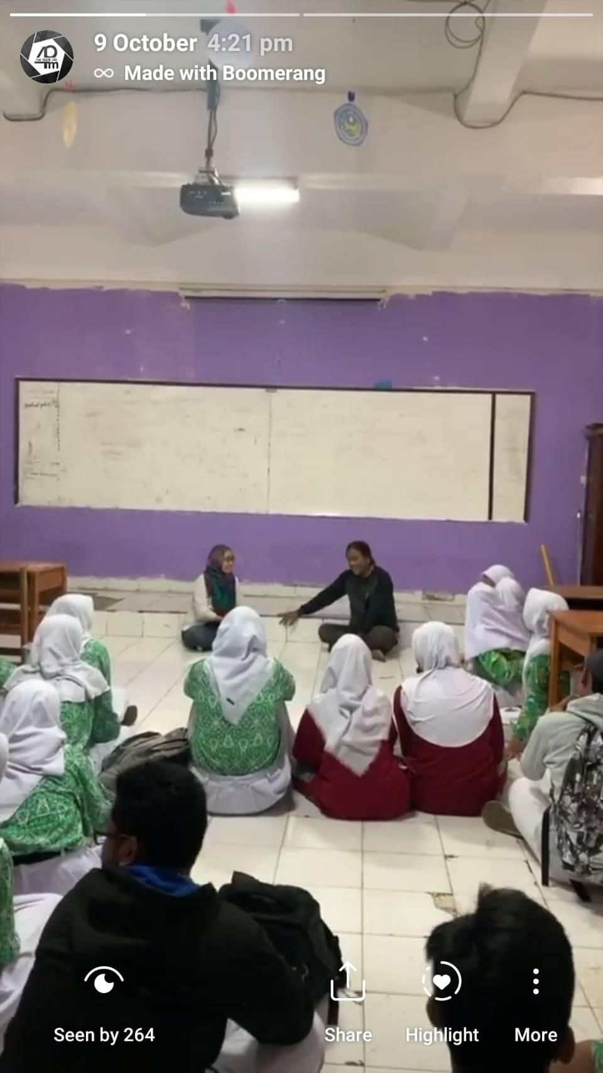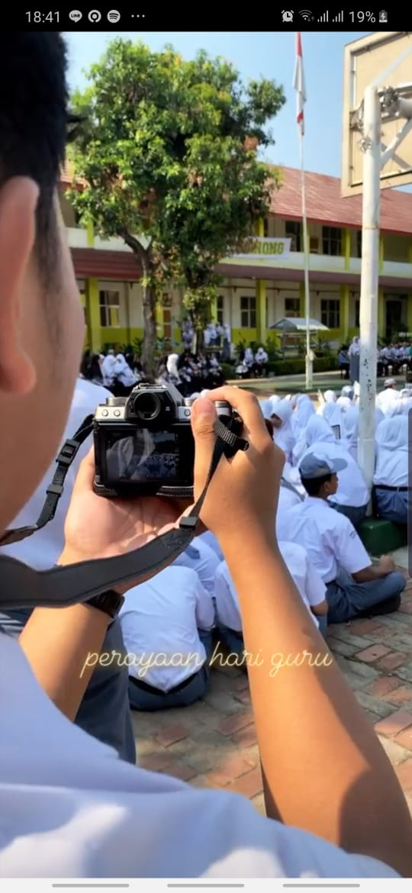

1. **KEJUARAAN**

|  |  |  |
| --- | --- | --- |
| No. | Nama Lomba | Juara |
| 1 | Lomba Video Klip Parade Cinta Tanah Air UNHAN 2019 | Juara 1 |
| 2. | Lomba Film Pendek Mekkah SMAN 1 Bogor | Juara 1 |
| 3. | Short Movie Bina Insani Cup 2018 | Juara 2 |
| 4. | D’Voyage Short Movie Competition Group B | Juara 2 |
| 5. | Festival Dwi Warna 2019 | Juara 2 |
| 6. | D’Voyage Short Movie Competition Group A | Juara 3 |
| 7. | Lomba Video Pesona Asian Games 2018 | Juara 3 |

1. **LOGO EKSKUL**

