CMPS 350 – Web Development
Chirp
Social Media Platform

Project Report – Phase 2
Database Integration, APIs & Statistics

Group 10
Khaled Elrefaey – 202309917
Yacine Merabet – 202408983
Tameem Ansari – 202208882
Sharif Hamad – 202209291

GitHub Repository: https://github.com/horder6947/cmps350-project-group-10

1. Project Overview

Chirp is a Twitter-style social media platform built for CMPS 350. Phase 1 established the front-end using vanilla HTML, CSS, and JavaScript with browser local storage as the data layer. Phase 2 replaces the local-storage backend with a real relational database managed through Prisma ORM, exposes the data via Next.js API routes, and adds a dedicated statistics page with seven platform-wide analytics queries.

2. Data Model

The conceptual model captures all entities required by the social media platform. The diagram below shows the Entity-Relationship structure; the Prisma schema is the implementation of that model.

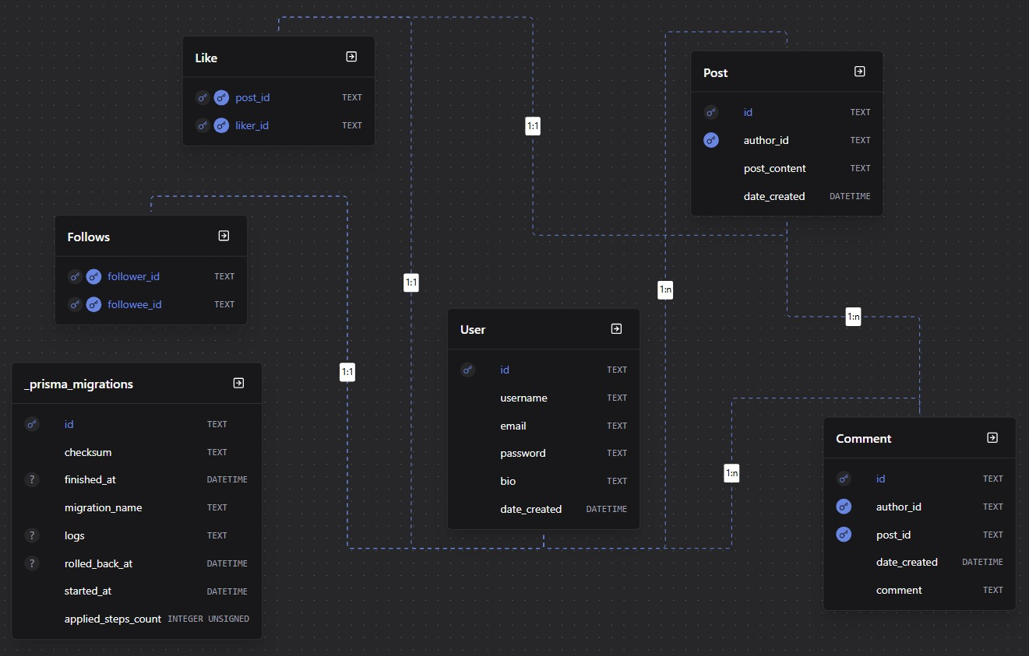

2.1 Entities & Relationships
The data model contains the following core entities:
- User – stores account credentials, display name, bio, avatar URL, and timestamps.
- Post – a tweet/chirp authored by a User, containing text content and a creation timestamp.
- Comment – a reply written by a User on a Post.
- Like – a join record linking a User to a Post (many-to-many).
- Follow – a self-referential join on User representing follower/following relationships.
- Retweet (optional) – a re-share of an existing Post by a different User.

2.2 Prisma Schema
The Prisma schema (prisma/schema.prisma) defines all models, fields, types, and relations. The key models are shown below:

model User {
id String @id @default(cuid(2))
username String
email String @unique
password String // plaintext password for easier testing and demo

bio String @default("No bio")
date_created DateTime @default(now())

following Follows[] @relation("Following")
followers Follows[] @relation("Followers")
posts Post[]
likes Like[]
comments Comment[]
}

model Follows {
follower_id String // FK
followee_id String // FK

followee User @relation("Followers", references: [id], fields: [followee_id], onDelete: Cascade)
follower User @relation("Following", references: [id], fields: [follower_id], onDelete: Cascade)

@@id([followee_id, follower_id])
}

model Post {
id String @id @default(cuid(2))

author_id String // FK
author User @relation(fields: [author_id], references: [id], onDelete: Cascade)

post_content String
date_created DateTime @default(now())

likes Like[]
comments Comment[]
}

model Like {
post_id String // FK
liker_id String // FK

post Post @relation(references: [id], fields: [post_id], onDelete: Cascade)
liker User @relation(references: [id], fields: [liker_id], onDelete: Cascade)

@@id([post_id, liker_id])
}

model Comment {
id String @id @default(cuid(2))
author_id String // FK
post_id String // FK
date_created DateTime @default(now())
comment String

author User @relation(references: [id], fields: [author_id], onDelete: Cascade)
post Post @relation(references: [id], fields: [post_id], onDelete: Cascade)
}

The schema enforces referential integrity at the database level through foreign key constraints generated by Prisma.

3. Database Initialization (seed.js)

The file prisma/seed.mjs populates the database with realistic sample data sourced from the Phase 1 JSON files plus additional synthetic records generated by Faker.js. Running the seed gives the database enough content to produce meaningful statistics.

3.1 Seed Script Excerpt

import { PrismaLibSql } from "@prisma/adapter-libsql";
import { PrismaClient } from "@/prisma/client/client";
import { faker } from "@faker-js/faker";

const prisma = new PrismaClient({
adapter: new PrismaLibSql({
url: process.env.TURSO_DATABASE_URL ?? "",
authToken: process.env.DATABASE_AUTH_TOKEN,
}),
log: ["query"],
});

const users = [];
const posts = [];

const seed = async () => {

// create 100 users, try catch needed if IDs or emails collide
await Promise.all(
Array.from({ length: 100 }).map(async () => {
const myUsername = faker.internet.username();
try {
const current_user = await prisma.user.create({
data: {
username: myUsername,
email: faker.internet.email({ firstName: myUsername }),
password: faker.internet.password({ memorable: true }),
bio: faker.lorem.sentence(4),
date_created: faker.date.between({
from: new Date('2026-01-01'),
to: new Date('2026-04-15')
})
},
select: {
id: true,
}
});
users.push(current_user.id)
} catch (e) { }
})
);

const users_count = users.length;

// create 300 posts, assign them to random users
await Promise.all(
Array.from({ length: 300 }).map(async () => {
try {
posts.push((await prisma.post.create({
data: {
author_id: users[Math.floor(Math.random() * users_count)],
post_content: faker.lorem.sentence(),
date_created: faker.date.between({
from: new Date('2026-04-16'),
to: new Date('2026-05-02')
})
},
select: {
id: true
}
})).id);
} catch (e) { }
})
);

const posts_count = posts.length;

// create 1500 follow records, random users will follow random users
await Promise.all(
Array.from({ length: 1500 }).map(async () => {
try {
await prisma.follows.create({
data: {
follower_id: users[Math.floor(Math.random() * users_count)],
followee_id: users[Math.floor(Math.random() * users_count)],
}
});
} catch (e) { }
})
);

// create 1000 comments, assign to random posts and users
await Promise.all(
Array.from({ length: 1000 }).map(async () => {
try {
await prisma.comment.create({
data: {
author_id: users[Math.floor(Math.random() * users_count)],
post_id: posts[Math.floor(Math.random() * posts_count)],
comment: faker.lorem.sentence(5)
}
});
} catch (e) { }
})
);

// add 5000 likes to posts, distribute randomly
await Promise.all(
Array.from({ length: 5000 }).map(async () => {
try {
await prisma.like.create({
data: {
post_id: posts[Math.floor(Math.random() * posts_count)],
liker_id: users[Math.floor(Math.random() * users_count)],
}
});
} catch (e) { }
})
);

};

try {
await seed();
await prisma.$disconnect();
} catch (e) {
console.error(e);
await prisma.$disconnect();
process.exit(1);
}

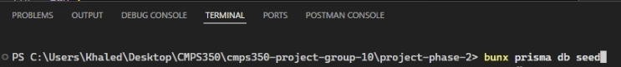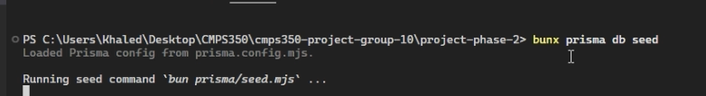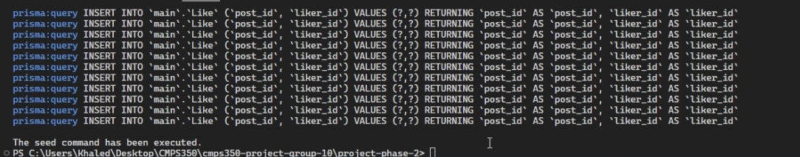

4. Data Repository

All database access is centralised in the repos/ directory. Each repository file corresponds to one entity and exposes typed functions that are called by the API route handlers. No raw SQL is written in the API layer; all queries, filters, sorting, and aggregations are expressed through Prisma Client and executed by the database engine.

4.1 Repository Structure
- repos/user.js – CRUD for users, follower/following queries
- repos/post.js – feed queries, create/delete post, like toggle
- repos/comment.js – list comments per post, add comment
- repos/statistics.js – all aggregation queries for the statistics page

4.2 Example Repository Functions
Get Paginated Feed (post.js)
import prisma from "@/repos/prisma";

export async function getPost(p_postid) {
try {
const result = await prisma.post.findUnique({
where: {
id: p_postid,
},
});
return result;
} catch (e) {
console.error(e);
}
}

Toggle Like (post.js)
export async function likePost(p_postid, p_likerid) {
try {
const result = await prisma.like.create({
data: {
liker_id: p_likerid,
post_id: p_postid,
},
});
return true;
} catch (e) {
console.error(e);
return false;
}
}

Most Liked Posts (statistics.js)

export async function getMostLikedPosts(p_count) {
try {
const result = await prisma.post.findMany({
select: {
id: true,
post_content: true,
date_created: true,
author: {
select: {
id: true,
username: true,
},
},
_count: {
select: {
likes: true,
comments: true,
},
},
},
take: p_count,
orderBy: {
likes: {
_count: "desc",
},
},
});
return result.map((row) => ({
id: row.id,
post_content: row.post_content,
date_created: row.date_created,
author: row.author,
likesCount: row._count.likes,
commentsCount: row._count.comments,
}));
} catch (e) {
console.error(e);
return [];
}
}

5. API Routes

Next.js App Router API routes (app/api/***/route.js) expose the repository functions as HTTP endpoints consumed by the frontend. The table below lists all implemented endpoints.

5.1 Example API Handler
GET /api/posts – News Feed
export async function GET(request) {
try {
const { searchParams } = new URL(request.url);
const authorId = searchParams.get("authorId");
const viewerId = searchParams.get("viewerId")?.trim() || "";
const followingOnly = searchParams.get("followingOnly") === "1";
const limit = Math.min(
Math.max(Number(searchParams.get("limit")) || 50, 1),
100,
);

const rows = authorId
? await postRepo.getPostsByAuthorForFeed(authorId, limit)
: followingOnly && viewerId
? await postRepo.getFollowingPostsForFeed(viewerId, limit)
: await postRepo.getPostsForFeed(limit);

const likedByPostId = new Set();
if (viewerId && rows.length > 0) {
const likes = await prisma.like.findMany({
where: {
liker_id: viewerId,
post_id: { in: rows.map((r) => r.id) },
},
select: { post_id: true },
});
for (const row of likes) likedByPostId.add(row.post_id);
}

return Response.json({
posts: rows.map((row) => mapPost(row, likedByPostId.has(row.id))),
});
} catch (error) {
console.error("GET /api/posts failed:", error);
return Response.json({ error: "Unable to load posts" }, { status: 500 });}
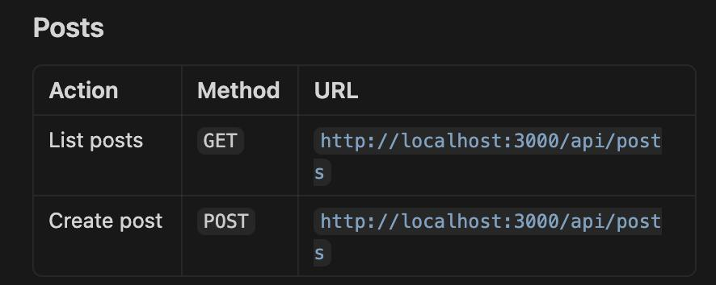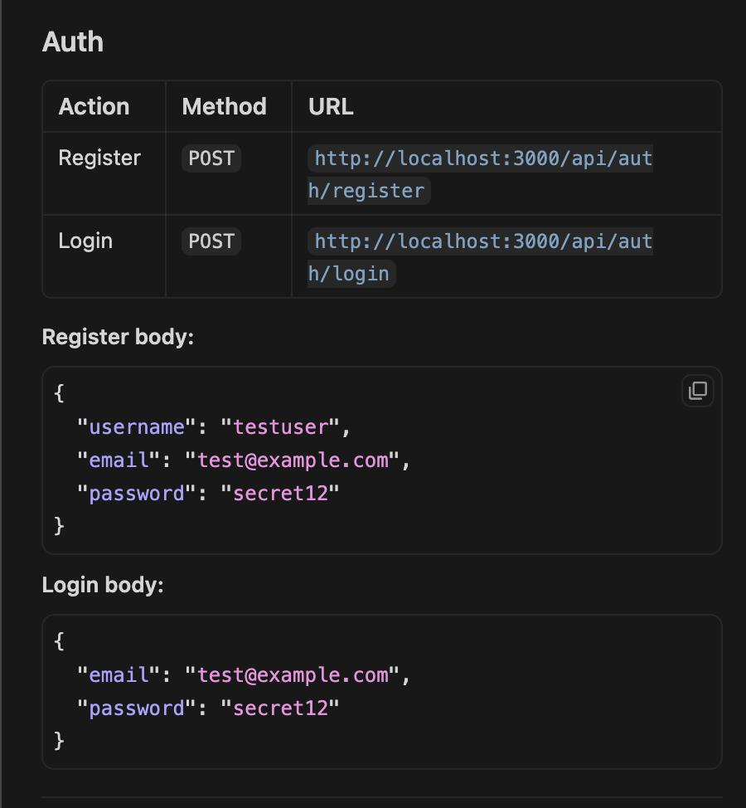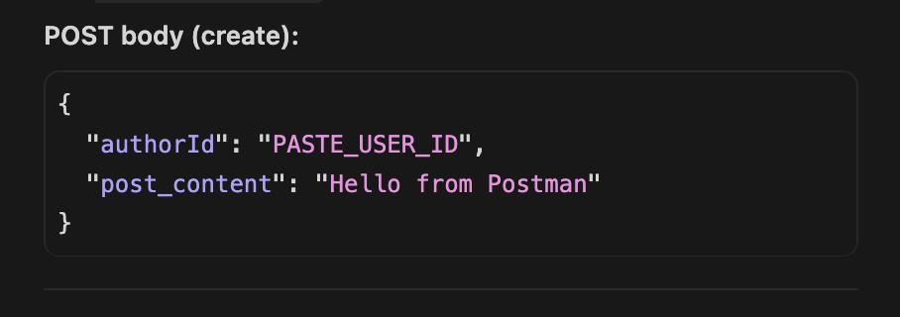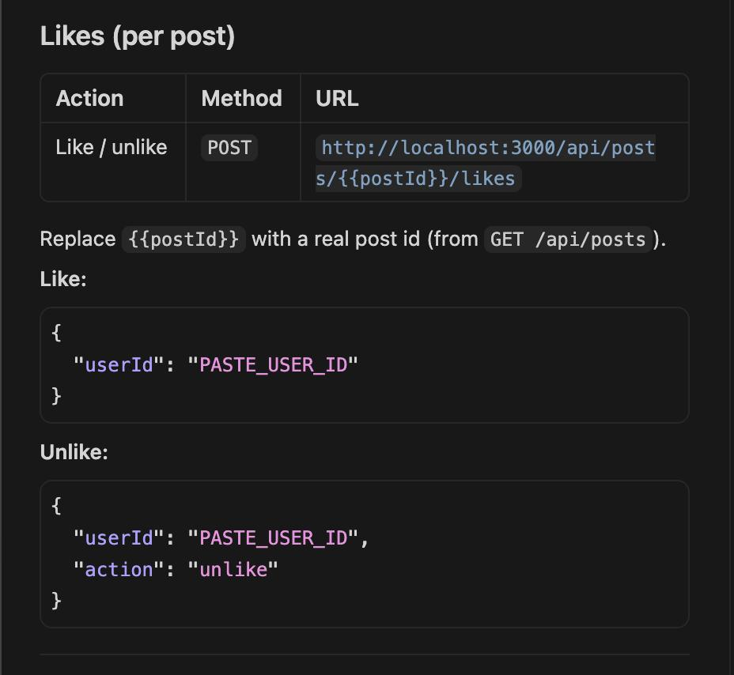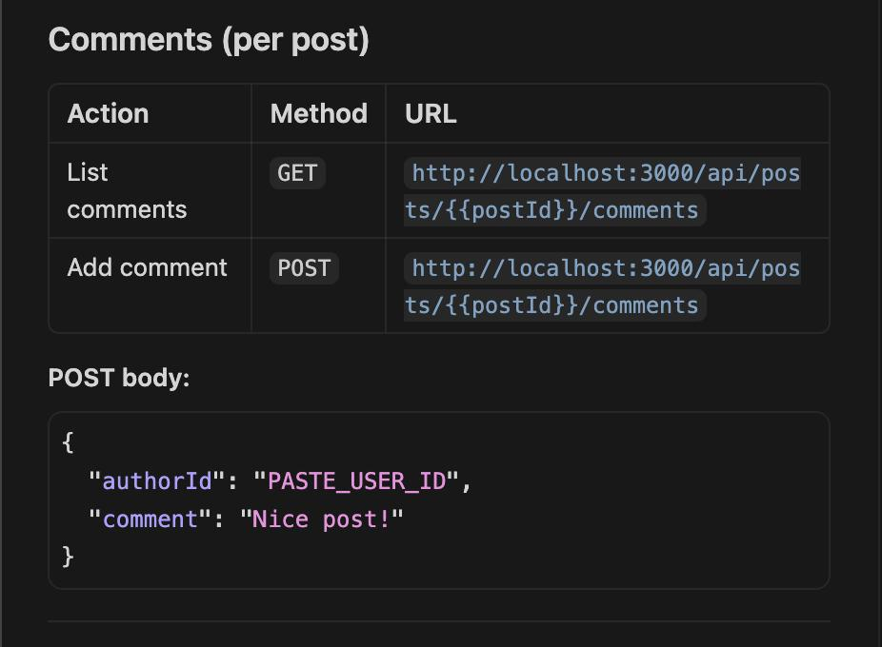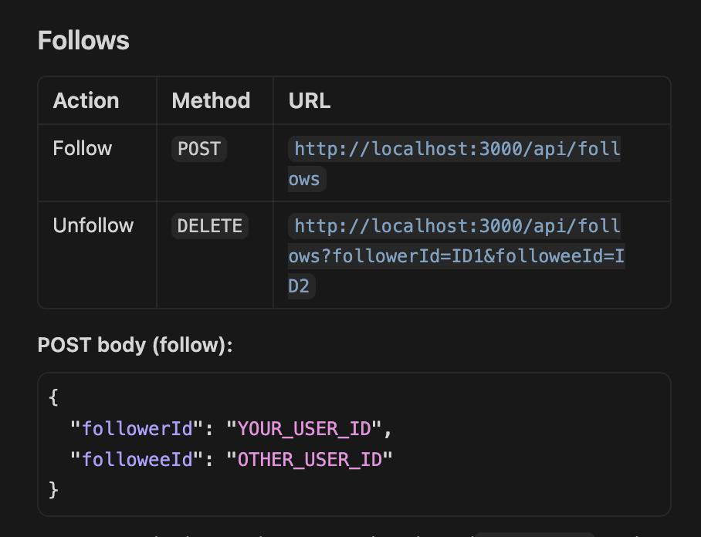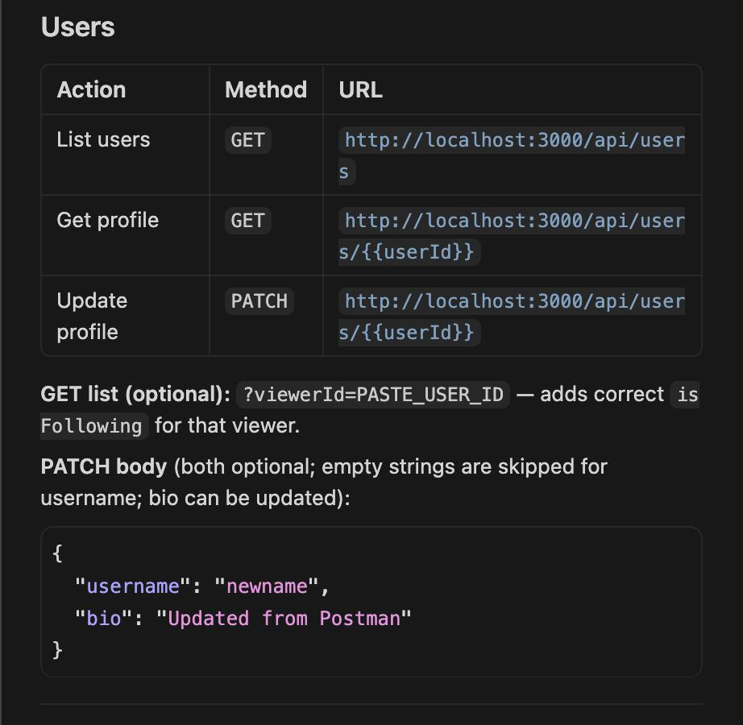

6. Statistics Use-Case

A dedicated /stats page built with Next.js server components and React displays seven platform analytics. Each statistic is powered by a Prisma query that executes the aggregation inside the SQLite database, returning only the final result to the application.

6.1 Statistics Queries
Stat 1 – Average Followers Per User

import { getFollowerSummary } from "@/repos/statistics";

export async function GET() {
try {
const data = await getFollowerSummary();
return Response.json(data);
} catch (err) {
console.error("GET /api/statistics/average-followers failed:", err);
return Response.json({ error: "Unable to load average followers" }, { status: 500 });
}
}

Stat 2 – Average Posts Per User

import * as comment from "@/repos/comment";
import * as follow from "@/repos/follow";
import * as like from "@/repos/like";
import * as post from "@/repos/post";
import prisma from "@/repos/prisma";
import * as user from "@/repos/user";

export async function getAveragePostsPerUser() {
const postsCount = await post.getTotalPostsCount();
const usersCount = await user.getUserCount();
if (usersCount !== 0) return postsCount / usersCount;
return 0;
}

Stat 3 – Average Likes per post

export async function getAverageLikesPerPost() {
const likesCount = await like.getTotalLikes();
const postsCount = await post.getTotalPostsCount();
if (postsCount !== 0) return likesCount / postsCount;
return 0;
}

Stat 4 – Average comments per post

export async function getAverageCommentsPerPost() {
const commentsCount = await comment.getCommentsCount();
const postsCount = await post.getTotalPostsCount();
if (postsCount !== 0) return commentsCount / postsCount;
return 0;
}

Stat 5 – Top 5 most liked posts

export async function getMostLikedPosts(p_count) {
try {
const result = await prisma.post.findMany({
select: {
id: true,
post_content: true,
date_created: true,
author: {
select: {
id: true,
username: true,
},
},
_count: {
select: {
likes: true,
comments: true,
},
},
},
take: p_count,
orderBy: {
likes: {
_count: "desc",
},
},
});
return result.map((row) => ({
id: row.id,
post_content: row.post_content,
date_created: row.date_created,
author: row.author,
likesCount: row._count.likes,
commentsCount: row._count.comments,
}));
} catch (e) {
console.error(e);
return [];
}
}

Stat 6 – new users this month

export async function getNewUsers() {
try {
return await prisma.user.findMany({
where: {
date_created: {
gte: new Date(Date.now() - 30 * 24 * 60 * 60 * 1000),
},
},
select: { id: true },
});
} catch (e) {
console.error(e);
return [];
}
}

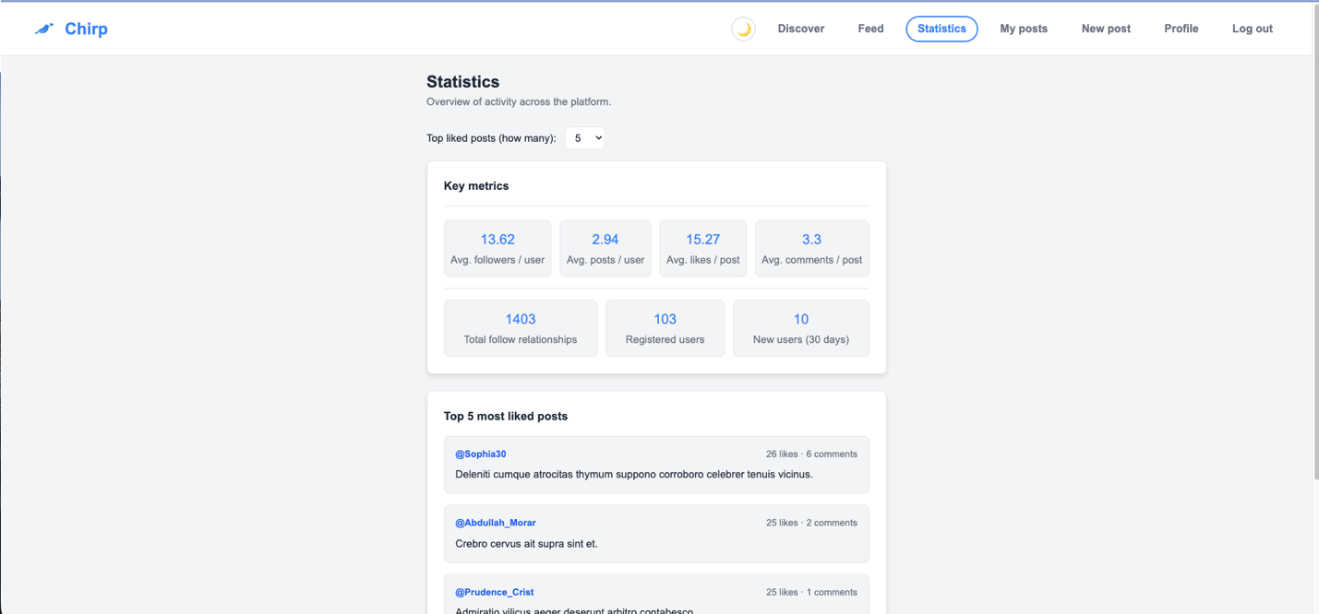

7. UI Design

The following screenshots document each page of the Chirp application running against the live database. Each caption explains what to show and why it matters for the grading rubric.

7.1 Login Page

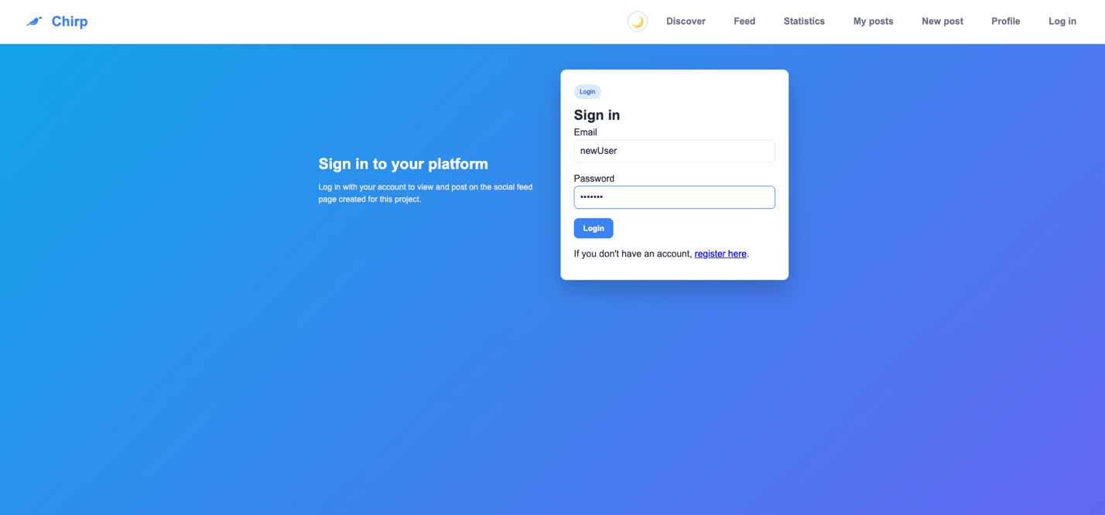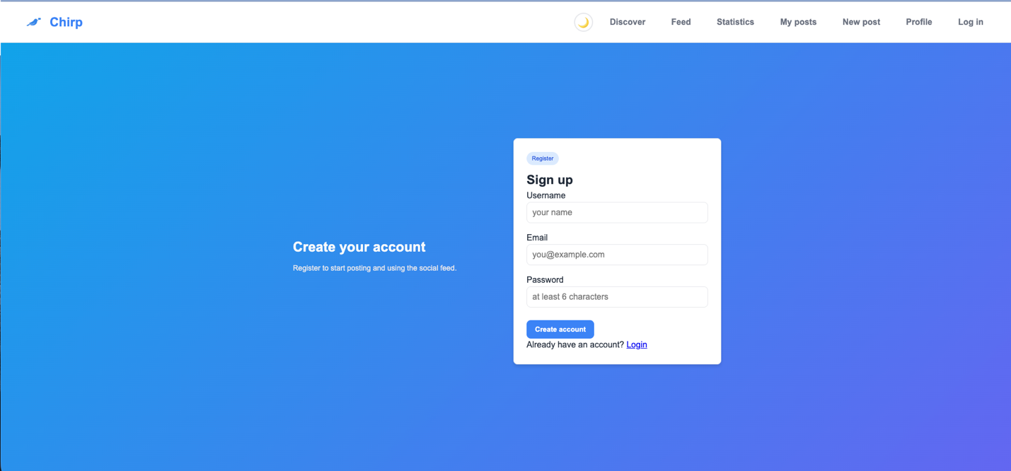

7.2 News Feed
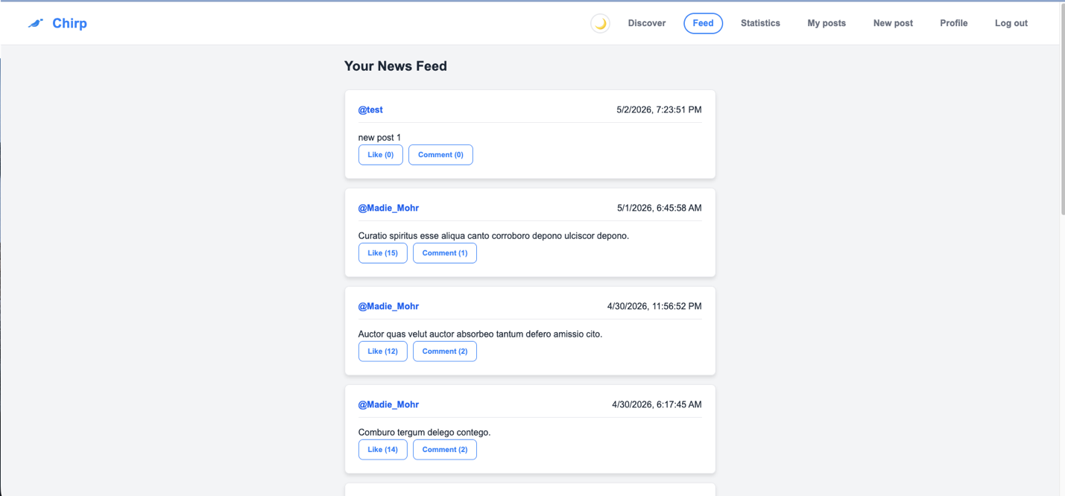

7.3 New Post

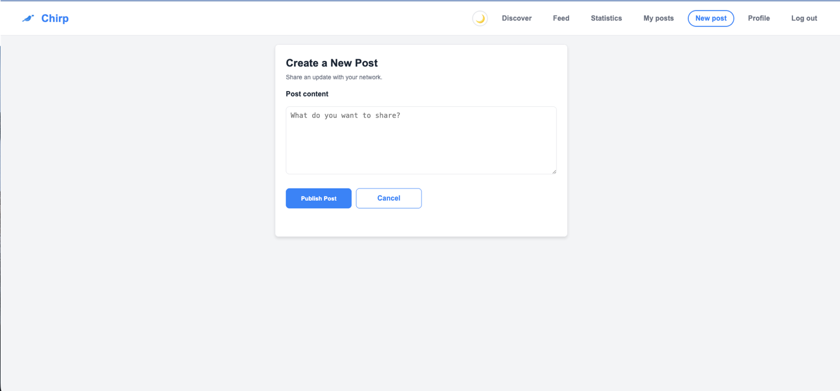

7.4 User Profile

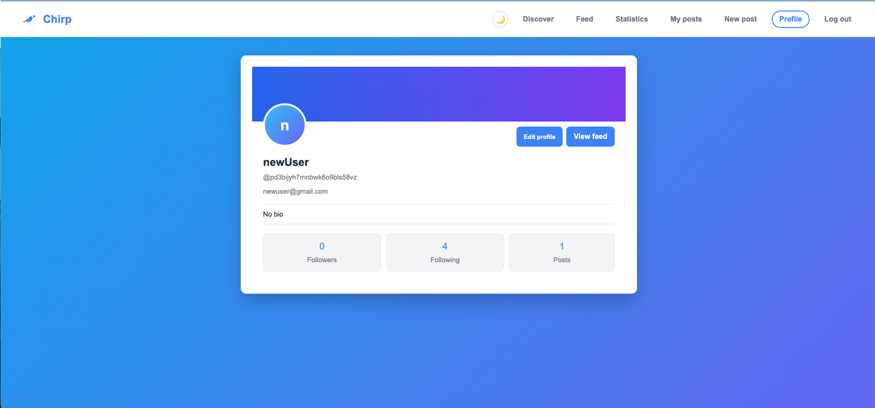

7.5 Discover / Users

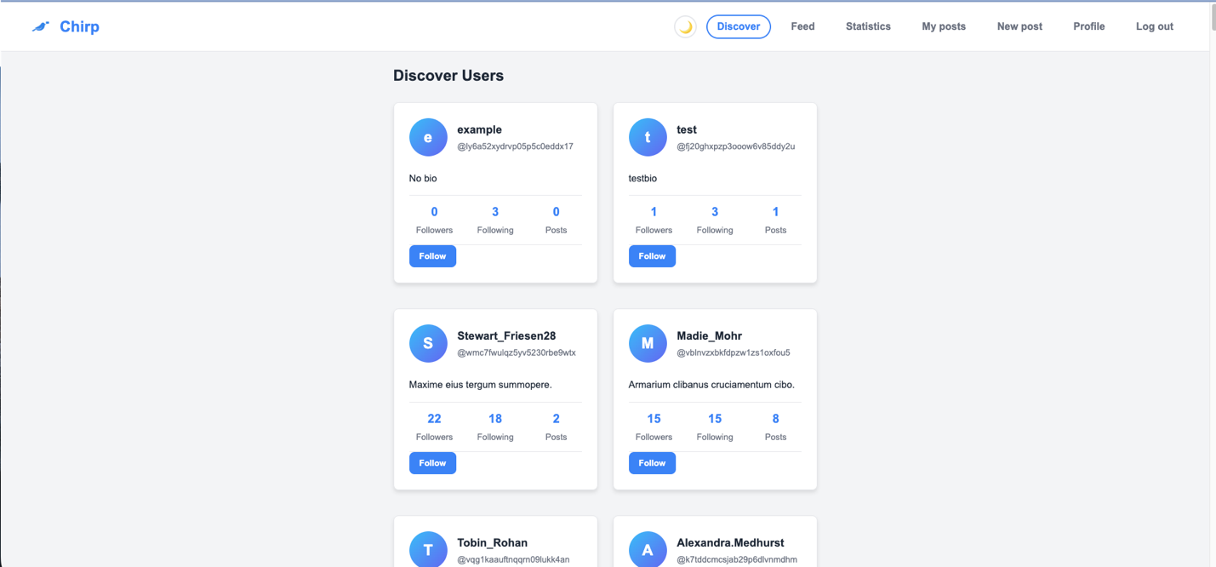

8. PRISMA Studio

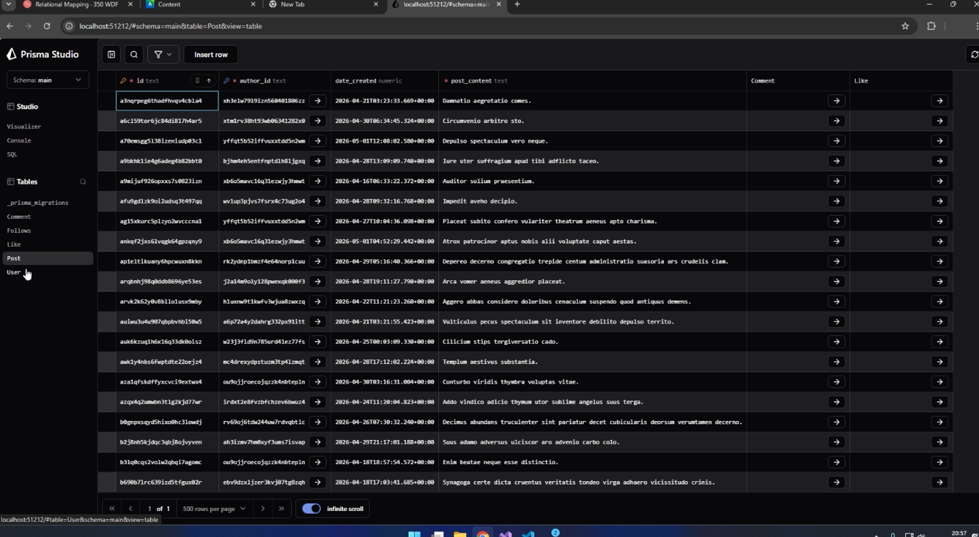

11. Accessing the website

The website was deployed by Vercel and can be accessed by the following link:

https://cmps350-project-group-10.vercel.app/statistics

Team members Contributions

Khaled Elrefaey – Seed DataBase, API, Statistics and Repository

Yacine Merabet – Design database, host website and DataBase

Tameem Ansari – Documentation and Statistics

Sharif Hamad – Frontend Conversion

