Incident Analysis Report: MirrorBlast C2 Triage
Analyst: Hordii Korol Date: January 27, 2026 Case ID: THM-WZ1-2026

1. Executive Summary
This report documents the forensic investigation of a high-priority network alert involving "Malware Command and Control Activity." Through systematic PCAP analysis, the activity was confirmed as a True Positive. The infection is attributed to the MirrorBlast malware family, a tool frequently utilized by the threat actor group TA505 (also known as Hive0065 or Graceful Spider).

2. Methodology & Toolset
The investigation utilized a standard SOC L1 toolkit to identify, verify, and trace the attack lifecycle:
- Brim: Log aggregation and initial signature identification.
- Wireshark: Deep Packet Inspection (DPI) and protocol analysis.
- VirusTotal: Threat intelligence and actor attribution.
- CyberChef: Sanitization and defanging of malicious Indicators of Compromise (IoCs).

3. Investigation Details

3.1 Alert Identification
Initial triage in Brim identified critical IDS signatures originating from an internal host.
- Alert Signature: ET MALWARE MirrorBlast CnC Activity M3
- Source IP: 172[.]16[.]1[.]102
- Destination IP: 169[.]239[.]128[.]11

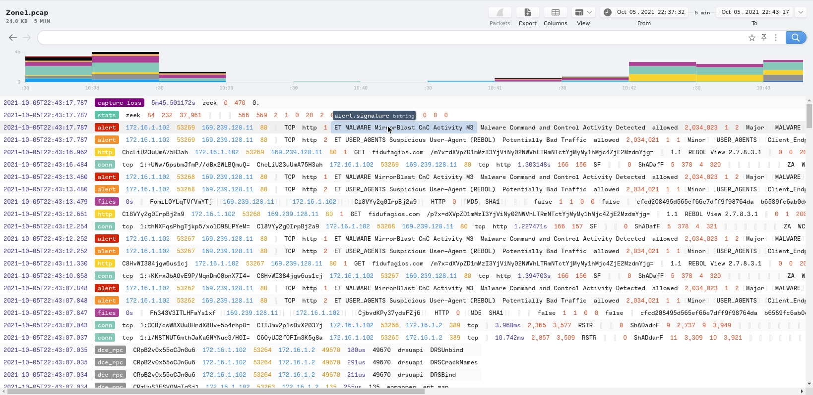

3.2 Threat Intelligence Attribution
The destination IP was correlated against global threat feeds to confirm its malicious status and intent.
- Threat Actor: TA505
- Malware Family: MirrorBlast
- Primary Vector: Windows Installer (.msi) delivery via HTTP.

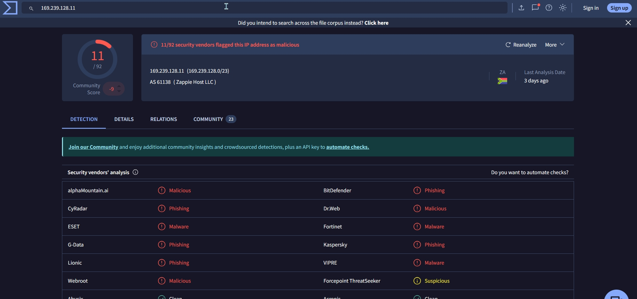

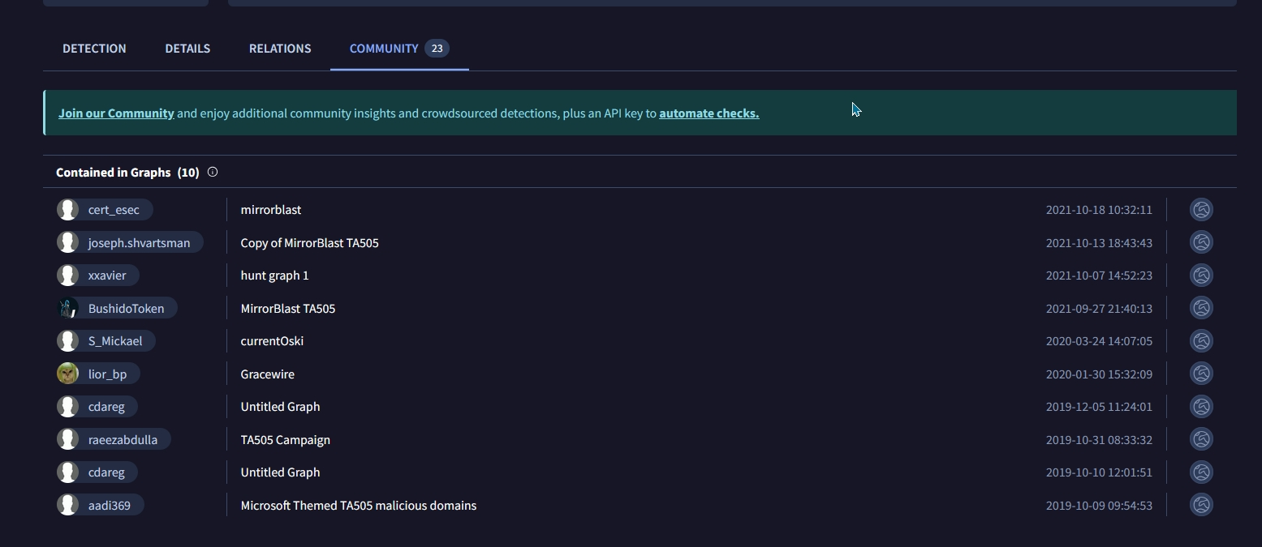

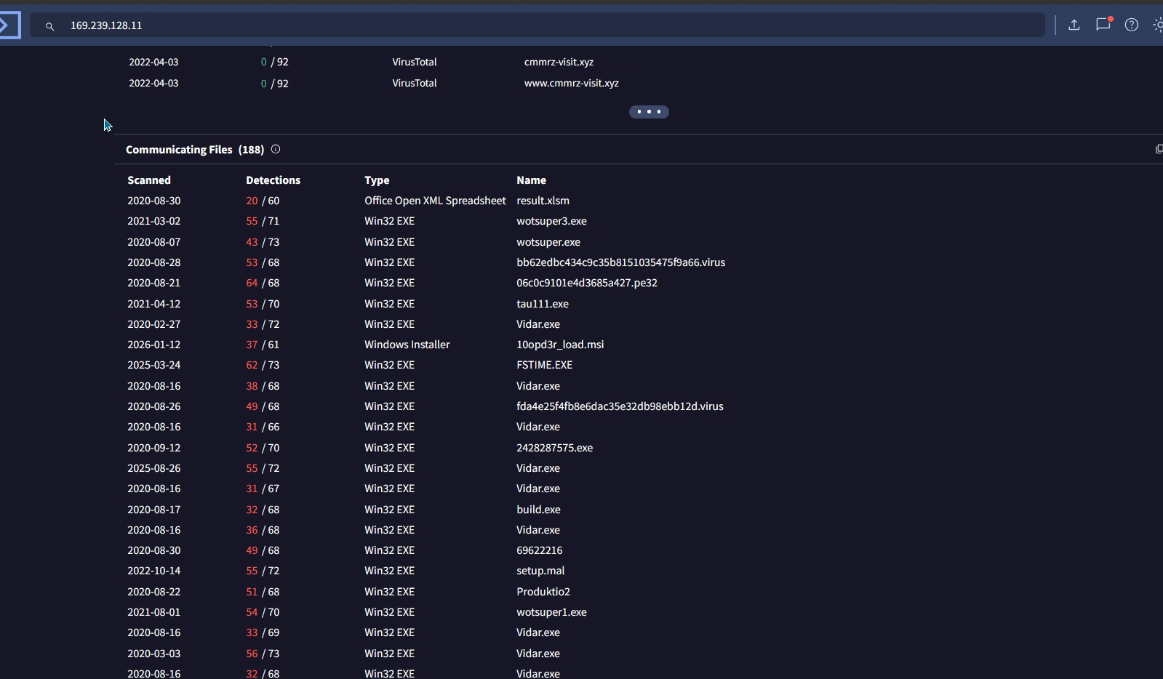

3.3 Protocol Analysis
Deep packet inspection revealed the specific communication methods used by the stager to communicate with the C2 server.
- User-Agent: REBOL View 2.7.8.3.1
- Request Method: HTTP GET with encoded parameters.

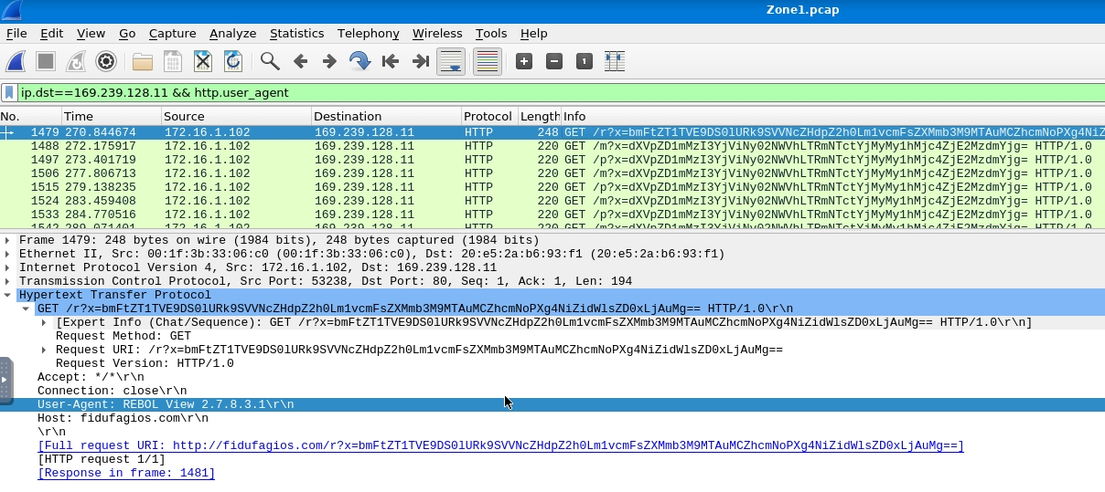

4. Attack Retrace & Infrastructure
The attack lifecycle involved the use of distributed infrastructure to provide redundancy for payload delivery.

4.1 Associated Infrastructure
Investigation of the source IP's HTTP history identified additional malicious endpoints.
- Secondary IP 1: 185[.]10[.]68[.]235
- Secondary IP 2: 192[.]36[.]27[.]92

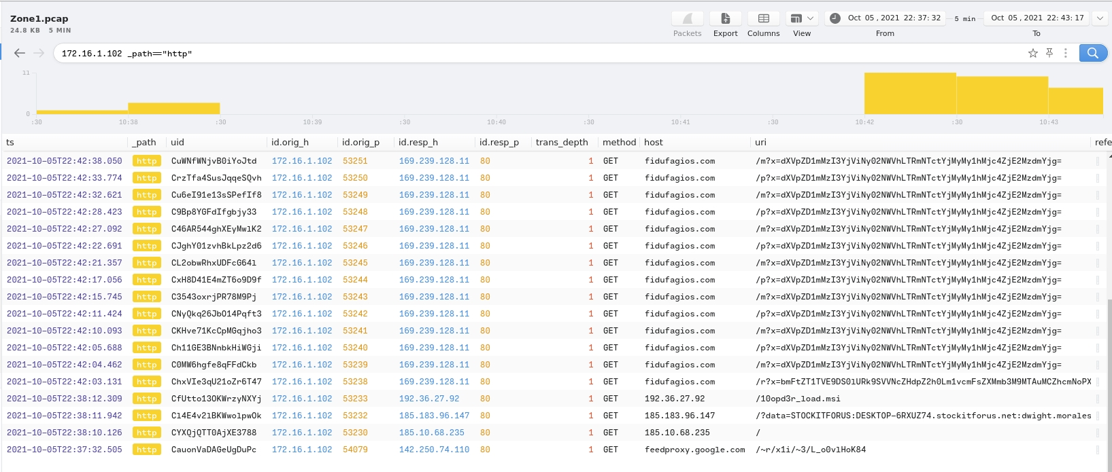

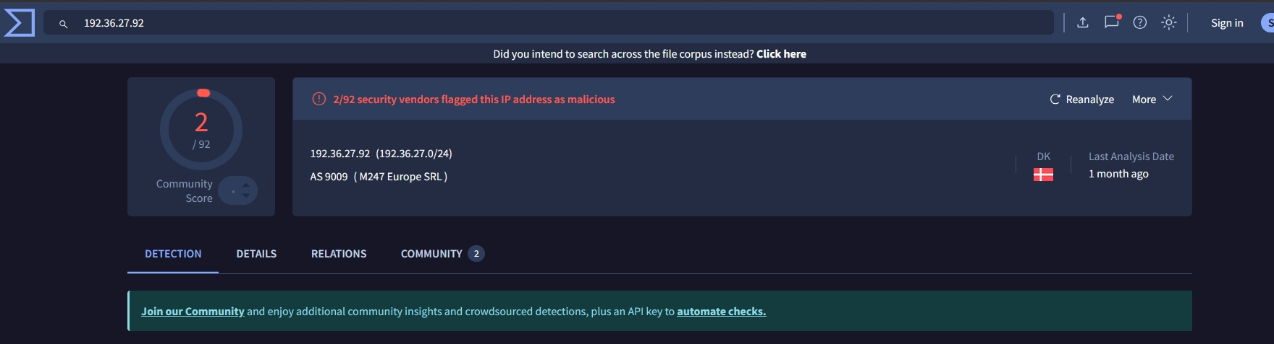

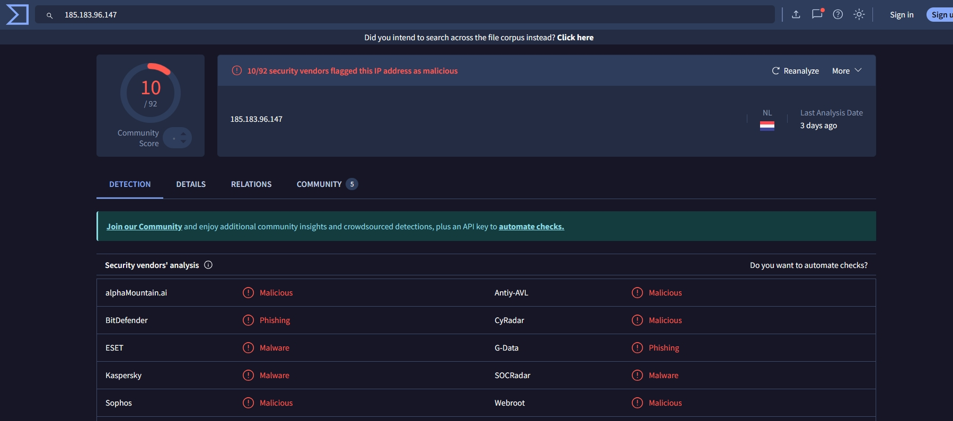

4.2 Malicious Artifacts
The following artifacts were retrieved from the network traffic, representing the initial infection stagers:
- filter.msi
- 10opd3r_load.msi

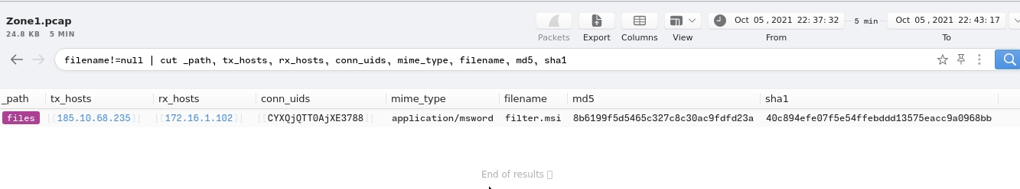

5. Host-Based Impact & Persistence
The stagers were configured to drop malicious binaries into non-standard system directories to evade detection.

5.1 Persistence Group A
- Directory Path: C:\ProgramData\001\
- Artifacts: arab.bin, arab.exe

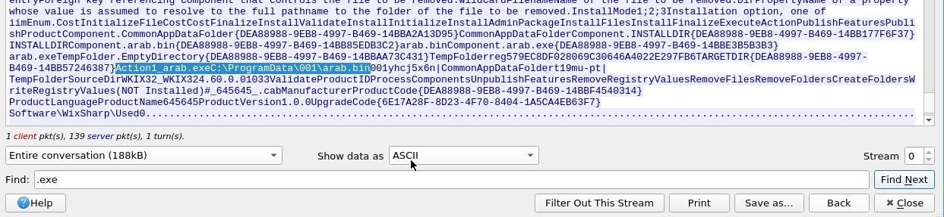

5.2 Persistence Group B
- Directory Path: C:\ProgramData\Local\Google\
- Artifacts: rebol-view-278-3-1.exe, exemple.rb

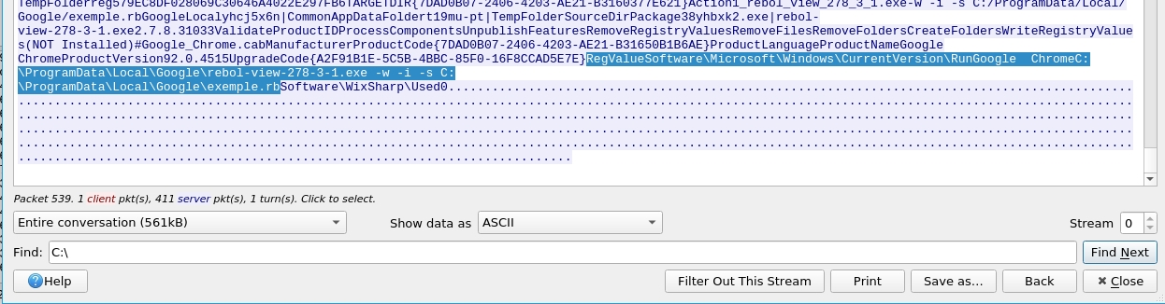

6. Conclusion
The investigation confirms a successful compromise of host 172.16.1.102. The presence of specialized Rebol interpreters and hidden script files in the \ProgramData\ directory indicates a sophisticated attempt at maintaining long-term access.

