Incident Analysis Report: Endpoint Intrusion Analysis
Analyst: Hordii Korol Date: January 27, 2026 Case ID: THM-SPL-NH01

1. Executive Summary
This report details a forensic investigation into a compromised workstation within the Finance Department of Widget LLC. The investigation, conducted via Splunk Enterprise, identifies a multi-stage intrusion that occurred during a period when endpoint security products were disabled. Key findings include the execution of credential harvesting tools, defense evasion via PowerShell, and the identification of persistent malicious binaries.

2. Methodology & Toolset
The investigation utilized enterprise-grade telemetry and search capabilities:
- Splunk (SPL): Primary tool for searching and correlating Windows Event Logs and Sysmon data.
- Sysmon (System Monitor): Leveraged to track process creation (ID 1), network connections (ID 3), and DLL loads (ID 7).
- VirusTotal: Used for external threat intelligence and malware family attribution.

3. Investigation Findings

3.1 Credential Harvesting & Execution
A malicious binary designed for credential theft was identified running from a temporary directory. This binary is a known password viewing tool often repurposed by threat actors.
- Malicious Binary Path: C:\Users\FINANC~1\AppData\Local\Temp\11111.exe
- Original Filename: ChromeCookiesView.exe
- Company Name: NirSoft

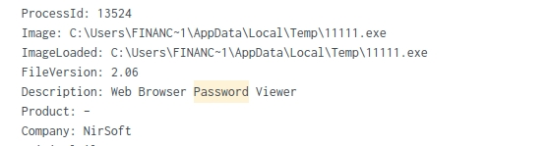

3.2 Malicious Payload Analysis
A secondary suspicious binary was identified in the same directory, which triggered multiple high-severity alerts on VirusTotal (54/70 detections).
- Binary Name: IonicLarge.exe
- Original Filename: PalitExplorer.exe
- C2 IP Address: 2[.]56[.]59[.]42

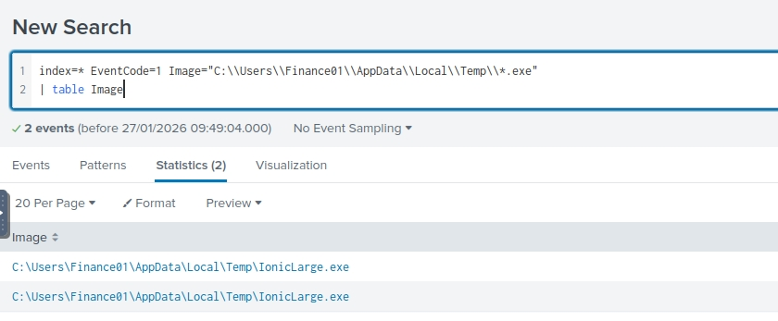

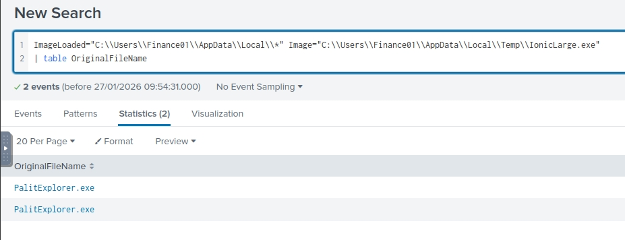

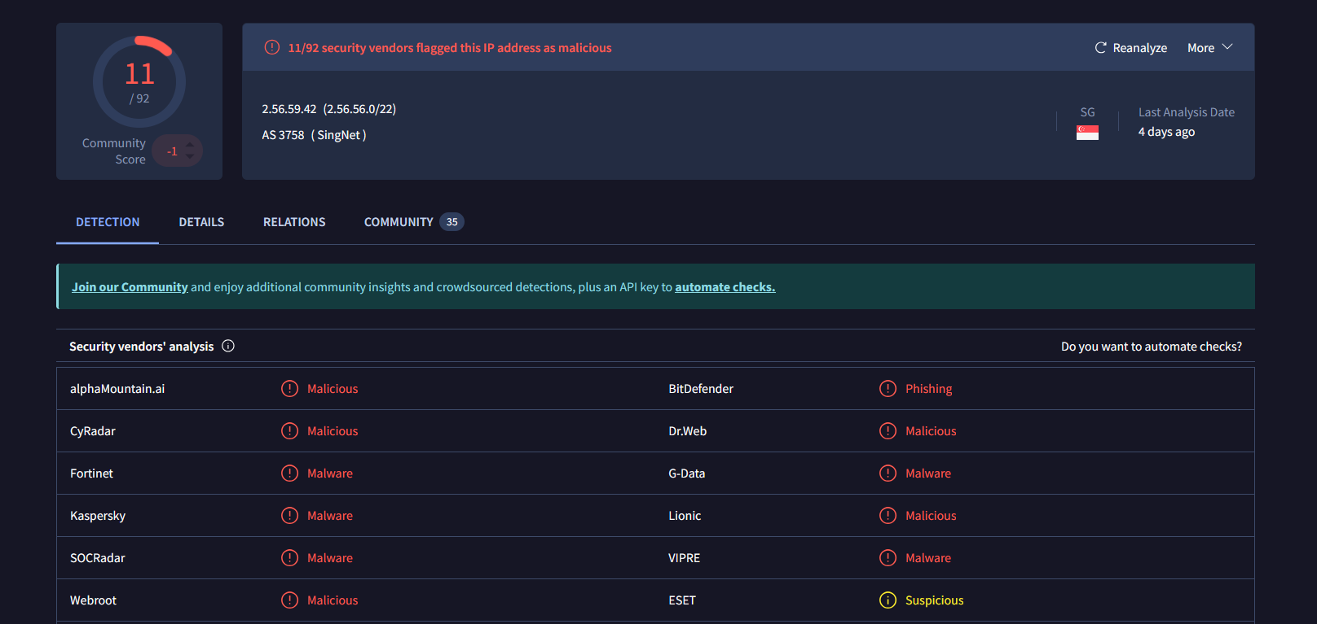

3.3 Defense Evasion (Windows Defender)
The adversary utilized PowerShell and WMIC to systematically disable Windows Defender and set specific exclusion IDs to maintain access without being detected.
- Registry Key Target: HKLM\SOFTWARE\Policies\Microsoft\Windows Defender
- Exclusion IDs Set: 2147735503, 2147737010, 2147737007, 2147737394

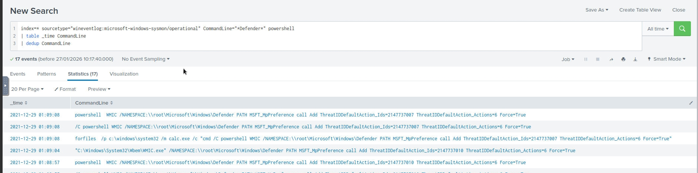

4. Host-Based Impact

4.1 Anti-Forensics (Process & File Deletion)
Evidence was found of the attacker attempting to cover their tracks by killing active processes and deleting the associated binaries from the system.
- Deleted Binaries: WvmIOrcfsuILdX6SNwIRmGOJ.exe and phcIAmLJMAIMSa9j9MpgJo1m.exe

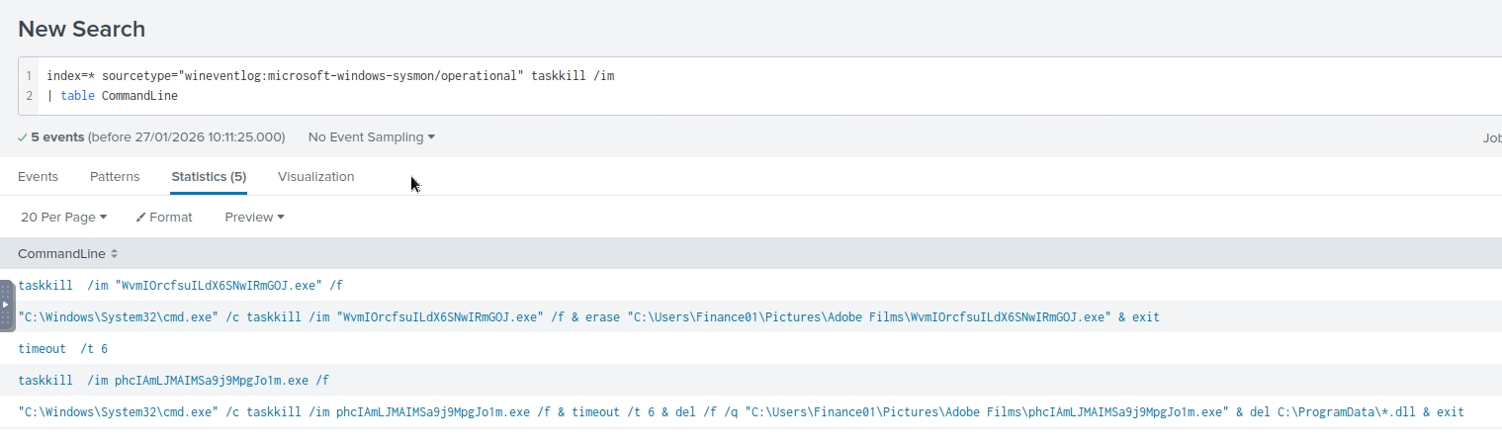

4.2 Secondary Malware Execution
A separate malicious binary was identified in the Roaming profile, utilizing DLL side-loading techniques to execute malicious code.
- Path: C:\Users\Finance01\AppData\Roaming\EasyCalc\EasyCalc.exe
- Loaded DLLs: ffmpeg.dll, nw.dll, nw_elf.dll

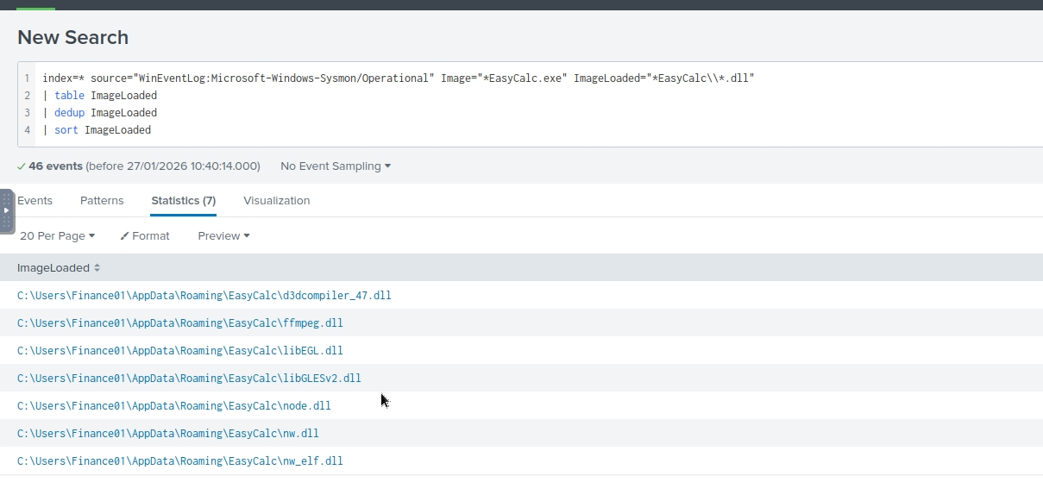

5. Conclusion
The workstation was successfully compromised by an actor using credential harvesters and defense evasion scripts. The presence of IonicLarge.exe and EasyCalc.exe indicates that the attacker established multiple points of persistence on the host.

