Presta Shop – Performance Report
02/09/2026

Evozon Software
http://www.evozon.com
Author: Horatiu Encian
Email: horatiu.encian@evozon.com

Contents
Overall Results / Executive Summary 3
Environment details 4
Script and execution notes 4
Caching and cookies 4
Login mechanism 4
User journeys 4
Media assets 5
User think time (wait time) 5
Types of testing performed 5
Glossary of terms 6
Load testing 6
Baseline run 6
Testing sessions 6
Concurrent user results 7
Average response time 7
95th percentile 7
Throughput 8
Average response time vs Throughput 9
Stepped Load test 9
Stress testing 11
Spike testing 12
Server Statistics 16
Conclusions 16
Annex 16

Overall Results / Executive Summary

- Trend: throughput scales almost linearly to 30 users, then falls while response times explode, retrograde throughput, i.e. a queue collapse, not a graceful capacity ceiling.
- Point of degradation: between 30 and 50 users. Users +67%, throughput −30%, average response time ×6.1, p95 ×5.7.
- Optimal operating point: ~10 req/s / ~24 users (77% of peak, p95 under ~1.5 s). Absolute maximum is 13 req/s / 30 users for short bursts. The 50-user run proves the limit: it delivers the same 9.16 req/s the system serves comfortably at ~22–24 users, for 8× the latency — zero extra capacity, all penalty.
- Error rate is a lagging indicator — do not use it as the SLO. At 100 users the site is functionally dead (p95 = 34.7 s) while still reporting 99.65% success. Errors only appear at 200 users (2.17%, incl. connections refused). Alert on p95 > 2,500 ms, or on throughput falling as users rise.
- Bottleneck is the static-asset fan-out on heavy HTML pages, not the application code. All AJAX/cart endpoints hold flat medians to 200 users (Ajax update cart: 58 ms median at 200 users), while every full-page [GET] collapses. An 11 KB login page slowing ×47 cannot be its own fault — it is queued behind the others.
- Highest-leverage fix: the 1.59 MB homepage. Slowest page even at 1 user (808 ms), highest volume, and 80% of all bandwidth at the knee. Then move static assets to a CDN and enable full-page caching for homepage/category.
Load test remark: the site does not fail, it stalls — safe to ~24 users / 10 req/s, collapses past 30, and the fix is static-asset delivery, starting with a 1.59 MB homepage.

Environment details
Field | Value
Run period | 24.08.2026 – 01.09.2026
Host | http://172.22.4.19
Port | 80
Run location | Evozon infrastructure — Romania (Cluj-Napoca), over VPN
Load generator | Single JMeter instance Apache JMeter 5.6.3

Script and execution notes

Caching and cookies
Cookies and browser caching were simulated, and both the cache and the cookies were cleared after each iteration. Every iteration therefore behaves like a first-time visit, which is a deliberately pessimistic model of real traffic.

Login mechanism
The application has a login mechanism, so the test covers both guest and authenticated traffic, split as follows:
60% guest users — Thread Group – Guest
40% logged-in users — Thread Group – Login
A single account was used for all logged-in threads: horatiu.encian@evozon.com.

User journeys
The plan covers the most important and most frequent journeys a user performs in this application. A Throughput Controller distributes the load across these journeys according to how often they occur in practice.
The frequency distribution can be derived in one of three ways: common sense, discussion with the client, or analysis of the logs collected from the live application. In this case common sense was used, as no information was available from the other two sources.

Frequency distribution
Journey | Share | Applies to
0. Login | 100% | Logged-in thread group only
1. Explore application / products | 50% | Both thread groups
2. Search | 30% | Both thread groups
3. Add to cart | 20% | Both thread groups
4. Update cart | 7% | Logged-in thread group only

No checkout scenario is covered by this test plan.

Media assets
The application does not use a CDN — all static resources are served from the application server itself. The script is configured to download all embedded resources, so that each sampler's timing reflects real browser behaviour as closely as possible.

User think time (wait time)
Proper load testing has to account for user think time. The goal is not to bombard the server with requests, but to reproduce a realistic usage pattern. Three pause lengths are defined and placed between requests according to how long a real user would plausibly pause between those actions. All three are configurable from outside the script.
Property | Value | Applied between
SHORT PAUSE TIME | 1000 ms (1 s) | Rapid, in-page actions
AVERAGE PAUSE TIME | 3000 ms (3 s) | Normal navigation steps
LONG PAUSE TIME | 5000 ms (5 s) | Steps needing user decision

Types of testing performed
Test type | Status | Notes
1. Load testing | Done | Baseline + 5 load levels
2. Stress testing | Done | All thread groups, infinite loops, long ramp-up
3. Spike testing | Done | Short ramp-up above the stress limit

Glossary of terms
Term | Meaning
Thread | One simulated user (thread ≈ user)
Ramp-up | The time it takes for the system to start all threads
Duration | Total run length in seconds, ramp-up included
Baseline | A single-user run establishing unloaded response times

Load testing
The objective is to establish how the system performs under a given load. Multiple runs were executed with an increasing number of threads.
A baseline run was performed first, to record response times with no contention.

Baseline run
Parameter | Value
Date | 28.08.2026
Threads | 1
Ramp-up | 1 s
Duration | 1200 s (20 minutes)
Start / End | 11:34 – 11:54

Testing sessions
Run | Date | Threads | Ramp-up (s) | Duration (s) | Start | End | Actual
Baseline | 28.08.2026 | 1 | 1 | 1200 | 11:34 | 11:54 | 20 min
Run 1 | 24.08.2026 | 50 | 300 | 3900 | 16:52 | 18:00 | ~65 min
Run 2 | 25.08.2026 | 100 | 1200 | 3600 | 14:42 | 15:42 | 60 min
Run 3 | 26.08.2026 | 200 | 1200 | 3600 | 08:55 | 09:55 | 60 min
Run 4 | 26.08.2026 | 30 | 1200 | 3600 | 11:39 | 12:39 | 60 min
Run 5 | 28.08.2026 | 10 | 300 | 3600 | 14:32 | 15:32 | 60 min

Concurrent user results

Average response time
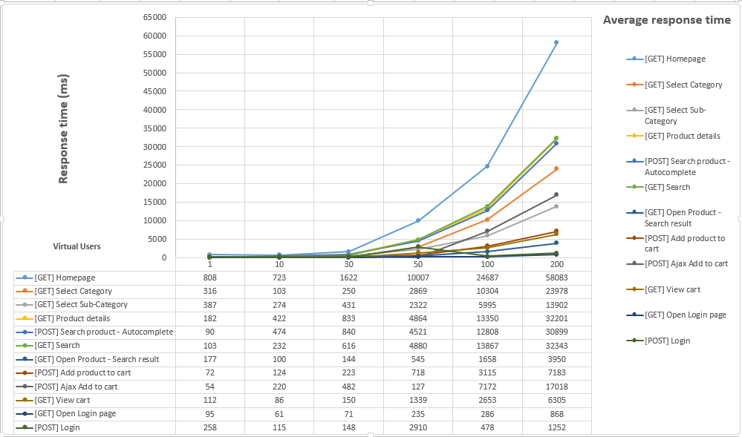

95th percentile
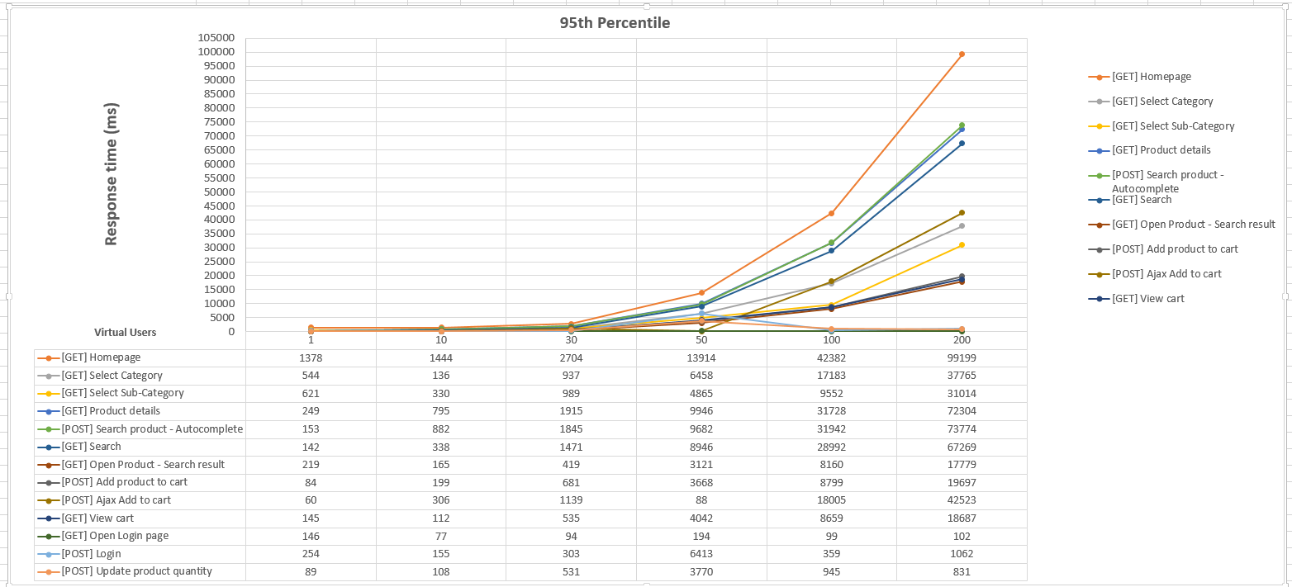

Throughput
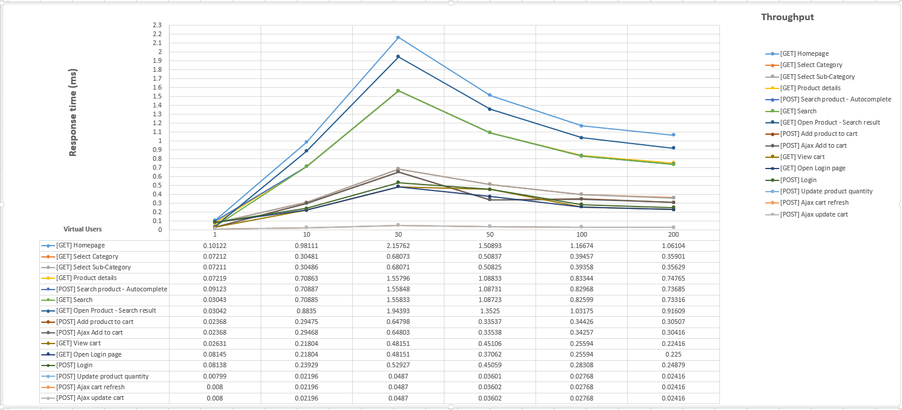

Average response time vs Throughput
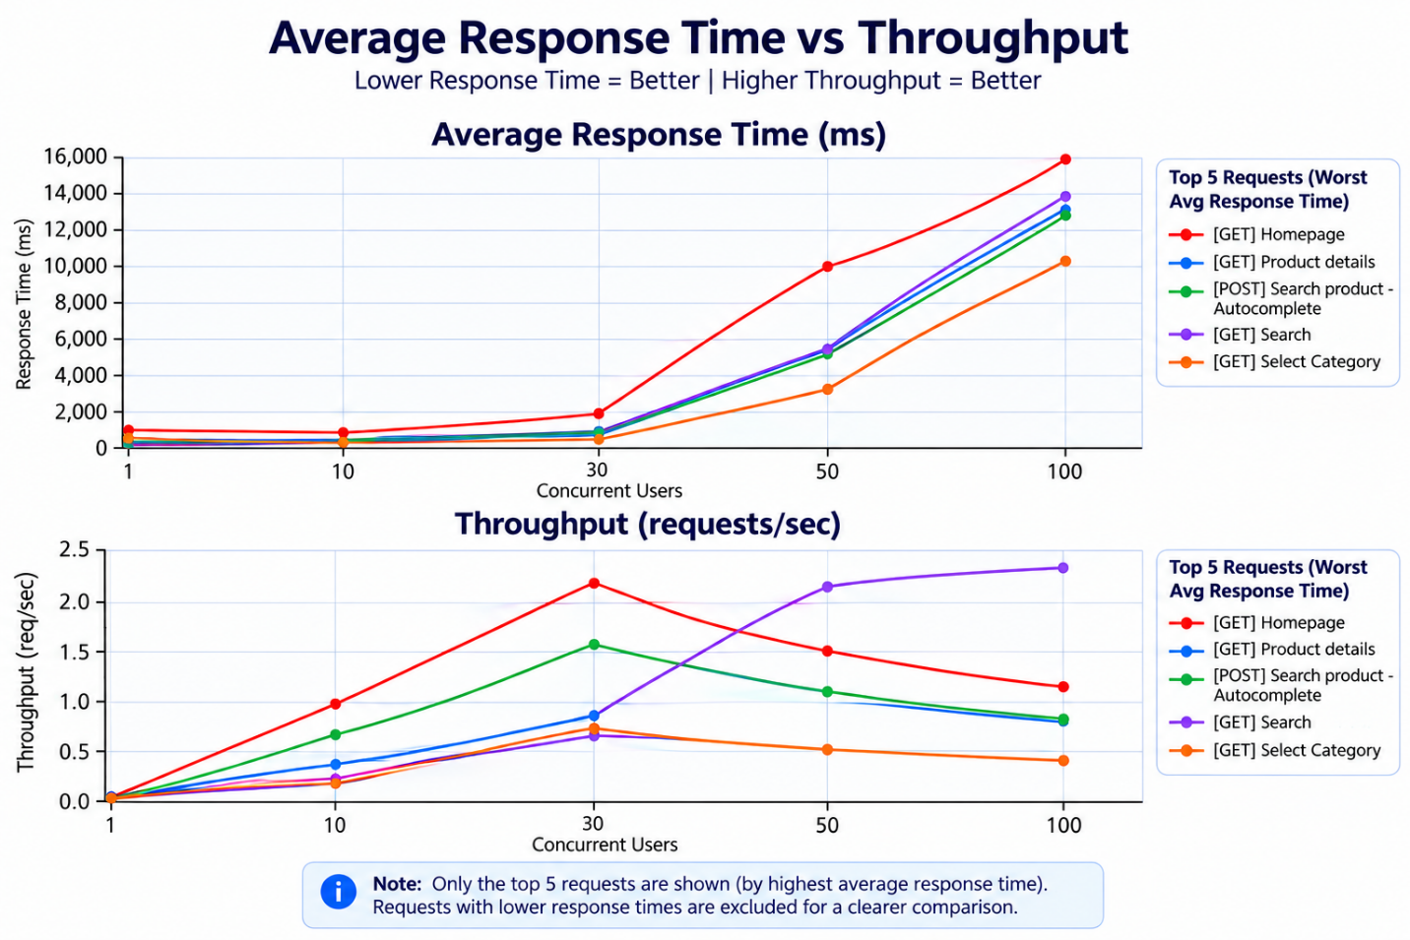

Stepped Load test
Another run that we did was to perform a Load test where we increased the load in steps of 5 threads for 1h until we reached a target load of 100 concurrent Threads. We wanted to see what is the load that brakes an SLA of 400ms response time
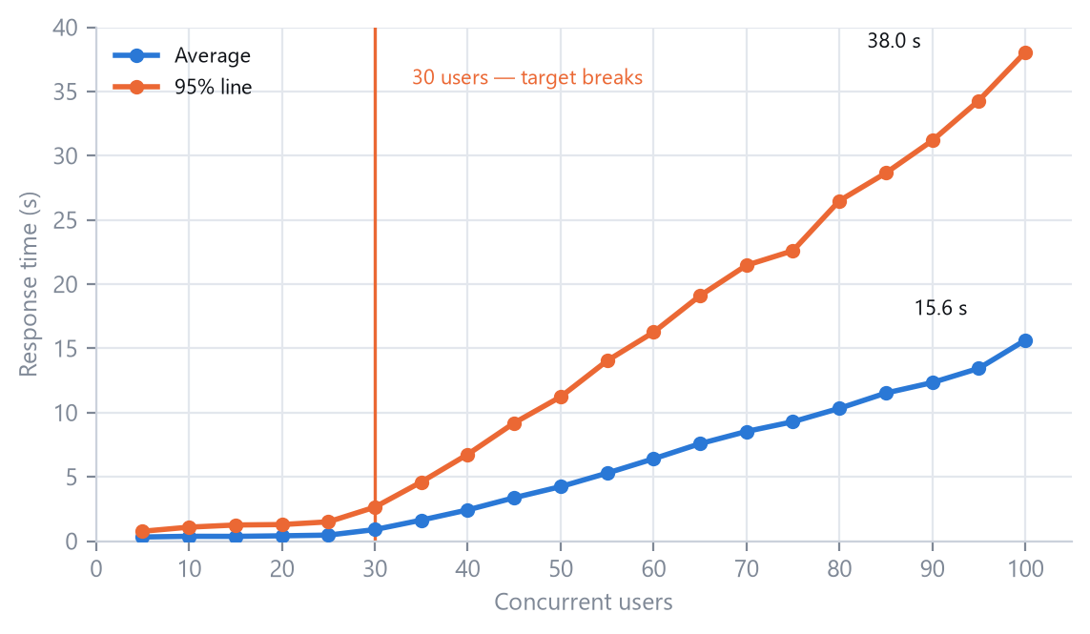

Throughput: The capacity is at 25 concurrent users
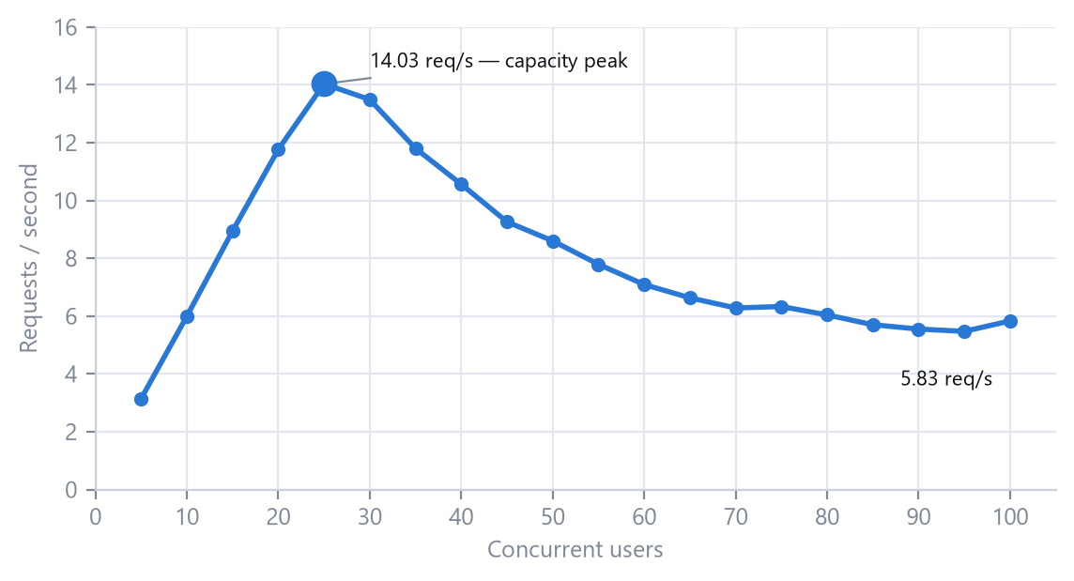

Results analysis
25 users is the capacity limit; 30 is the SLA breakpoint
Throughput peaks at 25 users, so that is where the server stops absorbing load. One step later the target breaks across the board: login page 167 → 419 ms, login POST 347 → 592 ms, search 159 → 270 → 631 ms. Quote 25 as the safe figure and 30 as the failure figure.
The homepage never meets 400 ms, at any load in this run
891 ms at 5 users, and it is the slowest label at every single step through to 31.4 s at 100. At roughly 1.6 MB with image_parser on, a homepage sample times the HTML plus all of its assets from the same host. Static-asset delivery is the first thing to change before re-testing.
Correctness held throughout, the app got slow, not broken
Error rate stays under 1.2% at every step, worst 1.11% at 85 users, and the failures are NoHttpResponseException on embedded images and SVGs rather than page errors. An error-threshold stop criterion would never have fired in this run, which is why response time is the criterion that matters here.

Stress testing
The goal of this testing type is to assess what is the systems breaking point
We performed a Stress testing session on 01.09.2026 between 08:30 and 09:42 with the following metadata
- Threads: 600
- Ramp-up: 3300
- Duration: 3600
The goal was to constantly increase the number of threads during the run.
After we analyzed the results we concluded that the breaking point of the application is after 180-200 virtual users. After that point we noticed a sharp increase in the number of errors reported. We didn’t let the script to run for the full hour because the error rate was already at high rates.

* In the graphs below on the right side we have the number of threads and on the left side we have the error rate
Error rate
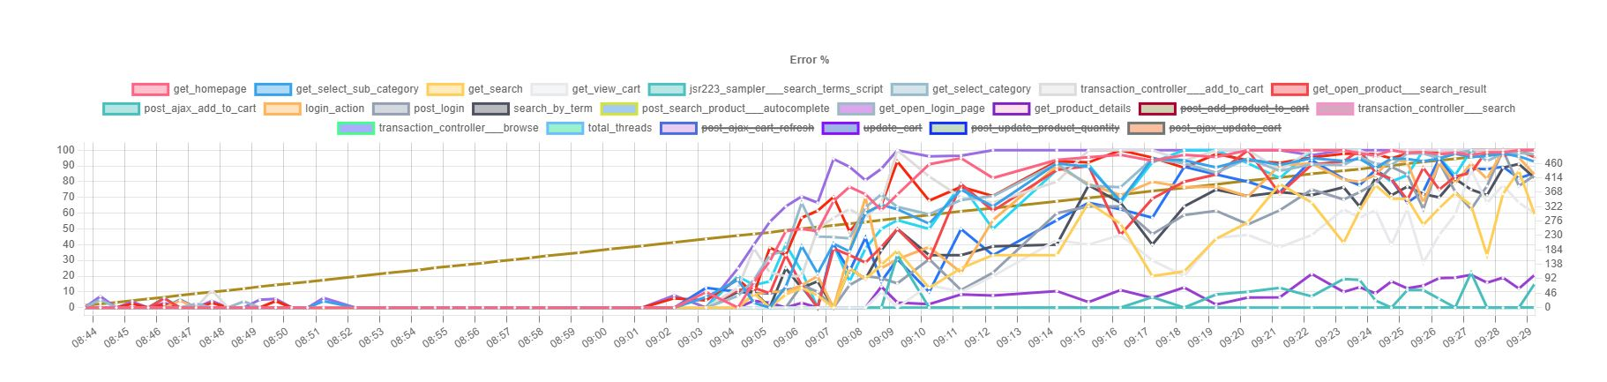

95th Percentile
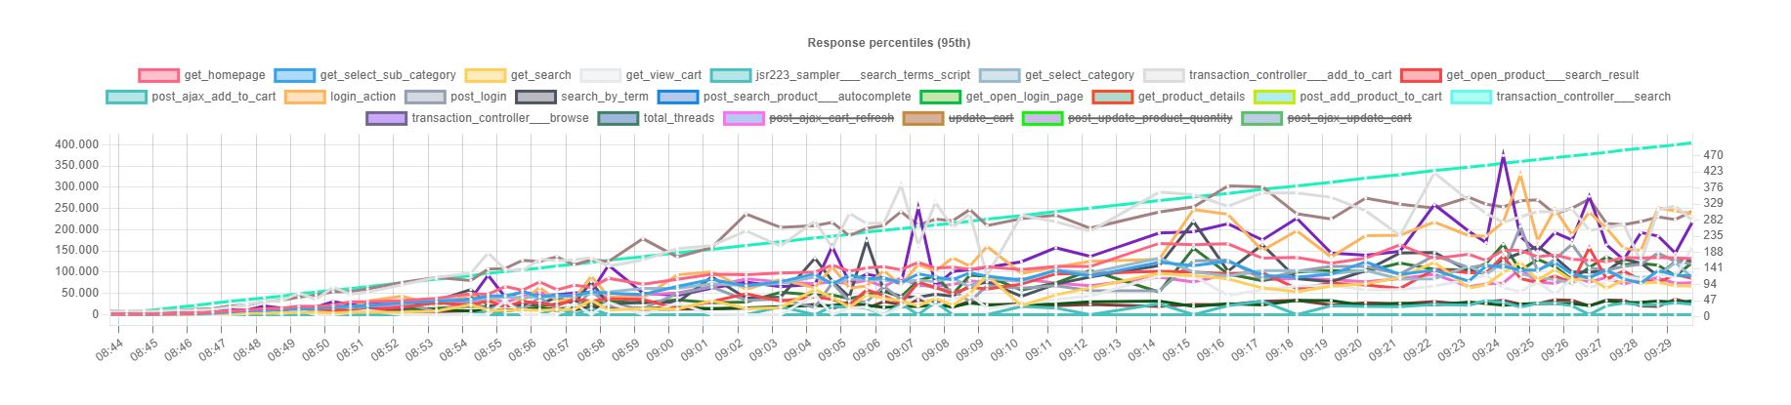
Average response time
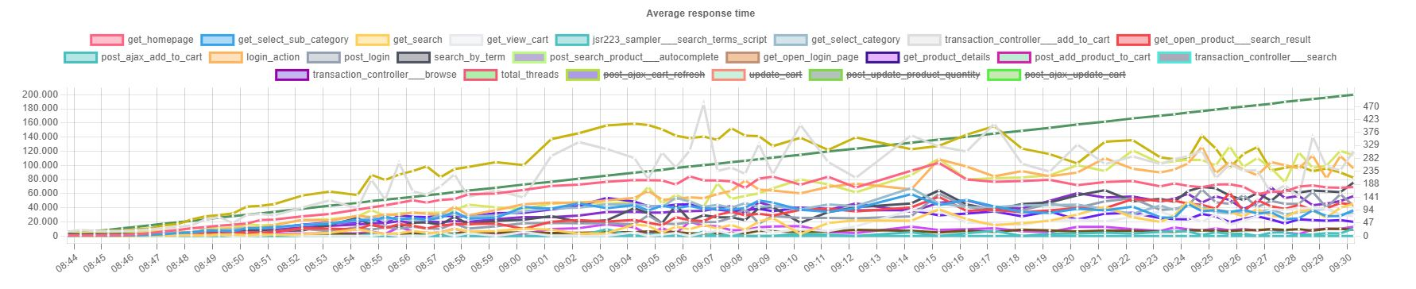

Spike testing
The goal of this testing type is to assess how the system behaves when there are sudden spikes in the number of users who use the application
We started by running a baseline load of 10 users for 1h and after a few minutes we started a script that produces a spike in the load of the application.
We noticed that everytime the load time spikes the response time increases but for what we tested we didn’t see any sudden increase of errors also after the spike stops the response times are returning to normal values. In conclusion the spikes at this level do not harm in an irreversible way the performance of the application.
There were errors in the timespan of the testing session but those were not related to the sudden spikes in the load.

We ran 3 spikes on 01.09.2026
Date: 01.09.2026
Baseline load | 10 users
Start | 11:00 AM

Spike | Start | End | Threads | Ramp-up (s) | Duration
Spike 1 | 11:25 | 11:27 | 50 | 10 | 2 min
Spike 2 | 11:29 | 11:31 | 80 | 10 | 2 min
Spike 3 | 11:38 | 11:40 | 130 | 10 | 2 min

Average response time
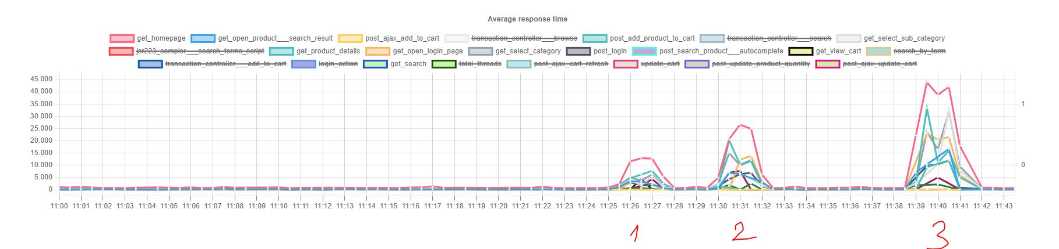
95th percentile
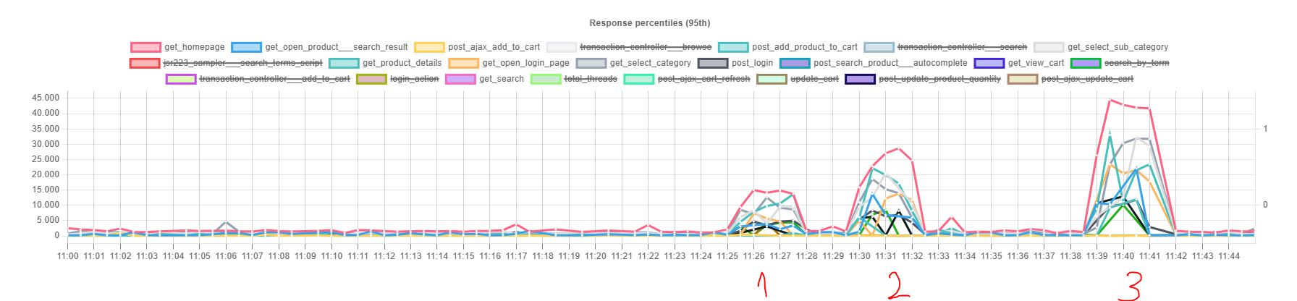
Error rates
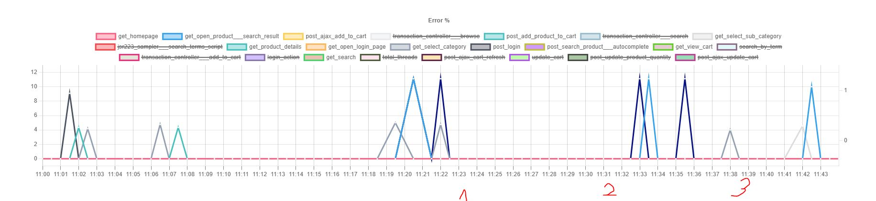
We run another 3 spike testing sessions on 02.09.2026 this time with greater spike load, this time with a load that we know is above the Stress point (breaking point) of the application
Date: 02.09.2026
Summary:
We noticed that the spike produces errors at those periods but the server recovers gracefully and after the spike stops the response times get back to normal and the errors tend to disappear.
Baseline load | 10 users
Start | 11:24 AM

Spike | Start | End | Threads | Ramp-up (s) | Duration
Spike 1 | 11:36 | 11:38 | 200 | 30 | 2 min
Spike 2 | 11:42 | 11:44 | 250 | 30 | 2 min
Spike 3 | 11:52 | 11:54 | 300 | 30 | 2 min
Average response time vs Error rates

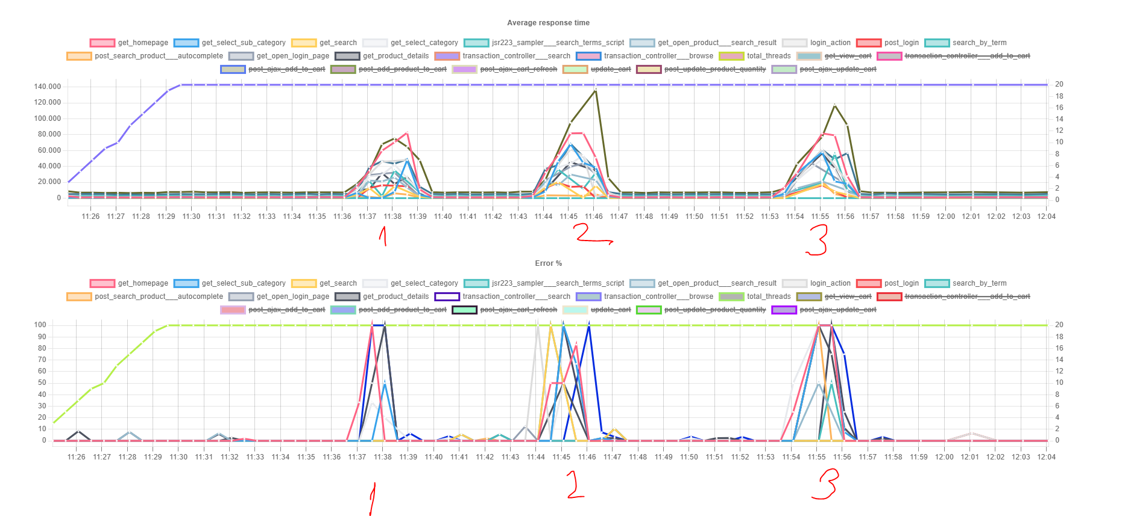
95th Percentile and Responses per second
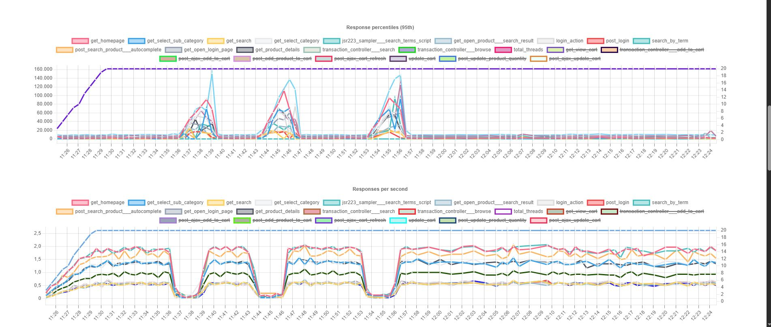

Server Statistics
No data

Conclusions
- Capacity: the application scales cleanly to 30 concurrent users / 13 req/s, beyond that point throughput falls instead of rising.
- Degradation point: between 30 and 50 users — throughput drops 30% while response times grow ×6 (0.6 s → 4.0 s average).
- Recommended ceiling: ~24 users / ~10 req/s, which keeps the 95th percentile under 1.5 s. Alert on p95 > 2.5 s, not on error rate — at 100 users the site is unusable (p95 = 34.7 s) while still reporting 99.65% success.
- Root cause and fix: the bottleneck is static-asset delivery, not the application code — AJAX endpoints stay fast at every load level. Start with the 1.59 MB homepage, then move static resources to a CDN and enable full-page caching.
- It is clear that the worst requests are GET requests that bring data – and the POST requests have no real problems even in higher loads

Top 5 worst requests:
- [GET] Homepage
- [GET] Select Category
- [GET] Product details
- [GET] Select Sub-Category
- [GET] Open Product - Search result

Annex
The following files are delivered with the report:
- The Jmeter script
- An archive with the runs
- An aggregated report excel file

