
SHIVAM GUPTA (BTCD24O1060) Cornerstone Project
Design and Development of a Confidence-Aware RAG Pipeline with Hallucination Detection
Milestone 1: Architecture and Pipeline Implementation

1. Architectural Objective
The primary objective of this system is to design and implement a Retrieval-Augmented Generation (RAG) pipeline that can estimate the reliability of its own retrieval and decline to answer when confidence is low. Rather than optimising solely for higher accuracy on every query, this architecture is built to execute a specific trade-off: suppressing the majority of hallucinated answers at the cost of withholding a small percentage of correct ones.

2. The Problem Statement
Standard RAG pipelines reduce hallucination but do not eliminate it. A conventional application answers in the same confident tone regardless of whether the retrieved passages actually support the generated text. This allows three critical failure modes to reach the user:
- The system receives a query outside its corpus but generates an answer anyway.
- The retrieved passages are correct, but the generator invents details, numbers, or causal links.
- The generator states something the passages actively refute because it relied on its pre-trained weights instead of the provided context.
Because users cannot distinguish between a highly confident factual answer and a highly confident hallucination, a wrong answer costs the user more than a safe abstention.

3. Architectural Approach
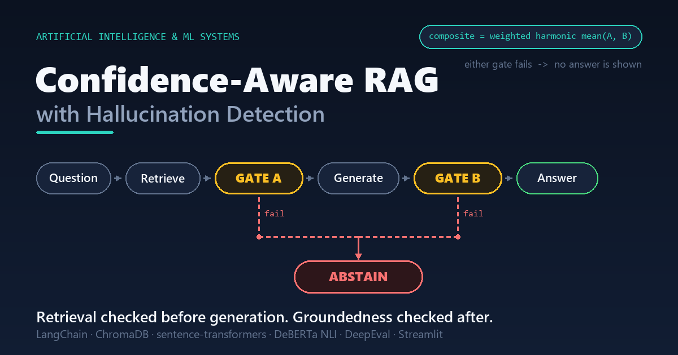
Figure 1. The two gates in the pipeline. Retrieval sufficiency is checked before generation, answer groundedness after, and if either gate fails, it suppresses the answer.

3.1 Decoupled Two-Stage Verification
Standard faithfulness metrics cannot be computed before generation because there are no claims to evaluate. Evaluating only after generation wastes compute resources on fluent, incorrect answers that are already inside the system.
To solve this, the pipeline applies a decoupled, two-stage evaluation utilizing specialized models for each distinct task:
 | Gate A, before generation | Gate B, after generation
Question asked | Could these passages support any answer to this question? | Is the answer that was produced entailed by these passages?
Model | Relevance reranker  cross-encoder/ms-marco-MiniLM-L-6-v2 | NLI cross-encoder  cross-encoder/nli-deberta-v3-base
Catches | Retrieval failure: the question is outside the corpus | Invented detail and outright contradiction
On failure | Abstain without calling the generator at all | Suppress the answer and report which claims failed

- Why We Use Two Different Models -
The gates use different model families because they are doing fundamentally different jobs. Before the AI generates an answer, there is no "hypothesis" to check, only a user's question. Therefore, deciding if a passage answers a question is purely a ranking problem, which is why Gate A uses a relevance reranker. On the other hand, Gate B is an entailment problem: it asks if a specific premise proves a specific hypothesis. So Gate A uses a reranker trained on relevance judgements and Gate B uses an NLI model.
- Why We Rejected Standard Cosine Similarity -
Most basic RAG systems use cosine similarity from the retriever as a cheap way to check relevance, but I deliberately rejected this as the deciding factor for Gate A. The issue is that MiniLM cosine values are not true, calibrated probabilities. For example, during testing, a passage that perfectly answered the question scored a 0.531. If we set a hard cut-off on a scale like that, it is just a random, arbitrary constant.
- The Solution: A Calibrated Reranker
Instead of relying on raw vector distance, Gate A uses the reranker's output passed through a sigmoid function. This forces the score to behave much more like a real probability, giving the gate a mathematically sound reason to allow or block the query. We still record the basic similarity statistics in the background on every query, but only to use as data for future calibration, not as active thresholds now.

3.2 Scoring one claim at a time
Instead of evaluating a generated answer as one massive block of text, Gate B breaks the response down line by line. Each sentence is treated as an individual claim and cross-checked against every retrieved passage, keeping the best entailment score and the worst contradiction score. I applied the RAGTruth hallucination taxonomy to categorise failures: if the contradiction probability hits 0.50, it is flagged as an "evident conflict", and if entailment simply falls below 0.50, it is flagged as "baseless information". The system specifically tests for contradiction first, because an AI actively arguing against the source material is a much worse failure than an AI simply adding unverified fluff.
- Building a Diagnostic UI
Working claim-by-claim is what makes this system highly diagnostic. Instead of just returning a generic final number and leaving the user to guess what went wrong, the interface points directly at the exact sentence that is unsupported and shows the source passage that came closest to supporting it.
- The "One Strike" Veto Rule
To make a final pass/fail decision, the gate takes the mean entailment probability across all the sentences. However, I implemented a strict veto rule: a single contradicted claim immediately overrides that mean and fails the entire gate outright. If the generator produces nine perfectly correct sentences and one absolute lie, those nine truths are not allowed to mathematically average out and hide the lie.

3.3 The Composite Score: Why a Standard Average Fails
I combined the two gate scores into a single composite using a weighted harmonic mean—0.4 for retrieval relevancy and 0.6 for groundedness. The choice of mean here is a critical engineering decision. If retrieval is excellent (say, 0.95) but the generated text is a complete hallucination (0.05), a standard arithmetic average gives a 0.50. That 0.50 looks like a borderline pass and would easily clear a mid-range threshold.
By using a weighted harmonic mean, that same 0.95 and 0.05 pair gets dragged down to about 0.08. Both conditions must hold, so a near-zero in either category dominates the final score. Good retrieval should never be able to "buy" credibility for a hallucinated answer. I gave groundedness the heavier weight (0.6) because a fluent, ungrounded answer is the exact failure mode this entire project is built to catch.

3.4 System Verdicts and User Transparency
Condition | Verdict | Shown to the user
Gate A below threshold | abstain_no_context | An abstention message. Generator is never run.
Gate A passes, Gate B below threshold | abstain_ungrounded | An abstention message listing the failed claims. The suppressed answer is hidden behind a disclosure control so the user can still inspect it.
Both gates pass, composite below threshold | flag_low_confidence | The generated answer, but tagged with an explicit low-confidence warning.
Both gates pass, composite above threshold | answer | The final answer, displayed with its passing scores and source passages.

Handling LLM Self-Refusals
There is one edge case I had to handle: sometimes Gate A passes, but the LLM generator explicitly outputs an "insufficient context" marker based on its prompt instructions. When this happens, the system honours the LLM's self-refusal directly and discards the text without scoring it, because running entailment math on a refusal string is meaningless. Right now, this logs identically to a Gate A abstention, but because that overstates the confidence layer's actual contribution, splitting LLM self-refusals into their own distinct telemetry category is my first priority for the next milestone.

4. What Was Built
Component | What it does
(The Data Layer)  ingest.py, embeddings.py, retriever.py | Handles PDF/DOCX/Markdown parsing, boundary-aware chunking, duplicate prevention via content-addressed IDs, and ChromaDB vector searches.
(The AI Adapters)  scorers.py | Houses the backends for the relevance reranker, the NLI cross-encoder, and the DeepEval judge.
(Confidence layer)  confidence.py | An isolated logic layer containing the two gates, the composite harmonic mean math, the contradiction veto rules, and the decision tables.
(Generation Layer)  generator.py, llm.py | Manages grounded generation over numbered passages, handling connections to Ollama, Groq, or Gemini, and tracking LLM self-abstention markers.
(The Main Controller & DB)  pipeline.py, store.py | Routes the execution flow  (Retrieve → Gate A → Generate → Gate B → Decide) and synchronously logs 30 specific fields per query into a SQLite database.
(The Frontend Interface)  app.py, pages/ | A Streamlit web application displaying real-time gate scores, live threshold sliders, and a dedicated telemetry monitoring dashboard. .
(Infrastructure)  tests/, scripts/ | Contains 31 model-free unit tests, staged smoke tests, and latency benchmarks.

5. Verification and Performance
System Testing
I implemented 31 unit tests covering the scoring mathematics and decision tables. These tests execute without loading any machine learning models, finishing in roughly a tenth of a second. This ensures the underlying decision logic is mathematically sound and immune to GPU contention or network failures.
End-to-End Validation
The pipeline was validated using a staged end-to-end smoke test to verify strict behavioural separation. For example, an out-of-corpus query correctly scored 0.000 at Gate A and was rejected before the generator ever triggered. Similarly, a deliberately fabricated answer scored 0.000 at Gate B and was successfully caught and labelled as an evident conflict.
Latency Budgeting
Adding security checkpoints adds processing time, so I strictly measured the latency overhead. On an RTX 4060, the entire two-gate confidence layer costs a median latency of roughly 134 milliseconds, breaking down to 16.1 ms for Gate A and 118.0 ms for Gate B. This justifies the architectural choice to use local models: the total verification cost remains significantly lower than a single round-trip API call to a hosted language model.

6. Status and Limitations
The architecture is finalised, the pipeline runs end-to-end, and the verification framework passes successfully
Known Limitations
- Uncalibrated Thresholds: The current gate thresholds (0.45 for Gate A, 0.60 for Gate B, and 0.55 for the composite) are arbitrary placeholders. They were selected purely to demonstrate that the mechanism works, not because empirical data supports them.
- Multi-Passage Vulnerability: Gate A's reranker evaluates source passages one at a time. Consequently, a complex question that requires combining facts from two separate passages might score poorly on each individually, creating a known weak spot for multi-hop queries.
- Coarse Claim Splitting: The system currently breaks answers down into individual claims using basic regular expressions over sentence boundaries. Using a sentence as a stand-in for a true logical claim is a deliberate but coarse simplification.
- Limited Evaluation Corpus: Initial verification was conducted on a small, six-chunk sample corpus rather than the full dataset. Therefore, this milestone claims successful implementation and verification, but no formal performance benchmarks yet.
Next Steps
The immediate priority is to deploy the local language model through both gates using the complete course materials corpus, and to initialise the benchmark harness required to calibrate the thresholds against real data

