
SHIVAM GUPTA (BTCD24O1060) Cornerstone Project

Design and Development of a Confidence-Aware RAG Pipeline with Hallucination Detection
Milestone 3: Calibration and Performance Validation

1. Objective
The arbitrary placeholder thresholds from Milestone 2 will be replaced by fitted thresholds. Mathematically safe but practically unusable, as 84% of a range of valid, answerable questions were rejected by the uncalibrated system. The primary goal of this stage is to investigate if empirically calibrated thresholds are able to recover lost answers without letting hallucinations back into the pipeline. Also, this milestone kick-starts a Judge Agreement Study to investigate whether our fast and local NLI scorer statistically agrees with a heavier and significantly slower LLM judge closely enough to be trusted as a baseline.

2. Threshold Calibration
Thresholds were fitted against the 150-item sample using the SQuAD 2.0 answerable/unanswerable labels as ground truth. Gate A was calibrated using Youden's J (maximising true positive rate minus false positive rate) over the reranker score. Gate B was calibrated using F1 over mean NLI faithfulness, strictly constrained to stay above the 0.15 contradiction cap so the calibration algorithm could not mathematically weaken the hard-fail rule.
Gate | Old (M2) | Fitted (M3) | ROC AUC | Chosen metric
Gate A | 0.45 | 0.45 | 0.652 | Youden J = 0.24
Gate B | 0.60 | 0.25 | 0.594 | F1 = 0.481
Composite | 0.55 | 0.33 | — | Harmonic mean at corner

Methodological Constraints: Two structural limitations in this calibration must be explicitly stated to contextualise the metrics
- In-Sample Optimism: We fitted and evaluated the thresholds on the same 150 items without a held-out split. Consequently, every performance metric in Section 3 is an in-sample figure and is inherently optimistic by a margin this sample cannot measure.
- Proxy Labelling for Gate B: Gate B's calibration relies on a proxy label rather than true claim-level groundedness annotations. Because it uses the same answerable/unanswerable labels as Gate A, Gate B's AUC partly re-measures answerability instead of strict groundedness.
Feature Selection and Model Simplicity
The Gate A threshold remained at 0.45, as it was already at the Youden-optimal point, while Gate B required a massive drop from 0.60 to 0.25. Both AUC scores are weak (0.652 and 0.594), indicating that the reranker score alone does not strongly separate answerable from unanswerable queries.
To see if multiple variables could improve this separation, a logistic model was fitted over all four retrieval features (rerank score, top similarity, mean similarity, similarity margin), achieving a cross-validated AUC of 0.673. Because this offered only a marginal 2-percentage-point gain over the single-feature threshold, we retained the simpler single-threshold design to avoid unnecessary complexity.

3. Post-Calibration Results
The 150-question sample was re-run using the calibrated thresholds. The baseline remains the static control run from Milestone 2, as changing the thresholds does not affect the unguarded arm, and reusing it keeps the comparison free of the generator's sampling noise.
Metric | M2 (uncalibrated) | M3 (calibrated) | Baseline | Δ vs baseline
EM | 0.480 | 0.447 | 0.127 | +0.320
F1 | 0.509 | 0.499 | 0.249 | +0.250
Abstention rate | 90.0% | 80.7% | 0.0% | —
Hallucination rate | 4.0% | 10.7% | 100.0% | -89.3%
Over-abstention rate | 84.0% | 72.0% | 0.0% | —

The Engineering Trade-Off: Calibration successfully moved the needle in the intended direction: the over-abstention rate dropped from 84.0% to 72.0%, meaning the system now answers 21 valid questions instead of just 12. However, this increased coverage mathematically requires assuming more risk: the hallucination rate rose from 4.0% to 10.7%, allowing 8 fabricated answers through instead of 3.
Condition | M2 answered | M3 answered | M3 abstained
Answerable (75) | 12 | 21 | 54
Unanswerable (75) | 3 | 8 | 67

This exact trade-off—sacrificing a small margin of safety to recover system usability—is the core dynamic this project was built to measure and optimise.

4. Risk-Coverage Analysis
A risk-coverage curve evaluates the system by plotting the error rate (risk) against the fraction of questions answered (coverage) as the threshold varies. A pipeline forced to answer everything achieves 100% coverage at the baseline's full error rate, while a pipeline answering a single question achieves near-zero coverage. The Area Under the Risk-Coverage curve (AURC) summarises this trade-off, where lower is better.
Metric | Guarded | Baseline | Improvement
AURC | 0.634 | 0.866 | 0.232
Risk at 50% coverage | 48.0% | 84.0% | 36.0% lower
Risk at 80% coverage | 55.0% | 87.3% | 32.3% lower

Interpreting the Curve
The guarded arm's AURC of 0.634 is 0.232 below the baseline, proving the confidence layer consistently produces less risk across every coverage level. At a forced 50% coverage operating point, the guarded arm suppresses risk to 48.0%, compared to the baseline's 84.0%—a massive 36% absolute reduction.
In a production environment, engineers select an operating point along this curve based on maximum acceptable error. It is worth noting that both arms are ranked by the same composite score; the baseline's curve is worse primarily because its generated answers are inherently wrong more often, not because its ranking signal differs.
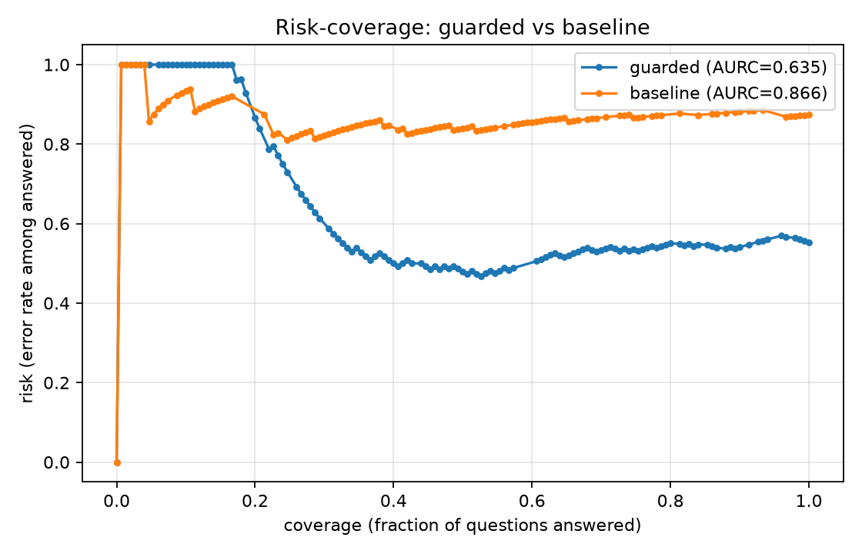
Figure 1. Risk-coverage curves for guarded and baseline arms. Lower and to the right is better.

5. Judge Agreement Study
To determine if the fast local NLI scorer can be trusted as a replacement for a heavier LLM judge, a subset of 34 items was evaluated against a DeepEval LLM judge (gemma2 via Ollama). An earlier attempt using qwen2.5:7b-instruct was abandoned because it deterministically failed every claim at temperature 0, rendering its scores meaningless.

5.1 The Scale Mismatch and Rate-Matching
Reporting raw agreement is misleading because the two scorers do not share a scale. The judge’s relevancy score never exceeded 0.448 on this subset, meaning a shared 0.45 cut-off causes the judge to fail every single item (yielding a Cohen’s Kappa of 0.000). To honestly measure whether they rank passages the same way, the judge was "rate-matched"—given whatever cut-off allowed it to pass the exact same number of items as the NLI scorer.

Gate | n | ρ | κ (shared cut-off) | κ (rate-matched) | Observed (rate-matched)
Gate A (relevancy) | 33 | 0.132 | 0.000 | 0.040 | 60.6%
Gate B (faithfulness) | 17 | -0.298 | -0.037 | -0.037 | 41.2%

5.2 Analysing the Disagreement
Even after rate-matching Gate A, kappa only rises to 0.040—a negligible overlap indistinguishable from random chance. On Gate B, rate-matching changes nothing because DeepEval’s faithfulness metric is uncalibrated, returning strictly binary verdicts (0.0 or 1.0) rather than a continuous score. The negative kappa (-0.037) indicates they agreed marginally less often than chance, with the judge passing 9 items the NLI scorer failed.

5.3 Latency vs. Reliability Trade-Off
This study cannot support the claim that the local scorer is an interchangeable substitute for the judge, though the tiny sample sizes (n=33 and n=17) mean confidence intervals are extremely wide. However, the local NLI scorer ran Gate B in 262 ms compared to the judge's 224.4 seconds—an 857× speedup. Because of this massive latency gap, the local scorer remains the only viable primary path, with the LLM judge strictly reserved for offline spot checks.

6. Status and Limitations
Milestone 3 successfully replaced arbitrary placeholder thresholds with fitted calibrations, supporting the claim that calibration reduces over-abstention with actual measurements. The evaluation framework is now fully measurable end-to-end.
Known Limitations
- Sample Size Variance: The 150-item sample means confidence intervals are wide. For example, the hallucination rate rising from 3 to 8 items could be statistical noise rather than a structural shift, which only a larger sample can clarify.
- Multi-Hop Vulnerability: Gate A’s weak AUC (0.652) indicates that retrieval features alone struggle to predict answerability. This performance is expected to degrade further on multi-hop datasets (like HotpotQA) since the reranker evaluates passages individually rather than synthesising them.
- The Judge Yardstick Flaw: The disagreement in Section 5 is real, but it is not solely a failure of the local scorer. Because DeepEval emitted uncalibrated binary verdicts instead of graded probabilities, it fundamentally cannot serve as a continuous reference standard for threshold calibration.

