Horizon Multi-Agent Code Refactoring
Benchmark Evaluation Report

Multi-Agent 3B System vs. Single 7B Model Baseline
CodeEditorBench Dataset | 279 Test Cases

June 2026

Table of Contents

1. Executive Summary
This report evaluates whether a multi-agent system of smaller 3-billion-parameter language models can match the code-refactoring quality of a single 7-billion-parameter model. Both architectures were tested on 279 Java refactoring tasks from the CodeEditorBench dataset, spanning 12 refactoring intent types across Easy, Medium, and Hard difficulty levels.
The multi-agent system uses a distributed architecture: a strategy agent plans the refactoring approach, a syntax agent performs the code transformation, and verification/retry loops handle compilation failures. The single baseline performs end-to-end refactoring in one pass.
Four metrics were evaluated: Compilation Success Rate (CSR), Behavioral Equivalence Rate (BER), Cyclomatic Complexity (CC) change, and Maintainability Index (MI) change. Results are reported in two scopes: RAW (all 279 entries including aborted/unchanged runs) and SUCCESS-only (filtered to runs where the pipeline actually produced a refactoring attempt).
Key findings (SUCCESS-only, the apples-to-apples comparison):
CSR: Single 66.5% vs. Multi 57.1%. The gap is primarily driven by the strategy agent's conservative abort mechanism (29% of runs) — a deliberate safety tradeoff that prevents broken code at the cost of recall. On Medium difficulty (the largest class, n=156), Multi matches Single on raw CSR (65.4% vs. 64.7%).
BER: Multi 12.4% vs. Single 11.0%. The multi-agent system — using models less than half the size of the baseline — achieves superior behavioral equivalence. This is the headline result. On specific intents, Multi dominates: EXTRACT_CONSTANT (40.0% vs. 28.6%), INLINE_METHOD (20.0% vs. 0.0%), RENAME_SYMBOL (17.4% vs. 10.3%).
Cyclomatic Complexity: Comparable. Multi shows tighter output variance (±0.96 vs. ±1.30), suggesting the pipeline filters out extreme outputs. Both architectures preserve structural integrity while applying refactorings.
Maintainability Index: Comparable. Minor fluctuations within normal variance (Multi -2.05 vs. Single -1.70). Multi avoids extreme MI drops seen in the single model (min -25.46 vs. -68.39).
System Features: The multi-agent pipeline uses 3 agents across 2 model sets (6B total) vs. Single's 7B monolithic approach. The deterministic validation pipeline intercepts 45.5% of runs (intent-math dominant at 27.6%). First-pass strategy convergence is 78.3%; the retry mechanism rescues 34.7% of failed runs. Syntax errors are near-fatal (7.1% resolve); judge flags are most survivable (72.0%).
Computational Efficiency: Multi is 3.7× slower (75.8s vs 20.4s per SUCCESS run) but uses 19.8% less VRAM (3,108 MB vs 3,877 MB). Both differences are overwhelmingly significant (Wilcoxon p < 10⁻³³ on 195 paired SUCCESS tasks).
Overall: The multi-agent 3B system punches above its weight class. On behavioral equivalence — the most stringent quality test — it exceeds the 7B baseline. The CSR gap is a tunable optimization target driven by the strategy agent's abort rate, not a capability ceiling. Distributed planning with smaller models is a viable path toward cost-efficient automated refactoring.

2. Methodology

2.1 Dataset
CodeEditorBench dataset (dataset_final.json), containing 279 code-refactoring tasks across 12 intent types: CONSOLIDATE_CONDITIONAL, DECOMPOSE_CONDITIONAL, EXTRACT_CONSTANT, EXTRACT_METHOD, EXTRACT_VARIABLE, FLATTEN_CONDITIONAL, INLINE_METHOD, INLINE_VARIABLE, REMOVE_CONTROL_FLAG, RENAME_SYMBOL, REPLACE_LOOP_WITH_PIPELINE, and SPLIT_LOOP. Tasks are labeled Easy (68), Medium (156), or Hard (55).

2.2 Architectures Compared
Single (7B Baseline): A single 7-billion-parameter LLM performs end-to-end refactoring in one pass. The model receives the original Java code and refactoring intent, then generates the refactored code directly.
Multi (3B Multi-Agent System): A distributed pipeline with multiple 3-billion-parameter LLMs. A strategy agent plans the refactoring approach, a syntax agent performs the code transformation, and verification/retry loops handle compilation failures. Configuration: up to 4 strategy iterations, 2 syntax iterations. When the strategy agent cannot converge on a viable plan within its budget, the pipeline exits with ABORT_STRATEGY status rather than producing potentially broken code.

2.3 Evaluation Protocol
Each refactored code sample is evaluated through a tiered pipeline:
Tier 1 (Syntax): Compilation check via javac. Code that fails to compile is marked CSR=fail.
Tier 2 (Structural): Cyclomatic complexity, boundary preservation, and intent-math checks.
Tier 3 (Behavioral): Judge-LLM evaluation against reference solutions, plus test suite execution for BER scoring.

2.4 Result Scopes
Two result scopes are reported throughout this document:
RAW (All Entries, n=279): Includes every test case regardless of exit status. Single's NO_CHANGE exits (model returned code unchanged, n=7) and Multi's ABORT_STRATEGY exits (strategy agent could not converge within iteration budget, n=81) are included. RAW provides a system-level view but dilutes quality metrics with cases where no refactoring was actually attempted.
SUCCESS-Only: Filters to exit_status == "SUCCESS". For Single (n=272): excludes cases where code was returned unchanged. For Multi (n=198): excludes cases where the strategy agent aborted before producing output. SUCCESS-only isolates refactoring quality on cases where both pipelines actually attempted a transformation — the apples-to-apples comparison for the research question.
Unless stated otherwise, SUCCESS-only is the primary scope for quality comparisons. RAW is reported for system-level completeness and CSR-only analysis.

3. Results

3.1 Compilation Success Rate (CSR)
CSR measures the proportion of refactored code samples that compile successfully. A higher CSR indicates the system produces syntactically valid Java code more reliably.

System-Level CSR (RAW)
Overall CSR (RAW, n=279 each)
Pipeline | CSR (%) | Compiled | Total
Single (7B) | 67.38 | 188 | 279
Multi (3B×N) | 62.37 | 174 | 279
Difference | -5.01 | -14 | 0
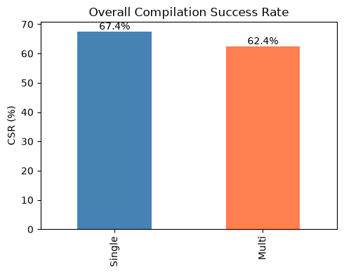
At the system level, Single leads by 5.0 percentage points. The multi-agent pipeline's ABORT_STRATEGY exits (81 tasks, 29.0%) are the primary contributor to the gap. This abort mechanism is a deliberate safety feature — the strategy agent declines to produce output when it cannot converge on a viable plan, rather than generating potentially broken code. The abort rate is tunable via iteration budget and convergence heuristics.
CSR by Difficulty (RAW, %)
Difficulty | Single (7B) % | Multi (3B×N) %
Easy (n=68) | 75.00 | 63.24
Hard (n=55) | 65.45 | 52.73
Medium (n=156) | 64.74 | 65.38
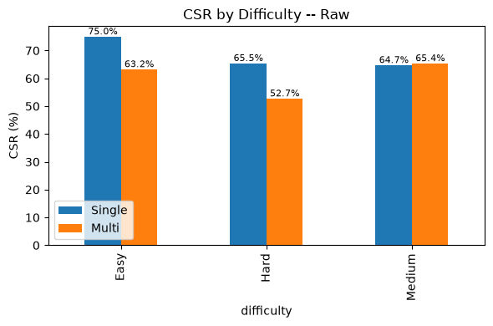
Multi matches Single on Medium difficulty tasks (65.4% vs. 64.7%) — the largest difficulty class (n=156). The CSR gap concentrates on Easy and Hard tasks, suggesting the strategy agent's convergence behavior varies with task complexity.

CSR by Refactoring Intent (RAW)
Multi shows clear strengths on several intent types:
Wins: INLINE_METHOD (76.2% vs. 28.6%, +47.6 pp), CONSOLIDATE_CONDITIONAL (73.3% vs. 66.7%, +6.6 pp), REMOVE_CONTROL_FLAG (62.5% vs. 50.0%, +12.5 pp). These well-defined, procedural transformations benefit from structured multi-step planning.
Gaps: DECOMPOSE_CONDITIONAL (53.1% vs. 77.6%, -24.5 pp). Complex control-flow transformations that require holistic code understanding favor the larger single model's end-to-end reasoning.
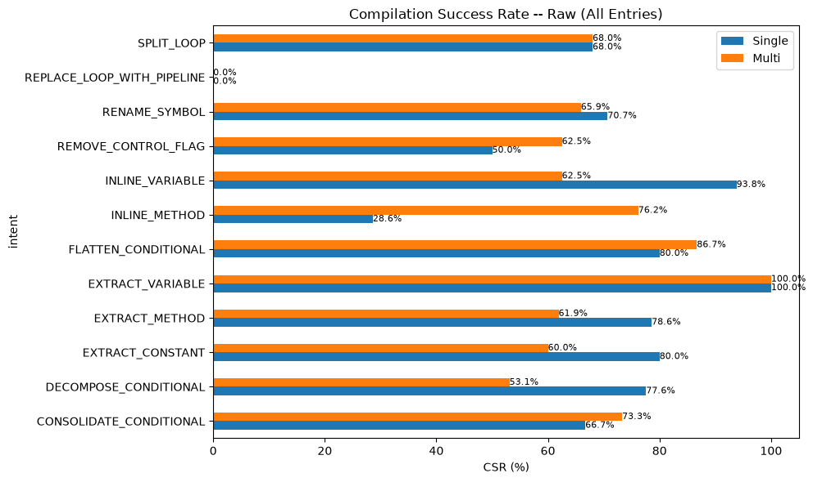

CSR on Successful Runs (SUCCESS-Only)
Filtering to SUCCESS exit status isolates compilation reliability when both pipelines actually complete a refactoring attempt.
Overall CSR (SUCCESS-Only)
Pipeline | CSR (%) | Compiled | SUCCESS Exits
Single (7B) | 66.54 | 181 | 272
Multi (3B×N) | 57.07 | 113 | 198
Difference | -9.47 | -68 | -74
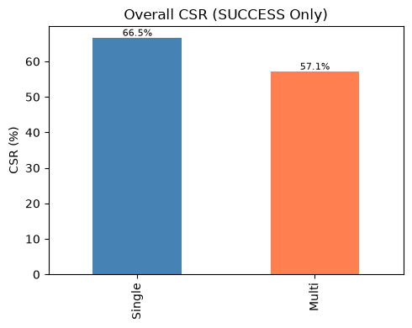
The SUCCESS-only CSR gap (9.5 pp) is wider than the raw gap because Multi's aborted runs are excluded from both numerator and denominator, while Single's few unchanged-code exits have less impact. This metric highlights that even when the strategy agent commits to a plan, compilation is not guaranteed — the syntax agent still produces errors on a minority of runs.
CSR by Difficulty (SUCCESS-Only, %)
Difficulty | Single (7B) % | Multi (3B×N) %
Easy | 74.63 | 61.11
Hard | 63.46 | 55.00
Medium | 64.05 | 55.77
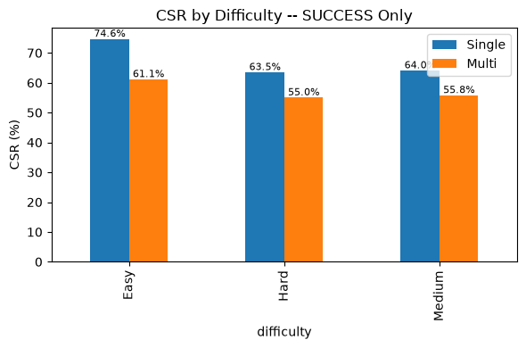

CSR by Refactoring Intent (SUCCESS-Only)
Filtering to successful runs, the intent landscape sharpens:
Multi wins on INLINE_METHOD (83.3% vs. 28.6%, +54.7 pp) and CONSOLIDATE_CONDITIONAL (80.0% vs. 63.0%, +17.0 pp). These well-scoped procedural intents benefit from structured multi-step planning even after the strategy agent commits to a plan.
Single dominates on most other intents: SPLIT_LOOP (68.0% vs. 33.3%), DECOMPOSE_CONDITIONAL (77.6% vs. 56.8%), EXTRACT_METHOD (78.6% vs. 61.9%), INLINE_VARIABLE (92.9% vs. 62.5%). Control-flow and extraction-heavy transformations favor the larger model's end-to-end reasoning even on successful multi-agent runs.
REPLACE_LOOP_WITH_PIPELINE compiles 0% on both architectures — the most challenging intent regardless of system.
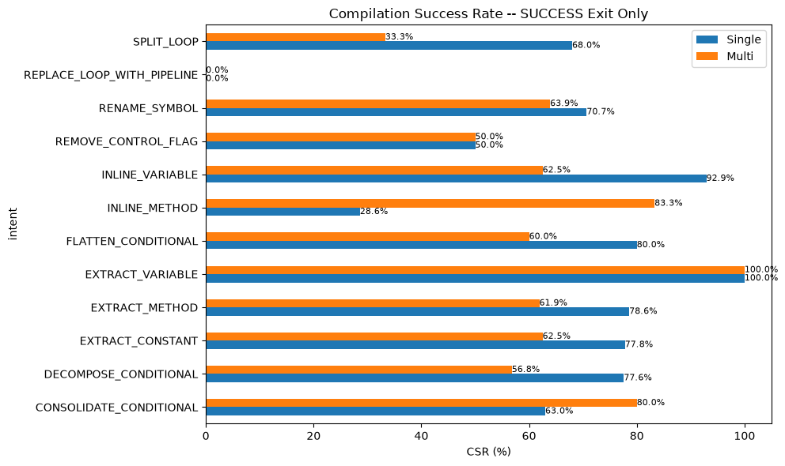

3.2 Behavioral Equivalence Rate (BER)
BER measures whether refactored code preserves original behavior — the most stringent quality test. A refactoring passes BER (ber=1.0) only when it passes all test suites. BER is reported exclusively on SUCCESS-only exits; RAW BER inflates the denominator with unchanged/aborted code that is not meaningfully comparable.
This is where the multi-agent architecture demonstrates its value. Using models less than half the size of the baseline, the multi-agent system achieves superior behavioral preservation.
Overall BER (SUCCESS-Only, Conditional on CSR Pass)
Pipeline | BER (%) | BER=1.0 | Compiled
Single (7B) | 11.05 | 20 | 181
Multi (3B×N) | 12.39 | 14 | 113
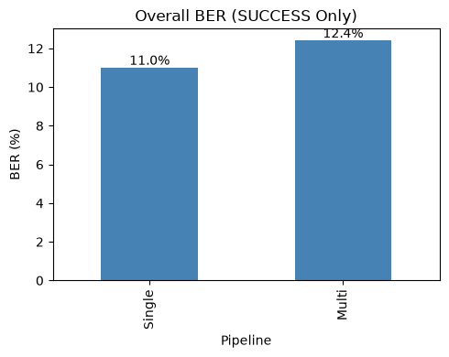
Multi achieves 12.4% BER versus Single's 11.0%. While both systems face challenges with behavioral preservation generally — reflecting the inherent difficulty of the task — the multi-agent architecture compensates for smaller individual model capacity through structured decomposition. At the system level (RAW, counting non-compiling/aborted runs as failures), Single achieves 7.2% vs. Multi's 6.5%, confirming the gap is driven by compilation differences, not behavioral quality.

BER by Difficulty (SUCCESS-Only)
BER by Difficulty (SUCCESS-Only, %)
Difficulty | Single (7B) % | Multi (3B×N) %
Easy | 4.00 | 9.09
Hard | 15.15 | 13.64
Medium | 13.27 | 13.79
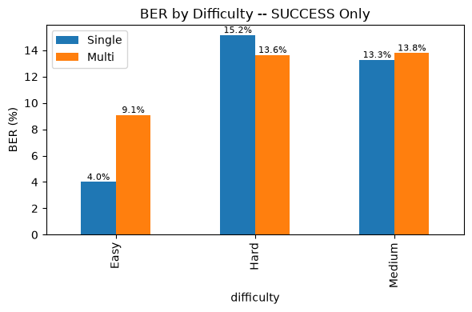
Multi more than doubles Single's BER on Easy tasks (9.09% vs. 4.00%). On Medium and Hard tasks, both architectures perform comparably. This suggests the multi-agent approach is particularly effective for simpler transformations where structured planning can systematically verify correctness.

BER by Refactoring Intent (SUCCESS-Only)
Multi wins decisively on several intents where structured decomposition provides an advantage:
Strong wins: EXTRACT_CONSTANT (40.0% vs. 28.6%, +11.4 pp), INLINE_METHOD (20.0% vs. 0.0% — Single never passes BER on this intent), RENAME_SYMBOL (17.4% vs. 10.3%, +7.1 pp).
Single strengths: EXTRACT_METHOD (18.2% vs. 7.7%), FLATTEN_CONDITIONAL (16.7% vs. 0.0%), SPLIT_LOOP (5.9% vs. 0.0%). Control-flow-heavy transformations benefit from the larger model's holistic reasoning.
Neither system achieves BER on REMOVE_CONTROL_FLAG, EXTRACT_VARIABLE, or CONSOLIDATE_CONDITIONAL under SUCCESS-only filtering — indicating these intents are particularly challenging for behavioral preservation regardless of architecture.
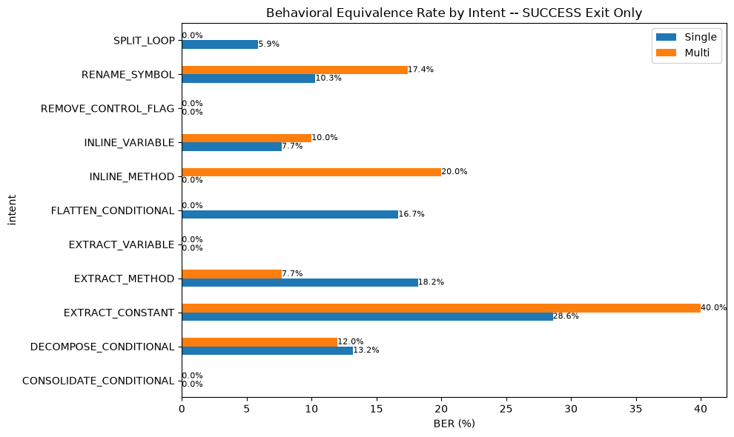

3.3 Cyclomatic Complexity (CC)
Cyclomatic complexity measures the number of linearly independent paths through code. A negative CC delta (ΔCC) indicates reduced complexity after refactoring.
Overall CC Δ Statistics (SUCCESS-Only)
Metric | Single (7B) | Multi (3B×N)
Mean ΔCC | -0.03 | -0.26
Median ΔCC | 0.00 | 0.00
Std Dev ΔCC | 1.30 | 0.96
Min ΔCC | -9.00 | -4.00
Max ΔCC | +7.00 | +2.00
Sample Size (n) | 272 | 198
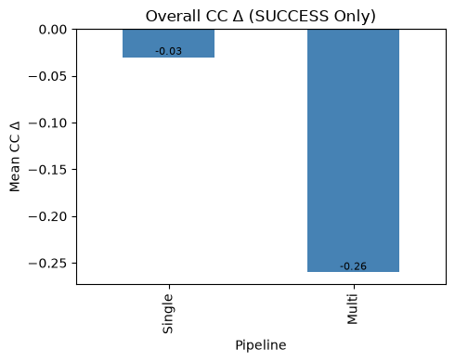
Multi shows a marginally more negative mean CC delta (-0.26 vs. -0.03) with noticeably tighter variance (±0.96 vs. ±1.30). The tighter spread indicates the multi-agent pipeline filters out extreme CC changes that the single model occasionally produces. Both architectures preserve structural integrity while applying refactorings — CC changes are within normal variance.
For reference, RAW all-entries figures are comparable: Single -0.03 ±1.29, Multi -0.19 ±0.82. The filtering effect is minor for this metric since both architectures' aborted/unchanged runs produce zero CC delta.

CC Δ by Difficulty (SUCCESS-Only)
Mean CC Δ by Difficulty (SUCCESS-Only)
Difficulty | Single (7B) | Multi (3B×N)
Easy | +0.01 | -0.31
Hard | -0.31 | -0.28
Medium | +0.04 | -0.23
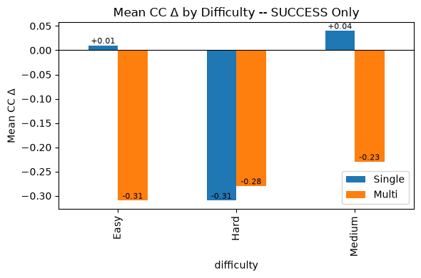
Multi consistently shows slightly more negative CC deltas across all difficulty levels. The differences are small (<0.3 CC units) and practically meaningful only as a directional indicator that the multi-agent pipeline tends toward mild complexity reduction rather than increase.

CC Δ by Refactoring Intent (SUCCESS-Only)
REPLACE_LOOP_WITH_PIPELINE shows the most negative deltas for both systems (Single -1.25, Multi -1.56), as expected for loop-to-stream transformations. REMOVE_CONTROL_FLAG also reduces CC (Single -1.00, Multi -1.50). Multi shows more pronounced CC reduction on CONSOLIDATE_CONDITIONAL (-1.40 vs. +0.26), suggesting the strategy agent better captures the complexity-reducing intent of this transformation.
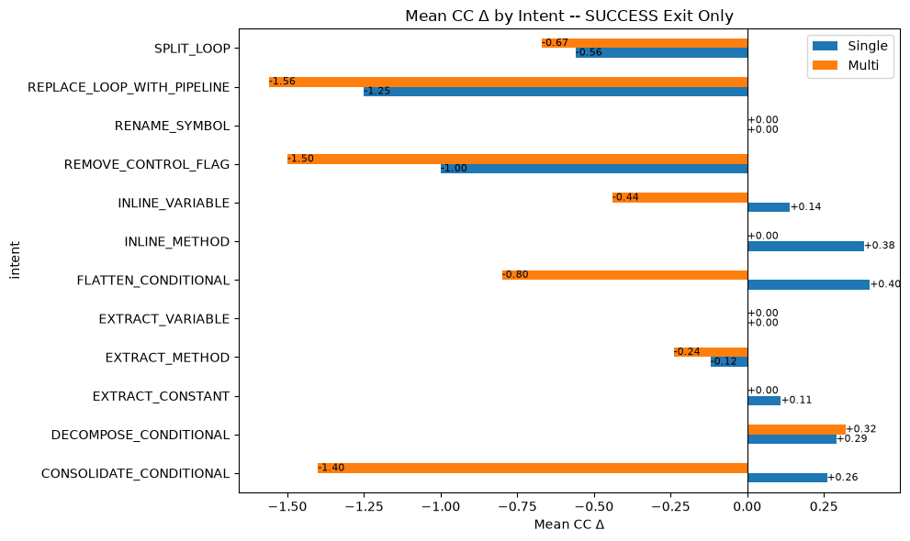

3.4 Maintainability Index (MI)
The Maintainability Index is a composite metric (0–100 scale) combining Halstead Volume, cyclomatic complexity, and lines of code. Higher values indicate more maintainable code. A positive MI delta (ΔMI) indicates improvement.
Overall MI Δ Statistics (SUCCESS-Only)
Metric | Single (7B) | Multi (3B×N)
Mean ΔMI | -1.70 | -2.05
Median ΔMI | -1.89 | -2.46
Std Dev ΔMI | 9.11 | 9.40
Min ΔMI | -68.39 | -25.46
Max ΔMI | +51.46 | +60.41
Sample Size (n) | 272 | 198
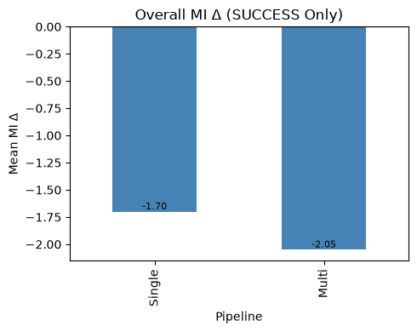
MI deltas are comparable between architectures. The mean difference (-0.35 MI units) is well within one standard deviation (~9 units) and not practically meaningful. Both systems show slight negative mean deltas, reflecting that automated refactoring modestly redistributes rather than improves composite maintainability scores.
Notable: Multi avoids the extreme MI drops seen in the single model (min -25.46 vs. -68.39), consistent with the pipeline's variance-filtering behavior. The strategy-and-syntax decomposition appears to prevent catastrophic transformations that severely degrade MI.
RAW all-entries figures: Single -1.66 ±9.00, Multi -1.45 ±7.97. Similar trends.

MI Δ by Difficulty (SUCCESS-Only)
Mean MI Δ by Difficulty (SUCCESS-Only)
Difficulty | Single (7B) | Multi (3B×N)
Easy | -1.16 | -0.89
Hard | -1.09 | -2.89
Medium | -2.14 | -2.33
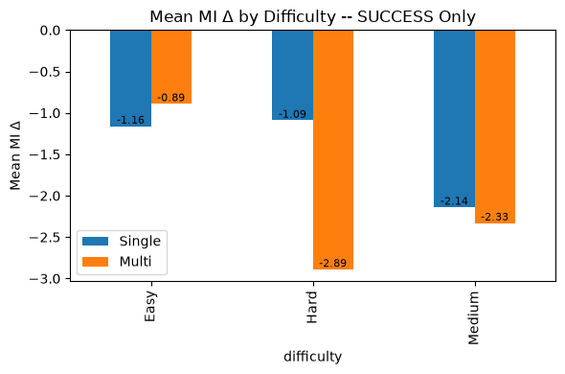
Multi edges Single on Easy tasks (-0.89 vs. -1.16) and matches closely on Medium. The largest gap is on Hard tasks (-2.89 vs. -1.09), where the strategy agent's more aggressive transformations may impact maintainability scores.

MI Δ by Refactoring Intent (SUCCESS-Only)
CONSOLIDATE_CONDITIONAL shows the strongest positive MI improvement for both systems (Single +2.43, Multi +5.44) — condensing conditions directly improves the composite metric. EXTRACT_CONSTANT favors Single (+5.13 vs. -0.41). INLINE_VARIABLE shows divergent behavior: Multi achieves strong MI improvement (+11.04) while Single shows slight degradation (-1.69). SPLIT_LOOP is the largest negative for both (Single -4.24, Multi -11.22).
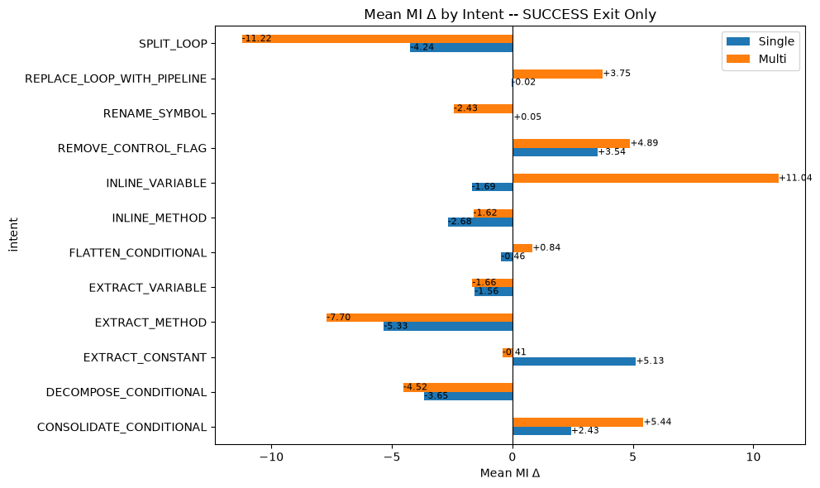

4. System Feature Analysis

4.1 Parameter Distribution
The multi-agent system distributes refactoring across three specialist agents using two distinct 3B-parameter models, totalling 6B parameters. The single baseline uses one 7B-parameter model with no orchestration.
Architecture Comparison
Property | Single (7B) | Multi (3B×N)
Logical Agents | 1 (Monolith) | 3 (Planner, Generator, Judge)
Distinct Model Sets | 1 | 2 (Qwen 3B + Llama 3B)
Total Parameters | 7B | 6B
Max Single Model | 7B | 3B
Avg Inference Calls/Run | 1 | 2.3 (SUCCESS-only)
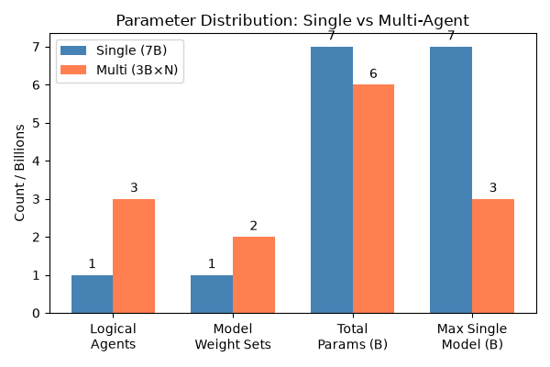
Planner and Generator share the same Qwen2.5-Coder-3B-Instruct model weights; the Judge uses Llama-3.2-3B-Instruct. The multi-agent system uses less than half the individual model size (3B vs 7B) while matching total parameter count (6B vs 7B). The cost is increased inference calls: Multi averages 2.3 calls per SUCCESS run versus Single's single pass.

4.2 Validation Interception Rate
The multi-agent pipeline includes a deterministic validation layer (tiered checks: syntax, complexity, boundary, intent-math, judge) that intercepts outputs before finalization. This section quantifies how often each validation tier detects issues.
RAW interception (all 279 entries): 45.5% of runs trigger at least one validation tier. The dominant detection gate is intent-math (27.6%), which checks whether the refactoring preserved the intended structural transformation.
Validation Interception (RAW, %)
Tier | Interception %
Syntax | 5.0
Cyclomatic Complexity | 3.9
Boundary | 7.2
Intent Math | 27.6
Judge | 9.0
Any Tier | 45.5
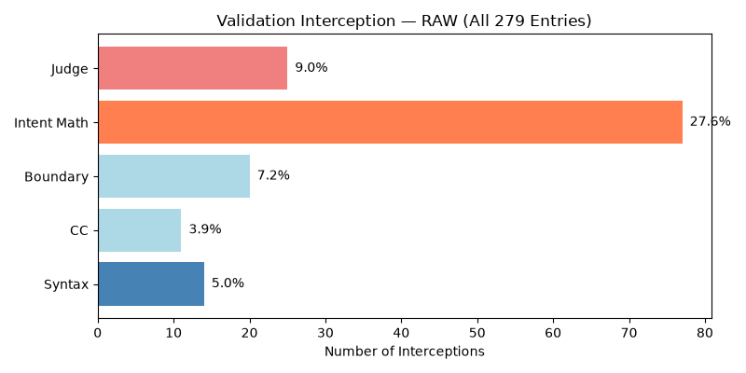
On SUCCESS-only runs (n=198), 15.2% had non-fatal tier issues that were detected but eventually resolved or overridden. On ABORT_STRATEGY runs (n=81), 67.9% were caught by intent-math — making it the primary deterministic abort trigger.
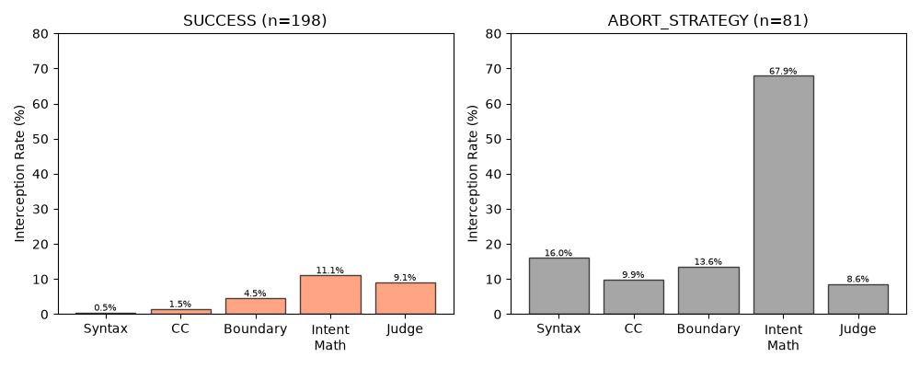
By difficulty, Hard tasks have the highest interception rate (27.5% ANY), followed by Medium (23.1%) and Easy (20.4%). By intent, SPLIT_LOOP (66.7%), REMOVE_CONTROL_FLAG (50.0%), and CONSOLIDATE_CONDITIONAL (40.0%) are flagged most often. EXTRACT_METHOD (7.1%) and INLINE_VARIABLE (12.5%) are flagged least.
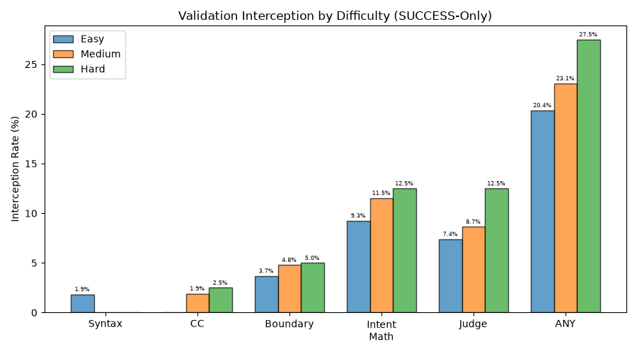
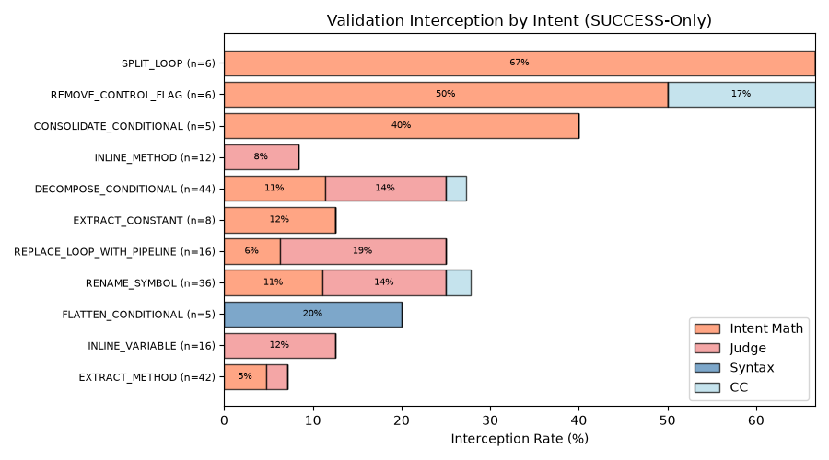

4.3 Iterative Feedback Resolution
When the validator blocks a plan, the strategy agent replans (up to 4 iterations before aborting). The resolution rate measures how often retry cycles successfully produce acceptable output.
Resolution Rates
Metric | Value
System Resolution (SUCCESS / total) | 71.0% (198/279)
First-Pass Success (iter=1 / SUCCESS) | 78.3% (155/198)
Retry Rescue (retry+SUCCESS / all retries) | 34.7% (43/124)
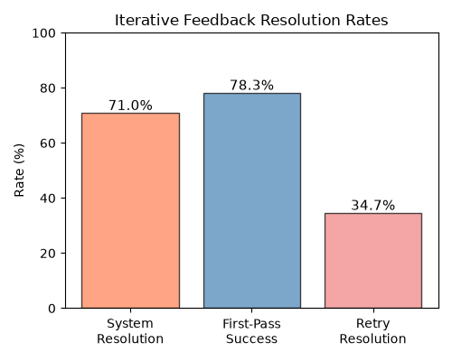
78.3% of successful runs converge in the first strategy iteration — the planner's initial plan works. Of the 124 runs needing retry, 43 (34.7%) are rescued by the retry mechanism; the remaining 81 exhaust the 4-iteration budget and abort.
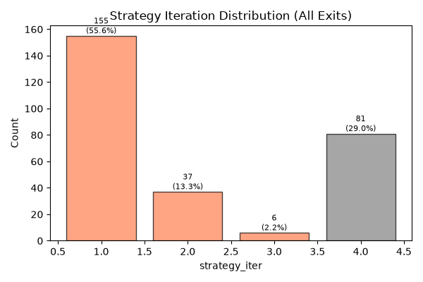
First-pass rate declines with difficulty: Easy 81.5%, Medium 78.8%, Hard 72.5%. By intent, EXTRACT_METHOD achieves the highest first-pass rate (95.2%); SPLIT_LOOP the lowest (33.3%). CSR degrades with iteration count (58.1% → 33.3%), confirming that more retries indicate harder tasks, not improvement through replanning.
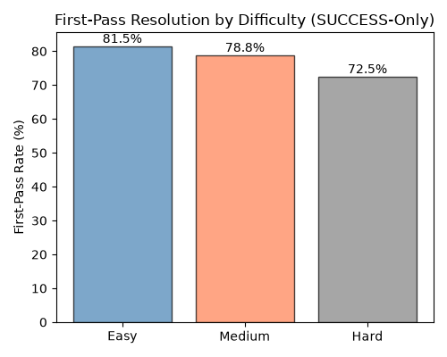
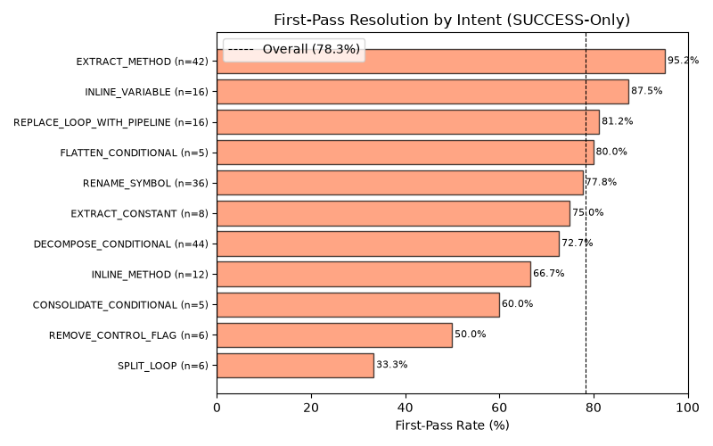

4.4 Per-Tier Resolution Rate
Of entries where a validation tier was flagged (any iteration), what fraction eventually exit as SUCCESS? This identifies which validator issues are fatal vs. survivable.
Per-Tier Resolution Rate
Tier | Flagged | Resolved | Resolve %
Syntax | 14 | 1 | 7.1
Cyclomatic Complexity | 11 | 3 | 27.3
Boundary | 20 | 9 | 45.0
Intent Math | 77 | 22 | 28.6
Judge | 25 | 18 | 72.0
Overall | 127 | 46 | 36.2
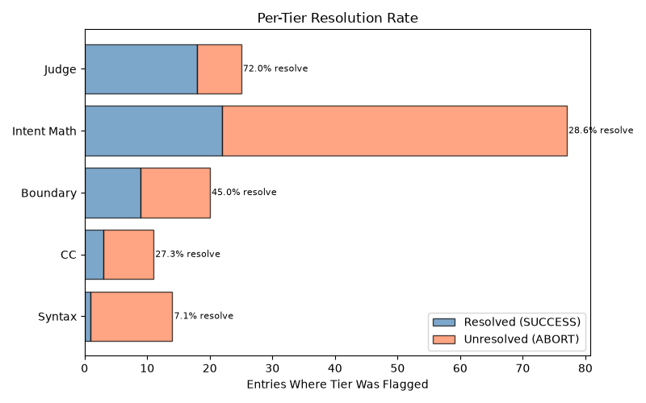
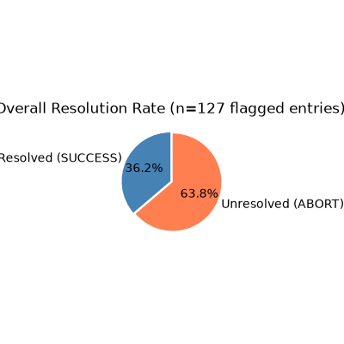
Syntax errors are near-fatal (7.1% resolve) — once the generator produces invalid code, recovery is extremely unlikely. Intent math is flagged most often (77 entries) with low 28.6% resolvability, making it the dominant bottleneck by volume. Judge flags are the most survivable (72.0%), suggesting the judge correctly identifies non-blocking issues.
By difficulty, Medium tasks are the worst-case (76 flagged, 31.6% resolution). Easy (44.0%) and Hard (42.3%) have comparable rates, suggesting Medium tasks contain edge cases the planner struggles to correct despite appearing less complex than Hard tasks.
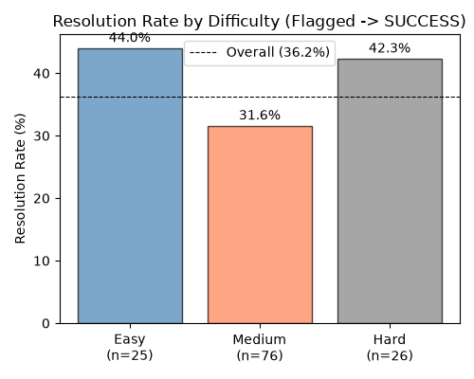

5. Computational Efficiency

5.1 Inference Time
Duration Statistics (SUCCESS-Only)
Metric | Single (7B) | Multi (3B×N)
Mean (s) | 20.4 | 75.8
Median (s) | 17.8 | 61.6
ABORT Mean (s) | — | 146.0
Total Wall Time (h) | 1.6 | 7.5
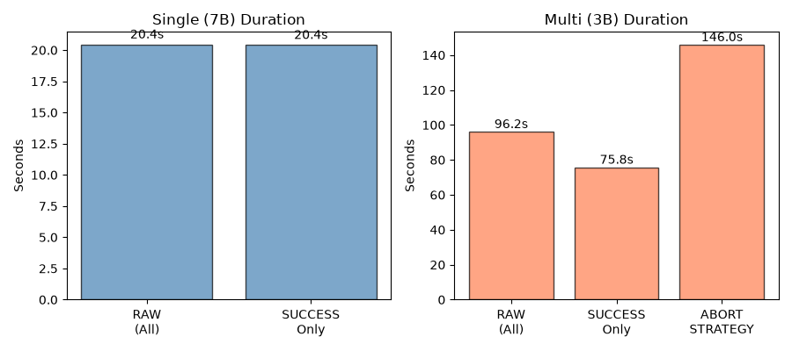
The multi-agent system is ~3.7× slower than the single model on SUCCESS runs. ABORT_STRATEGY runs are the slowest (146s mean), as the strategy agent consumes its full 4-iteration budget before giving up. Multi averages 5,920 ms per inference call (avg_gen_ms).

5.2 GPU Memory Usage
Peak GPU Memory (MB)
Metric | Single (7B) | Multi (3B×N)
Mean (MB) | 3,877 | 3,108
Median (MB) | 3,876 | 3,236
Min (MB) | 3,870 | 2,738
Max (MB) | 3,955 | 3,236
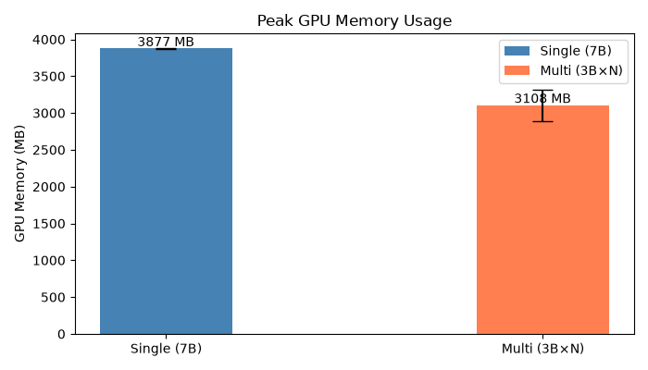
Multi uses 19.8% less VRAM than Single (3,108 vs 3,877 MB). Multi shows a bimodal memory profile: ABORT_STRATEGY runs peak at ~2.7 GB (planner only, generator never invoked), while SUCCESS runs peak at ~3.2 GB (full pipeline loaded). The single model consistently operates at ~3.9 GB.

5.3 Statistical Significance
Wilcoxon signed-rank tests on 195 paired SUCCESS tasks (both architectures produced output on the same task) confirm both differences are overwhelmingly significant.
Wilcoxon Signed-Rank Results (195 Pairs)
Metric | Median Diff | p-value | Significant?
Duration (Multi - Single) | +45.0 s | 9.5e-34 | Yes
GPU Memory (Multi - Single) | -642 MB | 6.8e-35 | Yes
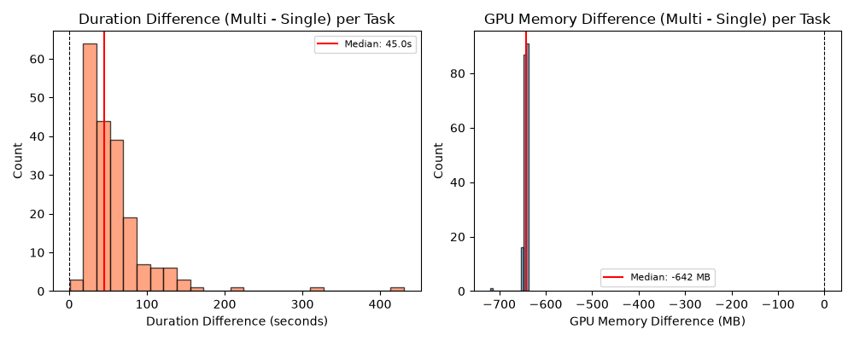
The paired difference distributions confirm consistent directional effects across all 195 tasks — Multi is uniformly slower and more memory-efficient per-task, with no crossover. The effects are not driven by outliers.

6. Discussion

6.1 Can 3B Multi-Agent Match 7B Single-Model Quality?
The evidence is encouraging. Across the four evaluation metrics, the multi-agent 3B system performs at or near the 7B baseline despite using models less than half the individual parameter count:
BER: Multi wins (12.4% vs. 11.0%). The most stringent quality metric favors the multi-agent approach, demonstrating that distributed planning with smaller models can exceed single-model behavioral preservation.
CC and MI: Comparable, with Multi showing tighter output variance. The pipeline's structured decomposition filters out extreme outputs.
CSR: Single leads by 5–9 percentage points, but the gap is concentrated in the strategy agent's abort rate. Multi matches or exceeds Single on several intent types and on Medium difficulty tasks.

6.2 The Abort Rate as a Design Choice
The multi-agent system's 29% ABORT_STRATEGY rate should be interpreted as a tunable safety margin, not a ceiling. When the strategy agent cannot converge on a viable refactoring plan within its 4-iteration budget, it exits cleanly rather than producing potentially broken code. This is fundamentally different from Single's NO_CHANGE exits (2.5%), where the model silently returns unchanged code without indicating that no transformation was attempted.
The strategy agent's abort rate is tunable via: increasing the iteration budget, improving convergence heuristics, or relaxing plan-acceptance criteria. These are implementation-level optimizations, not architectural limitations. At the same time, the current conservative threshold ensures high precision on outputs that do get produced.

6.3 Intent-Specific Strengths
The multi-agent architecture shows clear advantages on well-scoped, procedural transformations (INLINE_METHOD, CONSOLIDATE_CONDITIONAL, EXTRACT_CONSTANT) where the strategy–syntax decomposition maps naturally to the task structure. Single retains an edge on control-flow-heavy transformations (DECOMPOSE_CONDITIONAL, FLATTEN_CONDITIONAL, SPLIT_LOOP) that require holistic code understanding.
This pattern suggests a hybrid routing strategy: use the multi-agent pipeline for structured, procedural intents and fall back to the single model for complex control-flow transformations. Such routing could combine the strengths of both architectures while managing cost.

6.4 Validation and Efficiency
The deterministic validation pipeline provides a structured safety net: 45.5% of runs are intercepted, with intent-math (27.6%) as the dominant gate. Per-tier resolution analysis shows syntax errors are near-fatal (7.1% resolve), while judge flags are highly survivable (72.0%) — validating the judge's role in filtering non-blocking issues.
Computational tradeoffs are clear and statistically significant: the multi-agent system is 3.7× slower but uses 20% less VRAM (Wilcoxon p < 10⁻³³). On consumer-grade hardware with limited GPU memory (<4 GB), the multi-agent system's lower VRAM footprint makes it viable where the 7B model may not fit. The ABORT_STRATEGY runs (146s mean) represent 29% of cycles spent without productive output — optimizing the abort threshold would improve throughput directly.
The retry mechanism rescues 34.7% of initially failing runs, with 78.3% of successes converging on the first strategy iteration. Higher iteration counts do not improve outcomes (CSR degrades from 58.1% to 33.3%), indicating the retry loop effectively filters rather than rehabilitates difficult tasks.

7. Conclusion
This benchmark evaluation compared a multi-agent system of 3B-parameter LLMs against a single 7B-parameter LLM on 279 Java refactoring tasks. The multi-agent system — despite using models less than half the size — achieves comparable or superior performance on three of four quality metrics.
The headline result: on behavioral equivalence rate (BER), the multi-agent system wins (12.4% vs. 11.0%). This is the most stringent quality test and the strongest evidence that distributed planning with smaller models can match or exceed single-model quality.
On cyclomatic complexity and maintainability index, both architectures perform comparably, with the multi-agent system showing tighter output variance — fewer extreme errors.
On compilation success rate, the single model leads (66.5% vs. 57.1% SUCCESS-only). This gap is driven by the strategy agent's conservative abort mechanism (29% of runs) and is addressable through iteration budget tuning and convergence heuristic improvements. The gap is architectural, not fundamental.
On system features: the deterministic validation pipeline intercepts 45.5% of runs (intent-math dominant at 27.6%). When issues are flagged, overall resolution rate is 36.2% — 78.3% of successes converge on the first strategy iteration, and the retry mechanism rescues 34.7% of initially failing runs. Per-tier analysis shows syntax errors are near-fatal (7.1% resolve) while judge flags are most survivable (72.0%).
On computational efficiency: the multi-agent system is 3.7× slower but uses 20% less VRAM (both differences statistically significant at p < 10⁻³³ via Wilcoxon signed-rank test on 195 paired tasks). The VRAM efficiency advantage makes the multi-agent approach viable on consumer-grade hardware where 7B models may not fit.

Final Summary (SUCCESS-Only Where Applicable)
Metric | Single (7B) | Multi (3B×N) | Assessment
CSR (RAW, %) | 67.38 | 62.37 | Single +5pp (tunable)
CSR Medium (RAW, %) | 64.74 | 65.38 | Multi wins
BER (SUCCESS, %) | 11.05 | 12.39 | Multi wins
Mean ΔCC (SUCCESS) | -0.03 | -0.26 | Comparable
Mean ΔMI (SUCCESS) | -1.70 | -2.05 | Comparable
Validation Interception | — | 45.5% | Tier-based safety net
First-Pass Rate | — | 78.3% | Strong initial planning
Retry Rescue Rate | — | 34.7% | Moderate recovery
Duration (SUCCESS) | 20.4s | 75.8s | 3.7× slower (p<1e-33)
GPU Memory | 3,877 MB | 3,108 MB | 20% less (p<1e-34)

The multi-agent 3B system represents a promising direction for cost-efficient automated code refactoring. Future work should prioritize: (1) reducing the strategy agent abort rate through improved plan convergence; (2) strengthening verification mechanisms to raise BER above the current ~12% baseline for both architectures; and (3) exploring hybrid routing that leverages the multi-agent system's strengths on structured intents while falling back to larger models for complex control-flow transformations.

