**CORRECTIONS ON WEBSITE**

TOP LEFT CORNER MCSTAR LIMITED

OUR SERVICES (**UNDER THE BOREHOLE CONSTRUCTION SECTION)**

We work on constructing boreholes for domestic, commercial and community use. We drill and construct **manual** boreholes as well as **mechanized** boreholes.

GALLERY SECTION

Please replace last three pictures with these

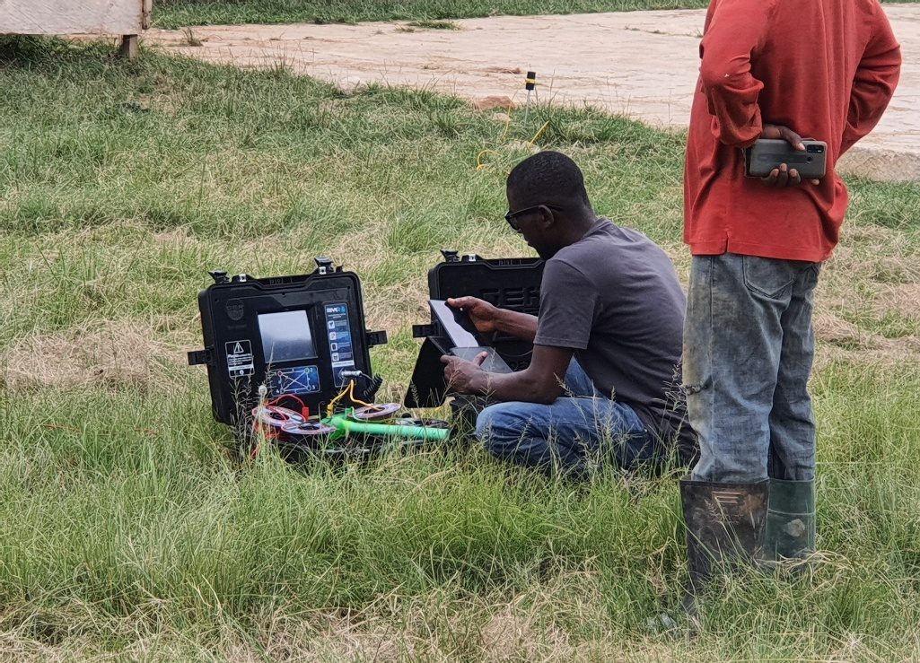

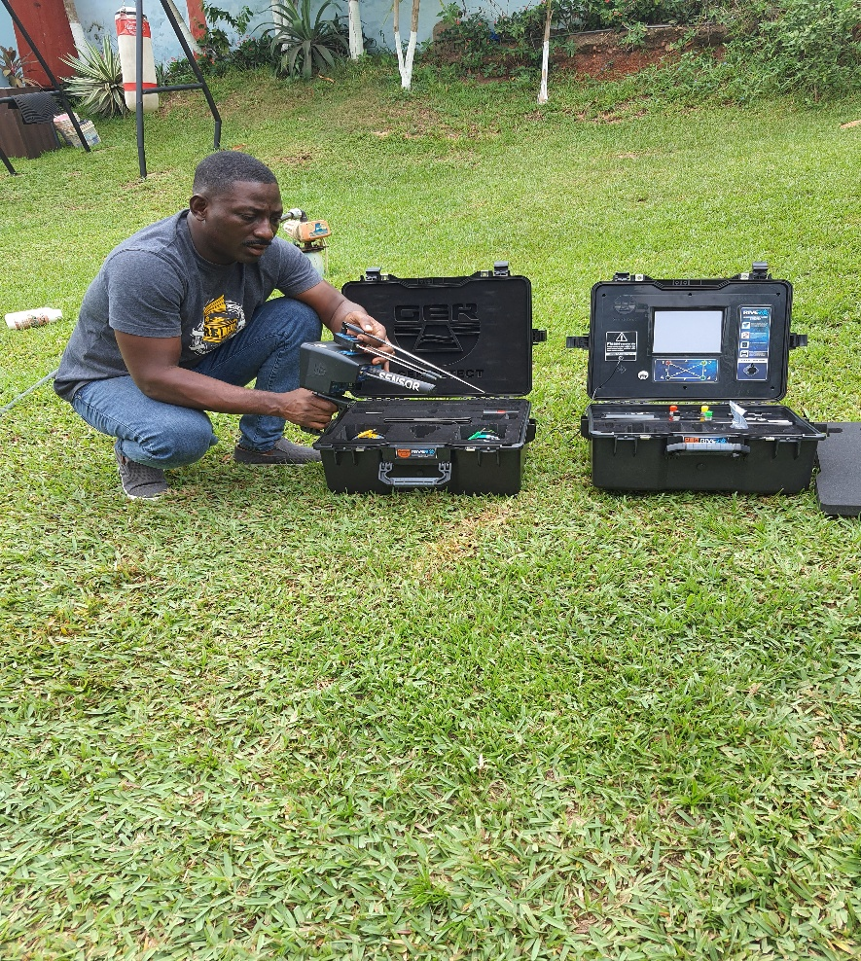

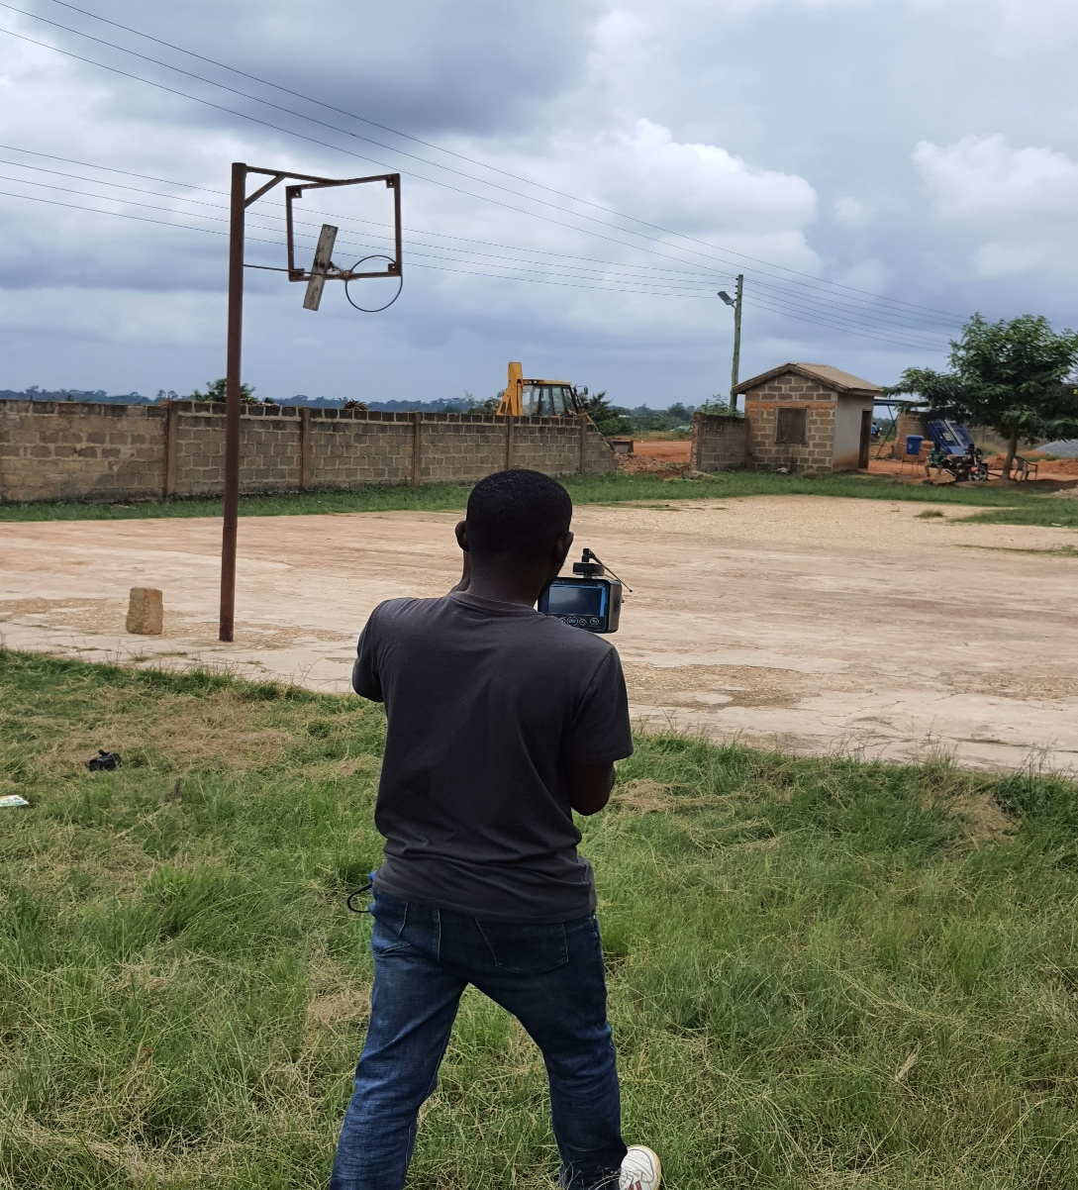

CONTACT INFO SECTION

Please remove +233 552836876