QUESTION 2

1. Many high schools in the United States prepare their University bound students for the Scholastic Aptitude Test (SAT) with test-preparation classes in which students take timed practice exams in the hope of reducing the time taken to complete the tests. In one school, the Principal is considering adopting the latest cutting-edge test-preparation software to assist students as they get ready for their SATs. However, before she purchases the new software, she wants to know if it really makes a difference in how the students perform.

A random test was performed on 12 students that was selected at random with a new time software and a old time software, the null and alternative hypotheses test was conducted to see the diference int the 2 software;

H0= mean Time old software is equal to the mean time new software.

H1 = mean Time old software is NOT equal to the mean time new software.

1. Alpa value is 0.005 p=0.005

R STUDIO T TEST

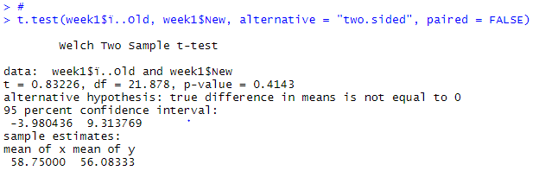

SPSS T TEST

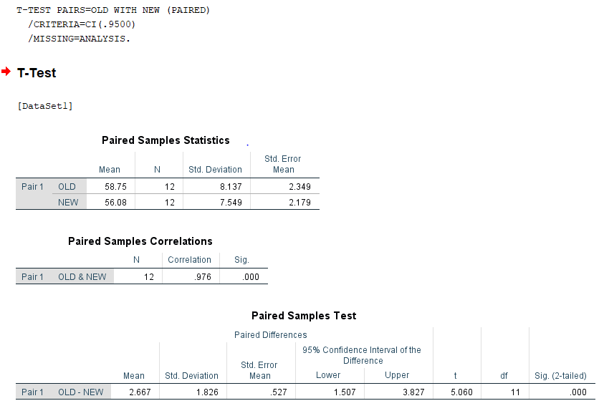

D.

SPSS

ALPA= 0.005

t = 5.05

Since the t value is greater than the alpa value we fail to reject the null hypotheses meaning that there is no difference in the population mean of both the new and old time software.

R STUDIO

ALPA= 0.005

P = 0.4

T= 0.83

Since the p value is greater than the alpa value we fail to reject the null hypotheses meaning that there is no difference in the population mean of both the new and old time software.