 THE GENTRY LAB
BRAND & REPORT STYLE GUIDE
THE GENTRY LAB
Cambodia Industrial Development Intelligence & Advisory Platform
INTERNAL REFERENCE · v2.0 · July 10, 2026

This guide documents two things: the platform's identity (logo, palette, type), and the bold, chart-forward report language modeled on The Gentry Lab's own AI Industrial Advisor report — built to read like an ADB, IFC, or World Bank publication. Use it for anything with the TGL name on it.

1. Brand Overview
The Gentry Lab is an industrial development intelligence and advisory platform for foreign investors, manufacturers, landowners, and development banks navigating Cambodia's industrial landscape. Every document that leaves the firm is a data product first and a piece of writing second. The brand exists to make that data trustworthy — and impressive — at a glance.

What we produce
■ Site advisory briefs — suitability scoring, strengths, constraints, recommendation
■ Sector and research briefs — cost benchmarks, regulatory guides, flood-risk atlases
■ The AI Industrial Advisor report — a full multi-page, development-bank-style document generated in-app

Advisory services
■ Land selection & SEZ feasibility
■ Technical due diligence
■ Permit navigation
■ Project delivery & EPC management
Contact: thegentrylab.com · Phnom Penh, Cambodia

2. Logo & Mark
The mark is a geometric “G” built from six flat shapes — no gradients, no drop shadows, no rotation.
  Square mark  App icons, cover bands, favicon |   Mark only  Letterheads, watermarks, light backgrounds

■ Never recolor, stretch, rotate, or add effects to the mark
■ Minimum clear space = the height of the mark itself
■ Below 16px / 0.2in, use the wordmark “TGL” in bold instead

3. Color Palette
Core brand tokens, pulled directly from the platform's design system:
Swatch | Name | Hex | Usage
 | Brand Black | #0A0A0B | Cover bands, headings, primary ink
 | Brand Accent | #FF5100 | Rules, tags, primary highlight
 | Accent Deep | #CC3300 | Key numbers, score callouts, recommendation quotes
 | Brand Muted | #71717A | Captions, metadata, source lines
 | Table Tint | #FFF3EE | Pale table-header fill (from the AI report)
 | Stone 50 / 200 | #FAFAF9 | Card backgrounds / borders
 | Page Background | #F5F4F0 | Report page background

Categorical palette
Five colors that code a section or report by subject — lifted directly from the AI Industrial Advisor's own category system (PCOLS). Use one per report or per section, consistently, so a reader can tell what they're looking at from the color alone before reading a word.
 | Investment | #CC3300 | Site briefs, deal-facing content, financial commitment
 | Infrastructure | #1A5C9E | Utilities, logistics, technical due diligence
 | Environmental | #217A4B | Sustainability, flood risk, compliance-positive findings
 | Legal | #7B3FA0 | Regulatory, permits, risk & considerations
 | Finance | #B86E00 | Cost benchmarks, economics, key figures

4. Typography
Inter / JetBrains Mono on the web; Arial / Consolas in Word documents (Inter isn't reliably installed on reader machines — Arial keeps every report looking identical everywhere). Headlines and key numbers run bold and large — this is a heavy, confident register, not a delicate one.
Role | Size | Weight / Notes
Cover title | 36–46pt | Bold, white on black cover band
Key-stat number | 28–32pt | Bold, categorical color, never black
Report title (H1) | 22–24pt | Bold, black, orange rule beneath
Section heading (H2) | 13–14pt | Bold, black
Body copy | 10.5–11pt | Regular, black
Caption / footnote / mono labels | 8–9pt | Regular, muted, monospace
Labels, tags, refs, and captions are always set in monospace — it signals “data,” not “prose.”

5. Report Design Language
Every multi-page report opens with the same four elements, in this order — modeled on the platform's own AI Industrial Advisor report and on ADB / IFC / World Bank publication conventions.

A. Cover band
A full-width black band holding: logo + wordmark, an eyebrow label, a large bold title, an optional subtitle, and a metadata line (category badge · reference number · date). A thick categorical-color rule runs beneath it — the single strongest visual cue in the whole document.

B. Key-stat row
Immediately after the cover, 3–4 stat cards in a row — big bold number, categorical-color left rule, mono label underneath. This is the “read this in five seconds” layer. Example:
88/100  SUITABILITY SCORE | 115kV  POWER GRID FEED | $2.4M  EST. LAND PREMIUM

C. Charts, not just tables
Every quantitative section gets a chart before its data table — bar charts for comparisons and readiness indices, line charts for trends, a donut for single scores. Brand orange is the primary series; blue is the comparison series when two are shown. Keep gridlines light, remove chart borders, label bars/points directly rather than relying on a legend where possible. Example:
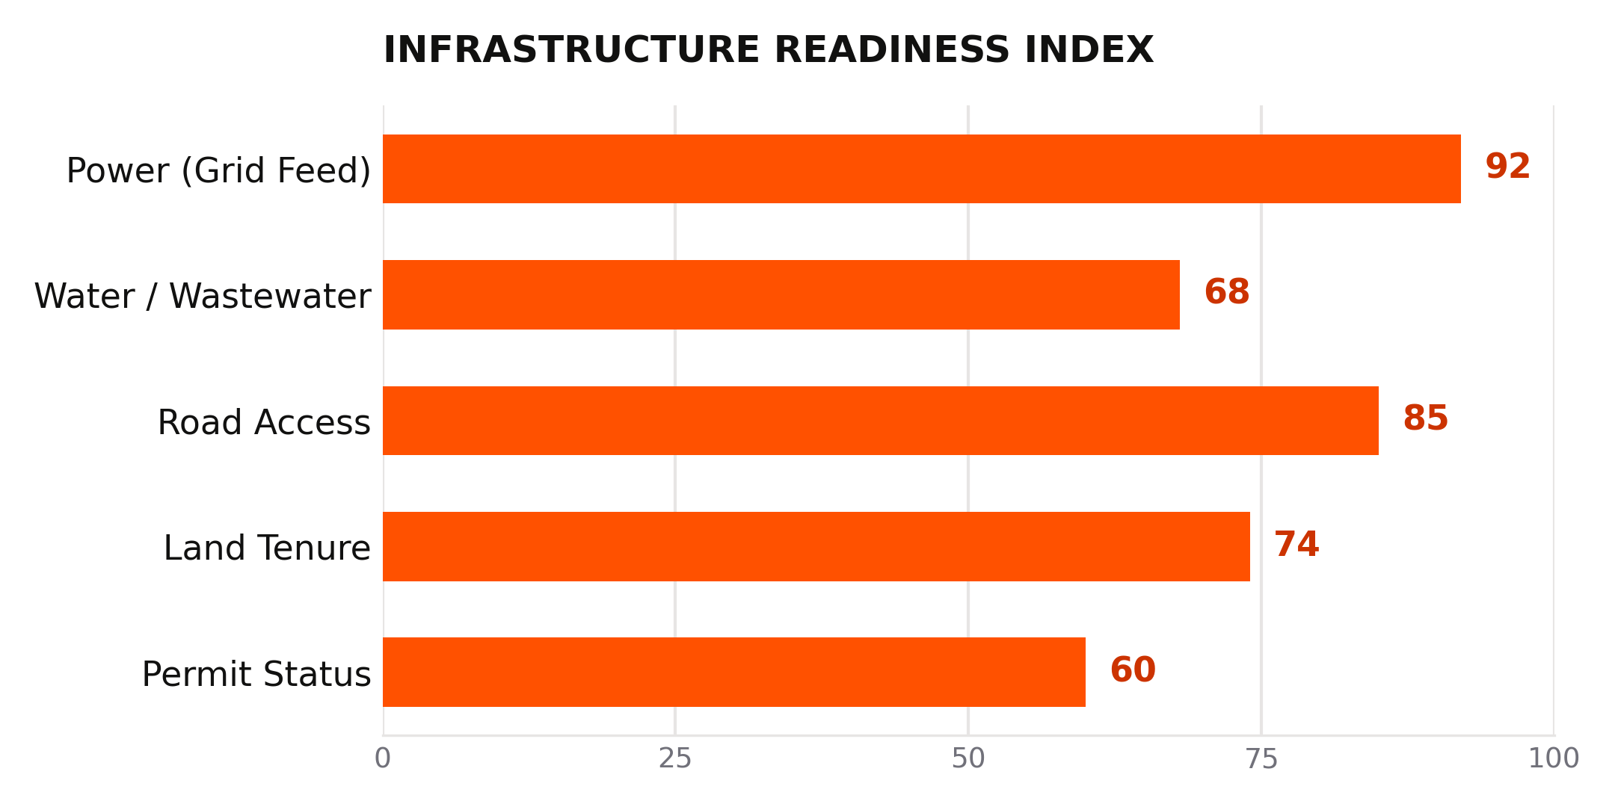
Bar chart — categorical comparison

D. Section tabs, pull-quotes, disclaimer footer
Each major section opens with a small colored-square tab (■ SECTION NAME) in its categorical color — a rhythm that lets a reader navigate by color down the page edge. Recommendations and key takeaways are set as pull-quotes: bold italic text against a thick categorical-color left rule, never buried in a paragraph.
■ EXAMPLE SECTION TAB
This is a pull-quote — the sentence a reader should be able to screenshot on its own.
Every content page carries a running header (logo mark · “AI INDUSTRIAL ADVISOR” · report title) and a footer with copyright, page number, and a one-line disclaimer: “AI-assisted advisory. Verify independently.” Long reports (4+ sections) open with a styled Contents page — roman numerals, categorical color per line, dot leaders — instead of a plain Word table of contents.

6. Voice & Tone
The Gentry Lab writes like an engineer briefing an investment committee: specific, sourced, and willing to commit to a recommendation.
■ Lead with the number, not the adjective — “115kV direct feed” beats “excellent power infrastructure”
■ Commit to a recommendation — hedge on the evidence, not on the conclusion
■ Name the constraint as plainly as the strength
■ Use industry terms of art without translating them (SEZ, EPC, MNC, bonded warehouse)

Do
“First-choice location for export-oriented light manufacturing requiring reliable utilities and immediate logistics access. Best suited for MNC anchor tenants or JV structures requiring proximity to capital.”

Don't
“This is a really promising site with a lot of potential that investors should definitely take a closer look at.”
Standard disclaimer: “Data is illustrative based on public information from CDC, the SEZ Board of Cambodia, EDC, and MPWT. Verify all information before making investment decisions.”

7. Available Templates & Assets
Live in the Brand folder alongside this guide:
■ Site Advisory Brief — cover band, key stats, score donut, infrastructure bar chart, strengths/constraints, recommendation pull-quote
■ General Research Report — cover band, styled Contents page, trend + comparison charts, risks, recommendation, sources
■ assets/ — logo-square.png, logo-mark.png, and the chart PNGs used above (regenerate with brand/make_charts.py using real data)
Start every new report from one of these two files rather than a blank document.

