 THE GENTRY LAB
RESEARCH REPORT
[Report Title]
[Subtitle — one line describing scope]
[SECTOR / CATEGORY TAG] · REF: TGL-RPT-[00] · [Date]

Prepared for [Client Name] · Prepared by [Author]

Contents
I Executive Summary ··
II Background ··
III Methodology ··
IV Findings & Analysis ··
V Risks & Considerations ··
VI Recommendation ··
VII Sources & Disclaimer ··

■ I · EXECUTIVE SUMMARY

Executive Summary
[3–5 sentences. State the headline finding first, then the two or three data points that support it, then the recommended action. A reader who stops here should already know what to do.]
[Optional: one-sentence takeaway, quotable on its own — the number a reader should remember.]

Key figures
[Val]  [METRIC 1] | [Val]  [METRIC 2] | [Val]  [METRIC 3]

■ II · BACKGROUND

Background
[Context: what prompted this report, what question it answers, and for whom. Keep it to the facts a new reader needs before the analysis makes sense.]
■ III · METHODOLOGY

Methodology
[Data sources, timeframe, and how figures were derived or verified. Name sources explicitly — CDC, SEZ Board, EDC, MPWT, press releases, site visits, etc.]
■ [Source 1 — what it provided]
■ [Source 2 — what it provided]
■ [Source 3 — what it provided]
■ IV · FINDINGS & ANALYSIS

Findings & Analysis

Trend
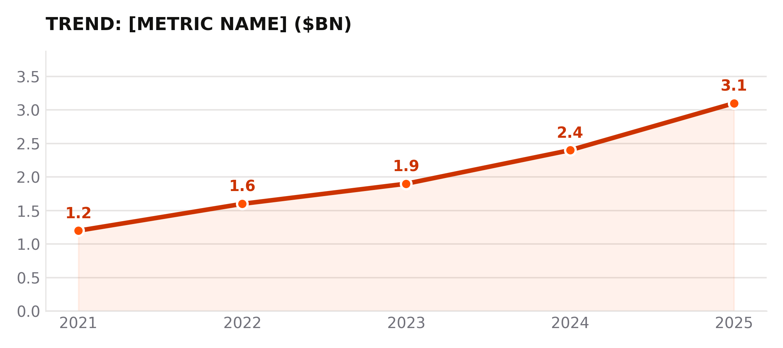
Replace with the report's actual metric and period

Comparative analysis
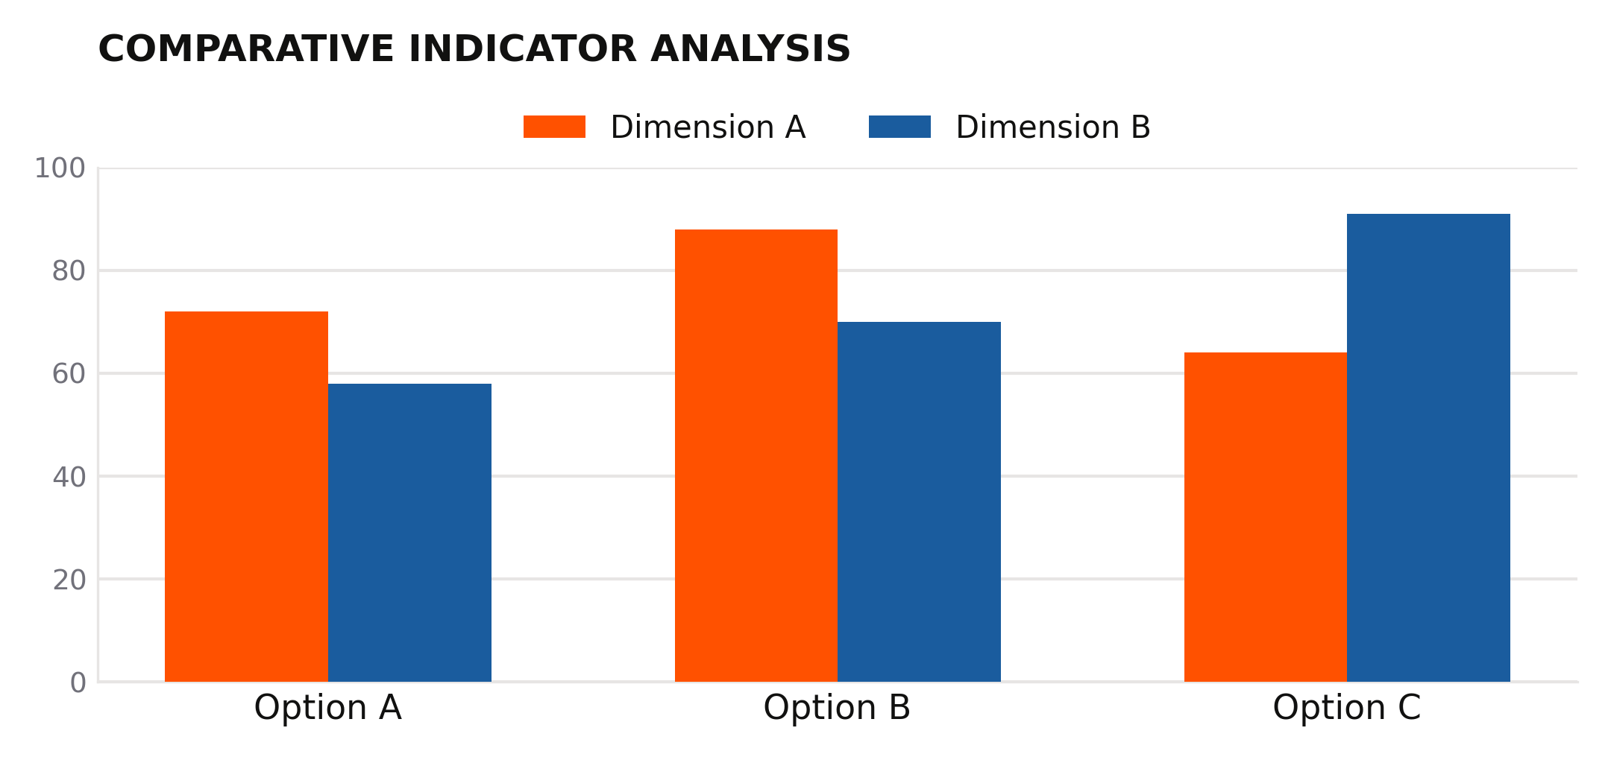
Replace dimensions and options with real comparison data

Comparison table
Option | [Dimension A] | [Dimension B]
[Option 1] | [Value] | [Value]
[Option 2] | [Value] | [Value]

■ V · RISKS & CONSIDERATIONS

Risks & Considerations
■ [Risk 1 — plain statement, no euphemism]
■ [Risk 2]
■ [Risk 3]
■ VI · RECOMMENDATION

Recommendation
[State the recommendation plainly. Commit to a position — hedge on the evidence, not on the conclusion.]

■ VII · SOURCES & DISCLAIMER

Sources & Disclaimer
■ [Source 1, with link or citation]
■ [Source 2, with link or citation]
AI-assisted research. Data is illustrative based on public information. Verify all information independently before making investment decisions.

