 THE GENTRY LAB
SITE ADVISORY BRIEF
[Site Name]
[Province, Cambodia] · [Zone Type — e.g. SEZ / Industrial Park]
INVESTMENT ADVISORY · REF: TGL-SITE-[00] · [Date]

[XX]/100  SUITABILITY SCORE | [115kV]  POWER GRID FEED | [$X]  LAND PREMIUM | [N]  TARGET SECTORS

■ SUITABILITY ASSESSMENT
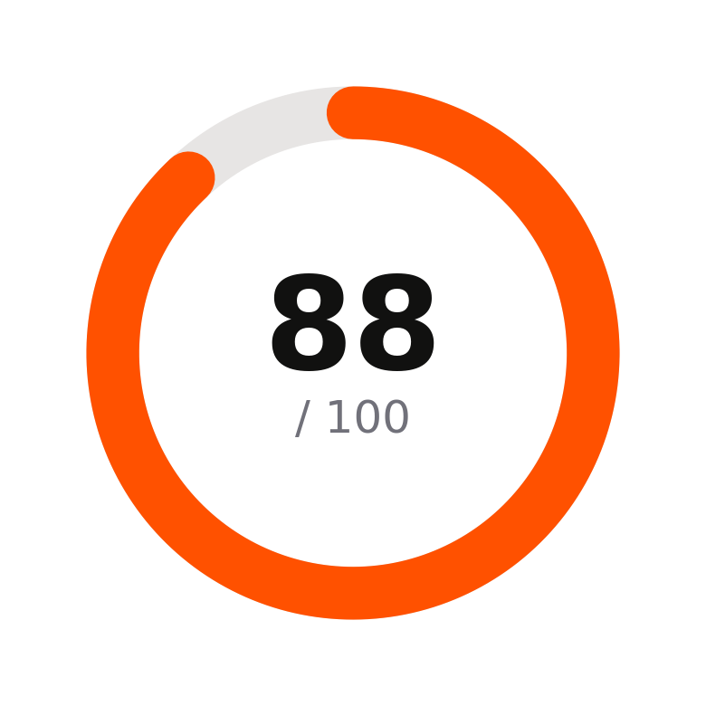 | [2–4 sentence overview: what the site is, its scale, its position in the regional cluster, and one or two headline stats. Write it the way you'd brief an investment committee: lead with the number, not the adjective.]

STRENGTHS  ■ [Strength 1]  ■ [Strength 2]  ■ [Strength 3]  ■ [Strength 4] | CONSTRAINTS  ■ [Constraint 1]  ■ [Constraint 2]  ■ [Constraint 3]

■ INFRASTRUCTURE & UTILITIES

Infrastructure Readiness
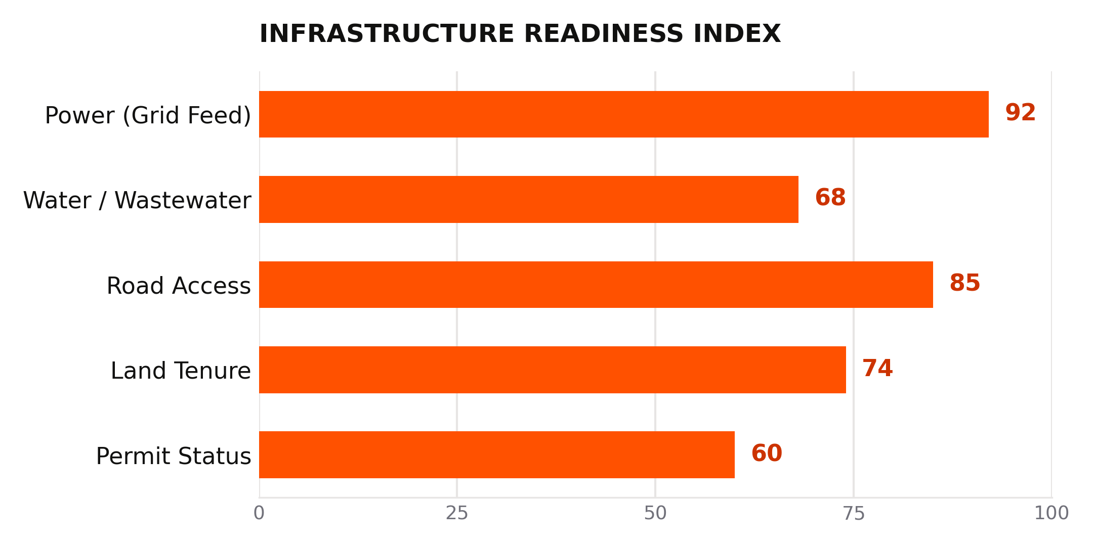
Illustrative index — replace with site-specific scoring
Utility | Capacity / Status | Notes
Power (grid feed) | [e.g. 115kV] | [Substation, headroom]
Water / Wastewater | [Capacity %] | [Treatment status]
Road access | [e.g. NR1 direct] | [Distance to port/airport]
Land | [Premium vs. comparable] | [Tenure type]

■ TARGET INDUSTRIES
[ [Industry 1] ] [ [Industry 2] ] [ [Industry 3] ] [ [Industry 4] ]
■ RECOMMENDATION
[State the recommendation plainly: who this site is best suited for, and under what conditions. Commit to a position — hedge on the evidence, not on the conclusion.]
AI-assisted advisory. Data is illustrative based on public information from CDC, the SEZ Board of Cambodia, EDC, and MPWT. Verify all information independently before making investment decisions.

