 THE GENTRY LAB
MACRO & EXTERNAL FACTORS BRIEF
Cambodia External Factors Outlook 2026
Trade policy, growth, capital flows, and cross-border risk — the forces shaping investment decisions from outside Cambodia's borders
PESTEL ANALYSIS · REF: TGL-MEF-01 · August 2026

Prepared for Investors, Developers & Institutional Partners · The Gentry Lab Research

Contents
I Executive Summary ··
II External Factor Landscape (PESTEL) ··
III Deep Dive — U.S. Tariff Reset ··
IV Deep Dive — Border Conflict Aftermath ··
V Regional Comparison ··
VI Risk Exposure Ratings ··
VII Implications & Recommendation ··
VIII Sources & Disclaimer ··

■ I · EXECUTIVE SUMMARY

Executive Summary
Cambodia enters the second half of 2026 with a more favorable external trade position than either of its two closest apparel-sector rivals, but a domestic growth picture that has softened. Following a February 2026 U.S. Supreme Court ruling that struck down the legal basis for the 2025 IEEPA tariffs, Cambodia's effective U.S. tariff rate has settled near a capped 19% — below Bangladesh's 25.6% and well below Vietnam's 28.1% as of late July 2026. That relative advantage, plus a new three-year U.S. duty-free Tariff Rate Quota for qualifying textile exports, gives Cambodia a real opening to capture sourcing reallocation from Vietnam over the next 12–18 months.
Set against that trade tailwind are three headwinds worth underwriting into any 2026 decision: a downgraded growth outlook (World Bank cut its 2026 forecast to 3.9% from 4.3%, IMF near 4.0%), a still-unresolved economic drag from the 2025 Cambodia–Thailand border conflict that closed roughly $5.6 billion in overland trade routes before the December 2025 ceasefire, and a widening minimum-wage gap with worker expectations that keeps labor relations a live compliance issue for garment-sector tenants. China remains the single largest external variable in either direction — the largest source of both FDI (46.8% of Q1 2026 inflows) and bilateral trade — meaning Cambodia's growth trajectory is now more tied to Beijing's investment cycle than to any other external actor.
Cambodia's 2026 external position is a tariff-driven opportunity riding on top of a growth slowdown and an unresolved border conflict — the trade story is better than it looks, the growth story is softer than it looks.

Key indicators
19%  US TARIFF CAP (VS 28.1% VN) | 3.9%  2026F GDP GROWTH (WORLD BANK) | $210  2026 GARMENT MIN. WAGE / MO | 46.8%  CHINA SHARE OF Q1 2026 FDI

■ II · EXTERNAL FACTOR LANDSCAPE

External Factor Landscape (PESTEL)
A five-factor scan of the conditions outside Cambodia's direct control that carry the most weight for an investment or site decision made in the second half of 2026.
POLITICAL & REGULATORY  ■ Cambodia–Thailand border ceasefire signed 27 Dec 2025 after conflict that displaced 500,000+ civilians; land-crossing trade only partially normalized.  ■ First Commercial Code in drafting — unifying commercial law and adding a framework for digital platforms, fintech and e-commerce.  ■ QIP investment approvals remain fast (20 working days) under the 2021 Law on Investment. | ECONOMIC  ■ World Bank cut 2026 GDP growth forecast to 3.9% (from 4.3%); IMF near 4.0%. Both project a 2027 rebound (World Bank: 5.1%).  ■ Riel holding a stable managed float near 4,000–4,100/USD; government pushing riel salary payments and de-dollarization of small transactions in 2026.  ■ Garment/footwear/travel-goods exports remained a bright spot in 2025 even as overall growth cooled.
SOCIAL & LABOR  ■ 2026 garment-sector minimum wage set at $210/month (up only $2 from 2025) — unions had sought $232, keeping wage pressure live for 2027 talks.  ■ Thailand's Labour Ministry has moved to admit no new Cambodian laborers since the border conflict, straining a historically large cross-border workforce and remittance channel. | TECHNOLOGICAL & INFRASTRUCTURE  ■ China-backed $1.7B Funan Techo Canal advancing — positioning Cambodia as a Mekong Corridor logistics hub.  ■ Commercial Code reform explicitly targets rules for digital businesses, online platforms and fintech, signaling formal regulatory catch-up with the region's digital economies.
ENVIRONMENTAL
■ 2025 Mekong-basin floods (Jul–Sep) killed 19, affected 31,000+ families and damaged thousands of hectares of cropland.
■ Unmitigated climate trends could cut Cambodia's GDP by close to 10% by 2050, with flood-exposed population potentially growing by ~4 million by the 2040s.

■ III · DEEP DIVE — U.S. TARIFF RESET

Deep Dive — U.S. Tariff Reset
The single biggest swing factor in Cambodia's 2026 external picture is trade policy, and it has moved twice this year. Cambodia's apparel exports were hit with a 49% tariff during the IEEPA period running from April 2025 to February 2026 — among the harshest rates applied to any exporting nation. A U.S. Supreme Court ruling on 20 February 2026 struck down IEEPA as a legal basis for reciprocal tariffs, which reset Cambodia toward a 10% Section 122 rate plus MFN duties.
Since 24 July 2026, an additional 10% has applied on top of MFN duties following a separate trade-policy adjustment, but Cambodia's government expects the total rate to stay capped near 19% pending the outcome of an active U.S. investigation into industrial overcapacity — with any further increase from that probe unlikely to exceed roughly 9 additional points. Layered on top of the tariff reset, Cambodia was named one of four countries (with Indonesia, Malaysia and Bangladesh) admitted to a new U.S. Tariff Rate Quota program that allows specified volumes of textile and apparel exports to enter duty-free for three years, provided manufacturers use U.S.-origin fabric, cotton or yarn.
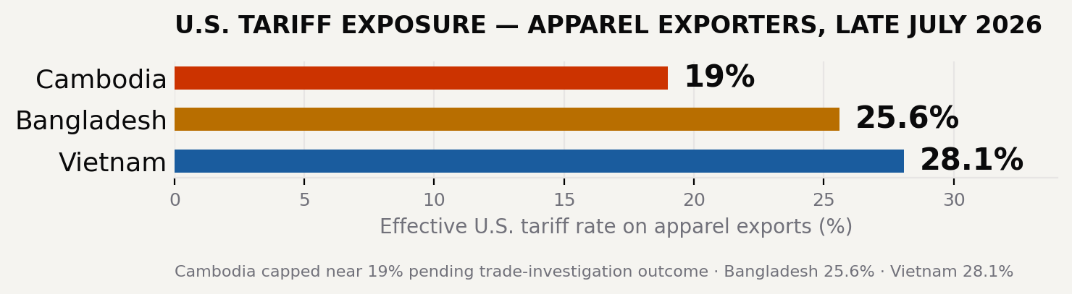
Effective U.S. tariff rate on apparel exports by exporting country, late July 2026
The net effect: Cambodia now sits meaningfully below both Vietnam and Bangladesh on landed tariff cost for the first time in this tariff cycle, a reversal from the IEEPA period when Cambodia (49%) and Vietnam (46%) were both penalized more heavily than Bangladesh (37%). For buyers reallocating orders away from Vietnam, Cambodia is currently the cheaper landed-cost option among the three — a window that is explicitly conditional on the pending U.S. investigation outcome and could close if the cap is breached.

■ IV · DEEP DIVE — BORDER CONFLICT AFTERMATH

Deep Dive — Border Conflict Aftermath
The Cambodia–Thailand border conflict that reignited in May 2025 caused more than 100 deaths and displaced over half a million civilians before a ceasefire was signed on 27 December 2025. Fighting in the second half of 2025 closed land crossings that had handled an estimated $5.6 billion in trade, forcing a rapid — but incomplete — pivot in Cambodia's logistics and fuel-supply routing.
The economic scar tissue is proving more durable than the conflict itself. Thailand's Labour Ministry has moved since March 2026 to admit no new Cambodian laborers, cutting off a cross-border workforce and remittance channel that Cambodian households have relied on for years, and pushing some returnees into informal, lower-security work at home. Independent assessments expect Cambodia's economy to have absorbed the shock without a structural break — growth around 5% during the worst of the conflict — but conclude the border relationship will continue to weigh on both economies well beyond the ceasefire date.
■ Trade routes: land-crossing normalization remains partial as of mid-2026; overland logistics planning should build in contingency capacity.
■ Labor market: the closure of new Thai labor admissions increases domestic labor supply pressure — a tailwind for garment-sector hiring, a headwind for wage restraint.
■ Remittances: reduced outbound labor flow to Thailand is a direct hit to rural household income and consumption capacity.
■ V · REGIONAL COMPARISON

Regional Comparison
Cambodia against its two nearest apparel-sourcing rivals on the dimensions most likely to move a 2026 sourcing or site decision.
Dimension | Cambodia | Bangladesh | Vietnam
US tariff (late Jul 2026) | ~19% (capped, pending) | 25.6% | 28.1%
2026 minimum wage (garment) | $210/month | Lower base, rising | Higher base than KH
Primary export exposure | Cotton apparel, travel goods | Cotton apparel (~2/3 of exports) | MMF-driven apparel
2026 GDP growth (est.) | 3.9–4.0% | Regional peer range | Regional peer range
Largest FDI source | China (46.8% of Q1 2026) | Mixed | Mixed / China-adjacent

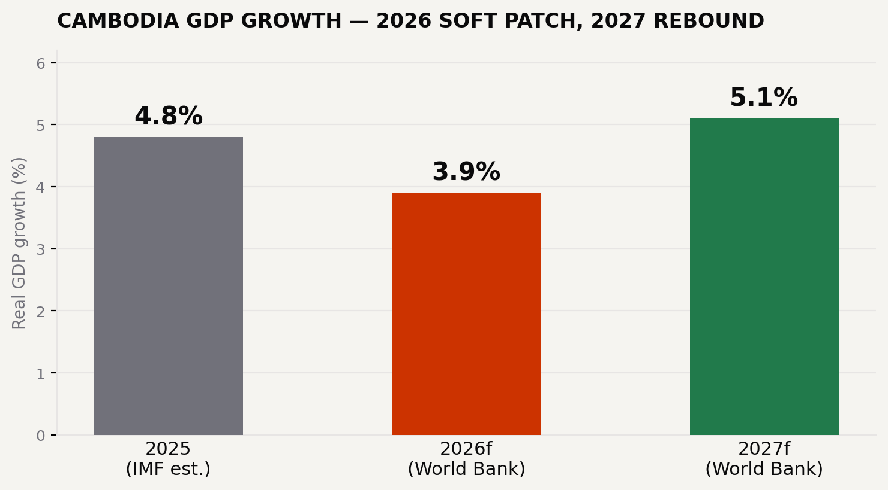
Cambodia real GDP growth, 2025 actual estimate to 2027 forecast — IMF / World Bank

■ VI · RISK EXPOSURE RATINGS

Risk Exposure Ratings
Qualitative exposure scoring (1 = low, 5 = high) for the external factors most likely to move a 2026 investment decision, based on the evidence in this brief.
Tariff / trade-policy risk (contingent on U.S. investigation outcome) ●●●○○
Cross-border conflict / logistics risk (Thailand corridor) ●●●○○
Currency / FX risk (riel stable, managed float) ●○○○○
Climate / flood risk (Mekong basin exposure) ●●●○○
China-investment concentration risk ●●●○○
Labor cost / wage-pressure risk ●●○○○
■ VII · IMPLICATIONS & RECOMMENDATION

Implications & Recommendation
For export-oriented manufacturing tenants, Cambodia's relative tariff advantage over Vietnam and Bangladesh is real but time-limited and conditional — it should be treated as a 12–18 month window rather than a structural repositioning, given it depends on the outcome of an active U.S. trade investigation. For investors weighing SEZ or industrial-park commitments, the border-conflict aftermath argues for logistics diversification (avoid single-corridor dependence on Thailand-linked routes) and for underwriting labor-cost inflation into 2027 wage negotiations rather than assuming the modest 2026 increase holds.
Move on Cambodia's tariff window now, but structure the commitment around 2027 wage-reset risk and Thailand-corridor logistics contingency — not around the tariff cap holding indefinitely.
China's outsized and growing share of both FDI and trade is the factor most likely to shape Cambodia's medium-term trajectory regardless of what Washington or Brussels decide next — any 2026 external-factors view that does not explicitly account for Beijing's investment cycle is incomplete.

■ VIII · SOURCES & DISCLAIMER

Sources & Disclaimer
■ DFDL — U.S. Tariff Increase on Cambodian Garments: Key Implications
■ Apparel Views / Global Textile Times — Cambodia secures US duty-free textile TRQ
■ Pham Fashion House — Vietnam Apparel Tariffs 2026
■ The Daily Star — US again imposes 10% tariff on Bangladesh
■ European Commission / KAS — EU trade relations with Cambodia, EBA status
■ Cambodia Investment Review — China biggest investor in Cambodia in Q1 2026
■ Khmer Times — Cambodia, China reaffirm economic cooperation
■ ISEAS Perspective 2026/35 — Cambodia's Economy before and after the 2025 Border Conflict
■ FULCRUM — The Economic Fallout from the Thailand-Cambodia Border Conflict
■ Fibre2Fashion — Cambodia raises 2026 monthly minimum wage to $210
■ Khmer Times — WB moderates Cambodia's 2026 GDP growth forecast to 3.9%
■ Cambodia Investment Review — Cambodia GDP Growth to Slow to 4.8% in 2025 and 4.0% in 2026 (IMF)
■ Cambodianess — De-Dollarization Back on the Agenda as Cambodia Promotes Riel Use
■ Kampucheathmey Daily — Cambodia pushes urgent Commercial Code reform as exports climb 19% in early 2026
■ Mekong River Commission / ScienceDirect — Flood and drought impacts, Lower Mekong Basin
AI-assisted research. External-factor assessments reflect public information available as of August 2026 and can change quickly — trade-policy caps, wage settlements, and border-corridor status in particular are subject to near-term revision. Verify all information independently before making investment or policy decisions.

