 THE GENTRY LAB
RESEARCH REPORT
Cambodia SEZ Landscape 2026
Special Economic Zones, Trade Preferences, and the Investment Outlook
INVESTMENT RESEARCH · REF: TGL-RPT-2026-01 · July 11, 2026

Prepared by The Gentry Lab Research Desk
32 / 71  SEZS OPERATIONAL / APPROVED | $15.5B  2025 EXPORT VALUE (+15.7%) | $10B  2025 APPROVED INVESTMENT (+45%) | 10%  US TARIFF — EXPIRES JUL 24, 2026

Contents
I Executive Summary
II Background
III Methodology
IV Findings & Analysis
V Risks & Considerations
VI Recommendation
VII Sources & Disclaimer

■ I · EXECUTIVE SUMMARY

Executive Summary
Cambodia's Special Economic Zone network scaled through 2025 into 2026: 32 zones are now operational across nine provinces, out of 71 total SEZs recorded since the program's inception, and the Council for the Development of Cambodia (CDC) approved a record $10 billion in fixed-asset investment last year — up 45% on 2024 — while garment, footwear, and travel-goods exports reached $15.5 billion, up 15.7%.
The investment case, however, no longer rests on cost and trade preference alone. Two preference shocks now converge on the same zones: a US tariff regime that swung from a threatened 49% to a negotiated 19% to a current 10% baseline within twelve months and resets again on July 24, 2026, and a scheduled loss of EU Everything But Arms access as Cambodia graduates from Least Developed Country status in 2026–27.
Treat 2026 as a diversification and negotiation window, not a steady state.

■ II · BACKGROUND

Background
This report was compiled to answer a question recurring across Gentry Lab client conversations in mid-2026: is Cambodia's SEZ investment case still intact after a year of US tariff volatility? It consolidates the current state of Cambodia's zone network, the capital flowing into it, and the trade-policy variables most likely to affect returns over the next 12–24 months.
■ III · METHODOLOGY

Methodology
Figures are drawn from CDC and Cambodian Special Economic Zone Board (CSEZB) releases, Cambodia's Ministry of Commerce export statistics, official USTR announcements and Section 122/301 tariff actions, EU DG TRADE GSP/EBA documentation, and Cambodian and international press reporting — all cited in Sources & Disclaimer.
Zone-level suitability scores shown in Section IV are The Gentry Lab's own proprietary Site Inspector methodology, shown for comparison only — not an official government ranking. Tariff and trade-preference figures are a snapshot as of this report's publication date and are explicitly time-stamped below, given how quickly they have moved over the past year.

■ IV · FINDINGS & ANALYSIS

Findings & Analysis

Zone landscape and concentration
Cambodia's 32 operational SEZs sit across nine of the country's 25 provinces, with the pipeline running far ahead of delivery — 71 zones have been gazetted or approved in total, meaning fewer than half of all designated SEZs are actually running. Investment and infrastructure concentrate around three clusters: Phnom Penh / Kandal, anchored by Phnom Penh SEZ; the Bavet border cluster (Manhattan SVS, Tai Seng Bavet, Polo Bavet), positioned on the NR1 corridor for Vietnam-adjacent logistics; and Sihanoukville, anchored by the deep-water Sihanoukville Autonomous Port.
A gap this wide between gazetted and operational status means a zone's presence on the CSEZB registry is not proof it is investment-ready — verify grid connection, wastewater capacity, and road access at the specific zone, not the province.
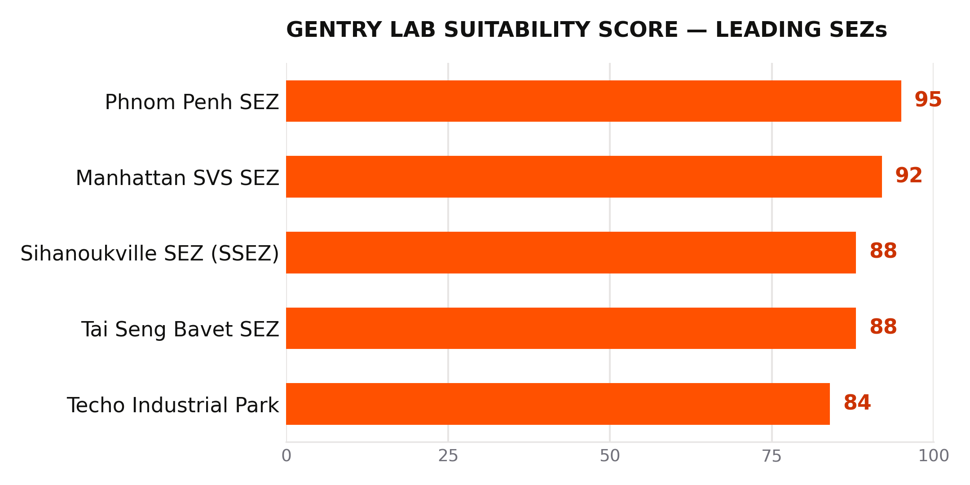
The Gentry Lab Site Inspector — proprietary scoring, not an official ranking

Capital flows
CDC approved 630 investment projects worth $10 billion in 2025 — a 45% jump in value and a 52% jump in project count over 2024's 414 — generating an estimated 438,000 jobs. Garment and non-garment manufacturing, infrastructure, agriculture/agro-industry, and tourism drew the bulk of approvals. SEZ-located projects have consistently made up roughly a third to two-fifths of new approvals in months with published detail (36 of 83 projects in June 2025; 11 of 29 in October 2025), with China accounting for more than half of total approved investment value — a concentration that ties zone occupancy more closely to Chinese outbound investment policy than most tenants may appreciate. Momentum has continued into 2026: CDC approved a further $2.6 billion in the first four months of the year.

Export performance
Garments, footwear, and travel goods — together roughly half of Cambodia's total export value — reached $15.5 billion in 2025, up 15.7% year-on-year, produced across more than 1,682 registered factories employing over 900,000 workers, most of them women. Footwear grew fastest (+24.5%), garments carried the volume ($11.4B, +16.5%), and travel goods grew more modestly (+3.8%) — early evidence that Cambodia's manufacturing base, while still garment-led, is diversifying at the margin.
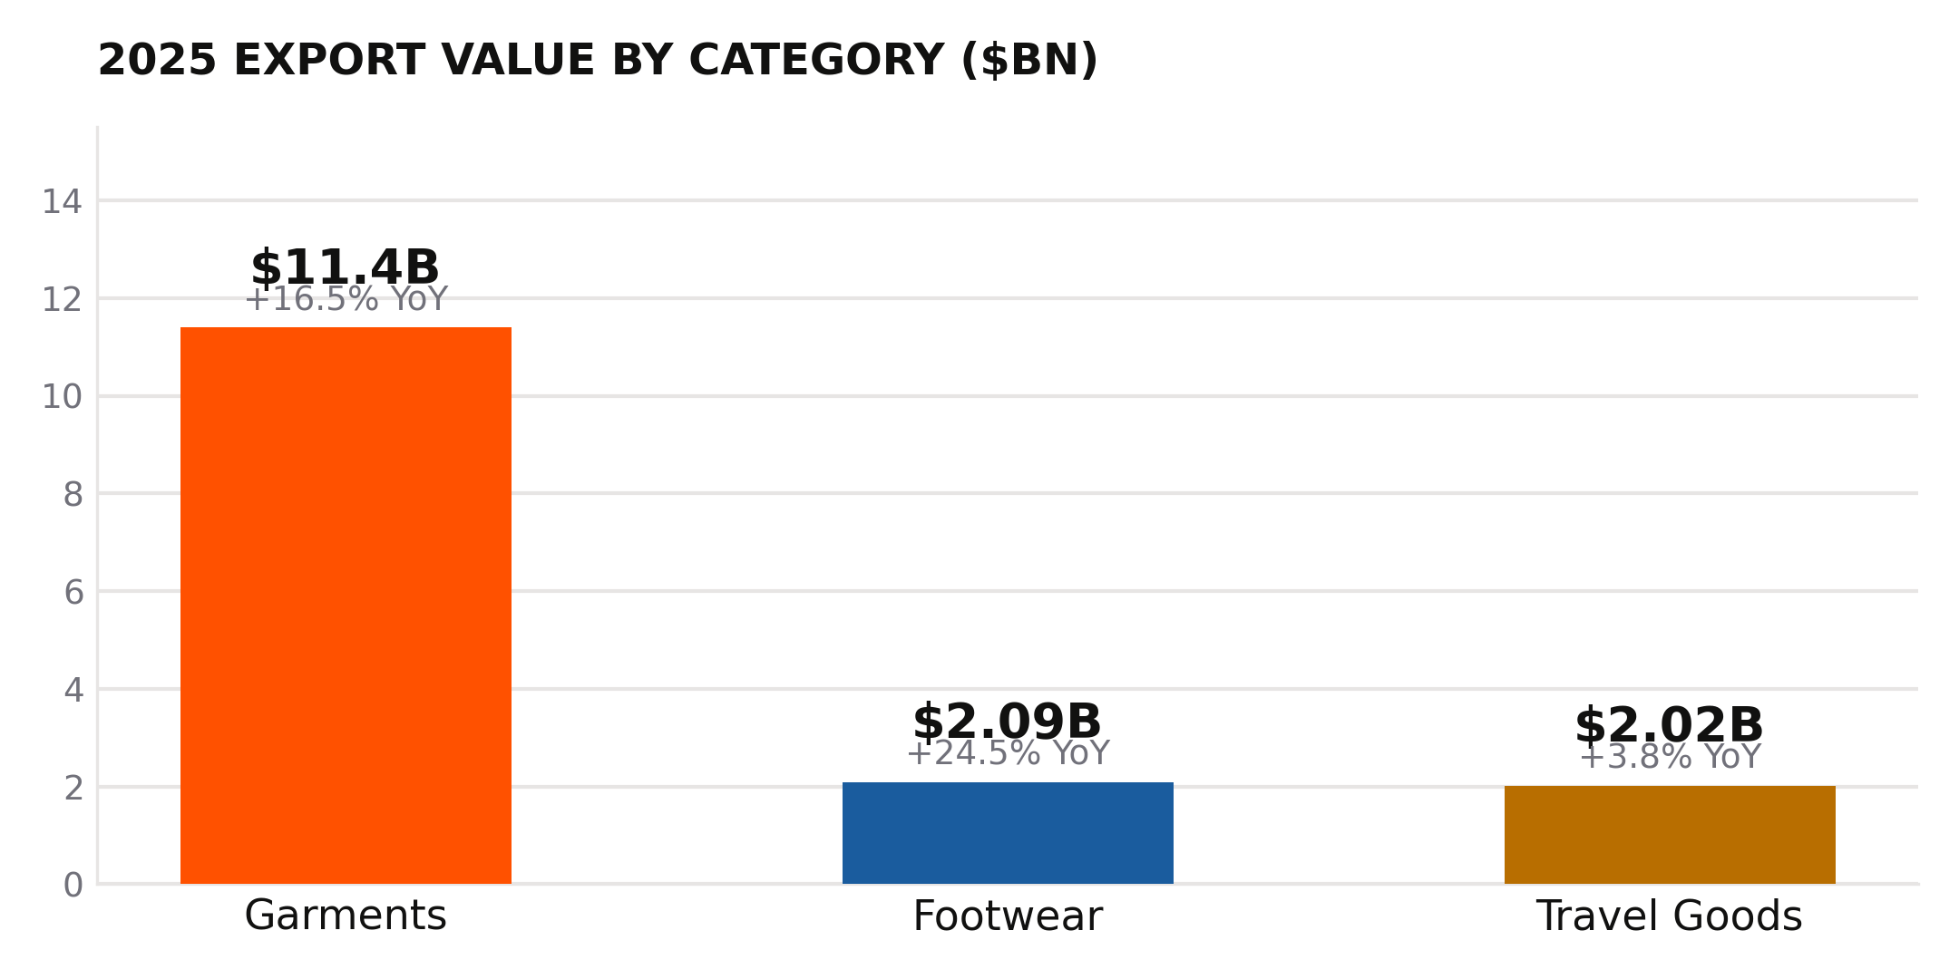
Source: Cambodia Ministry of Commerce, via Xinhua / Cambodia Investment Review, Jan 2026

The trade-preference squeeze
Two separate mechanisms are compressing Cambodia's preferential market access at the same time. On the US side, the tariff rate applied to Cambodian exports has been unusually volatile: an April 2025 “reciprocal tariff” announcement threatened rates as high as 49%, negotiations brought that down to a flat 19% by August 2025, and a February 20, 2026 US Supreme Court ruling striking down country-specific reciprocal surcharges left Cambodia on a 10% Section 122 baseline — which itself expires July 24, 2026, with USTR having proposed a 12.5% Section 301 duty across 46 countries, Cambodia among them, as the likely replacement.
On the EU side, Cambodia's duty-free Everything But Arms access — already partially withdrawn since 2020 over human rights findings — is scheduled to end entirely once Cambodia graduates from Least Developed Country status, expected in 2026–27. Neither shock is hypothetical, and both land inside the same 12–18 month window that most SEZ tenancy and financing decisions are made against.
Cambodia's SEZ case has shifted from “lowest-cost, preference-backed” to “competitively-costed, preference-uncertain.” The diligence question for 2026 is not whether to build here — it's how exposed a given supply chain is to a tariff reset on July 24.

■ V · RISKS & CONSIDERATIONS

Risks & Considerations
■ US tariff reset, July 24, 2026 — the current 10% Section 122 baseline expires on this date; USTR's proposed 12.5% Section 301 replacement is not yet finalized. Model both outcomes, not just the current rate.
■ EU LDC graduation — Everything But Arms access is structurally, not cyclically, at risk as Cambodia's graduation date is confirmed for 2026–27; don't assume today's duty-free terms hold through a facility's full investment horizon.
■ Zone pipeline overhang — 71 approved SEZs vs. 32 operational means gazetted status is not a proxy for infrastructure readiness.
■ Investment concentration — China represents over half of approved FDI value; bilateral or geopolitical shifts would disproportionately affect zone occupancy and secondary-market rents.
■ Labor cost drift — the 2026 garment-sector minimum wage rose to $210/month base ($227–238 with standard benefits), up from $208 in 2025; still regionally competitive, but a rising baseline worth tracking against Vietnam and Bangladesh.
■ VI · RECOMMENDATION

Recommendation
Prioritize SEZs and tenants with diversified, non-US/non-EU offtake or enough margin to absorb a tariff reset — and re-underwrite any Cambodia investment case after July 24, 2026, and again once Cambodia's LDC graduation date is formally confirmed.

■ VII · SOURCES & DISCLAIMER

Sources & Disclaimer
■ CDC / CSEZB — SEZ Smart Search
■ US Department of State — 2025 Investment Climate Statement: Cambodia
■ Khmer Times — Cambodia approves 630 investment projects worth $10 bln in 2025
■ AKP — CDC Approves Investment Projects Worth US$2.6 Billion in First Four Months of 2026
■ Cambodia Investment Review — Garment, Footwear and Travel Goods Exports Hit $15.5B in 2025
■ Xinhua — Cambodia makes 15.5 bln USD from exports of garments, shoes, travel goods in 2025
■ USTR — Fact Sheet: US and Cambodia Reach Agreement on Reciprocal Trade
■ Reuters (via Investing.com) — Cambodia deputy PM says 19% US tariff rate averts collapse of garments sector
■ DFDL — US Tariff Increase on Cambodian Garments: Key Implications and Strategic Considerations
■ European Commission — Everything But Arms (EBA)
■ Xinhua — Cambodia raises monthly minimum wage for garment industry to $210 for 2026
Zone suitability scores are The Gentry Lab's own proprietary Site Inspector methodology, not an official government ranking. All other figures are sourced to the releases above and are current as of this report's publication date — verify against primary sources before making investment decisions. AI-assisted research.

