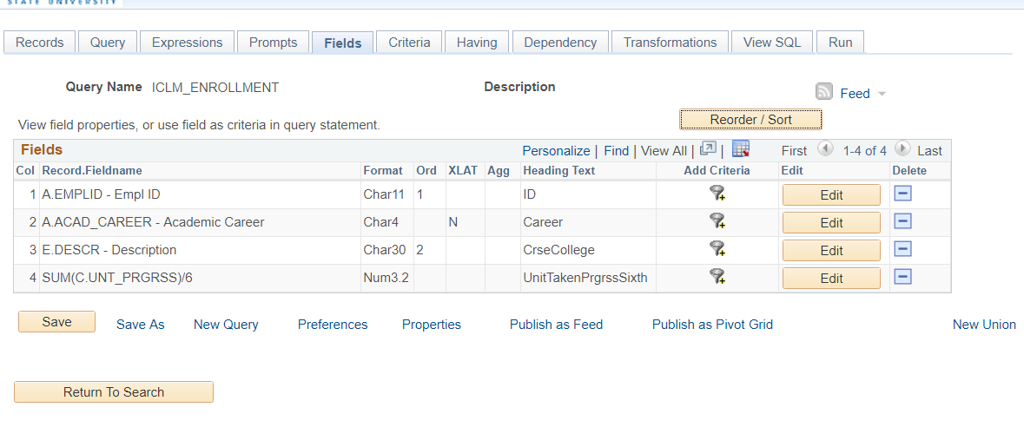

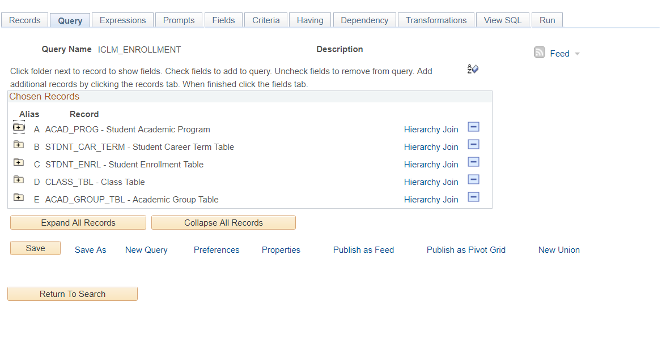

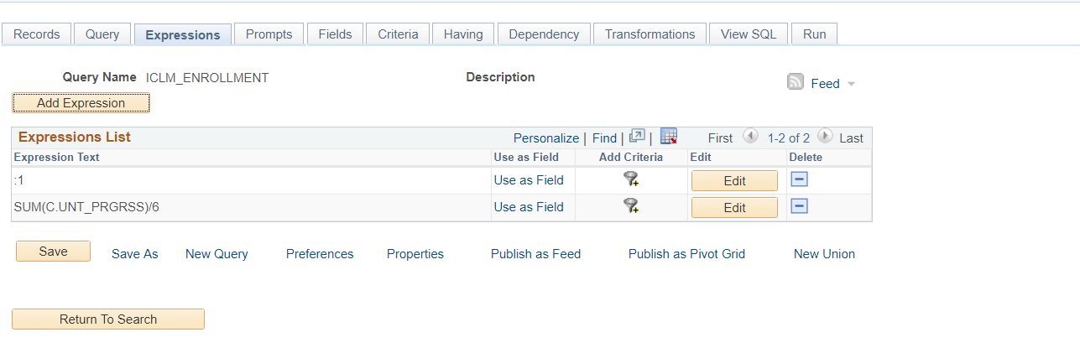

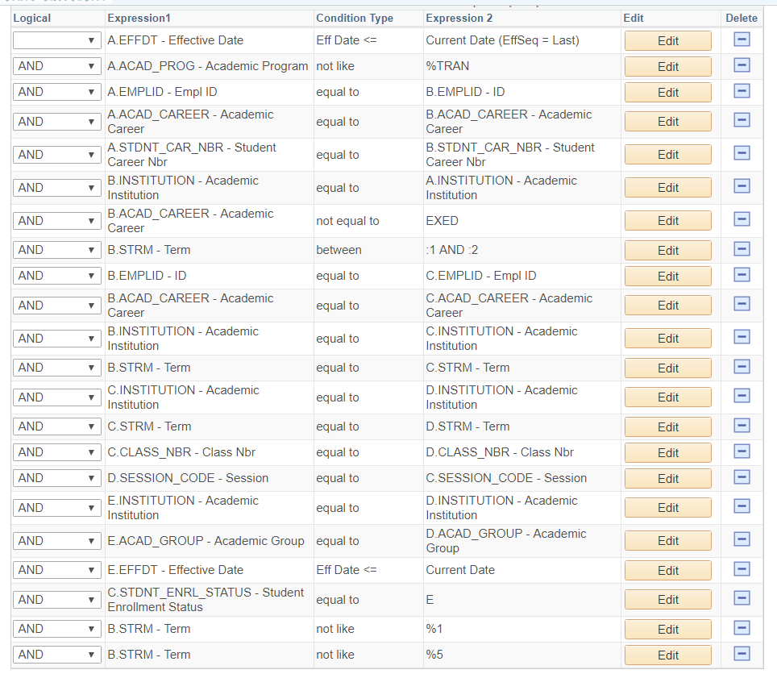

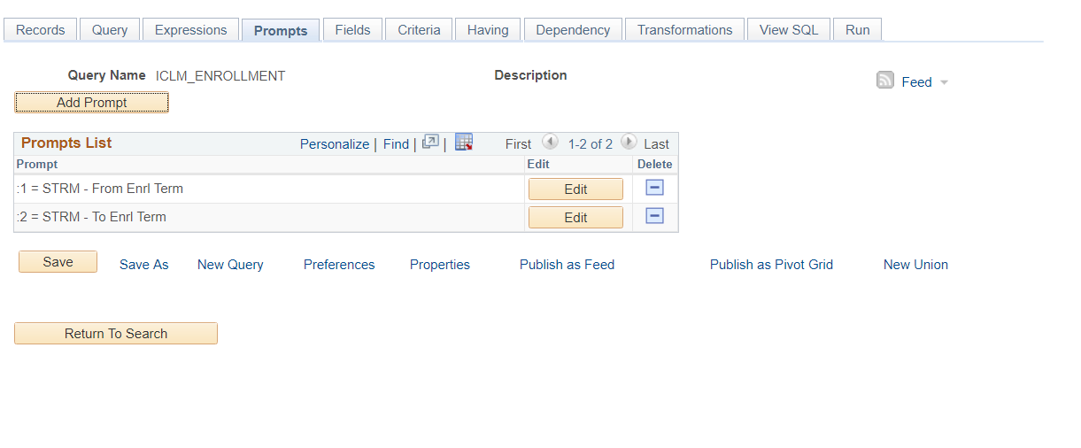

|  |  |
| --- | --- |
| **Query SQL** | |
|  | SELECT A.EMPLID, A.ACAD_CAREER, E.DESCR, SUM( C.UNT_PRGRSS)/6    FROM PS_ACAD_PROG A, PS_STDNT_CAR_TERM B, PS_STDNT_ENRL C, PS_CLASS_TBL D, PS_ACAD_GROUP_TBL E    WHERE ( A.EFFDT =          (SELECT MAX(A_ED.EFFDT) FROM PS_ACAD_PROG A_ED          WHERE A.EMPLID = A_ED.EMPLID            AND A.ACAD_CAREER = A_ED.ACAD_CAREER            AND A.STDNT_CAR_NBR = A_ED.STDNT_CAR_NBR            AND A_ED.EFFDT <= SYSDATE)      AND A.EFFSEQ =          (SELECT MAX(A_ES.EFFSEQ) FROM PS_ACAD_PROG A_ES          WHERE A.EMPLID = A_ES.EMPLID            AND A.ACAD_CAREER = A_ES.ACAD_CAREER            AND A.STDNT_CAR_NBR = A_ES.STDNT_CAR_NBR            AND A.EFFDT = A_ES.EFFDT)       AND A.ACAD_PROG NOT LIKE '%TRAN'       AND A.EMPLID = B.EMPLID       AND A.ACAD_CAREER = B.ACAD_CAREER       AND A.STDNT_CAR_NBR = B.STDNT_CAR_NBR       AND B.INSTITUTION = A.INSTITUTION       AND B.ACAD_CAREER <> 'EXED'       AND B.STRM BETWEEN :1 AND :2       AND B.EMPLID = C.EMPLID       AND B.ACAD_CAREER = C.ACAD_CAREER       AND B.INSTITUTION = C.INSTITUTION       AND B.STRM = C.STRM       AND C.INSTITUTION = D.INSTITUTION       AND C.STRM = D.STRM       AND C.CLASS_NBR = D.CLASS_NBR       AND D.SESSION_CODE = C.SESSION_CODE       AND E.INSTITUTION = D.INSTITUTION       AND E.ACAD_GROUP = D.ACAD_GROUP       AND E.EFFDT =          (SELECT MAX(E_ED.EFFDT) FROM PS_ACAD_GROUP_TBL E_ED          WHERE E.INSTITUTION = E_ED.INSTITUTION            AND E.ACAD_GROUP = E_ED.ACAD_GROUP            AND E_ED.EFFDT <= SYSDATE)       AND C.STDNT_ENRL_STATUS = 'E'       AND B.STRM NOT LIKE '%1'       AND B.STRM NOT LIKE '%5')    GROUP BY  A.EMPLID,  A.ACAD_CAREER,  E.DESCR    ORDER BY 1, 3 | |