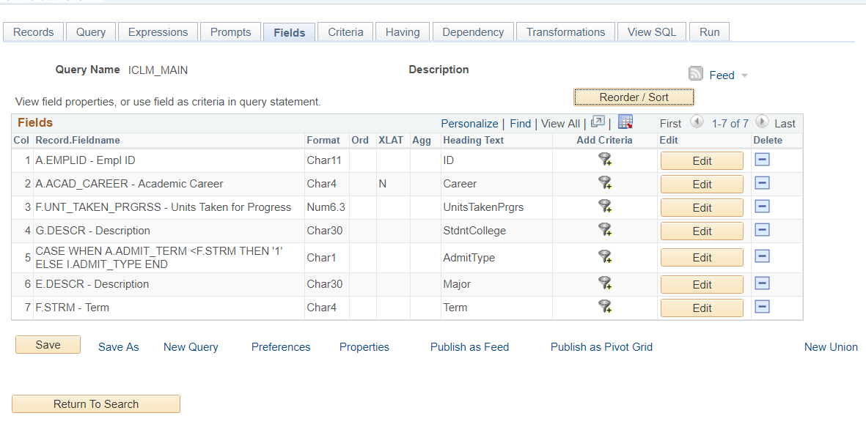

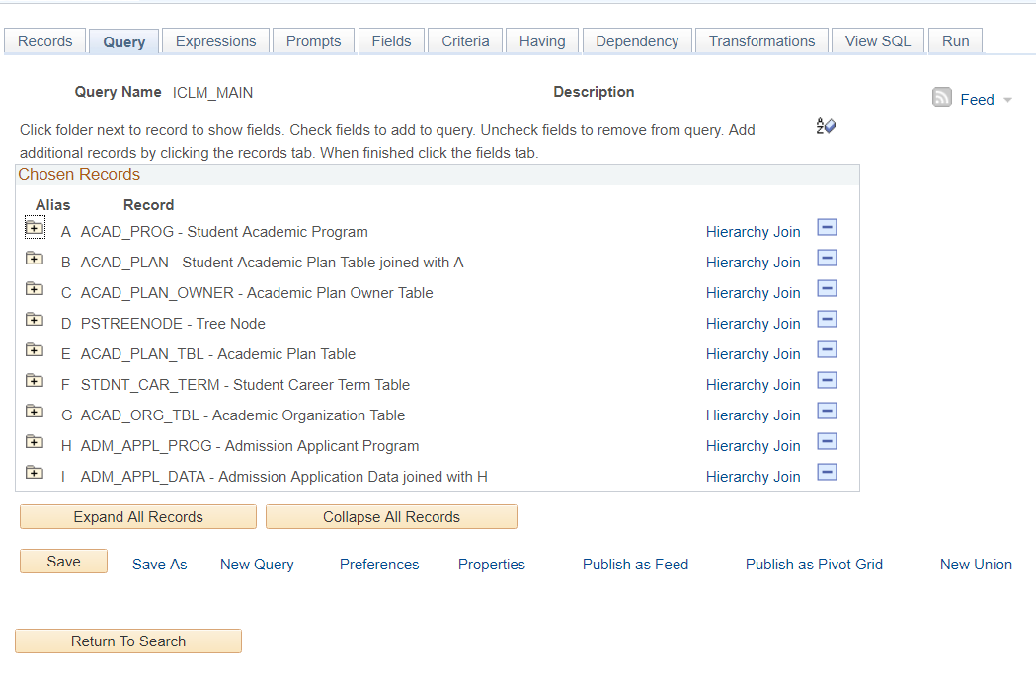

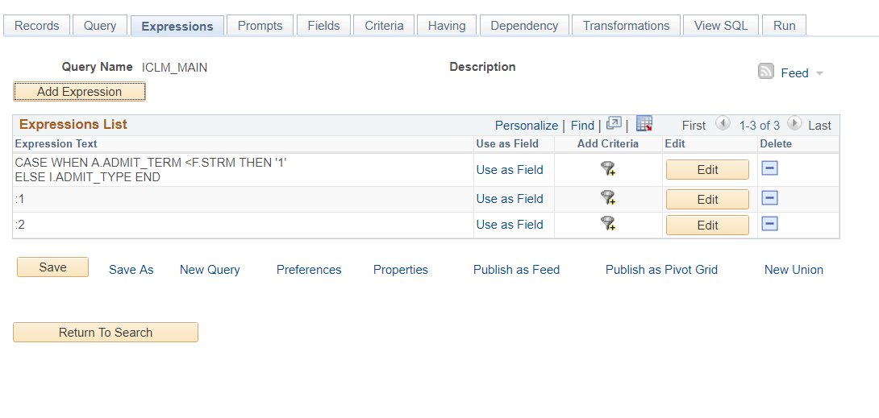

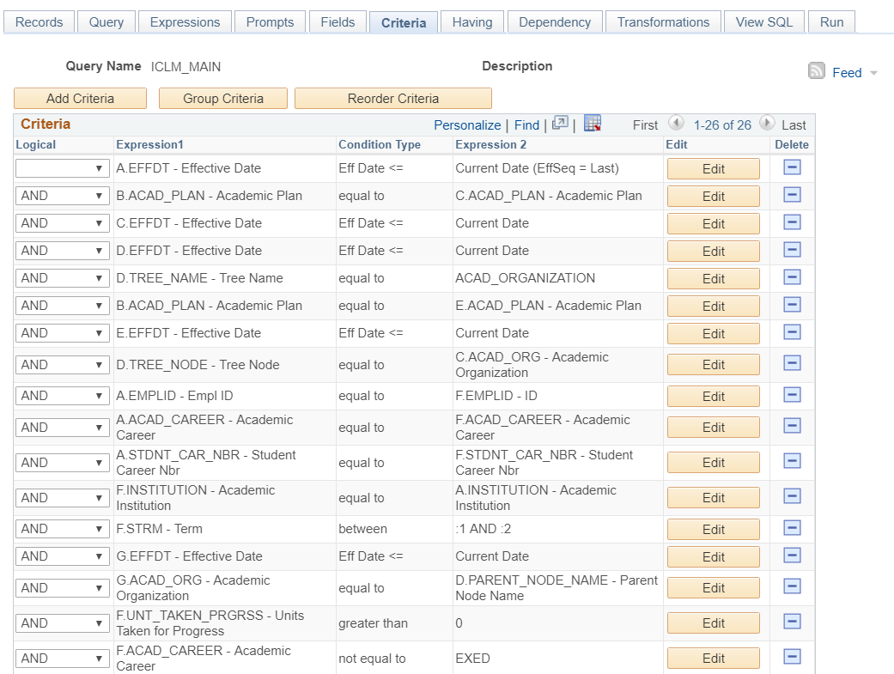

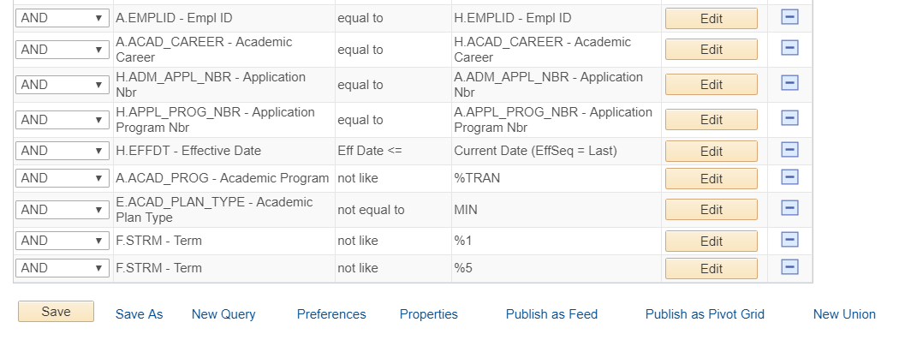

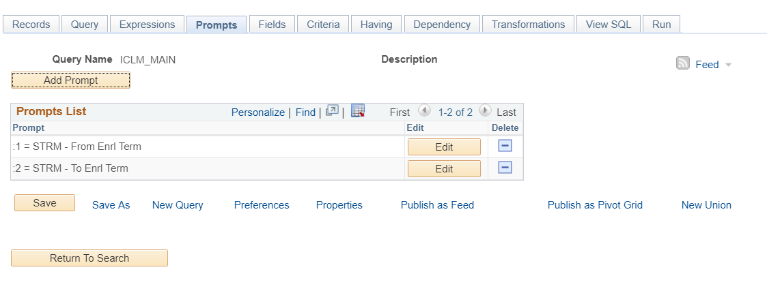

|  |  |  |
| --- | --- | --- |
|  | | |
|  | **Query SQL** | | |
|  | | SELECT DISTINCT A.EMPLID, A.ACAD_CAREER, F.UNT_TAKEN_PRGRSS, G.DESCR, CASE WHEN  A.ADMIT_TERM <F.STRM THEN '1' ELSE  I.ADMIT_TYPE END, E.DESCR, F.STRM    FROM PS_ACAD_PROG A, PS_ACAD_PLAN B, PS_ACAD_PLAN_OWNER C, PSTREENODE D, PS_ACAD_PLAN_TBL E,  PS_STDNT_CAR_TERM F, PS_ACAD_ORG_TBL G, PS_ADM_APPL_PROG H, PS_ADM_MAINT_SCTY H1, PS_ADM_APPL_DATA I,  PS_ADM_APPL_SCTY I1    WHERE ( B.EMPLID = A.EMPLID      AND B.ACAD_CAREER = A.ACAD_CAREER      AND B.STDNT_CAR_NBR = A.STDNT_CAR_NBR      AND B.EFFDT = A.EFFDT      AND B.EFFSEQ = A.EFFSEQ      AND I.EMPLID = H.EMPLID      AND I.ACAD_CAREER = H.ACAD_CAREER      AND I.STDNT_CAR_NBR = H.STDNT_CAR_NBR      AND I.ADM_APPL_NBR = H.ADM_APPL_NBR      AND H.EMPLID = H1.EMPLID      AND H.ACAD_CAREER = H1.ACAD_CAREER      AND H.STDNT_CAR_NBR = H1.STDNT_CAR_NBR      AND H.ADM_APPL_NBR = H1.ADM_APPL_NBR      AND H.APPL_PROG_NBR = H1.APPL_PROG_NBR      AND H1.OPRCLASS = 'PPSONOMA'      AND H1.OPRID = 'MCGOWANR'      AND I.EMPLID = I1.EMPLID      AND I.ACAD_CAREER = I1.ACAD_CAREER      AND I.ADM_APPL_NBR = I1.ADM_APPL_NBR      AND I1.OPRCLASS = 'PPSONOMA'      AND I1.OPRID = 'MCGOWANR'      AND ( A.EFFDT =          (SELECT MAX(A_ED.EFFDT) FROM PS_ACAD_PROG A_ED          WHERE A.EMPLID = A_ED.EMPLID            AND A.ACAD_CAREER = A_ED.ACAD_CAREER            AND A.STDNT_CAR_NBR = A_ED.STDNT_CAR_NBR            AND A_ED.EFFDT <= SYSDATE)      AND A.EFFSEQ =          (SELECT MAX(A_ES.EFFSEQ) FROM PS_ACAD_PROG A_ES          WHERE A.EMPLID = A_ES.EMPLID            AND A.ACAD_CAREER = A_ES.ACAD_CAREER            AND A.STDNT_CAR_NBR = A_ES.STDNT_CAR_NBR            AND A.EFFDT = A_ES.EFFDT)       AND B.ACAD_PLAN = C.ACAD_PLAN       AND C.EFFDT =          (SELECT MAX(C_ED.EFFDT) FROM PS_ACAD_PLAN_OWNER C_ED          WHERE C.INSTITUTION = C_ED.INSTITUTION            AND C.ACAD_PLAN = C_ED.ACAD_PLAN            AND C_ED.EFFDT <= SYSDATE)       AND D.EFFDT =          (SELECT MAX(D_ED.EFFDT) FROM PSTREENODE D_ED          WHERE D.SETID = D_ED.SETID            AND D.SETCNTRLVALUE = D_ED.SETCNTRLVALUE            AND D.TREE_NAME = D_ED.TREE_NAME            AND D_ED.EFFDT <= SYSDATE)       AND D.TREE_NAME = 'ACAD_ORGANIZATION'       AND B.ACAD_PLAN = E.ACAD_PLAN       AND E.EFFDT =          (SELECT MAX(E_ED.EFFDT) FROM PS_ACAD_PLAN_TBL E_ED          WHERE E.INSTITUTION = E_ED.INSTITUTION            AND E.ACAD_PLAN = E_ED.ACAD_PLAN            AND E_ED.EFFDT <= SYSDATE)       AND D.TREE_NODE = C.ACAD_ORG       AND A.EMPLID = F.EMPLID       AND A.ACAD_CAREER = F.ACAD_CAREER       AND A.STDNT_CAR_NBR = F.STDNT_CAR_NBR       AND F.INSTITUTION = A.INSTITUTION       AND F.STRM BETWEEN :1 AND :2       AND G.EFFDT =          (SELECT MAX(G_ED.EFFDT) FROM PS_ACAD_ORG_TBL G_ED          WHERE G.ACAD_ORG = G_ED.ACAD_ORG            AND G_ED.EFFDT <= SYSDATE)       AND G.ACAD_ORG = D.PARENT_NODE_NAME       AND F.UNT_TAKEN_PRGRSS > 0       AND F.ACAD_CAREER <> 'EXED'       AND A.EMPLID = H.EMPLID       AND A.ACAD_CAREER = H.ACAD_CAREER       AND H.ADM_APPL_NBR = A.ADM_APPL_NBR       AND H.APPL_PROG_NBR = A.APPL_PROG_NBR       AND H.EFFDT =          (SELECT MAX(H_ED.EFFDT) FROM PS_ADM_APPL_PROG H_ED          WHERE H.EMPLID = H_ED.EMPLID            AND H.ACAD_CAREER = H_ED.ACAD_CAREER            AND H.STDNT_CAR_NBR = H_ED.STDNT_CAR_NBR            AND H.ADM_APPL_NBR = H_ED.ADM_APPL_NBR            AND H.APPL_PROG_NBR = H_ED.APPL_PROG_NBR            AND H_ED.EFFDT <= SYSDATE)      AND H.EFFSEQ =          (SELECT MAX(H_ES.EFFSEQ) FROM PS_ADM_APPL_PROG H_ES          WHERE H.EMPLID = H_ES.EMPLID            AND H.ACAD_CAREER = H_ES.ACAD_CAREER            AND H.STDNT_CAR_NBR = H_ES.STDNT_CAR_NBR            AND H.ADM_APPL_NBR = H_ES.ADM_APPL_NBR            AND H.APPL_PROG_NBR = H_ES.APPL_PROG_NBR            AND H.EFFDT = H_ES.EFFDT)       AND A.ACAD_PROG NOT LIKE '%TRAN'       AND E.ACAD_PLAN_TYPE <> 'MIN'       AND F.STRM NOT LIKE '%1'       AND F.STRM NOT LIKE '%5' )) | |