**Program Name: proj1.asm**

**Programmer: Austin Horne**

**Class: CSCI 2160**

**Lab: Proj1**

**Date: September 27, 2012**

**Purpose: To evaluate a set of given mathematical equations expressed in Java**

**notation. The variables are defined in the data segment.**

**Screenshot of problem a)**

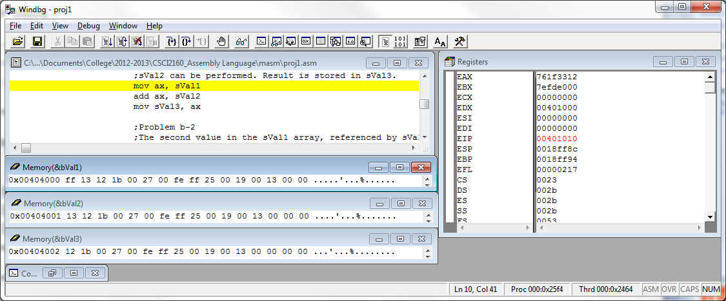

**Screenshot of problem b)**

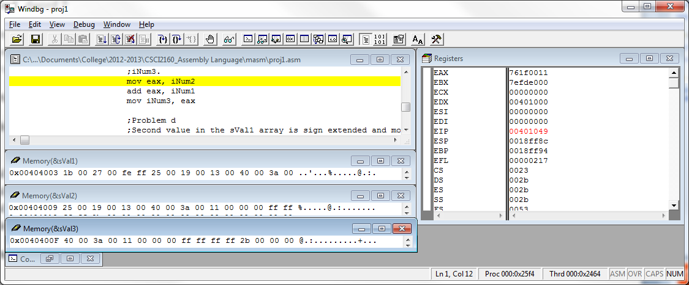

**Screenshot of c)**

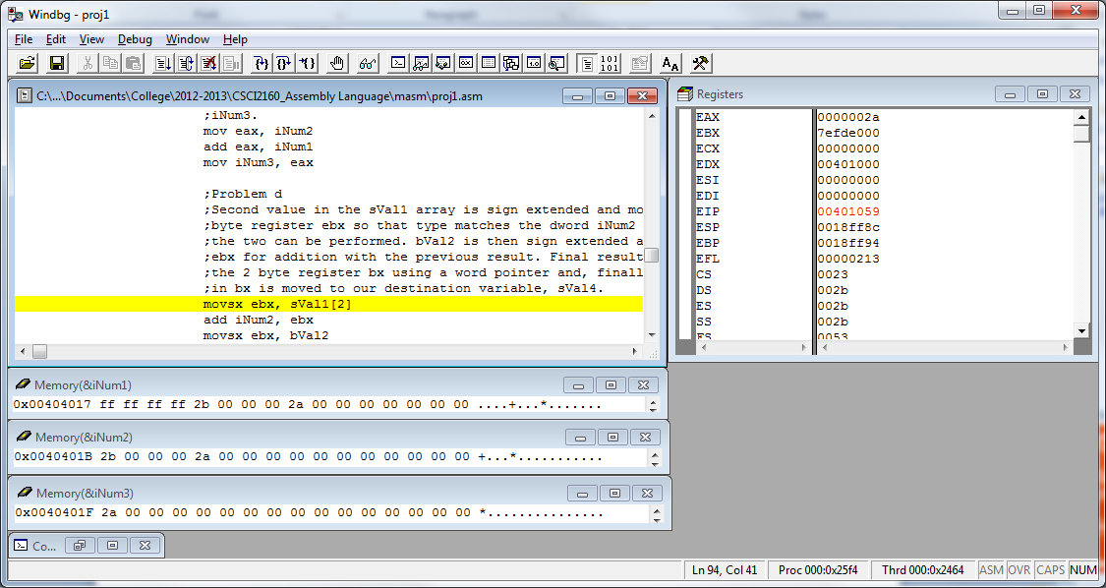

**Screenshot of d)**

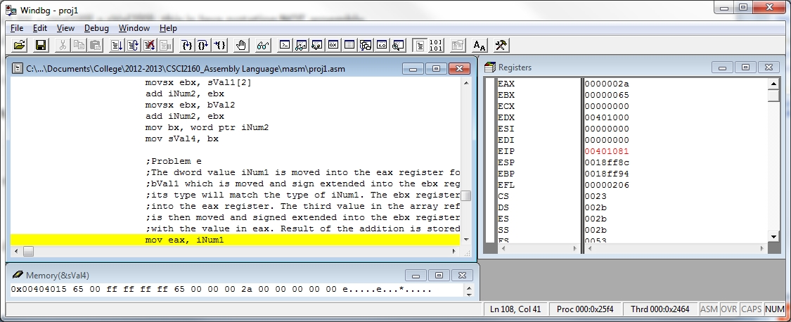

**Screenshot of e)**

