**FIT1050**

**Assignment 3**

**Report**

**Teh Yee Hong 33591938**

**URL**

Redesign:

<https://horngy.github.io/theBloomRoom.github.io/>

Original Website:

<https://www.busybeeflorist.com.au>

<https://web.archive.org/web/20250314145854/https://www.busybeeflorist.com.au/>

**Overview of Site (92 words)**

This website is a redesign project for Busy Bee Florist, a small family-owned flower shop based in Clayton that operates through both physical and online store. They are most known for offering the freshest and highest quality flower to build a loyal customer base.

The redesign website is named as “The Bloom Room”. The primary objective of this redesign is to enhance user experience by improving it’s visual appeal, as well as providing a faster and easier navigation. This ensures that customer can browse through the website comfortably and make purchase easily.

**Target Audience (98 words)**

The target audience for The Bloom Room includes gift buyers for a wide range of occasions, from joyful moments like birthdays, anniversaries and new baby celebrations to more gloomy ones like sympathy and get well wishes. Event planner for weddings and funerals are also part of The Bloom Room’s audience, as the shop does provides customized arrangement. Moreover, the shop also offers reliable and quick deliveries to nearby areas, making it a convenient choice for online shoppers to send or receive flowers conveniently. With its diverse offerings and services, The Bloom Room appeal to a large customer base.

**Information Architecture (167 words)**

The most important information architecture decision the use of a hierarchical organisation structure. The homepage follows a clear and logical layout by having a large brand image that establishes identity. Then followed by the broad category of “Today’s Special” and “Flowers” that leads into more specific content like individual flower products. The “Flowers” section are expandable and collapsible to maintain a clean and minimalist design. It also uses a subjective and inexact organisation scheme by filtering product by occasion, allowing customers to quickly find flowers for specific needs. Then on the lower page, users find the “About Us”, “Contact Info” and a footer for additional site links. At the top level, a navigation bar provides access to key areas like cart and sort by occassions.

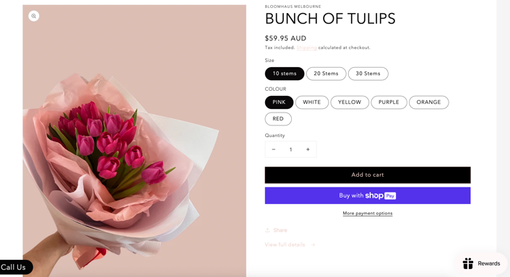This structure reflects Jakob’s Law as it works te same way as other sites they already know. Features like always accessible nagivation bar and a sliding cart panel without redirecting to a new page align with common user experience and enhance usability.

(BLOOMHAUS, 2022)

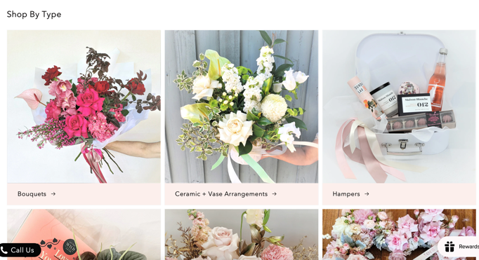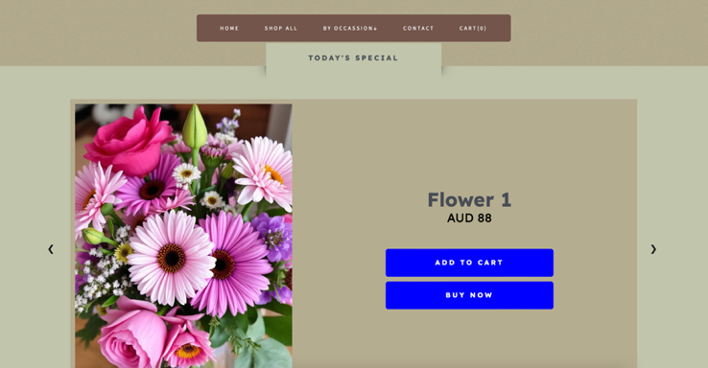

(BLOOMHAUS, 2022)

**Visual Design Style (152 words)**

The most significant visual design decision was having a natural toned background paired with a clean and minimalist layout. The website features a gradient from olive to brown background, with different colour content blocks and brown navigation elements. This design brings a calm, approachable, organic boutique atmosphere that reflects the business’s identity (Leo, 2023).

The redesign also includes large and bold headings, clear and significant buttons, and more than enough whitespace to guide user attentions and reduce visual strain. Fonts family like “Lexend” were also choosen for clarity, avoiding overdecorated and weird styles (Beard, 2023). Key buttons like “Add To Card” and “Buy Now” are extra large and use distinct colour to stand out from the surroundings.

The overall layount and design is clean and predicatable, allowing customers to locate content easily. This choice aims to create an experience that reflects the nature-inspired aesthetic while avoiding unnecessary clutters, giving customers a modern and pleasant browsing experience.

**Image Optimisation (179 words)**

The most important image optimisation decision was choosing an appropraite image format that balances file size and image quality. Initially, I planned to use AV1 Image File Format (AVIF), a modern image file format known for high quality image compression. However, after testing, I discovered that AVIF is not supported by all browsers, including Internet Explorer, which could particularly negatively affect the user experience of customers with such browsers.

As a result, I adopted Web Picture Format (WebP). While it is not as excellent as AVIF, WebP still offers good file size reduction comparing to the older formats like JPEG and PNG (Osmani, 2021). More importantly, WebP also has a wider browser support, which made it a more reliable choice. Image quality and clarity remains the top priority since showcasing flowers is the core of the business, and WebP does present image details without too much degradation.

And to further optimise loading performance, lazy loading was also implemented to only load images required, reducing bandwidth consumption and eanbles faster load time.

This decision does ensure a balance between support, and performance.

**Web Content Accessibility (156 words)**

The most significant web content accessibility decision was emphasizing on text readability and ease of interaction to support a wider range of customers, including those with visual impairments or general accessibility needs.

Readable typography are applied throughout the whole site as clear sans-serif fonts were choosen and overdecorative fonts are intentionally avoided to ensure text remains easy to read. Generous line spacing around text are also applied to prevent visual clutters and reduce strains for customers. Another important consideration was contrast, high contrast against the natural toned background improves readability and supports user with low vision, leading to a cleaner presentation.

For usability, large and clear buttons and navigation link were also implemented to make it easier to use. Alternative text was also added to all images, even though now all alt text are just place holder like “flower1”, they can be changed to their actual flower name to support reader users and improve overall accessibility.

(Monash, 2025)

**JavaScript Interactivity (198 words)**

The most important JavaScript feature implemented centered around a shopping cart system that was not from the original website. Implementing this feature allow users to review and manage their flowers before checkout, making purchases more organized and user friendly. It also encourages user to buy more items at once, increasing transaction value.

When a user clicks to add a product into cart, the addToCart function will be called. It will increase the total item count and update the total price accordingly. Each product with its price will be stored temporarily in an array. While this data is not yet saved in an actual database and it resets upon refreshing the page, it is enough to demonstrate the cart’s functionality.

Then the function will call another function named updateCart that updates the cart content for HTML, listing flowers’ name and price. To improve usability, the cart panel can be closed by using the openOrCloseCart function. When the cart panel is opened, a semi opaque black screen will be behind the cart panel, clicking it will close the cart. This does enhance overall user experience by providing another way to exit the cart view apart from the continue shopping button.

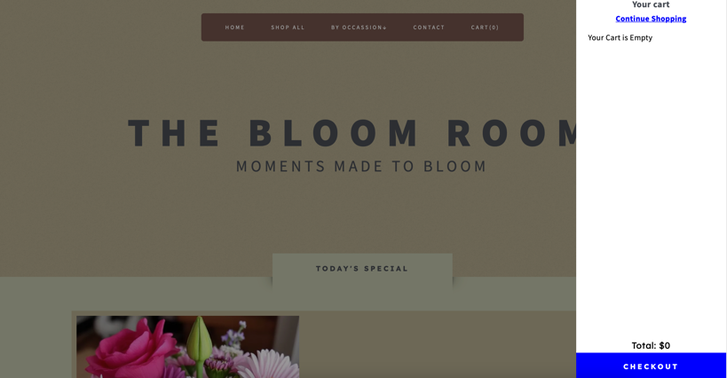

(Apple, 2024)

All ai images are from pixlr, 2024. They are being cited separately in my HTML code.

Additional references are also cited in HTML code.

**References**

Apple. (2024). *Apple Store Online*. Apple. <https://www.apple.com/store>

Beard, M. (2023, April 28). *Why we use the dyslexia-friendly font, Lexend*. Tinknstink.co.uk; tink n stink. <https://www.tinknstink.co.uk/blog/why-we-use-the-dyslexia-friendly-font-lexend>

*BLOOMHAUS*. (2022, August 16). BLOOMHAUS MELBOURNE. <https://www.bloomhaus.com.au>

*Embedding a map | Maps Embed API*. (n.d.). Google Developers. <https://developers.google.com/maps/documentation/embed/embedding-map>

Leo, C. W. (2023, September 21). *What is considered a natural color?* Color with Leo. <https://www.colorwithleo.com/what-is-considered-a-natural-color/>

Monash University. (2025). *Web content accessibility* [PowerPoint slides]. FIT1050 Web Fundamentals, Week 8. Monash University.

Osmani, A. (2021, September 29). *Using Modern Image Formats: AVIF And WebP*. Smashing Magazine. <https://www.smashingmagazine.com/2021/09/modern-image-formats-avif-webp/>

*Palette - Coolors*. (2025). Coolors.co. <https://coolors.co/palette/edc4b3-e6b8a2-deab90-d69f7e-cd9777-c38e70-b07d62-9d6b53-8a5a44-774936>

pixlr. (2024). *AI Image Generator: Turn Text to Images, art generative photo*. Pixlr. <https://pixlr.com/image-generator/>

*PNG to WEBP*. (2025, April 10). Cloudinary. https://cloudinary.com/tools/png-to-webp