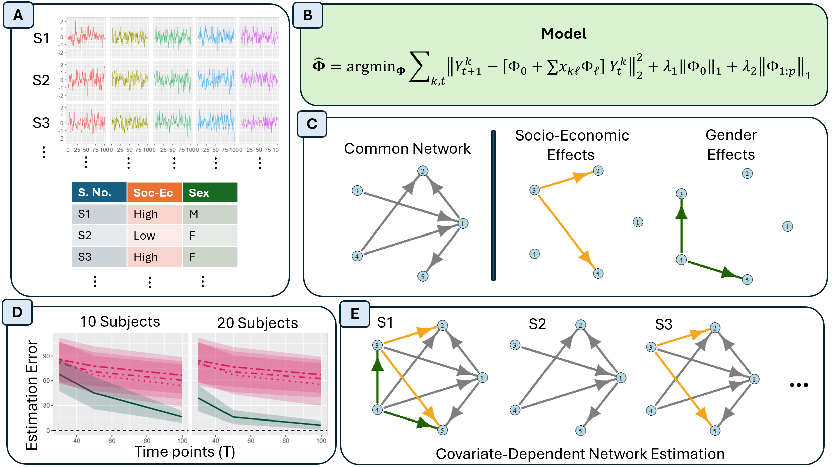
Figure 1: Visualization of the Covariate-Dependent Vector Auto-Regression (CD-VAR) model. (A) We analyze longitudinal measures of variables (e.g., depression, anxiety, sleep quality) for each subject in the study, as well as their subject-level features. (B) Equations for the covariate dependent network model. The network estimation is performed through a penalized framework. (C) Output of the CD-VAR model: a directed network of common connections across all subjects, and the estimated effects that subject-level features have on the networks. (D) Numerical simulation experiments demonstrate improvements in estimation performance compared to methods in the literature. (E) Our model allows for the estimation of covariate dependent networks varying across subjects.

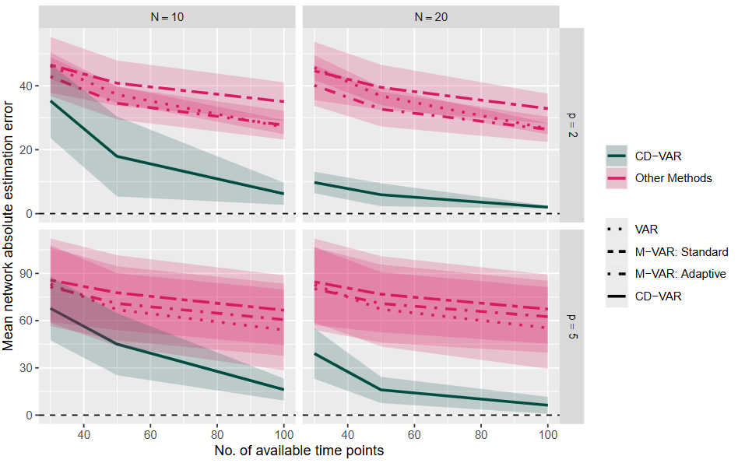
Figure 2: Comparison of the CD-VAR model to the VAR and Multi-VAR methods on simulated data, in terms of mean network absolute estimation error. I explore different number of explanatory covariates (p = 2, 5), available subjects (N = 10, 20), longitudinal observations per subject (T = 30, 50, 100). The proposed CD-VAR obtains the best network estimation performance in all scenarios.

