Covariate Dependent Network Modelling for Multi-Subject Longitudinal Studies: High-Dimensional Testing and New Horizons
Jose Angel Sanchez Gomez
Assistant Professor
Department of Statistics
University of California Riverside

Project summary (1700 char, or ~250 words) [Current: 1696 char]
In psychology, there is a growing interest in estimating causal networks that model the connections between psychological variables and individual behavioral patterns. These networks help gain a deeper understanding of the links between different psychological variables (e.g., anxiety, depression) and behavioral patterns (e.g., sleep quality, exercise, social engagement). To measure these relationships, researchers conduct longitudinal studies where these variables are repeatedly measured for multiple subjects across time. To appropriately model these data, statistical models must recognize that not all individuals are equal: factors like age, socioeconomic status, or prior mental health diagnoses may influence how behavioral and psychological variables relate to each other over time. In collaboration with scholars in the department of Psychology at UCR, I have developed the novel Covariate-Dependent Vector Auto-Regressive model (CD-VAR), which estimates a common psychological causal network across subjects, and quantifies how individual characteristics may affect the network structure. I have successfully developed the method’s software and have shown its outstanding performance for causal network estimation for a variety of simulated conditions. With the support of this grant, I will develop tests to measure the statistical significance of covariate network effects and validate their robustness under simulated and real data. Finally, I will use the CD-VAR model on the GLOBEM longitudinal human behavior dataset, to test the effect that demographic and socioeconomic factors may have on the causal network composed of psychological and behavioral states of individuals.

Project description (7000 char, or ~1000 words) [Current: 6258 char]
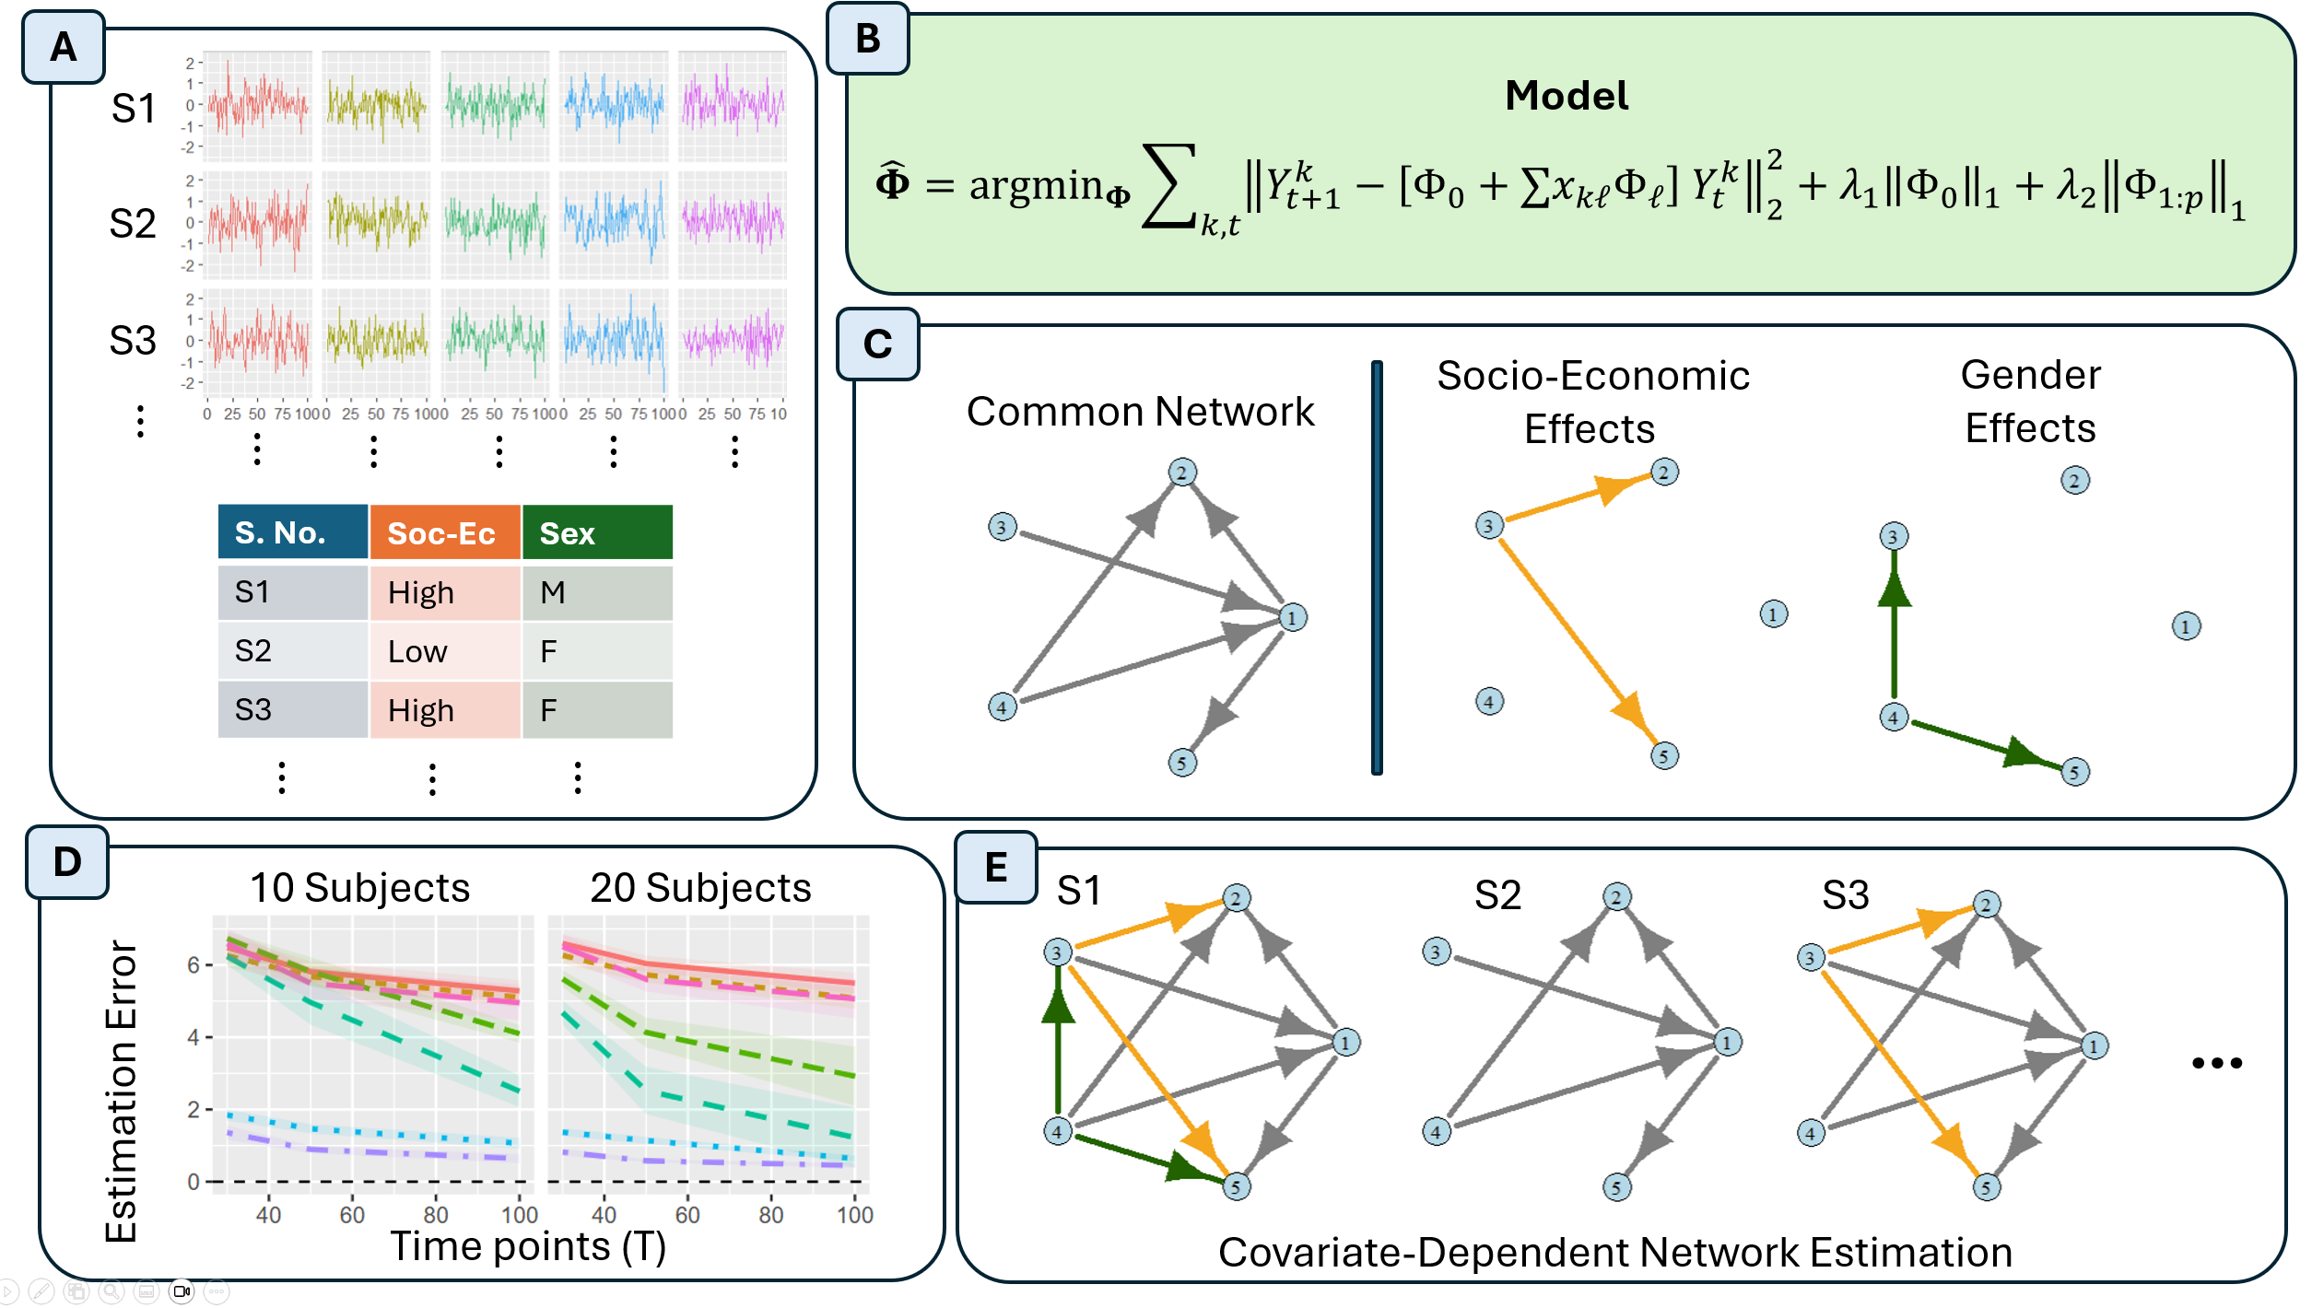
Figure 1: Visualization of the Covariate-Dependent Vector Auto-Regression (CD-VAR) model. (A) Inputs of the algorithm are multivariate time series for each subject in the study, as well as a set of covariates that describe subject-level features. (B) Mathematical model for the estimation of covariate dependent network models. We use a penalized framework to perform the network estimation. (C) Output of the CD-VAR model: a directed network of common connections across all subjects, and the estimated effects that individual features have on subject networks. (D) We observe improvements in estimation performance compared to methods in the literature. (E) Our model allows for the estimation of covariate dependent networks varying across subjects.

In psychological studies, it is vital to study how a variety of psychological traits and behavioral patterns relate to each other over time. For example, we may want to study the causal connections between a variety of psychological states, e.g., levels of depression, anxiety, etc., and behavioral patterns such as sleep quality, physical activity, engagement in social behavior, among others. One approach is to model these relationships via a causal network, where nodes represent psychological or behavioral traits, and a link between them corresponds to a directed causal relationship between them. In early studies, the focus has been to estimate these causal relationships assuming subject homogeneity, i.e., aggregating data across subjects in the study to explore the common causal structures shared across all individuals [citations].
This problem is particularly challenging due to what is known as the “curse of dimensionality.” To explain this, consider the GLOBEM longitudinal human behavior dataset, a study with 705 participants, who got assessed in terms of more than 10 behavioral measures over 10 weeks. Each daily assessment provides an observation, which gives us a dataset with a total of 70 x 705 ~ 50,000 observations. To simplify our discussion, we consider using only 10 behavioral features. Traditional methods that do not account for cross-subject heterogeneity would estimate a single network on the 10 features, which requires the estimation and testing of 10 x 10 = 100 parameters. To provide a more accurate analysis of the data, we may allow for cross-subject heterogeneity. This requires estimating a different network for each subject, giving us a total of 10 x 10 x 705 =70,500 parameters! In this case, the number of parameters of interest far surpasses the number of observations, making basic statistical tasks like hypothesis testing challenging. While some procedures have been developed for performing hypothesis tests in high-dimensional scenarios (Javanmard & Montanari, 2014; Candès et al., 2018; Javanmard & Montanari, 2018; Dai et al., 2023), to the best of our knowledge, the development of such tests for causal networks estimated for longitudinal studies with multiple subjects remains unexplored.
In recent years, there is a growing recognition that these behavioral and psychological causal network relationships are highly dependent on individual characteristics. This has led to the development of methods that can account for both common traits, as well as quantifying individual features. For example, GIMME (Gates & Molenaar, 2012; Gates et al, 2017; Lane et al., 2018) selects a common network structure via sequential testing. More recently, multi-VAR (Fisher et al., 2022; Crawford et al., 2024) utilizes penalized optimization to perform automatic common and individual network selection.
While methods like GIMME and Multi-VAR allow for cross-subject heterogeneity and can handle high-dimensional problems, they stop their efforts at estimating the heterogeneous parameters. It remains unexplored (a) whether this subject heterogeneity can be explained by underlying factors, and (b) whether the differences across the subjects are statistically significant or just result of noisy estimates. In this project, I propose the following two hypotheses: (i) the heterogeneity across subjects observed in these causal networks may be closely related to underlying individual characteristics: age, gender, any prior mental health diagnosis, socio-economic status, among others; and (ii) it is possible to develop methods to test the statistical significance of cross-subject heterogeneity, even in complex, high-dimensional scenarios. Derived from the above two hypotheses, the central aim of my project proposal is to develop a statistical model that can quantify and test the effect that underlying subject characteristics may have on the network of their psychological features over time.
In collaboration with scholars from the department of psychology at UCR, I have developed the Covariate-Dependent Vector Auto-Regressive model (CD-VAR), which is designed to (1) estimate the common causal networks across subjects and (2) determine the effect that external features may have on these causal networks. This is a novel method that can provide explanations for the origin of cross-subject variability across causal networks of multi-subject longitudinal studies. I have successfully developed software for performing the estimation of these network models and have verified its desirable performance on preliminary simulated data, which was designed to mimic realistic data scenarios.
While the method has currently been developed for the analysis of cross-subject psychological data, this model is flexible and has the potential to derive insights in a wide variety of scenarios. For example, in neuroscience, we may be interested in estimating the links among different regions of the brain based on time-varying brain signals across multiple patients. In this context, it is vital to quantify and test the effect that a variety of neurological conditions, or patients’ individual characteristics, may have on their brain connectivity. In economic data, researchers may be interested in deriving the connections among different economic indicators with the financial health of a country over time, and account for the individual characteristics of each country. These, among other examples, showcase the potential applicability of the CD-VAR model, and the importance of developing shareable software that can be accessed and used by scholars across disciplines.

Career Significance (3400 char, or ~500 words) [Current: 2483 Char]
With the funding from this early career grant, over the year 2026-2027, the goal is to achieve the following research milestones.
- Implement the testing procedures for determining the significance of covariate effects on high-dimensional causal networks. This work will be based on prior testing procedures such as Javanmard & Montanari (2014) and Javanmard & Montanari (2018). The work is substantive, since it requires technical adaptations for the context of heterogeneous longitudinal studies, and calls for an extensive mathematical analysis of the problem of heterogeneous time series.
- Analyze data from psychological longitudinal studies. One already available (talk about Gene’s data).
- Complete research visits to scholars interested across disciplines and universities to promote applications of CD-VAR and related methods, to expand the range of applications of the CD-VAR models beyond the psychological context and explore potential extensions of the model tailored to their domain-specific needs.
Beyond the project aims, we consider this research grant can represent a building block for the development of further research on methods for complex time-varying data. Here I provide a summary of the impact of this research on my early career at UCR.
- The project described above represents a new research direction. Furthermore, to the best of my knowledge, no work has tackled similar explorations of covariate dependent causal networks in longitudinal data. Establishing a track record in the area will be essential for pursuing extramural funding in the future, which our group is aiming to pursue.
- This project stems from dialogue with interdisciplinary scholars within the UCR campus. I believe this to be a great opportunity to broaden my areas of interest and to develop highly impactful research within UCR.
- The funds of this grant may contribute to the recruitment of a first Ph.D. student, which represents a relevant milestone in my academic career.
- The project described in this application provides a wide range of opportunities for publication. We are currently envisioning the publication of an article focused on the robustness of our statistical methodology, a tutorial paper that clarifies how to use our developed CD-VAR, and an article on quantitative psychology, analyzing multi-subject longitudinal data. We consider the support of this grant to be vital to propel this research and allow for further extensions and refinements.

Budget (3400 char, or ~500 words) [Current: 1749 char]
Senior/Key Personnel - $15,000 USD.
Jose Sanchez Gomez, Ph.D., PI (effort 1 summer month). Dr. Jose Sanchez Gomez is a Professor of Statistics at the University of California, Riverside. Dr. Sanchez Gomez will oversee the project management across all aims, and the coordination of efforts across collaborators and graduate students.
Other Personnel - $28,500 USD.
TBN, Graduate Student (effort 1 quarter + 1 summer month). This portion of the budget has the aim of covering the salary of a graduate student research assistant, to contribute to the development of the “CD-VAR” software package in R language.
Computational Resources – $4,500 USD
Computer Resources for Principal Investigator. A total of $ 2,500 USD will be used to purchase modern computer equipment with high-performance capabilities, which will aid in the development of software by the principal investigator.
High Performance Computing Center subscription (12 months). A total of $1000.00 USD from the budget will be used to cover the cost of subscription to the HPCC cluster computing of Dr. Jose Sanchez Gomez laboratory for the academic year 2026-2027. This will be essential for the processing and analysis of high-throughput time-series data throughout the project.
Computer Resources for Graduate Student. A total of $1,000 will be allocated to the purchase of computer equipment for the use of a hired GSR assistant. This will facilitate the work of the GSR assistant in the development of the CD-VAR software package in R.
Travel - $2,000 USD
A total of $2,000 USD will be allocated to the participation of the PI Sanchez Gomez to conferences and university visits to present results and explore further collaborations with scholars.
Total Direct Costs – $50,000 USD

Optional: Special funding circumstances (1700 char, or ~250 words)

References
Candès, E., Fan, Y., Janson, L., & Lv, J. (2018). Panning for gold: ‘model-X’ knockoffs for high dimensional controlled variable selection. Journal of the Royal Statistical Society Series B: Statistical Methodology, 80(3), 551-577.
Crawford, C. M., Park, J. J., Chow, S. M., Ernst, A. F., Pipiras, V., & Fisher, Z. F. (2024). Penalized subgrouping of heterogeneous time series. arXiv preprint arXiv:2409.03085.
Fisher, Z. F., Kim, Y., Fredrickson, B. L., & Pipiras, V. (2022). Penalized estimation and forecasting of multiple subject intensive longitudinal data. Psychometrika, 87(2), 403-431.
Gates, K. M., & Molenaar, P. C. (2012). Group search algorithm recovers effective connectivity maps for individuals in homogeneous and heterogeneous samples. NeuroImage, 63(1), 310-319.
Gates, K. M., Lane, S. T., Varangis, E., Giovanello, K., & Guiskewicz, K. (2017). Unsupervised classification during time-series model building. Multivariate behavioral research, 52(2), 129-148.
Javanmard, A., & Montanari, A. (2014). Confidence intervals and hypothesis testing for high-dimensional regression. The Journal of Machine Learning Research, 15(1), 2869-2909.
Javanmard, A., & Montanari, A. (2018). Debiasing the LASSO: optimal sample size for Gaussian designs. The Annals of Statistics, 46(6A), 2593-2622.
Lane, S. T., Gates, K. M., Pike, H. K., Beltz, A. M., & Wright, A. G. (2019). Uncovering general, shared, and unique temporal patterns in ambulatory assessment data. Psychological methods, 24(1), 54.

For more information, see: https://physionet.org/content/globem/1.1/.

