Covariate Dependent Network Modelling for Multi-Subject Longitudinal Studies: High-Dimensional Testing and New Horizons
Jose Angel Sanchez Gomez
Assistant Professor
Department of Statistics
University of California Riverside

Project summary (1700 char, or ~250 words) [Current: 1698 char]
In psychology, there is a growing interest in estimating causal networks, which help gain a deeper understanding of the links between different psychological variables (e.g., anxiety, depression) and behavioral patterns (e.g., sleep quality, exercise, social engagement). To measure these relationships, researchers conduct longitudinal studies where these variables are repeatedly measured for multiple subjects across time. To appropriately model these data, statistical models must recognize that not all individuals are equal: factors like socioeconomic status or prior mental health diagnoses may influence how behavioral and psychological variables relate to each other over time. In collaboration with scholars in the department of Psychology at UCR, I have developed the novel Covariate-Dependent Vector Auto-Regressive model (CD-VAR), which estimates common psychological causal network across subjects, and estimates how individual characteristics may affect the network structure. I have successfully developed statistical software and have shown its outstanding performance for causal network estimation for a variety of simulated conditions. The central aim of this proposal is to develop statistical tests for the CD-VAR, to determine whether individual characteristics have statistically significant effects on the estimated psychological causal networks. With the support of this grant, I will develop these statistical tests and validate their robustness on simulated and real data. Finally, I will use the CD-VAR model on longitudinal human behavior datasets, to test the effect that socioeconomic factors have on psychological and behavioral causal networks across individuals.

Project description (7000 char, or ~1000 words) [Current: 6973 char]
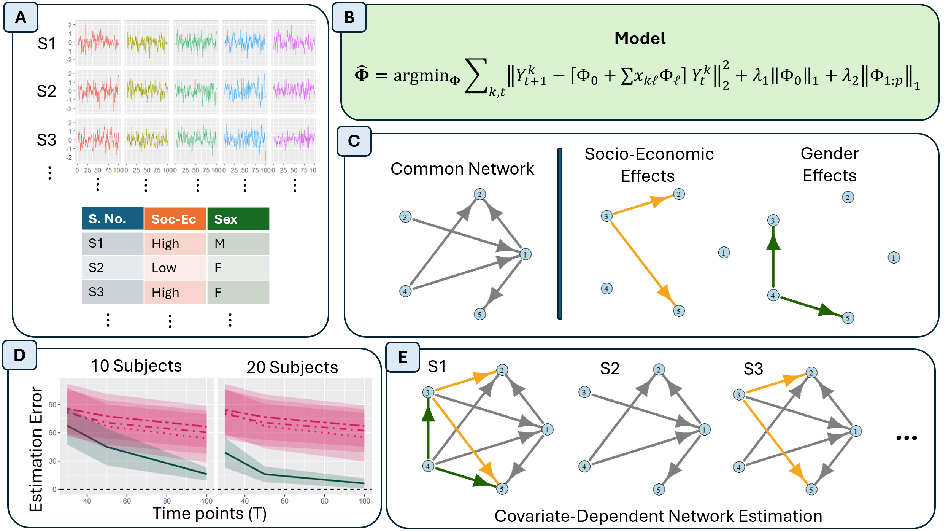
Figure 1: Visualization of the Covariate-Dependent Vector Auto-Regression (CD-VAR) model. (A) Inputs of the algorithm are multivariate time series for each subject in the study, as well as a set of covariates that describe subject-level features. (B) Mathematical model for the estimation of covariate dependent network models. We use a penalized framework to perform the network estimation. (C) Output of the CD-VAR model: a directed network of common connections across all subjects, and the estimated effects that individual features have on subject networks. (D) Our current numerical simulation experiments demonstrate improvements in estimation performance compared to methods in the literature. (E) Our model allows for the estimation of covariate dependent networks varying across subjects.

In psychological studies, it is vital to study how a variety of psychological traits and behavioral patterns relate to each other over time. For example, we may want to study the causal connections between a variety of psychological states, e.g., levels of depression, anxiety, and behavioral patterns such as sleep quality, physical activity, engagement in social behavior, among others. One approach is to model these relationships via a causal network, where nodes represent psychological or behavioral traits, and a link between them corresponds to a directed causal relationship between them. In early studies, the focus has been to estimate these causal relationships assuming or inducing subject homogeneity, i.e., aggregating data across subjects in the study to explore the common causal structures shared across all individuals (Petersson et al., 1999; Kherif et al., 2003; Ramsey et al., 2011; Basu & Michailidis, 2015).
In recent years, there is a growing recognition that these behavioral and psychological causal network relationships are highly dependent on individual characteristics. This has led to the development of methods that can account for both common traits, as well as quantifying individual features. For example, GIMME (Gates & Molenaar, 2012; Gates et al, 2017; Lane et al., 2018) selects a common and individual network structure via sequential testing. More recently, multi-VAR (Fisher et al., 2022; Crawford et al., 2024) utilizes penalized optimization to perform automatic common and individual network selection.
This problem is particularly challenging due to what is known as the “curse of dimensionality.” For example, consider the GLOBEM longitudinal human behavior dataset (Xu et al., 2022), a study with 705 participants assessed in terms of behavioral measures over 10 weeks. Each daily assessment provides an observation, which results in a dataset with a total of 70 x 705 ~ 50,000 observations. To simplify our discussion, we consider only 10 behavioral features. Traditional methods that do not account for cross-subject heterogeneity would estimate a single network on the 10 features, which requires the estimation and testing of 10 x 10 = 100 parameters. To provide a more accurate analysis of the data, we may allow for cross-subject heterogeneity. This requires estimating a different network for each subject, giving us a total of 10 x 10 x 705 =70,500 parameters! In this case, the number of parameters of interest surpasses the number of observations, rendering basic statistical tasks like hypothesis testing challenging. While some procedures have been developed for performing hypothesis tests in high-dimensional scenarios (Javanmard & Montanari, 2014; Candès et al., 2018; Javanmard & Montanari, 2018; Dai et al., 2023), to the best of my knowledge, the development of tests for causal networks in longitudinal studies with multiple subjects remains unexplored.
While methods like GIMME and Multi-VAR allow for cross-subject heterogeneity in high-dimensional problems, it remains unexplored (a) whether subject heterogeneity can be explained by underlying factors, and (b) test whether the differences across the subjects are statistically significant or noise. In this project, I propose the following two hypotheses: (i) the heterogeneity across subjects observed in these causal networks may be closely related to underlying individual characteristics: age, gender, socio-economic status, among others; and (ii) it is possible to develop methods to test the statistical significance of cross-subject heterogeneity, even in high-dimensional scenarios. Derived from these hypotheses, the central aims of this proposal are the following.
- Develop a statistical model to test the effect that underlying subject characteristics may have on the causal network of psychological features.
- Apply our proposed methods and tests to real longitudinal psychological data and explore further collaborations of our methodology to other longitudinal data contexts.
Working towards these aims, in collaboration with scholars from the department of psychology at UCR, I have developed the Covariate-Dependent Vector Auto-Regressive model (CD-VAR). The CD-VAR is designed to (1) estimate the common causal networks across subjects and (2) determine the effect that external features may have on these causal networks. This is a novel method that can provide explanations for the origin of cross-subject variability across causal networks of multi-subject longitudinal studies. I have successfully developed software for performing the estimation of these network models and have verified its desirable performance on extensive simulated data experiments designed to mimic realistic data scenarios. Network estimation accuracy results are presented in Figure 2.
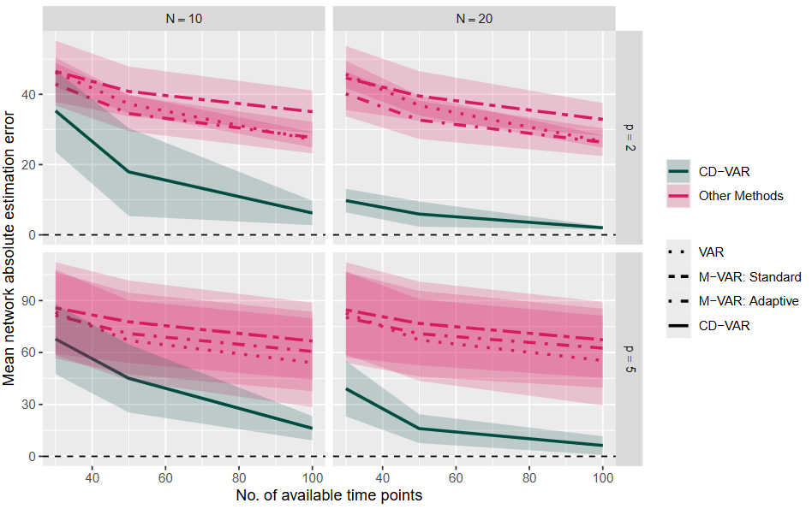
Figure 2: Comparison of the CD-VAR model to the VAR and Multi-VAR methods on simulated data, in terms of mean network absolute estimation error. I explore different number of explanatory covariates (p = 2, 5), available subjects (N = 10, 20), longitudinal observations per subject (T = 30, 50, 100). The proposed CD-VAR obtains the best network estimation performance in all scenarios.
I have successfully developed the CD-VAR model for the analysis of cross-subject psychological data. I believe this model is flexible and has the potential to derive insights in a wide variety of scenarios. For example, in neuroscience, we may be interested in estimating the links among different regions of the brain based on time-varying brain signals across multiple patients. In this context, it is vital to quantify and test the effect that a variety of neurological conditions, or patients’ individual characteristics, may have on their brain connectivity. In economic data, researchers may be interested in deriving the connections among different economic indicators with the financial health of a country over time, and account for the individual characteristics of each country. These, among other examples, showcase the potential applicability of the CD-VAR model, and the importance of exploring new potential collaborations in a variety of scientific domains.

Career Significance (3400 char, or ~500 words) [Current: 3398 Char]
With the funding from this early career grant, over the year 2026-2027, the goal is to achieve the following research milestones.
[A1] Develop testing procedures for determining the significance of covariate effects on high-dimensional causal networks. This work will be based on high-dimensional testing procedures such as Javanmard & Montanari (2014) and Javanmard & Montanari (2018). The work is substantive, since it requires technical adaptations for the context of heterogeneous longitudinal studies, and calls for an extensive mathematical analysis.
[A2] Implement the novel testing procedures for our CD-VAR. This will entail translating the results obtained in [A1] to code that can be applied to a variety of contexts. This implementation will be validated through both numerical simulation experiments and real data.
[A3] Analyze data from psychological longitudinal studies. We are interested in analyzing the GLOBEM longitudinal human behavior dataset (Xu et al., 2022), to which I have successfully gained access to. This dataset measures behavioral patterns across 705 subjects across 10 weeks, across multiple years. We aim to explore how socioeconomic and demographic variables may influence the behavioral patterns of these individuals.
[A4] Promote applications of the CD-VAR method to a wider range of applications. This will be achieved by: (i) organizing a new UCR-hosted workshop Methods and Applications of Longitudinal and Time series data Across disciplines (UCR MALTA workshop), to encourage new collaborations across campus; and (ii) participation in conferences and research visits to scholars across disciplines, to expand the range of applications of the CD-VAR models beyond the psychological context.
Beyond the project aims, this research grant will represent a building block for the development of further research on methods for complex time-varying data. Here I provide a summary of the impact of this research on my early career at UCR.
- This interdisciplinary project has been the result of weekly conversations with scholars from the department of Psychology at UCR since October 2024. Obtaining funding for this project represents an important step towards expanding my interdisciplinary work with scholars at UCR.
- The organization of the new UCR MALTA workshop will provide further opportunities for interdisciplinary collaborations across the UCR campus.
- This project represents a new direction in my research program. Furthermore, to the best of my knowledge, no work has tackled similar explorations of covariate dependent causal networks in longitudinal data. Establishing a track record in the area will be essential for pursuing extramural funding in the future, which I am aiming to pursue.
- The funds of this grant may contribute to the recruitment of a first Ph.D. student, which represents a relevant milestone in my academic career.
- The project described in this application provides a wide range of opportunities for publication. We are currently envisioning the publication of an article focused on the robustness of our statistical methodology, a tutorial paper that clarifies how to use our developed CD-VAR, and an article on quantitative psychology, analyzing multi-subject longitudinal data. We consider the support of this grant to be vital to propel this research and allow for exploring further extensions.

Budget (3400 char, or ~500 words) [Current: 3310 char]
Senior/Key Personnel - $15,000 USD.
Jose Sanchez Gomez, Ph.D., PI (effort 1 summer month). Dr. Jose Sanchez Gomez is a Professor of Statistics at the University of California, Riverside. Dr. Sanchez Gomez will oversee the project management across all aims, and the coordination of efforts across collaborators and graduate students.
- Development of the test of covariate-dependent network effects [A1]. Additionally, work on the implementation of the novel testing procedure in the R programming language [A2].
- Guidance and mentoring of a hired graduate student researcher (GSR) in the development of systematic simulations that evaluate the performance of the testing procedure for a variety of simulated and real data scenarios linked to longitudinal causal networks in psychology [A2, A3].
- Promotion and development of new collaborations through the participation in and organization of academic congresses [A4].
Other Personnel - $25,664 USD.
TBN, Graduate Student (effort 1 quarter + 2 summer months). This portion of the budget has the aim of covering the salary of a graduate student research assistant, to contribute to the design of systematic evaluation of the CD-VAR in simulated and real data scenarios. The tasks will comprise the following:
- GSR quarter support ($18,328 USD): Design of systematic simulated examples, that mimic real-world data scenarios found in psychological longitudinal studies. These simulations are to be performed on the HPCC computer cluster and will be based on previous simulation work shared in Section 1 [A2].
- GSR summer support ($7336 USD): Analysis of the GLOBEM longitudinal human behavior dataset through CD-VAR as well as other methods in the literature [A3].
Computational Resources – $4,500 USD
Computer Resources for Principal Investigator: $ 2,500 USD will be used to purchase high-performing computer equipment, for the development and testing of software by the principal investigator [A2, A3].
High Performance Computing Center subscription (12 months). A total of $1000.00 USD from the budget will be used to cover the cost of subscription to the UCR High Performance Computing Center (HPCC) of Dr. Jose Sanchez Gomez laboratory for the academic year 2026-2027. This resource is essential for the evaluation of the CD-VAR in simulated and real data [A2, A3].
Computer Resources for Graduate Student. A total of $1,000 will be allocated to the purchase of computer equipment for the use of a hired GSR assistant. This resource aims to facilitate the GSR assistant in the development of the CD-VAR systematic evaluation through numerical simulations, as well as the analysis of the GLOBEM dataset [A2, A3].
Travel & Events - $4,836 USD
A total of $4,836 USD will be allocated to the participation and organization of the PI Sanchez Gomez of conferences and university visits to explore further collaborations with scholars.
- Conference participation ($2500 USD). Allocated to the attendance of national conferences on statistics and quantitative methods in psychology [A4].
- Event Organization ($2336 USD). Allocated to the organization of the UCR MALTA workshop, for longitudinal and time series methods across disciplines. If possible, funds may be partly used to offer travel allowances for speakers [A4].
Total Direct Costs – $50,000 USD

References
Basu, S., & Michailidis, G. (2015). Regularized estimation in sparse high-dimensional time series models. The Annals of Statistics, 1535-1567.
Candès, E., Fan, Y., Janson, L., & Lv, J. (2018). Panning for gold: ‘model-X’ knockoffs for high dimensional controlled variable selection. Journal of the Royal Statistical Society Series B: Statistical Methodology, 80(3), 551-577.
Crawford, C. M., Park, J. J., Chow, S. M., Ernst, A. F., Pipiras, V., & Fisher, Z. F. (2024). Penalized subgrouping of heterogeneous time series. arXiv preprint arXiv:2409.03085.
Fisher, Z. F., Kim, Y., Fredrickson, B. L., & Pipiras, V. (2022). Penalized estimation and forecasting of multiple subject intensive longitudinal data. Psychometrika, 87(2), 403-431.
Gates, K. M., & Molenaar, P. C. (2012). Group search algorithm recovers effective connectivity maps for individuals in homogeneous and heterogeneous samples. NeuroImage, 63(1), 310-319.
Gates, K. M., Lane, S. T., Varangis, E., Giovanello, K., & Guiskewicz, K. (2017). Unsupervised classification during time-series model building. Multivariate behavioral research, 52(2), 129-148.
Javanmard, A., & Montanari, A. (2014). Confidence intervals and hypothesis testing for high-dimensional regression. The Journal of Machine Learning Research, 15(1), 2869-2909.
Javanmard, A., & Montanari, A. (2018). Debiasing the LASSO: optimal sample size for Gaussian designs. The Annals of Statistics, 46(6A), 2593-2622.
Kherif, F., Poline, J. B., Mériaux, S., Benali, H., Flandin, G., & Brett, M. (2003). Group analysis in functional neuroimaging: selecting subjects using similarity measures. Neuroimage, 20(4), 2197-2208.
Lane, S. T., Gates, K. M., Pike, H. K., Beltz, A. M., & Wright, A. G. (2019). Uncovering general, shared, and unique temporal patterns in ambulatory assessment data. Psychological methods, 24(1), 54.
Petersson, K. M., Nichols, T. E., Poline, J. B., & Holmes, A. P. (1999). Statistical limitations in functional neuroimaging II. Signal detection and statistical inference. Philosophical transactions of the Royal Society of London. Series B: Biological Sciences, 354(1387), 1261-1281.

Ramsey, J. D., Hanson, S. J., & Glymour, C. (2011). Multi-subject search correctly identifies causal connections and most causal directions in the DCM models of the Smith et al. simulation study. NeuroImage, 58(3), 838-848.Van Den Heuvel, M. P., & Hulshoff Pol, H. E. (2010). Specific somatotopic organization of functional connections of the primary motor network during resting state. Human brain mapping, 31(4), 631-644.
Xu, X., Zhang, H., Sefidgar, Y., Ren, Y., Liu, X., Seo, W., ... & Dey, A. (2022). GLOBEM dataset: multi-year datasets for longitudinal human behavior modeling generalization. Advances in neural information processing systems, 35, 24655-24692.

For more information, see: https://physionet.org/content/globem/1.1/.

