Week_7 Task and hands-on_Activity
Github_repo_url = https://github.com/horrondor/DevOps_intern_Davine/tree/main/weekly_Tasks/week_7/k-8

Screenshot of Running Cluster

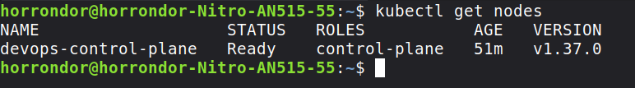

Screenshot of Pods

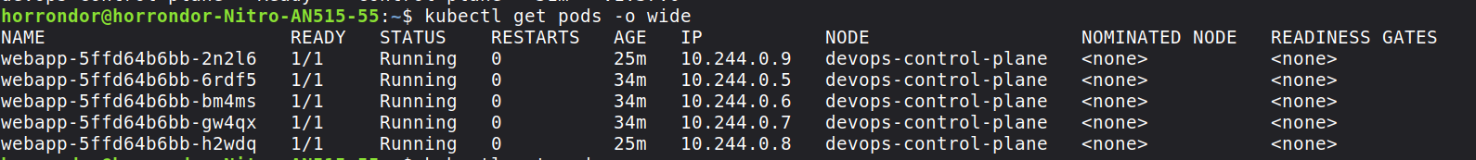

Screenshot of Deployment
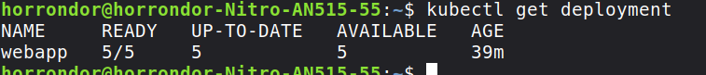

Screenshot of Service
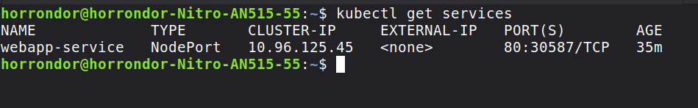

Screenshot of ConfigMap/Secret

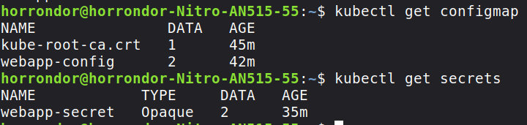

Screenshot of kubectl commands

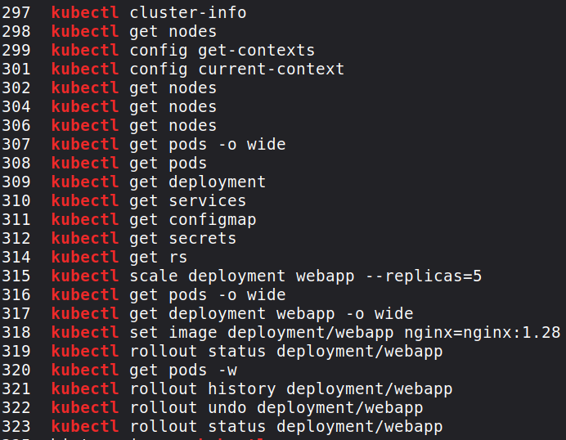

Kubernetes Architecture Diagram
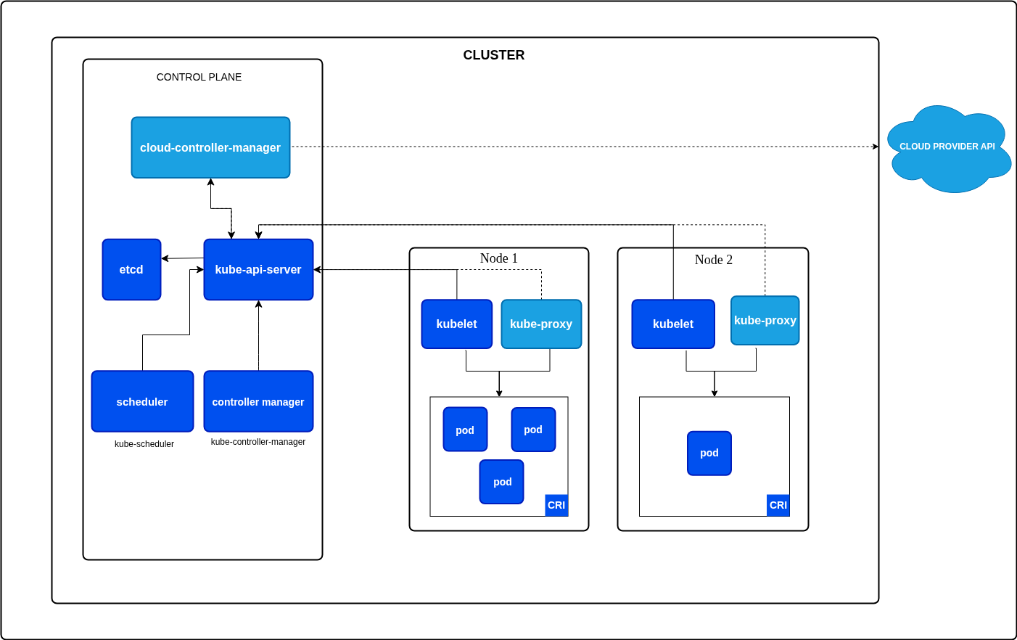

Screenshot of 3 Running Replicas

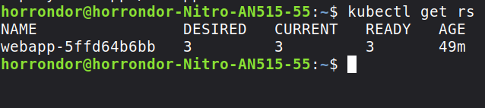

Screenshot of Scaling

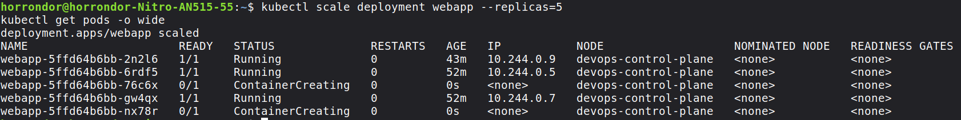

Screenshot of Rolling Update
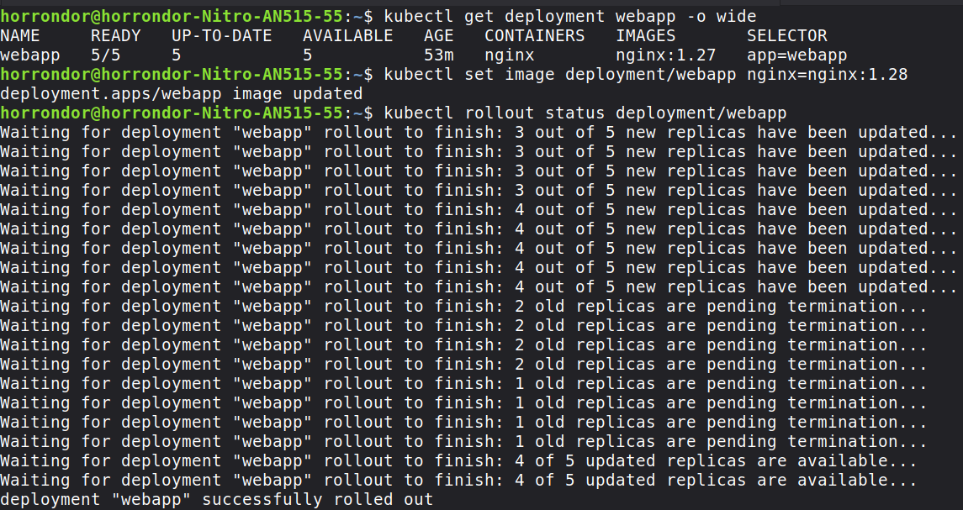

Screenshot of Rollback
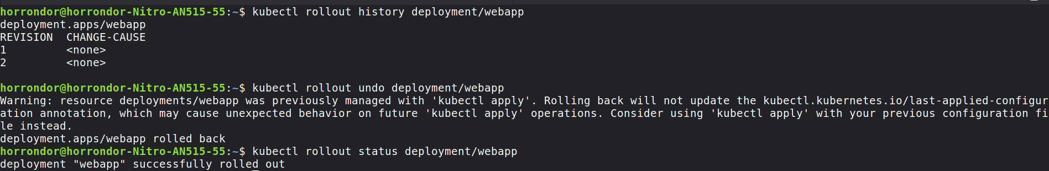

Screenshot of Application Access
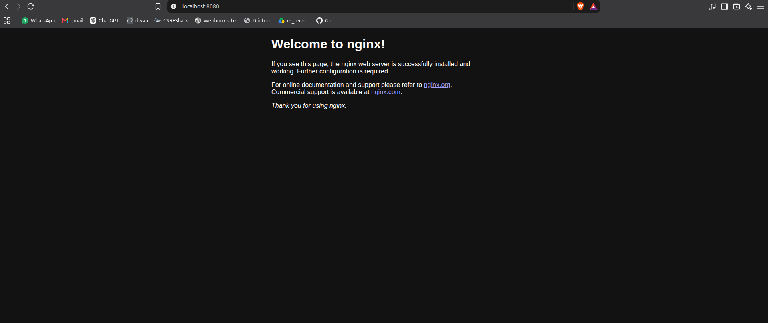

Short explanation of what happened during scaling and rollback

Scaling
The Deployment was initially configured with 3 replicas. I scaled the Deployment up to 5 replicas, and Kubernetes automatically created additional Pods to match the desired replica count. I then scaled it back down to 3 replicas, and Kubernetes removed the extra Pods.

Rollback
I performed a rolling update by changing the application's container image. Kubernetes created a new Deployment revision and gradually replaced the old Pods. After verifying the rollout, I used kubectl rollout undo to roll back the Deployment to the previous revision. Kubernetes then restored the previous application version and successfully rolled out the Pods.

