Slavery in Late-19th-Century Siam
A portfolio-level data science reconstruction, 1850–1905, with a focus on Lao / Isan exploitation
Custom historical dataset • statistical reconstruction • network analysis • political economy
This report reconstructs slavery in Siam as a measurable system of labor extraction, debt, war captivity, and ethnic classification rather than as a purely legal institution. Using a manually coded dataset built from 10 historical sources (6 primary) and 252 observation rows, the project estimates plausible slave-stock ranges, dependent-inclusive Lao captive totals, debt-redemption burdens under the 1905 law, census omission shares, and budget/trade indicators of Bangkok-centered state formation. The central finding is that Lao / Isan people were not peripheral to Siamese slavery: they were structurally important to crown labor, Bangkok construction, specialized urban production, and the transition from slavery to bureaucratically managed labor.

Project asset | Value
Sources coded | 10 total (6 primary)
Raw historical observations | 252 rows
Processed analytical tables | 13 CSV files
Generated figures | 10 PNG files
Core raw dataset | data/raw/historical_observations.csv

Executive summary
The project asks a simple but difficult question: what did slavery in Siam look like at scale, and how did it work to the advantage of Bangkok-centered elites? The answer that emerges from the data is that Siamese slavery was neither marginal nor reducible to a plantation analogy. It was a large, layered labor regime combining debt bondage, hereditary status, war-captive incorporation, corvée substitution, and administrative classification.
Scenario estimates built from Bowring's 1850s population bounds and contemporary slave-share claims place the enslaved population in the rough range of 1.1 to 2.1 million people. Bowring's own list of crown-controlled war captives makes Lao the single largest named group among listed royal captive fighting men. When dependents are added using Grabowsky's able-bodied-male population benchmark, the implied Lao captive population tied to the crown is on the order of tens of thousands, with a central estimate near 80,000.
The project also shows that the transition to abolition did not simply dissolve coercion. The 1905 law credited four ticals per month against debt; depending on the starting obligation, freedom could still take years. At the same time, the late nineteenth century saw a sharp expansion of the Ministry of Local Government, stronger provincial administration, and growing foreign trade. Abolition therefore appears less as a purely humanitarian rupture than as part of a broader reorganization of labor, sovereignty, and state legibility.
A second major finding concerns ethnic classification. The 1904 census—indispensable but politically structured—detailed only about half the kingdom, omitted the Lao heartland of Udon and Isan from its detailed count, and folded many Lao into administratively Thai categories. In this sense, the census was not only a source about slavery and population; it was part of the state machinery that reworked those categories.
Headline metrics
Metric | Value | Interpretation
Estimated enslaved population (low) | 1.12 million | Conservative mid-century lower bound
Estimated enslaved population (high) | 2.10 million | Upper plausible mid-century bound
Lao share of listed royal war captives | 43.5% | Bowring's fighting-men list
Central Lao captive estimate incl. dependents | 80,000 | 20,000 × 4
1904 detailed census coverage | 49.5% | Detailed-census share of kingdom
Udon + Isan share of national population | 22.3% | Omitted Lao heartland share
Months to freedom for 100-tical debt | 25 months | Under 1905 four-tical monthly credit
Months to freedom for 400-tical debt | 100 months | Inflated debt note example
Local Government budget growth | 51.0x | 1894–95 to 1903–04
Export growth | 51.5% | 1897 to 1902

Data construction and analytical design
The project's core asset is a long-form historical observation table rather than a single aggregate spreadsheet. Each row records one coded observation: a population count, price, wage, budget entry, legal rule, bounded statement, or coded qualitative fact. That structure is important because the sources themselves are heterogeneous. A treaty, a census explanation, a diplomatic travel account, and a community study do not naturally fit into one rectangular panel without losing context.
Primary sources were prioritized wherever possible. Bowring's 1857 account supplies numbers on captive groups, wages, prices, and legal categories. The British consular report for 1880 provides a snapshot of trade, public works, labor scarcity, and the fiscal encouragement of monopolies. The official 1904 publication The Kingdom of Siam provides budget and trade data as well as an apologetic official narrative about slavery. The 1905 abolition law provides the operative legal mechanism of emancipation. These were triangulated with Grabowsky's translation and analysis of the 1904 census, Van Roy's reconstruction of Lao captive communities in Bangkok, and Cruikshank's discussion of corvée, taxation, and abolition chronology.
Two methodological decisions matter especially. First, the project distinguishes between direct source values and inferred values. For example, Bowring's 20,000 Lao war captives are directly reported, while the dependent-inclusive 80,000 estimate is an explicit inference using Grabowsky's note that able-bodied taxable men were roughly one quarter of the population. Second, the dataset separates administrative ethnicity from historically interpreted ethnicity. That is essential because the 1904 census and related administrative reforms often coded Lao populations as Thai.
Project assets at a glance
Project asset | Value
Long-form raw dataset | 252 coded historical observations
Source registry | 10 sources with primary/secondary flags and URLs
Processed tables | 13 derived CSVs for scale, census, debt, networks, and abolition
Figures | 10 visualizations including a Lao labor network graph
Notebook | Executable Jupyter notebook with full analysis code

1. Scale and demographics
There is no complete mid-century slave census for Siam, so scale must be reconstructed through bounded estimation. Bowring cited population totals between roughly 4.5 and 5.0 million as plausible, while also reproducing Pallegoix's 6 million benchmark. On slavery itself, the bishop's estimate of one third of the population and Bowring's stronger claim that there were 'much more than a third' of Siamese who were slaves create a range rather than a point estimate (Bowring 1857, vol. 1, pp. 62–63, 193).
Using scenario analysis rather than false precision, the project places the plausible slave stock at about 1.125 million under a conservative lower-bound reading and around 2.1 million under an upper plausible interpretation. Even the low scenario implies that slavery was a macro-social institution, not a residual condition affecting only a narrow fringe.
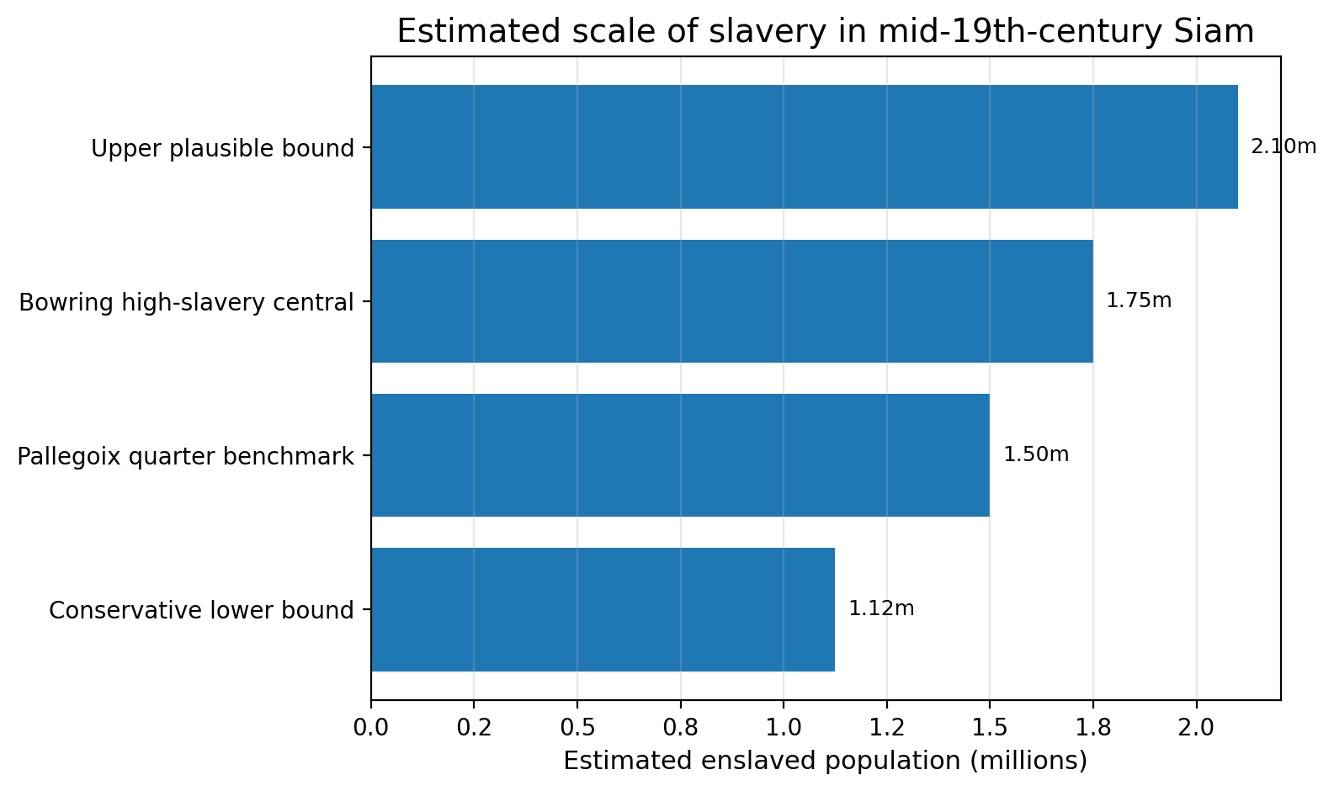
Figure 1. Mid-century slave-stock scenarios built from Bowring's population bounds and contemporary slave-share claims.
Bowring's list of royal war captives adds a crucial ethnic dimension. Among listed 'fighting men' belonging nearly all to the kings, he reported 20,000 Lao, compared with 10,000 Cochin Chinese, 10,000 Peguans, 5,000 Malays, and 1,000 Burmese (Bowring 1857, vol. 1, pp. 190–191). Lao therefore account for about 43.5 percent of the listed royal war-captive fighting men. If those fighting men represented roughly one quarter of the total population tied to those captive households, the implied Lao captive population attached to the crown reaches roughly 80,000 at the central multiplier, with a 60,000–100,000 sensitivity range.
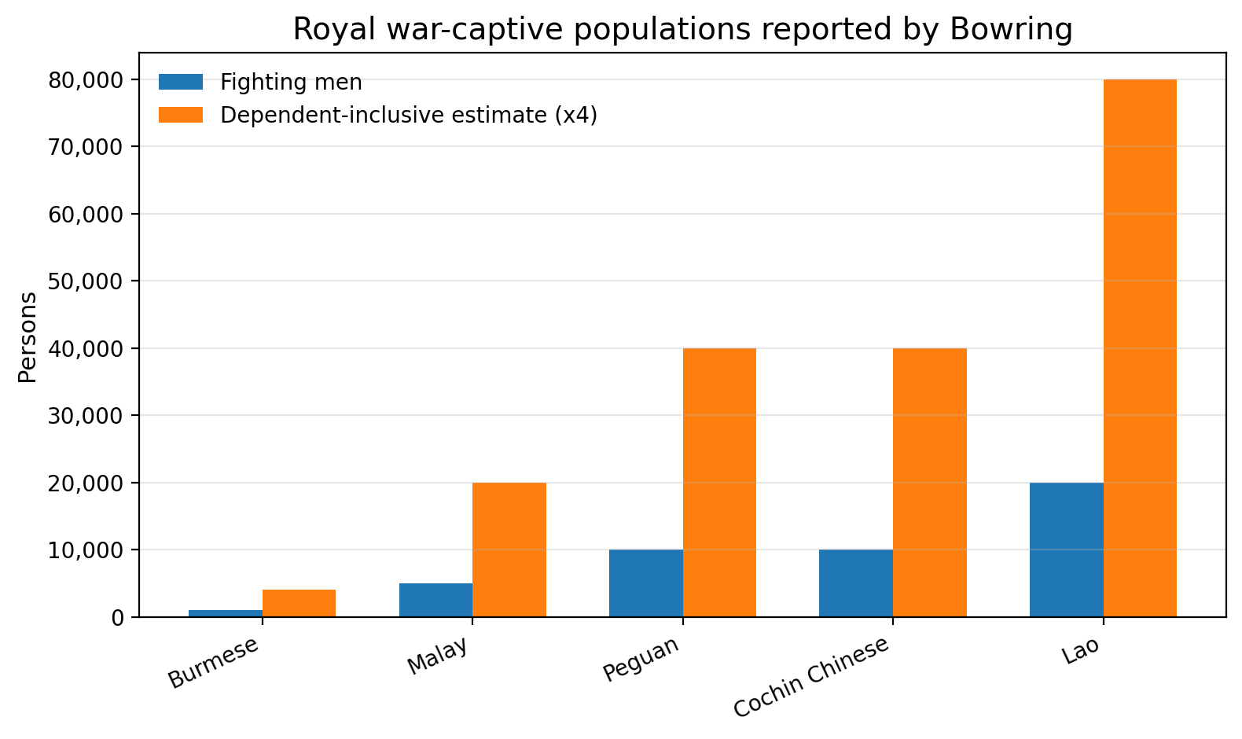
Figure 2. Bowring's listed royal war-captive groups, with a dependent-inclusive central estimate (×4).
2. Labor systems, women, and children
Bowring's slavery chapters make clear that Siamese slavery was economically differentiated and gendered. He reported redeemable price ranges of 80–120 ticals for men and 60–100 for women, while also describing 'irredeemable' sales—especially of young girls sold by parents. He remarked that more than four fifths of those girls absconded when they could, suggesting that the official legal status of a sale tells us little about consent or welfare (Bowring 1857, vol. 1, pp. 193–195).
Children were directly commodified. Bowring included an example contract in which a husband and wife sold their son for 100 ticals. He also noted that sons of certain royal captive groups became slaves to the king, while daughters could be sold by their parents. This was not merely labor extraction in the present; it was the legal reproduction of dependent labor across generations.
Women appear in at least three analytically distinct roles: as priced redeemable labor, as vulnerable subjects of sale or forced marriage, and as kinship conduits into elite households. Van Roy's reconstruction of Bang Yi-khan, for example, shows Lao daughters being absorbed into Thai elite households as wives and consorts, while sons found routes into later government service. This makes clear that gendered labor in slavery included reproductive, domestic, and status-making functions, not just field or workshop work.
The 1905 abolition law freed children born to slave parents and barred free persons from entering slavery, but it did not erase existing debts at once. Instead it credited four ticals per month against debt principal. The resulting time to freedom varied dramatically with debt size.
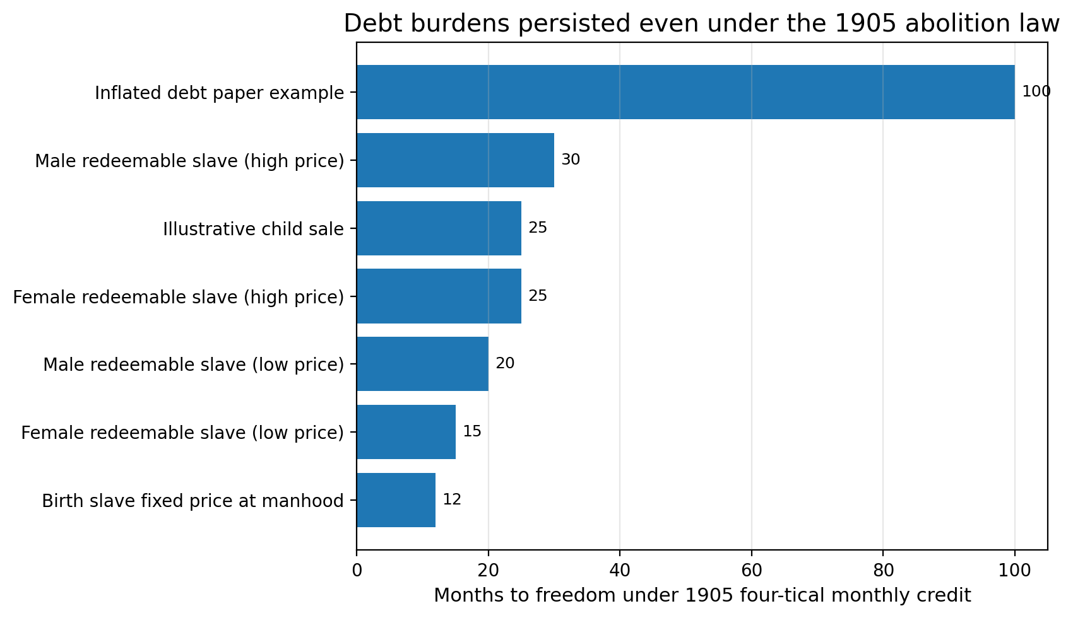
Figure 3. Time to freedom under the 1905 law depended on inherited or accumulated debt burdens.
3. Census coverage, Lao / Isan omission, and ethnic erasure
The 1904 census is invaluable because it provides populations, households, and race totals for twelve detailed monthons. But it is also a political document. Grabowsky shows that Bangkok, Isan, Udon, Phayap, Burapha, and southern tributary territories were not all covered in the same way, and that the procedures of registration favored the Thai category. He states plainly that Lao had to be registered as Thai in the emerging nationalist-administrative order (Grabowsky 1996).
This matters quantitatively. The detailed 1904 census covered only about 49.5 percent of the kingdom's estimated population. Udon and Isan alone accounted for about 22.3 percent of the national estimate, and the omitted share rises to almost 29.6 percent if Phayap is added. In other words, the very regions most central to the Lao question were underrepresented in the detailed frame.
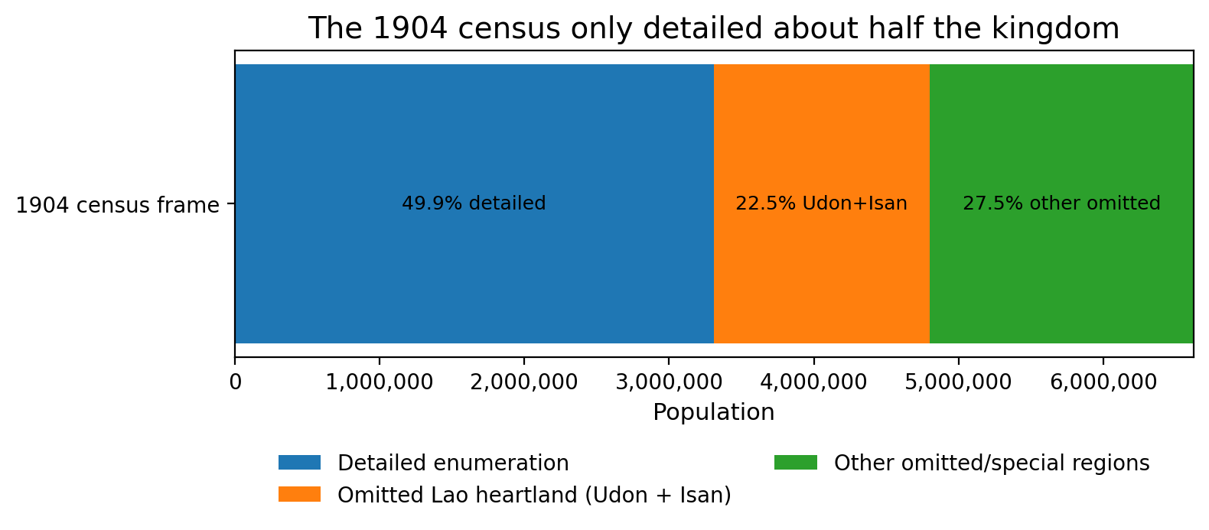
Figure 4. Roughly half the kingdom lay outside the detailed-census frame in 1904; Udon and Isan alone formed a major omitted share.
Within the detailed frame, the census recorded 3,308,032 persons in twelve monthons. The largest were Nakhon Si Thammarat, Krung Kao, and Nakhon Ratchasima. These numbers are analytically useful, but they cannot be mistaken for a neutral national baseline because the omitted Lao regions were not trivial residuals.
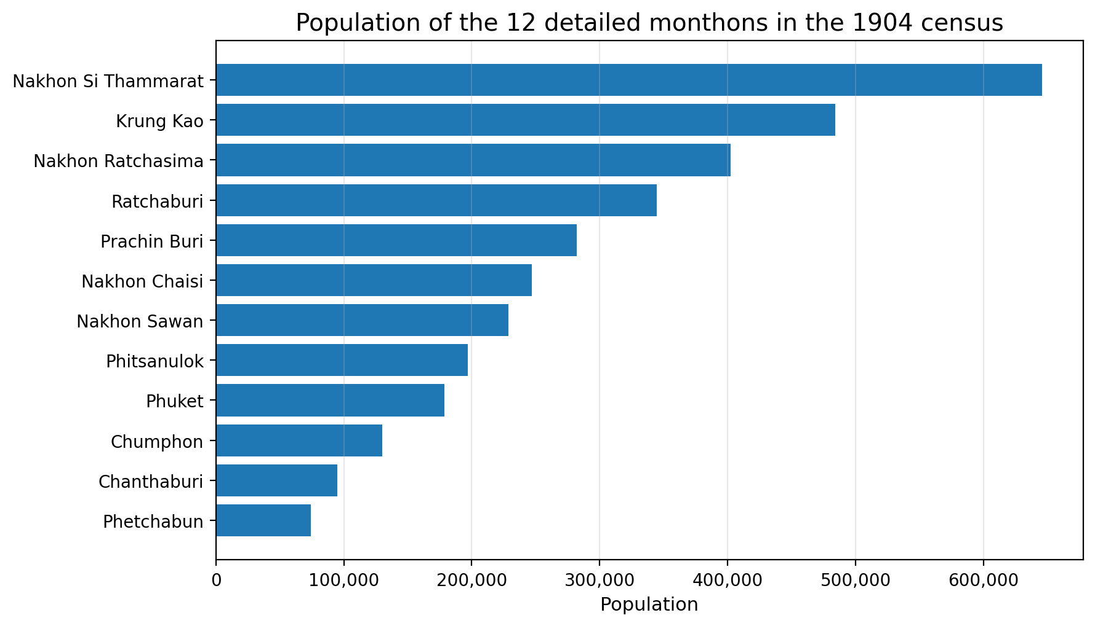
Figure 5. Population in the twelve detailed monthons of the 1904 census.
The race totals for the detailed monthons show Thai, Malay, Chinese, Khmer, Mon, and Karen populations, but they must be read as state categories rather than pure ethnographic reality. A census can both measure and erase. Here it did both at once.
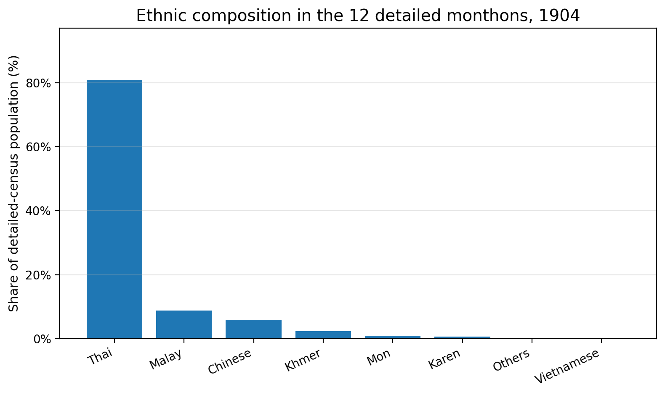
Figure 6. Race totals in the detailed-census monthons; the 'Thai' category already contains administrative absorption effects.
4. Bangkok Lao captive-labor network
Van Roy's case studies allow the project to move beyond aggregate demography and reconstruct how Lao captivity worked inside Bangkok. The resulting picture is not one of a single generic labor pool. Instead, Lao captive communities were settled in distinct neighborhoods and routed into specialized economic and political functions: naval craft production, sawmills, shipyards, stevedoring, palace landscaping, palace sanitation, goldsmithing, ornamental casting, military-police insignia production, and elite household incorporation.
This is especially important for assessing how Bangkok-centered elites benefited. The beneficiaries were not only private masters in a narrow sense. They included the monarchy, the Front Palace, noble households, the palace bureaucracy, later Western firms operating at the port, and an urban economy increasingly linked to export logistics. Lao captivity thus helped bridge older royal labor organization and newer forms of market-connected urban work.
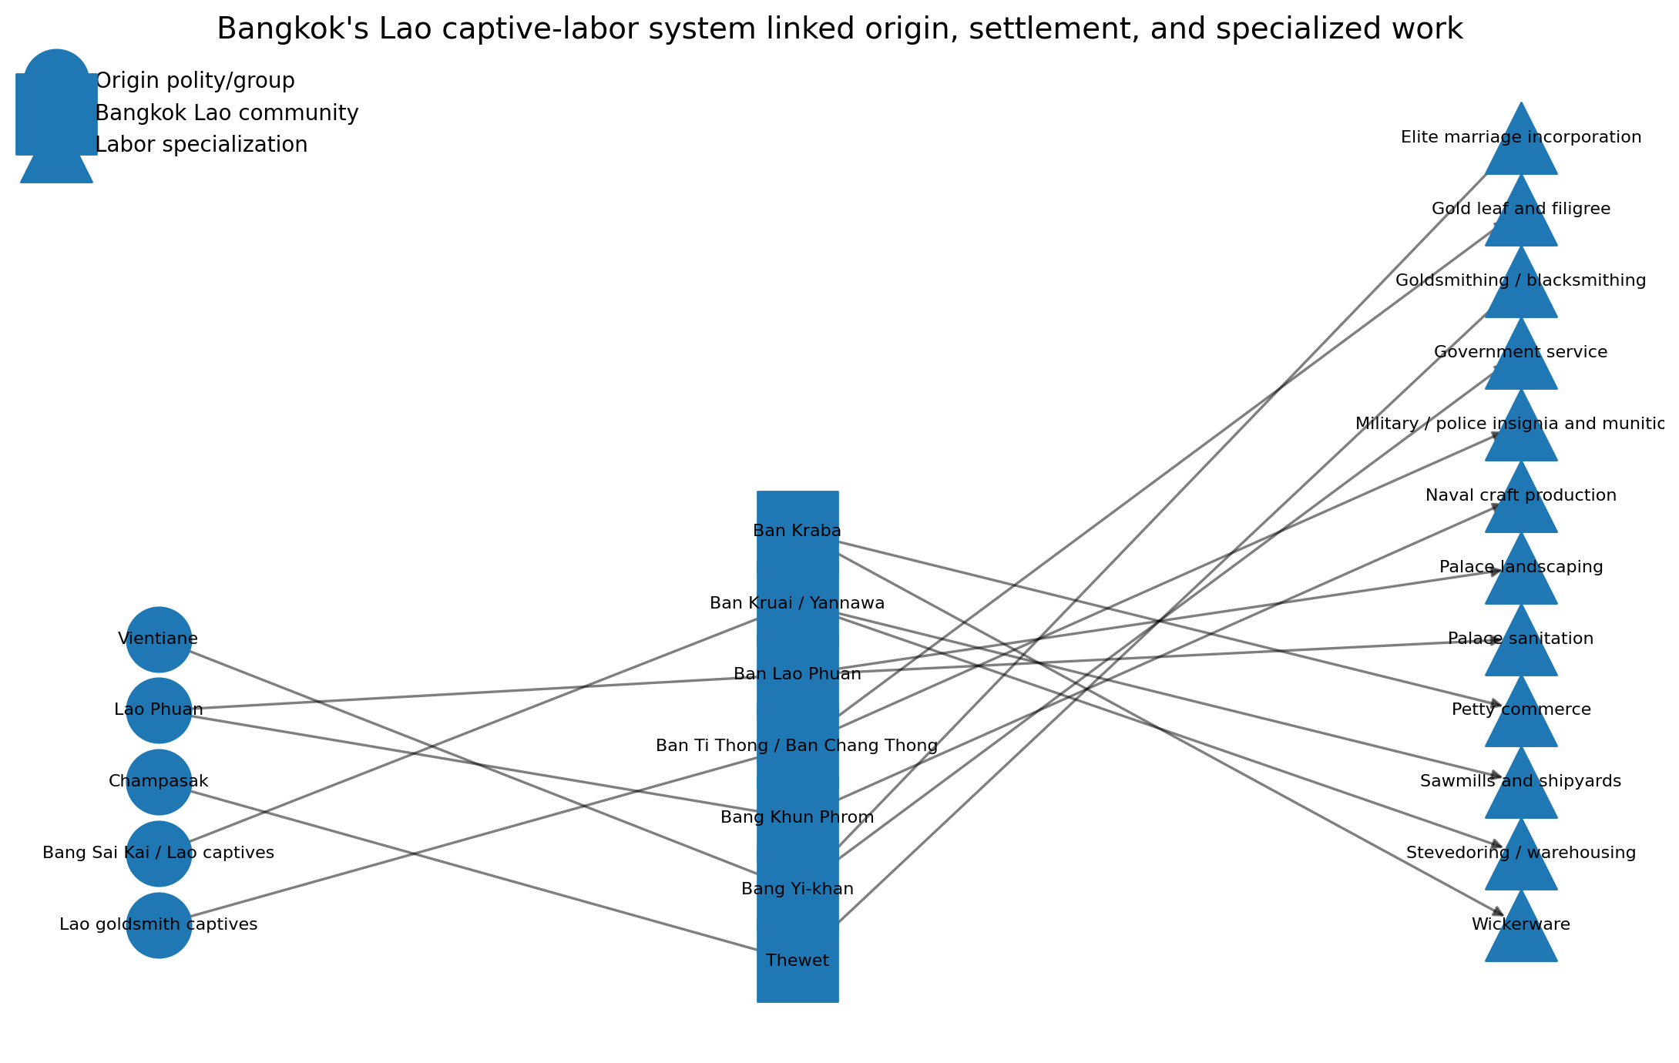
Figure 7. Lao captive labor linked origin polities, Bangkok settlements, and specialized forms of work.
5. Political economy of abolition, extraction, and state-building
The 1880 British consular report described a kingdom with falling exports, slightly falling imports, subsistence pressure, rising labor prices, and no spending on useful public works. The same report also complained that opium shops, spirit shops, and gambling houses were being encouraged and that slavery still existed 'in full force' throughout the kingdom. Taken together, those details imply an extractive political economy oriented less toward broad welfare than toward revenue and labor control.
By 1903–04, however, the official state publication shows a more centralized and capacious state. Revenue stood at 45.54 million ticals, and the Ministry of Local Government alone had grown from about 206,000 ticals in 1894–95 to more than 10.5 million. Gendarmerie, provincial administration, and revenue offices all expanded. Export values rose from 57.69 million ticals in 1897 to 87.40 million in 1902, while imports rose from 40.97 million to 65.42 million. This is the fiscal context in which abolition occurred.
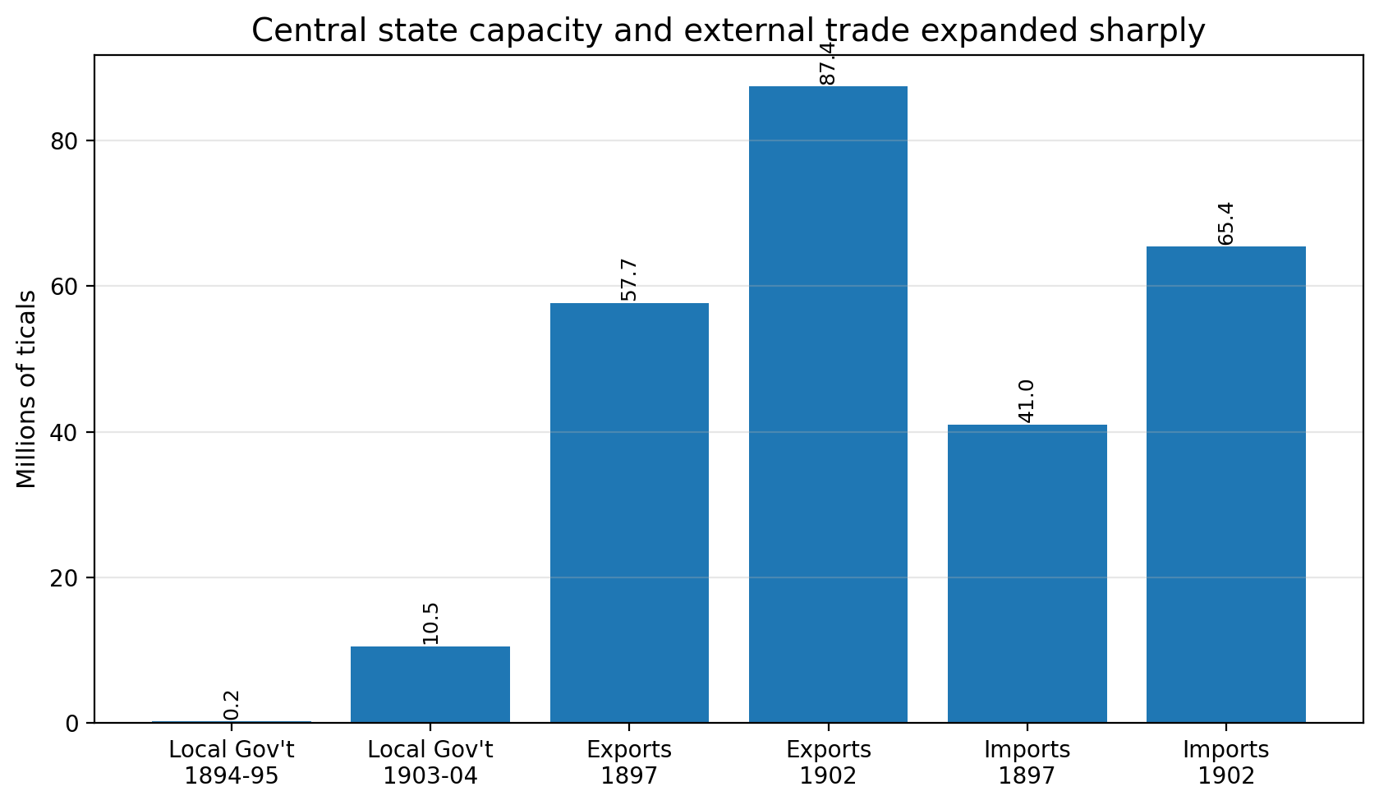
Figure 8. State capacity and external trade both expanded sharply during the late reform era.
Cruikshank's account helps explain why slavery and corvée could be attractive to rulers. He notes that a phrai trying to escape corvée could face a monthly payment of 6 baht, whereas a slave before 1873 was associated with a 5 baht annual tax paid by the master. That cost differential made dependency structurally convenient. Abolition therefore changed not only moral language but the fiscal and administrative organization of labor.
External pressure mattered too. Van Roy stresses French interest in Lao captive communities after the 1893 crisis; FRUS documents the 1904–05 Siam-French settlement; and the Anglo-French declaration of 1904 placed Siam within a formal imperial diplomatic arrangement. The abolition timeline is therefore best understood as the joint product of domestic reform and external constraint, not as either factor alone.
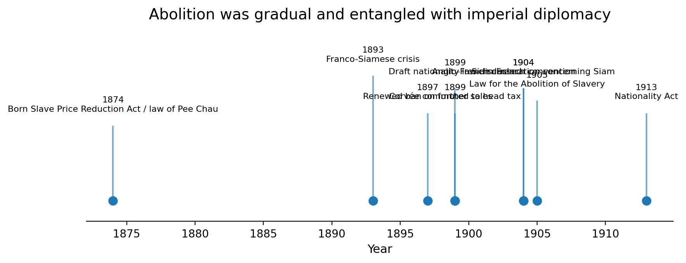
Figure 9. Abolition was gradual and closely entangled with diplomatic settlement and labor-regime reform.
6. Welfare proxies and regional disparity
Direct welfare measures are sparse, so this project uses proxies cautiously. Bowring noted that masters were obliged to supply rice and salt fish but not clothing. The 1880 consular report described a progressive diminution of means of subsistence. The Kingdom of Siam (1904) stated that the Korat plateau had almost no rice to spare for export. These are not nutrition surveys, but together they indicate that the welfare floor for dependent labor was thin and regionally uneven.
The 1904 census also recorded houses and persons per house for the detailed monthons. Household size is not a direct welfare measure, but it offers a rough demographic proxy for settlement pattern and crowding. The figure below should therefore be read cautiously and comparatively, not as a literal quality-of-life ranking.
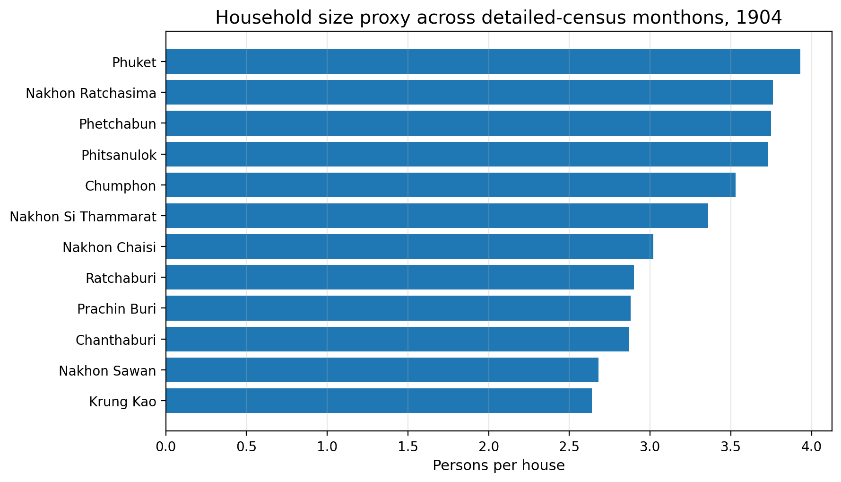
Figure 10. Persons per house across the detailed-census monthons, used here only as a rough comparative proxy.
Limitations and conclusion
This project has three main limitations. First, the archival record is elite-authored: diplomats, officials, and later scholars dominate the surviving evidence. Second, the 1904 census is incomplete and politically shaped. Third, the project necessarily combines materials from the 1850s, 1880, 1904, and 1905, which means it reconstructs a system over time rather than offering a perfect single-year snapshot.
Even with those limitations, the data are sufficient for a strong structural conclusion. Slavery in Siam was a large, multiform system of labor dependence that helped sustain a Bangkok-centered order. Lao / Isan people were essential to that system not only as border populations but as captives, builders, artisans, palace workers, and later urban laborers folded into new administrative and commercial regimes. The abolition of slavery did matter, but it worked through gradual debt reduction, classification change, and labor reorganization rather than through a single clean break with coercion.
For portfolio purposes, the deeper contribution of the project is methodological: it shows how messy, fragmentary, qualitative historical evidence can be converted into a linked dataset, analyzed statistically with transparent assumptions, and presented as a rigorous economic-history argument.
Primary sources used
Bowring, John. 1857. The Kingdom and People of Siam, Vol. 1. London: John W. Parker and Son. URL: https://archive.org/download/kingdompeoplesi1bowr/kingdompeoplesi1bowr.pdf
British Foreign Office / Consul-General in Siam. 1881. Report by Her Majesty's Agent and Consul-General in Siam for the Year 1880. URL: https://seadelt.net/Asset/Source/Document_ID-267_No-01.pdf
Carter, A. Cecil, ed. 1904. The Kingdom of Siam. Siamese Section, Louisiana Purchase Exposition. URL: https://ia601301.us.archive.org/22/items/kingdomofsiammin00louirich/kingdomofsiammin00louirich.pdf
Office of the Historian, U.S. Department of State. 1905. Law for the Abolition of Slavery, Ratanakosindr Sok 124. URL: https://history.state.gov/historicaldocuments/frus1905/d930
Office of the Historian, U.S. Department of State. 1905. Siam-French Convention and related diplomatic correspondence. URL: https://history.state.gov/historicaldocuments/frus1905/d927
British Treaty Series. 1905. Declaration between the United Kingdom and France concerning Siam, Madagascar, and the New Hebrides. Signed April 8, 1904. URL: https://treaties.fcdo.gov.uk/data/Library2/pdf/1905-TS0007.pdf
Secondary works used for reconstruction
Cruikshank, R. B. 1975. "Slavery in Nineteenth Century Siam." Journal of the Siam Society 63(2). URL: https://thesiamsociety.org/wp-content/uploads/1975/03/JSS_063_2j_Cruikshank_SlaveryIn19thCenturySiam.pdf
Grabowsky, Volker. 1996. "The Thai Census of 1904: Translation and Analysis." Journal of the Siam Society 84(1). URL: https://thesiamsociety.org/wp-content/uploads/1996/03/JSS_084_1d_Grabowsky_ThaiCensus1904.pdf
Le May, Reginald. 1920. "The Coinage of Siam." Journal of the Siam Society 18(3). URL: https://thesiamsociety.org/wp-content/uploads/2020/02/JSS_018_3b_LeMay_CoinageOfSiam.pdf
Van Roy, Edward. 2009. "Under duress: Lao war captives in Bangkok in the nineteenth century." Journal of the Siam Society 97. URL: https://so06.tci-thaijo.org/index.php/pub_jss/article/view/158250

