Advances in Battery Technology

Alyanna Y. Castillo, *UWEE*, Patrick G. Ma, *UWEE*, Ryan A. McDaniel, *UWEE*

*Abstract*—This paper will outline a few specific examples of the current advances in battery technology.  These examples will cover a few different types of organic batteries, flexible batteries, and supercapacitors.  Each of these has a different application for the future of electronic systems, ranging from electronic paper to waste water power management.  The applications of batteries is vast, and advancing battery technology beyond the bulky and heavy devices that are common now is essential for new electronics to become successful.

*Index Terms*— Advances, bacteria, battery, capacitors, electric cars, flexible, nanodot, nanoporous nickel-fluoride, StoreDot, supercapacitor.

# INTRODUCTION

B

atteries have become more and more important in the world of technology in the last few years.  The rise of smartphones in the consumer space made the demand for long-lasting batteries apparent.  High oil prices have shifted the focus of the automotive industry to efficient alternatives, like electrically powered vehicles.  Despite all of this demand, batteries are still the limiting factor in several revolutionary designs.

A typical battery is very large and bulky for the amount of energy it provides.  The designer of an electric car not only has to worry about carrying around the passengers, but also the immense weight of the batteries needed to power it. On a smaller scale, the main contribution to the weight and thickness of a smartphone is the battery that powers it. The battery has a very short lifespan - an owner of a smartphone has no doubt complained about how they have to recharge their year-old phone halfway through the day.  Luckily, researchers have been looking into smaller, lighter, and longer lasting alternatives to current battery technology.  The first of which, is the supercapacitor.

# Supercapacitors

Supercapacitors are an alternative way of storing energy. Also known as ultracapacitors or double-layer capacitors, they differ from regular capacitors in that they have a very high capacitance. Energy is stored through static charge instead of an electrochemical reaction. Table 1 shows a chart comparing the performance of a supercapacitor to a Li-ion battery [1]. The table shows the few advantages supercapacitors have. They may be charged and discharged an unlimited number of times without the same memory leak as most regular batteries. For example, after 10 years a supercapacitor may go from 100% to 80% in maximum storage. They also have a charge time of 10 seconds, making them ideal for fuel cells in electric cars. However at full charge, they discharge faster than li-on batteries, which discharge 5% a month. A supercapacitor can decreases from 100% to 50% in a month due to its linear discharge rate. Research is being done to resolve these issues, such as the Store Dot.

|  |  |  |  |  |
| --- | --- | --- | --- | --- |
|  | Energy[1] | Power[2] | Life Cycle | Discharge Time |
| Battery | High | Low | Short | Slow |
| Super Capacitor | Low | High | Long | Fast |

Table 1. Battery and Supercapacitor Comparison

The table shows the few advantages supercapacitors have. They may be charged and discharged an unlimited number of times without the same memory leak as most regular batteries. For example, after 10 years a supercapacitor may go from 100% to 80% in maximum storage. They also have a charge time of 10 seconds, making them ideal for fuel cells in electric cars. However at full charge, they self discharge faster than ii-on batteries, which discharge 5% a month. A supercapacitor can decreases from 100% to 50% in a month due to its linear discharge rate. Research is being done to resolve these issues, such as the Store Dot.

# StoreDot

StoreDot is an Israeli company that plans to reinvent the battery using Quantum Dot technology [2].  Their specific trademark is called Nanodot, which is a small protein called a peptide that can hold an electric charge.  The company would sandwich these peptides between two dielectric sheets.  After placing an electrode on each sheet, the system would become a new type of supercapacitor.

StoreDot’s supercapacitor would have the advantages of both batteries and supercapacitors.  The capacitor would charge quickly and discharge slowly, and it could be recharged and discharged several times before losing capacity.  The problem with the nanodot capacitor is that the company has only created a prototype for the concept, not a consumer prototype. Demo videos for the concept can be found on YouTube, which shows how the technology can be used to fully charge a near empty Samsung Galaxy S4 within 30 seconds. A screenshot of the video can be found in Fig. 1 [3]. A consumer prototype has yet to be developed. Beginning mass production on this type of capacitor would be difficult as well, since it is a completely new method of storing energy. There is still a lot of work to do for StoreDot, and their technology will have be proven a bit more before it hits the mass market.

. 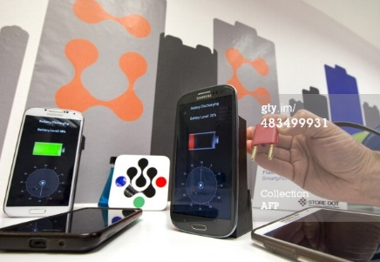

Figure 1. Screenshot of StoreDot Concept Video

# Microbial Battery

The microbial battery was developed by a team at Stanford University.  They call it a Microbial Fuel Cell (MFC), and it uses exoelectrogens to generate electricity from sewage [4].  Exoelectrogens are a type of bacteria that evolved to emit electricity upon digestion of plant and animal waste.  These bacteria can be placed in a sample of waste water along with some kind of catalyst in order to store electricity.

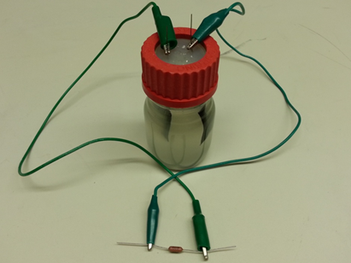

Figure 2. Stanford’s Microbial Battery

Researchers at Stanford demonstrated the use of exoelectrogens by adding them to a sample of waste water along with some silver oxide (Fig. 1).  Two electrodes were attached to the container holding the waste water, and the team waited while the bacteria fed on all of the garbage in the liquid.  As the bacteria ate, the silver oxide would capture the electrons being emitted, which would cause the silver oxide to turn into silver metal and accumulate on the electrodes.  When the bacteria finishes eating, all the silver metal is taken out of the waste water and reoxidized to release the stored electricity.

The process described above would yield approximately 30% of energy that is contained in waste water.  This is actually a pretty good efficiency rating, considering solar panels also are only around 30% efficient.  However, there is more solar energy out there than there is waste water energy.  The researchers hoped that this process could be used to offset the cost of waste water treatment, not necessarily power consumer electronics. Microbial fuel cells have not been deployed in waste water plants yet.  The Stanford experiment was only a proof of concept, and in a real application silver oxide is too expensive to use as a catalyst.

# Flexible Batteries

As devices become smaller and more powerful, the need for smaller batteries increases. Flexible battery technology is a solution to this problem, since they do not have the same physical limits as lithium ion batteries or supercapacitors. These make them ideal for wearable computers and roll-up displays. Recently, flexible batteries have been incorporated into RFID tags, smart cards, smart labels, and smart stickers. Smart stickers thermometers on packages of meat can track the temperatures of the product as it is being transported. Bus passesand credit cards can be electronic because flexible batteries can be placed in them without being bulky.

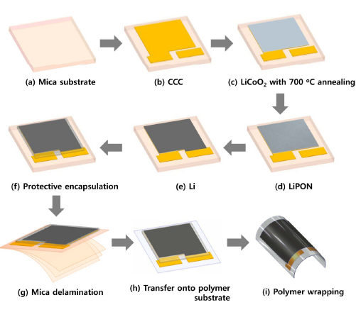

Figure 3. Universal Approach for Flexible Thin-Film Li-Ion Batteries

   Most flexible batteries share a similar appearance. They are essentially the Li-ion battery created with thin layers of each chemical, as depicted in Figure 2 [5]. Energy is stored through electrochemical reactions between the different layers. However, there are various types of flexible batteries that are designed by different labs. For example, Blue Spark Technology specializes in disposable flexible batteries, which are commercially available. These non rechargeable batteries look like band aids and can be used in implantable medical devices.

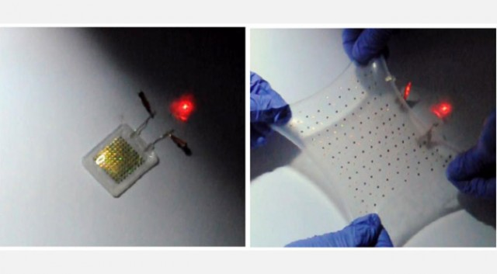

Figure 4. Stretchable Battery

The University of Illinois has a flexible lithium ion battery that can stretch but still retain charge, as shown in the image above. The battery is made up of tiny lithium ion cells which are connected by a network of silicon wires. Fig 5 below shows a close up of how the cells are connected in these batteries [6].

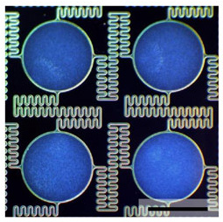

Figure 5. Close-Up of Stretchable Battery

These silicon wires have a spring shape to them as shown above, allowing them to be stretched out and retain charge. Unlike Blue Spark’s batteries, these can be wirelessly recharged through induction.

Despite the physical advantages of flexible batteries, many still have the same problems as regular batteries, such as a low life cycle and low power density (kilo-watts/kg). Even high capacitance materials like lithium and graphene, which are used in high performance batteries, are generally brittle and difficult incorporate into flexible batteries.

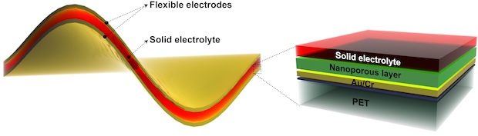

Figure 6. Nickel Based Flexible Battery

Rice University’s flexible battery design has the advantages of a supercapacitor and a battery. Instead of lithium, they use a layer of nanoporous nickel-fluoride electrodes [7]. From the figure above, the structure is similar to a supercapacitor since the layers are of solid electrolytes instead of the liquid/gel electrolytes used in most flexible batteries [8]. However, it behaves like a battery through its electrochemical reactions for storing energy. The nano-sized pores in the nickel layer give more flexibility than lithium, allowing the battery to retain its supercapacitor/battery qualities even after being flexed 1000 times.  Below is a table comparing the characteristics of Rice’s flexible battery to a supercapacitor and a Li-ion battery:

|  |  |  |
| --- | --- | --- |
| Type | Energy Density[3] | Power Density[4] |
| Li-On Battery | 200 | 0.005-0.4 |
| Supercapacitor | 5-25 | 10-100 |
| Ni-Flex Battery | 384 | 112 |

Table 2. Nickel Flexible Battery Comparison

From the table, the flexible battery has the energy density of a Li-ion battery, but retains the power density of a supercapacitor. Though further research is required to develop a manufacturing process for these batteries, these seem to be the ideal design for flexible batteries.

# Future

The commercial needs of products will be the largest driver of future battery development. As a result of this commercial driving force, the field of battery technology will diversify to match the needs of the devices and machines which use it. Since the consumer electronics industry was the first adopter of battery technology, some of the biggest steps forward have come about as a result of the need for batteries that combine lightweight, moderate power, and increasingly longer capacity batteries. Battery companies are trying to make batteries that are lighter, faster charging and flexible.

With the increased viability of ultra portable medical devices, manufacturers have to add to the existing consumer battery technology. Not only must batteries be lightweight, but now they must be a fraction of the size. Already battery technology can print batteries of the tiniest proportions. Expect future batteries to become even more compact and unobtrusive.

At the other end of the spectrum, automobile manufacturers are focusing heavily on electric vehicles. This demanding batteries capable of very high power capacities and the ability to deliver moderately high currents. weight is less of an issue, but minimization is still important. In this area of battery development, the use of more efficient nanocrystals and other lithium manufacturing techniques may become a significant factor. Improvements here are expected to deliver cars with gas mileage beyond 1000 miles per gallon.

Large scale power has also begun to place demands on batteries, as shown in Fig. 6 [7]. These batteries would be used to store massive amounts of energy --and deliver large amounts of current and voltage. Weight is a non-issue in this area, but the difficulty lies in creating efficient batteries able to deliver such large amounts of power quickly and store excess power as production and demand fluctuate. Being capable of capturing power from intermittent renewable energy sources and outputting clean power is a major factor in development for this field of electrical engineering.

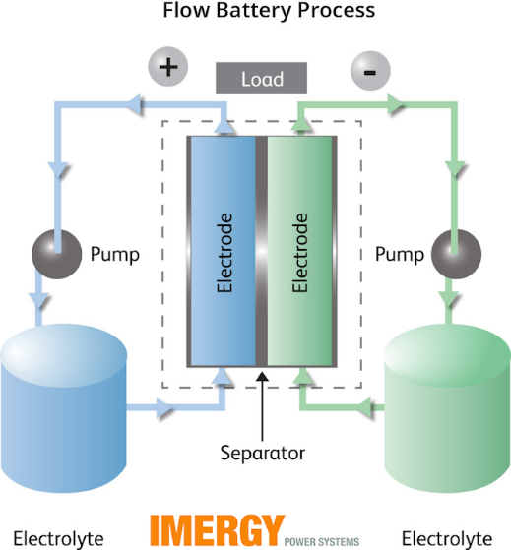

Figure . Large-Scale Power Battery Concept

Recently, several companies such as Aquion Energy and Sumitomo have announced batteries designed specifically for large-scale power grids [10]. It is reasonable to expect large-scale power batteries to form the basis for power management and energy storage in future power grids.

# Conclusion

As the technology we rely on becomes more and more advanced, the demands on batteries to meet our energy needs increases. With more fields of electrical engineering looking for consistent or portable power delivery, battery research has begun to increase. A single solution is no longer possible to address the diverse needs of each industry.

In addition to continued research in existing technologies, new approaches to batteries have shown commercial promise. In particular, supercapacitor-like batteries such as StoreDot and bio-chemical microbial alternatives show promise to revolutionize how are batteries viewed at large. Flexible and printable batteries are opening new avenues and markets for existing products and allowing the creation of devices which recently existed as only concepts. The research and concepts of today are quickly becoming the reality of tomorrow.

Acknowledgment

R. McDaniel, P. Ma, and A. Castillo thanks Payman Arabshahi for giving us this assignment and the Electrical Engineering at the University of Washington for giving us the opportunity to take this course.

References

[1] “*Lithium-based Batteries Information – Battery University.*” [Online]. Available: http://batteryuniversity.com/learn/article/lithium_based_batteries. [Accessed: 31-May-2014].

[2] “*Israeli company develops bio-organic LED displays to compete with OLEDs*.” [Online]. Available: http://www.oled-info.com/israeli-company-develops-bio-organic-led-displays-compete-oleds. [Accessed: 26-May-2014].

[3] “*Israel-Technology-Communications-Phone-Charger*.” [Online]. Available: http://www.gettyimages.com/detail/news-photo/member-of-the-israeli-startup-storedot-demonstrates-a-bio-news-photo/483499931. [Accessed: 26-May-2014].

[4] “*Stanford scientists use ‘wired microbes’ to generate electricity from sewage.*” [Online]. Available: http://www.eurekalert.org/pub_releases/2013-09/ssoe-ssu091113.php. [Accessed: 26-May-2014].

[5] E. Xu, “*Flexible, Transparent Battery: Unveiled by Stanford Professor and Graduate Student.*” [Online]. Available: http://www.eurekalert.org/pub_releases/2013-09/ssoe-ssu091113.php. [Accessed: 26-May-2014].

[6] S. Xu, Y. Zhang, and J. Cho, “*Stretchable batteries with self-similar serpentine interconnects and integrated wireless recharging systems*,” *Nature Publishing Group*, vol. 4, Feb. 2013.

[7] M. Williams, “*Flexible battery, no lithium required,*” 28-Apr-2014. [Online]. Available: http://news.rice.edu/2014/04/28/flexible-battery-no-lithium-required/. [Accessed: 04-May-2014].

[8] Y. Yang, G. Ruan, G. Wang, and J. M. Tour, “*Flexible Three-Dimensional Nanoporous Metal-Based Energy Devices.*” Journal of the American Chemical Society, 30-Apr-2014. [Accessed: 24-May-2014]

[9] *“Imergy Power Systems and Flextronics to Collaborate on Advanced Energy Storage Solutions.*” Solar Novus Today, 2-Dec-2013. [Online]. Available: http://www.solarnovus.com/imergy-power-systems-and-flextronics-to-collaborate-on-advanced-energy-storage-solutions_N7254.html. [Accessed: 24-May-2014]

[10] AquionEnergy, “*S10 Battery Stack for Stationary, Long-Duration Applications*.” [Online]. Available: <http://www.aquionenergy.com/energy-storage-battery>. [Accessed: 24-May-2014].

1. Energy-Density (watt-hours / kg)
2. Power-Density (kilo-watts / kg)
3. (watt-hours/kg)
4. (kilo-watts / kg)