Overview of commands to interact with DLP reader and RFID tags (TI HI-plus)

# Interacting with the Reader

The DLP reader has a host protocol depicted in Figure 1.

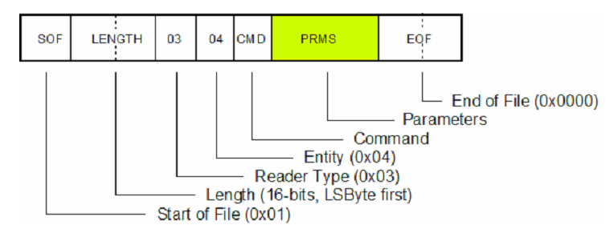

Figure :DLP host protocol

The protocol begins with a 0x01 (Start Of File) byte, then 2-bytes for the length (Least Significant Byte first). Bytes 5 and 6 are always 0x03 and 0x04 respectively and they are followed by a command byte. There are THREE basic commands we can use (see Figure 2).

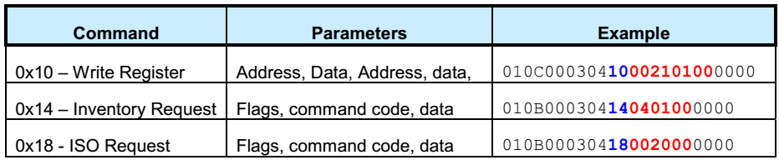

Figure :Basic RFID tag commands

Communication with the RFID tags uses the ISO15693 protocol commands. To use these commands, the ISO request command is passed to the DLP reader and the parameters are the actual ISO15693 command.