User Manual

step 1 - running the web application:

1.1: navigate to server directory, and then run the command node index.js.  
 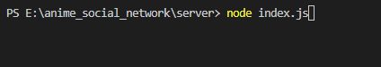

1.2: navigate to client directory, and then run the command npm start.

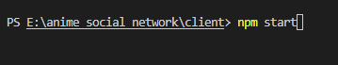

step 2 - connecting to the web:

2.1: to sign in an existing user, go to Login and fill the correct username\password combination.

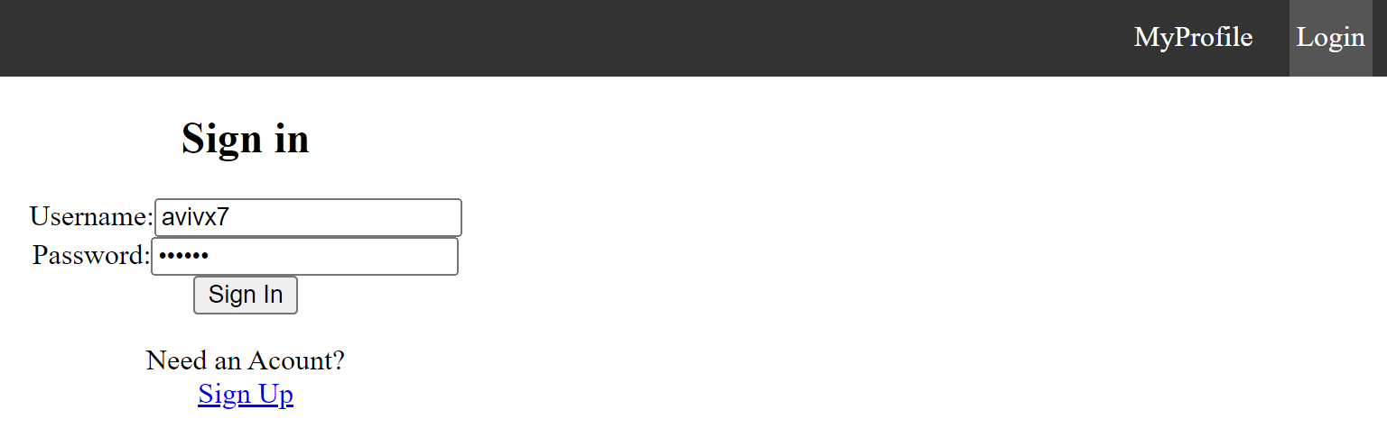

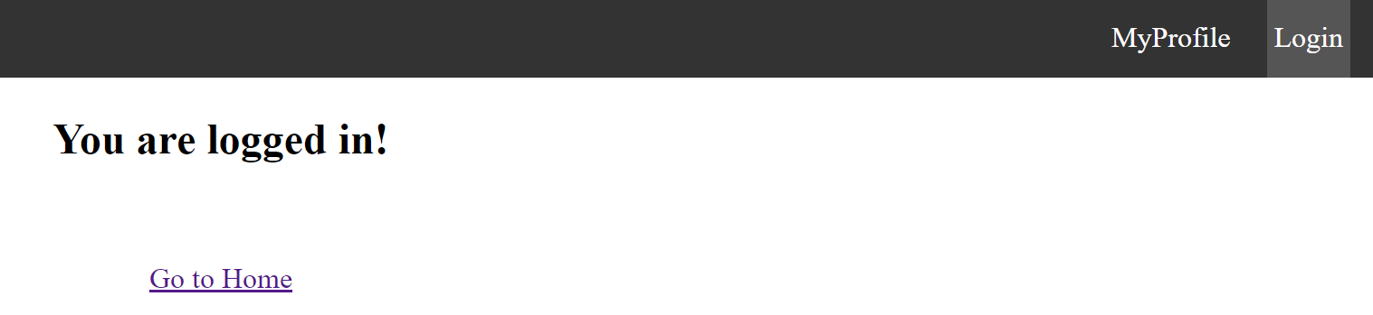

2.2(optional): to register go to Login and then click Sign up and fill your information.

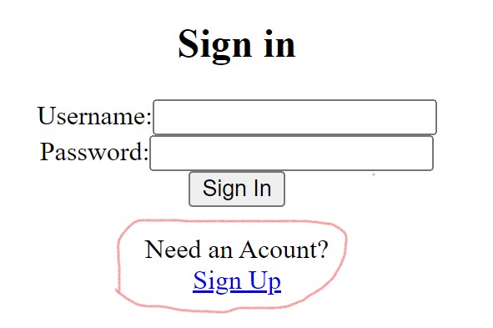

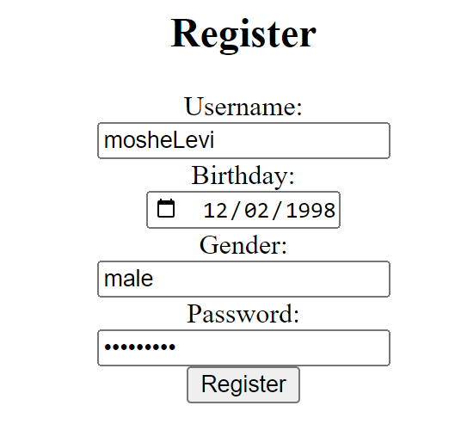

step 3 - using the application:

* in the Home page, you can search for anime\user information.
* in the profile page, you can watch your favorites animes, recent reviews, etc.  
   

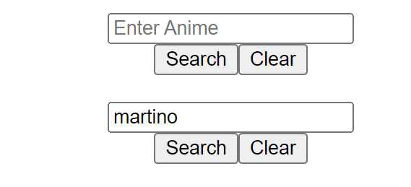 



Profile page:

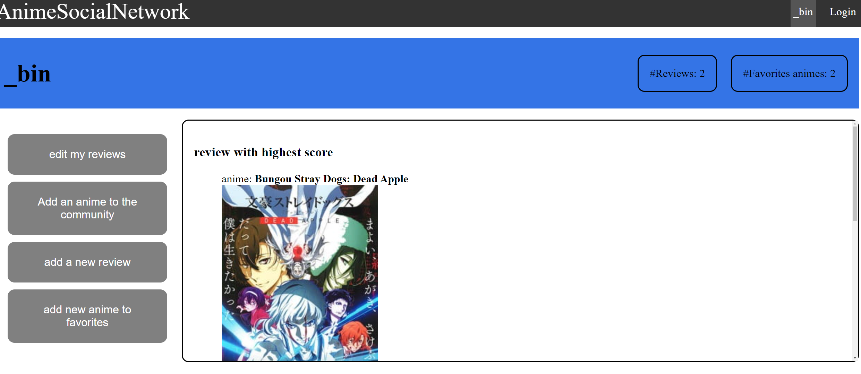

Edit review:

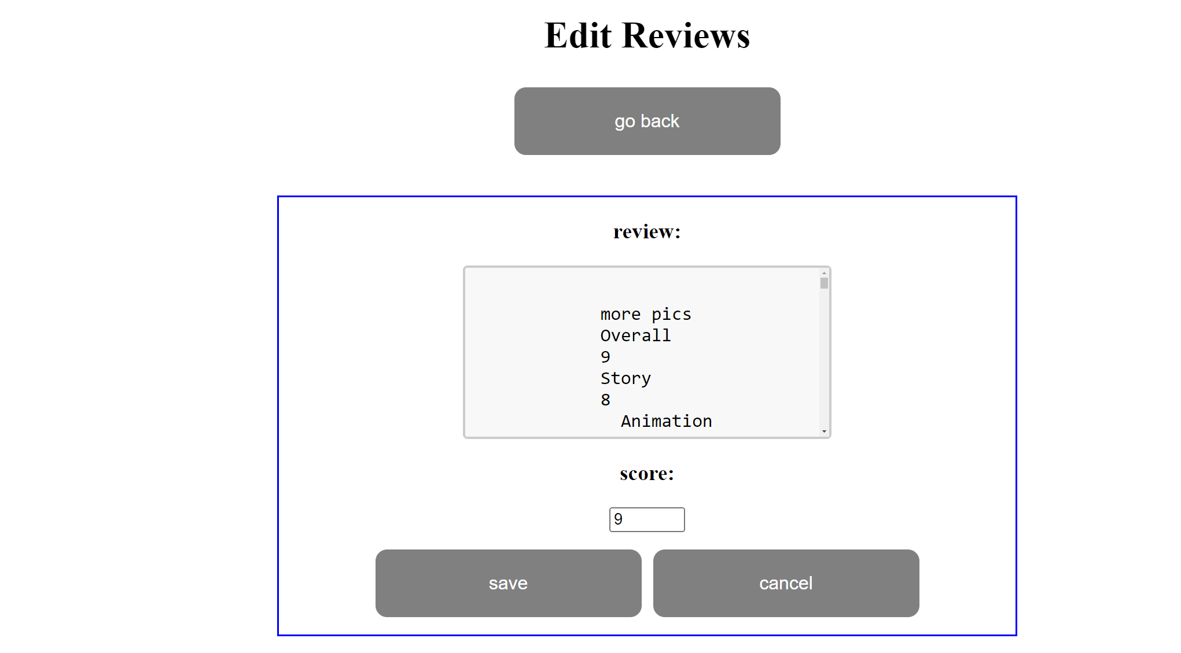 

Add anime:

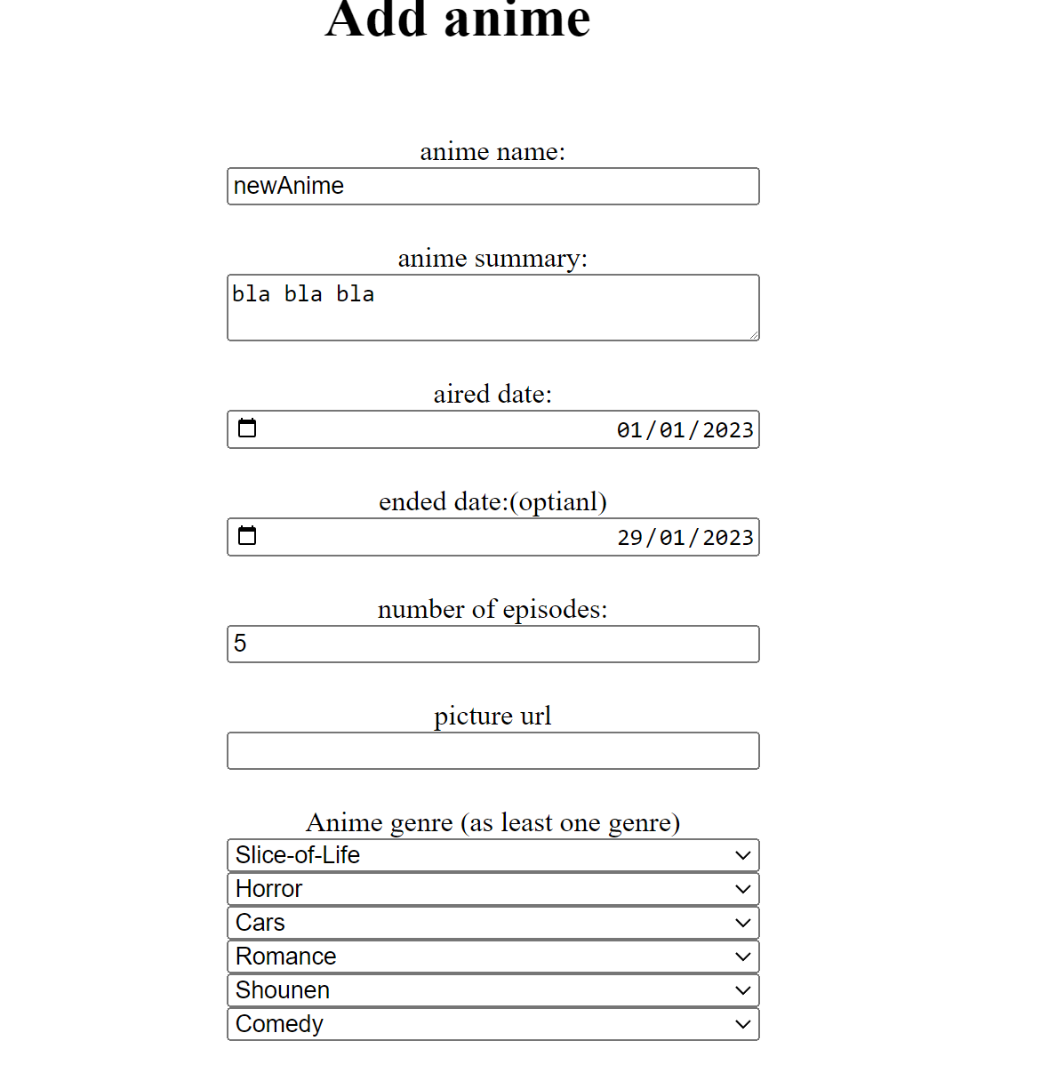

Add new review:

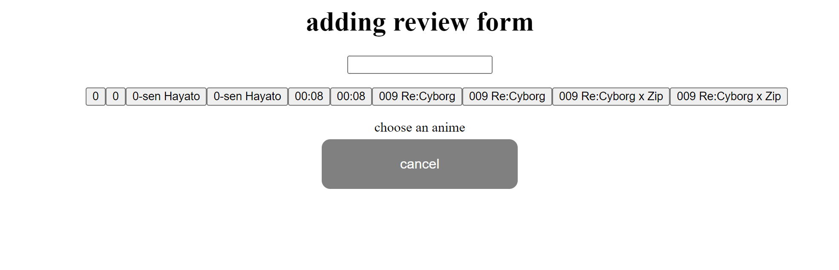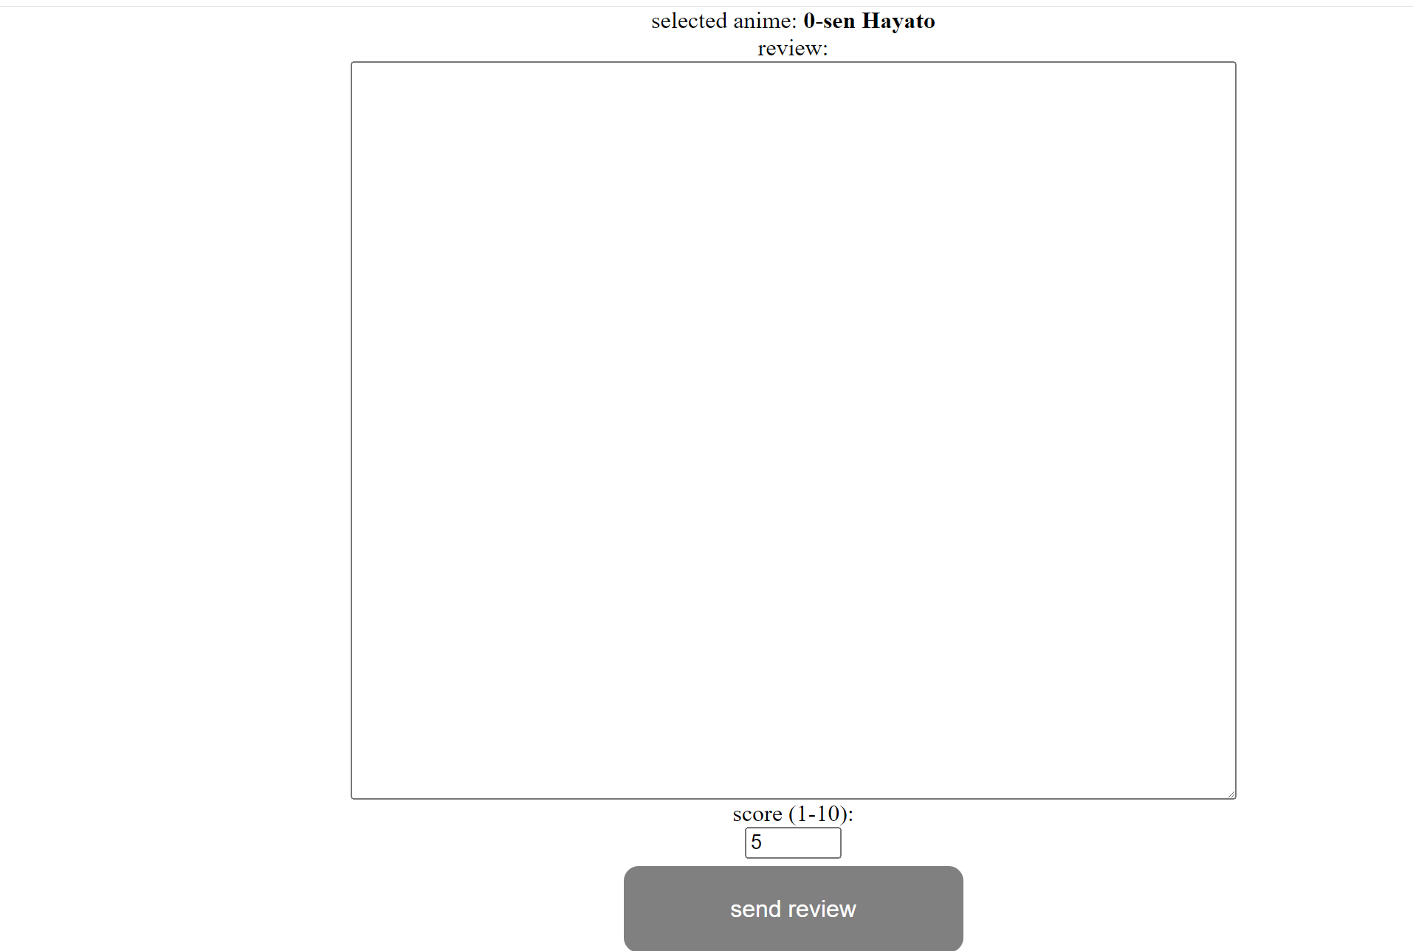

Add anime to favorites:

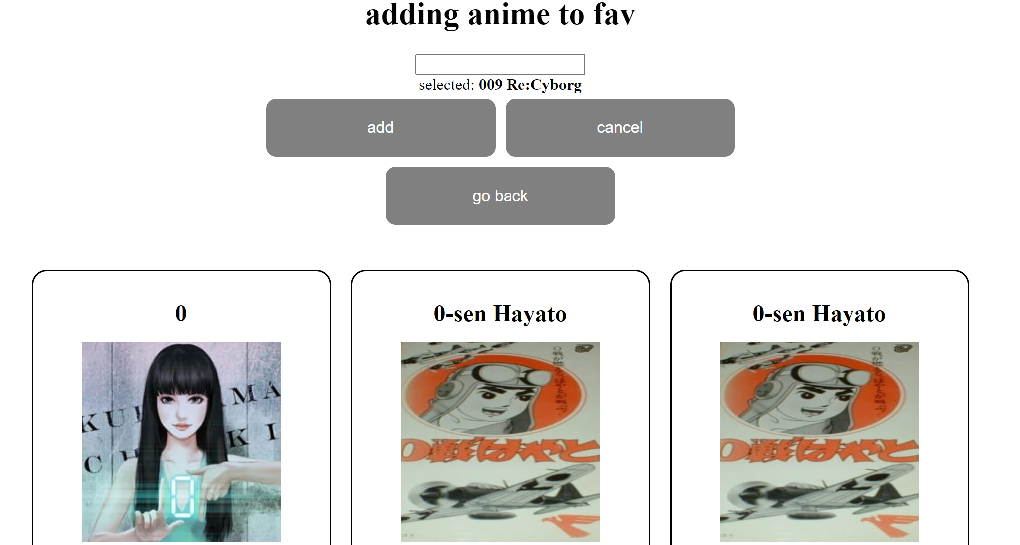

if you wish to sign in different user, repeat step 2.