Who owns digital learning resources founded by taxpayers? [0]

2016-03-05 Author: PLOTKIN Hal [1]blog[2] Geodata: Palo Alto[3] teaching[4] / open educational resources[5] / politics[6] / usa[7]
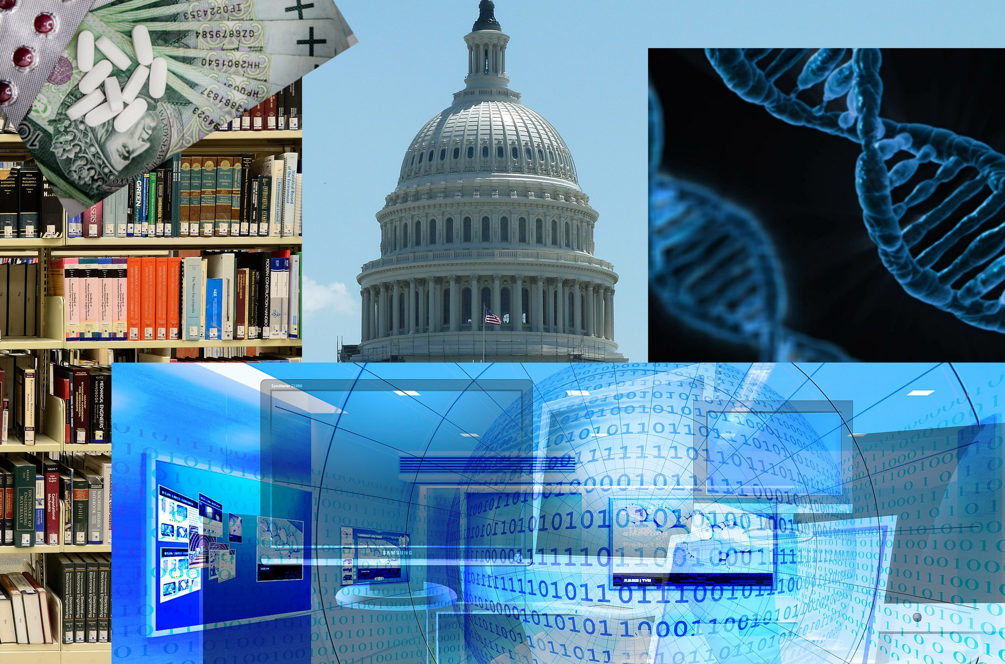
Image remixed by Horst JENS[8] sources/rights: Gerd Altmann[9], Michael Jarmoluk[10], public domain pictures[11], elastic computer farm[12], Jackelberry[13] at Pixabay cc 0/public domain[14]
Everyone wants to be a successful venture capitalist. That’s the conclusion I draw from written protests[15] lodged with the U.S. Department of Education by several higher education groups to a sensible and arguably long overdue rule change[16] proposed late last year by the Obama administration. The Obama administration’s goal, which is conveyed in a document called a Notice of Proposed Rulemaking[17], is to modernize federal contracting procedures for the digital age by requiring the use of open licenses on new intellectual property produced with U.S. Department of Education grants.
The grants, an estimated $2.8 billion in 2015[18], are often used to produce and test the impact of cutting-edge learning resources, including educational games and assessments. Barring a federal retreat and, with any luck, the updated rule requiring public access to these taxpayer-financed digital learning resources goes into effect later this year, that is, unless the administration backtracks and caves under pressure from groups such as theAssociation of American Universities and the Association of Public Land Grant Colleges[19].
The new requirement for open licenses as the default would allow anyone to freely use and improve digital learning resources if they were financed by taxpayers. The objections raised by university administrators and technology licencing managers are easy to understand: there’s an enormous amount of money at stake. Universities, and oftentimes the well-situated individuals who run them, are positioned to rake in huge sums if they can stop the Department of Education’s proposed new rule. What’s more, the chance to join the ranks of Silicon Valley’s tech elite beckons. Who wouldn’t want to be the next John Hennessy[20] ?
The trick is this next round of big money payouts can only happen if the college administrators can stop the public from owning what the public paid for. In practical terms, what the university administrators seek is an extension of the Bayh-Dole Act, a Reagan-era law that privatized the fruits of taxpayer-financed research. Bayh-Dole was one of the first major examples of the way right wing dogma was enshrined into federal law during the ascendancy of conservative economics post-Carter. The bipartisan law granted universities patent rights to federally-funded inventions created on their campuses. With their latest filings, the colleges now seek to extend their claims of ownership to works financed by the public past those that can patented, such as new inventions, to those that can only be copyrighted, such as digital books, tests, and other online learning resources.

Big Pharma is the Model
Big Pharma is a good example of how the relationship between federally-funded research on campus and commercial markets now works (or doesn’t). Gene-splicing technology, for example, was invented by Herbert Boyer and Stanley Cohen in 1977. Before they expired in 1997, the patents granted to their universities under Bayh-Dole had generated more than \$200 million in royalty payments for the University of California at San Francisco and Stanford, where the two scientists worked. Experts universally agree gene splicing technology gave rise to the modern biotech industry.
What is less well-known is that progress in practical applications of genetic medicine dramatically accelerated after, not before, the university patents expired. According to the FDA, 41 new molecular entities and biotech drugs were approved in the U.S. during 2014[21], nearly twice the average annual rate during the 1980’s[22], when the gene splicing technology was still locked down. One reason: the recent discovery that accurate genetic information, which is now more readily available at lower costs, doubles the success rate of new investigational drugs[23].
The issue of whether the Big Pharma model should be extended past patents to also include copyrights has gained traction recently as more and more education moves online, a transition that has many rent-and royalty seeking university technology managers and investors sensing a potentially lucrative new opportunity. They hope, for example, to claim ownership and cash in big time when the federal government provides a grant to produce new online educational games that move obvious ideas, such as a math quiz or a problem set suited for students with dyslexia or autism, from pen and paper into a digital format.

But what if gene splicing technology had been available for free use by every interested scientist when it was first invented, nearly 40 years ago?
Before universities are permitted to expand the financial incentives they enjoy to also claim ownership of copyrightable works produced at their schools that are paid for by taxpayers they should first be required to accurately report the opportunity costs associated with the last wave of federal research privatization. What if Bayh-Dole had never been enacted and gene splicing technology had been available for free use by every scientist and researcher when it was first invented, nearly 40 years ago? What if the federal government had mounted an aggressive effort at that time — four decades ago — to develop and train research teams to use free, open gene splicing technology to improve public health? Are there better, faster models of drug discovery and development that don’t involve giving an exclusive patent to the university where the publicly-funded research happened to take place? And finally, what is the name of your loved one who might still be alive today if open science had come before private profits?
Even if the present Big Pharma-University research model really is the very best way imaginable to most rapidly develop important new drugs and bring them to market at affordable prices, which remains very much an open question, there is no good reason to extend the same Reagan-era privatization scheme to federally funded educational resources. There are already ample venture capital funds available — \$48 billion in 2014 — to support proprietary ed tech ventures. Put simply, if university administrators want to become venture capitalists in the world of educational resources that is perfectly fine. But they should use their own money, not the public dime.
Before computers, there was no question that when the government used tax dollars to build a new brick and mortar school, the public owned that school. No one would have ever dared propose that the contractor who received public funds to build a school should also get the keys to the school along with the right to extract royalty payments from all those who entered. The U.S. Department of Education is merely trying to make sure the same rules apply today when federal funds are used to create what are essentially digital schools. The outcome will determine whether Department of Education grants create public educational resources that everyone everywhere can immediately use and build on, or whether the fruits of those investments will be bottled up for decades by academic institutions and administrators hoping to charge rent on new digital educational products, tools and resources the public already paid for.
Hal Plotkin is the Senior Open Policy Fellow at Creative Commons USA and a former Senior Policy Adviser in the Office of the Under Secretary, U.S. Department of Education (2009–2014). Mr. Plotkin is also a former Silicon Valley correspondent for CNBC.com.
This article was first published at Medium.com[24] under a creative commons attribution (cc-by 4.0) license[25].
About this article:


Name: Hal PLOTKIN[26]
Contact: @HalPlotkin[27], contact form[28]
Shorturl: http://goo.gl/Qdfp5F[29]
Hashtag: #oer
Fork / improve: on Github[30]
License for text and photos in this article, unless indicated otherwise (e.g. Image rights notice below pictures): creative commons attribute 4.0 (cc-by)[31]
Extras:: Author's Blog[32], original article at medium.com[33]
about the author: Hal W. Plotkin (born September 14, 1957) is an American journalist and activist. He is currently the senior open policy fellow at Creative Commons[34]
From 2009 to 2014, Plotkin served as the Senior Policy Advisor in the Office of the Under Secretary of Education, United States Department of Education[35], which has responsibility for all federal U.S. higher education policies and programs.
In 2003, Plotkin initiated the Foothill-De Anza Community College District's Policy on Public Domain Learning Materials which are now more commonly known as Open Educational Resources[36].read more of Wikipedia entry about Hal Plotkin...[37]
Donate author: No donation address given yet.
Location: 37.441883;-122.143019[38]
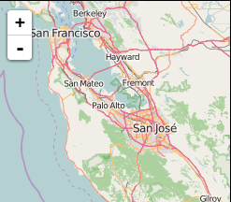

technical terms explained by Wikipedia:


FDA[39]: The Food and Drug Administration (FDA or USFDA) is a federal agency of the United States Department of Health and Human Services, one of the United States federal executive departments. The FDA is responsible for protecting and promoting public health through the regulation and supervision of food safety, tobacco products, dietary supplements, prescription and over-the-counter pharmaceutical drugs (medications), vaccines, biopharmaceuticals, blood transfusions, medical devices, electromagnetic radiation emitting devices (ERED), cosmetics, animal foods & feed and veterinary products.
The FDA was empowered by the United States Congress to enforce the Federal Food, Drug, and Cosmetic Act, which serves as the primary focus for the Agency; the FDA also enforces other laws, notably Section 361 of the Public Health Service Act and associated regulations, many of which are not directly related to food or drugs. These include regulating lasers, cellular phones, condoms and control of disease on products ranging from certain household pets to sperm donation for assisted reproduction.read more of Wikipedia entry about FDA...[40]

Bay-Dole Act[41]: The Bayh–Dole Act or Patent and Trademark Law Amendments Act (Pub. L. 96-517, December 12, 1980) is United States legislation dealing with intellectual property arising from federal government-funded research. Sponsored by two senators, Birch Bayh of Indiana and Bob Dole of Kansas, the Act was adopted in 1980, is codified at 94 Stat. 3015, and in 35 U.S.C. § 200-212, and is implemented by 37 C.F.R. 401.
The key change made by Bayh–Dole was in ownership of inventions made with federal funding. Before the Bayh–Dole Act, federal research funding contracts and grants obligated inventors (where ever they worked) to assign inventions they made using federal funding to the federal government. Bayh–Dole permits a university, small business, or non-profit institution to elect to pursue ownership of an invention in preference to the government. read more of the Wikipedia entry about Bay-Dole Act...[42]

[0] http://internationalopenmagazine.org/2016-03-05-who_owns_digital_learning_resources.html
[1] http://internationalopenmagazine.org/author/plotkin-hal.html
[2] http://internationalopenmagazine.org/category/blog.html
[3] http://www.openstreetmap.org/?mlat=37.441883&mlon=%20-122.143019#map=16/37.441883/-122.143019&layers=N
[4] http://internationalopenmagazine.org/tag/teaching.html
[5] http://internationalopenmagazine.org/tag/open-educational-resources.html
[6] http://internationalopenmagazine.org/tag/politics.html
[7] http://internationalopenmagazine.org/tag/usa.html
[8] http://spielend-programmieren.at/
[9] https://pixabay.com/en/banner-header-monitor-binary-909710/
[10] https://pixabay.com/en/medications-money-cure-tablets-257333/
[11] https://pixabay.com/en/dna-biology-medicine-gene-163466/
[12] https://pixabay.com/en/library-books-knowledge-information-1147815/
[13] https://pixabay.com/en/us-capitol-government-washington-dc-477987/
[14] https://creativecommons.org/publicdomain/zero/1.0/
[15] https://www.eff.org/deeplinks/2016/01/why-are-universities-fighting-open-education
[16] http://www.ed.gov/news/press-releases/us-department-education-launches-campaign-encourage-schools-goopen-educational-resources
[17] http://www.regulations.gov/#!documentDetail;D=ED-2015-OS-0105-0001
[18] http://atlas.newamerica.org/competitive-grants-entitlements-formula-funding
[19] http://cogr.edu/COGR/files/ccLibraryFiles/Filename/000000000264/DoEd_12-14-15_aau_aplu_autm_cogr.pdf
[20] http://www.wsj.com/articles/SB117226912853917727
[21] https://www.plunkettresearch.com/trends-analysis/biotechnology-drugs-pharmaceuticals-business-market/
[22] http://www.raps.org/Regulatory-Focus/News/2014/10/03/20488/How-Many-Drugs-has-FDA-Approved-in-its-Entire-History-New-Paper-Explains/
[23] http://medicalxpress.com/news/2015-07-genetic-association-drug-significantly-boost.html
[24] https://medium.com/@hplotkin/who-owns-digital-learning-resources-funded-by-taxpayers-543160cbf1f4#.8yhwvrr47
[25] https://creativecommons.org/licenses/by/4.0/
[26] https://en.wikipedia.org/wiki/Hal_Plotkin
[27] https://twitter.com/HalPlotkin
[28] http://plotkin.com/contact/
[29] http://goo.gl/Qdfp5F
[30] https://github.com/horstjens/internationalopenmagazine/blob/master/content/blog/2016-03-05-who_owns_digital_learning_resources.md
[31] https://creativecommons.org/licenses/by/4.0/
[32] http://brucebyfield.com/
[33] https://medium.com/@hplotkin/who-owns-digital-learning-resources-funded-by-taxpayers-543160cbf1f4#.8yhwvrr47
[34] https://en.wikipedia.org/wiki/Creative_Commons
[35] https://en.wikipedia.org/wiki/United_States_Department_of_Education
[36] https://en.wikipedia.org/wiki/Open_Educational_Resources
[37] https://en.wikipedia.org/wiki/Hal_Plotkin
[38] http://www.openstreetmap.org/#map=11/37.3873/-122.1309
[39] https://en.wikipedia.org/wiki/Food_and_Drug_Administration
[40] https://en.wikipedia.org/wiki/Food_and_Drug_Administration
[41] https://en.wikipedia.org/wiki/Bayh–Dole_Act
[42] https://en.wikipedia.org/wiki/Bayh–Dole_Act

