Can Kenya’s Laptops For Schools Project Deliver Greater Learning Efficiency? [0]
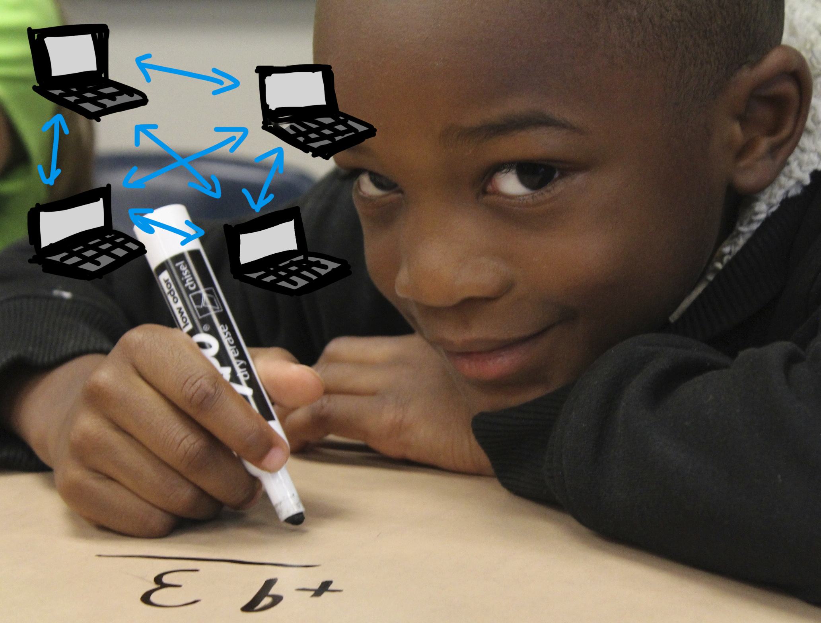
Image rights: cc 0/public domain[1] Image sources: Pixabay by Sandra Schön[2] and April Bryant[3]

This article was published 2016-02-24 by the author on iAfrikan[4] and later on his blog[5]. Republished by international open magazine under cc-by-sa license with friendly permission from the author
Following a protracted wait for the implementation of the promised laptop project for schools, the Kenya government finally announced that the exercise would kick off this month.
Speaking to the media, the newly appointed ICT CS Joe Mucheru[6] intimated that the pilot phase of the digital literacy program[7] is to kick off in selected primary schools in all the 47 counties.
This follows the awarding of tenders to Moi University[8], and Jomo Kenyatta[9] University of Agriculture and Technology[10]. The two institutions are mandated to conduct what the CS termed as “Proof of Concept”.
Technology integration to support education in classrooms is a phenomenon that continues to trend in Africa. Countries such as South Africa (through ) and Zimbabwe (through Econet wireless program) have in recent times been testing technology integration concept to support learning in schools.
With Kenya following suit, enthusiastic citizens will be eager to know if indeed this concept has the likelihood to transform our education system for the better.

The Potential impacts of using laptops for teaching and learning
Since the introduction of free primary education in Kenya, there has been a steady increasing demand in training and education.
In principle, this means that traditional teaching and learning methods will not suffice to take the country from Universal Primary Education (UPE)[11] into the Education For All (EFA)[12] agenda as stipulated in the Millennium development Goals (MDGs)[13]. This clearly calls for a business re-engineering process, a paradigm shift, and the adoption of alternative methodologies that will encourage continuous improvement of instruction, and personalized learning in our schools.
Therefore as the government readies to launch the digital literacy program in the course of the month, it’s of utmost importance to endeavor to look beyond the general hype behind ICT enabled learning in the quest to answer the question – can laptops deliver greater learning efficiency?
In recent years, a number of studies have been carried out by ICT4D experts to evaluate the impact of ICT enabled learning.
These studies have concluded that this mode of instruction can aid yield immense positive outcomes to learners and educators alike, but only if supported by holistic approaches such as appropriate policies, infrastructure, professional development, and curricula.
For instance, from a learner’s perspective, a Centre for Youth Empowerment and Leadership study indicates that technology enhanced learning can aid students increase motivation and performance; On average, a learner who does not use ICT enabled learning is rated at 50th percentile statistically, while one that uses ICT enabled learning ranks at about 70th percentile.
Another empirical research has it that if blended with Open Educational Resources (OERs)[14], laptops can provide equalized access to collective knowledge and provide many more learners with access to quality education through the use of books and curricula widely available on the Internet.
Additionally, laptops can empower learners with real life learning opportunities. This practical and real life experiences allow learners gain soft skills, such as time and work management, a course that permits for the enhancement of language and ICT skills, which can be acknowledged as being essential in this era. In general, laptops can deliver greater learning efficiency to learners, as well as promote continuous improvement of instruction and personalized learning.
From teachers’ perspective, laptops can be more effective tools capable of instilling educators with a more positive attitude towards their work in terms of increasing lesson planning, preparation and productivity.
This in turn aids educators to provide more personalized learning to their learners. These viewpoints definitely are clear indicators that effective learning can emanate from using ICTs to broaden educational opportunity and help students develop 21st century skills.

Caveat
Despite the numerous advantages of ICT enhanced learning among learners and educators, there is a flip side to these devices.
For instance, in order to enable teachers properly integrate devices in the classroom, there is a profound need for adequate investment in technology access and curriculum resources for them to apply what they learn in professional development activities. To this effect, it may be difficult to transform teaching and learning in an ICT enabled classroom environment without the sufficient technology skills required. Another factor is that of the distracting nature of the devices to the learners;
By design, technology enabled learning should by all means adhere to the principles of ergonomics. Ideally, a difficult gadget to navigate may adversely hamper learners’ engagement-a key requisite for learning.
From a technical angle, considering both educators and learners lack professional technical expertise in the event of device malfunction, it puts them at a disadvantage to handle such eventualities. In as much as it may be a non issue, it is essential especially for the educator to have basic technical trouble-shooting skills.

Conclusion
A COL review argues that though not tested statistically, laptops are more effective as learning tools when used with a student-centered approach, rather than within teacher-controlled environments.
Correspondingly, Intel findings[15] indicate that there are no longitudinal, randomized trials conclusively linking ICT enhanced learning with positive learner outcomes”. Nevertheless, there is need for the government to launch the digital literacy project to provide not just formal education, but all forms of learning if the country is to achieve the UN Sustainable Development Goals (SDGs)[16].
If implemented in a pensive and calculated manner, Kenya is bound to attain economic progress and become competitive globally as a result from developing a better educated workforce through ICT enabled learning.
about this article:


Author: Bonface WITABA[17]
Contact: @bswitaba[18], bswitaba@yahoo.co.uk[19]
Shorturl: http://goo.gl/zBdrL2[20]
Hashtag: #Kenya
Fork / improve: on Github[21]
Extras:: Author's Blog[22]
License for text and photos in this article, unless indicated otherwise (e.g. Image rights notice below pictures): creative commons attribute share-alike 4.0[23]
Location: -1.292066, 36.821946[24]

about the author: ICANN Fellow, and DiploFoundation Internet Governance alumni (Switzerland). He has also been nominated as the 2015 African young scholar and fellow in Communication Policy Research: south (CPRsouth), Yuan Ze University, Taiwan.
Bonface founded Centre for Youth Empowerment and Leadership (CYEL), an initiative that has won several international ICT awards for its concerted efforts to empower youth through digital inclusion.
He works as an e-learning tutor, consultant in technology and Policy areas of Internet Governance.
Donate author: Please use PayPal.com[25] to send donations to the author directly: bswitaba@yahoo.co.uk

explained by Wikipedia:
ICT[26]:
Information and communications technology (ICT) is an extended term for information technology (IT)[27] which stresses the role of unified communications[28] and the integration of telecommunications (telephone lines and wireless signals), computers as well as necessary enterprise software, middleware, storage, and audio-visual systems, which enable users to access, store, transmit, and manipulate information.
The term ICT is also used to refer to the convergence of audio-visual and telephone networks with computer networks through a single cabling or link system. There are large economic incentives (huge cost savings due to elimination of the telephone network) to merge the telephone network with the computer network system using a single unified system of cabling, signal distribution and management.
However, ICT has no universal definition, as "the concepts, methods and applications involved in ICT are constantly evolving on an almost daily basis." The broadness of ICT covers any product that will store, retrieve, manipulate, transmit or receive information electronically in a digital form, e.g. personal computers, digital television, email, robots. For clarity, Zuppo provided an ICT hierarchy where the all levels of the hierarchy "contain some degree of commonality in that they are related to technologies that facilitate the transfer of information and various types of electronically mediated communications."

[0] http://internationalopenmagazine.org/2016-03-01-kenia.html
[1] https://creativecommons.org/publicdomain/zero/1.0/
[2] https://pixabay.com/en/laptop-network-networking-peer-r22-341419/
[3] https://pixabay.com/en/boy-math-student-desk-elementary-1126140/
[4] http://www.iafrikan.com/2016/02/24/laptops-for-learning-can-they-deliver-greater-learning-efficiency/
[5] https://bonfacewitaba.wordpress.com/2016/03/01/can-kenyas-laptops-for-schools-project-deliver-greater-learning-efficiency/
[6] https://www.linkedin.com/in/joemucheru
[7] http://www.icta.go.ke/category/digischool/
[8] http://www.mu.ac.ke/
[9] http://www.jkuat.ac.ke/
[10] http://www.jkuat.ac.ke/
[11] http://www.un.org/millenniumgoals/education.shtml
[12] http://www.unesco.org/new/en/education/themes/leading-the-international-agenda/education-for-all
[13] http://www.un.org/millenniumgoals/
[14] http://www.unesco.org/new/en/communication-and-information/access-to-knowledge/open-educational-resources/what-are-open-educational-resources-oers/
[15] http://www.intel.com/content/www/us/en/education/intel-education.html
[16] http://www.un.org/sustainabledevelopment/sustainable-development-goals/
[17] https://bonfacewitaba.wordpress.com/
[18] https://twitter.com/bswitaba
[19] https://bonfacewitaba.wordpress.com/about/
[20] http://goo.gl/zBdrL2
[21] https://github.com/horstjens/internationalopenmagazine/blob/master/content/blog/2016-03-01-kenia.md
[22] https://bonfacewitaba.wordpress.com/
[23] https://creativecommons.org/licenses/by-sa/4.0/
[24] http://www.openstreetmap.org/#map=12/-1.3258/36.9065
[25] http://www.paypal.com/
[26] https://en.wikipedia.org/wiki/Information_and_communications_technology
[27] https://en.wikipedia.org/wiki/Information_technology
[28] https://en.wikipedia.org/wiki/Unified_communications

