Pirate Bay founder builds the ultimate piracy machine [0]
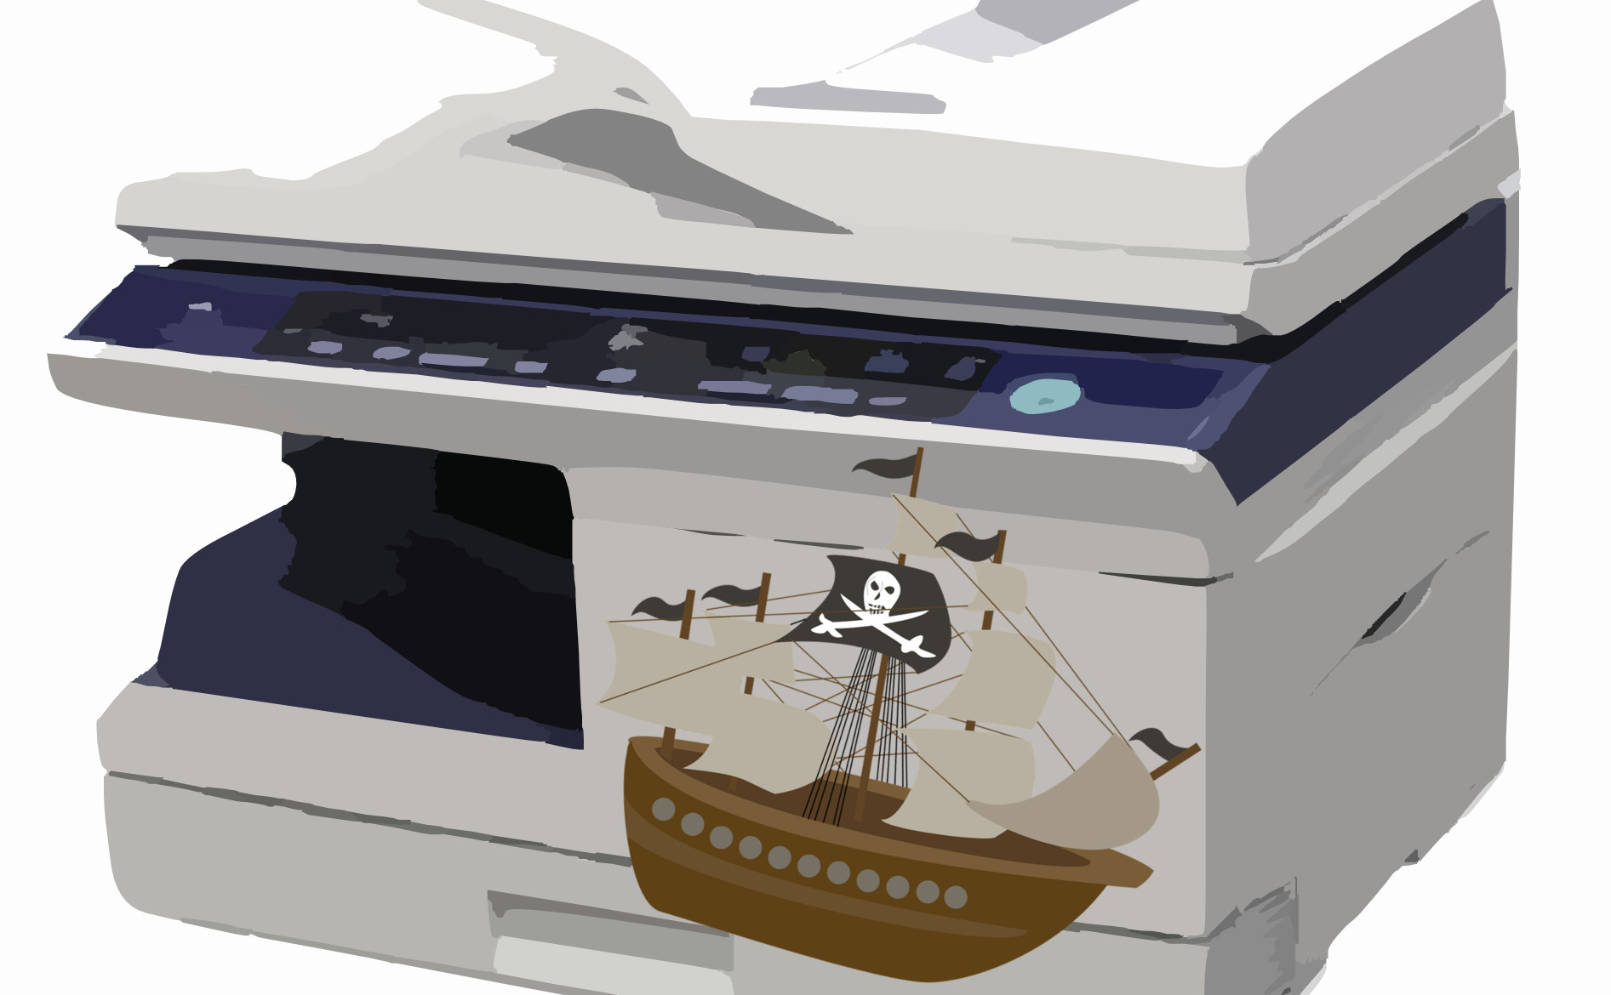
Image remixed by Horst JENS. Image sources: pixabay / cc0 Public domain
first posted at 2015-12-19 at torrentfreak.com[1]

[2]Peter Sunde[3]. Image rights: copyrighted free to use
Pirate Bay co-founder Peter Sunde served his prison sentence last year but still owes the entertainment industries millions in damages. Some might think that he's learned his lesson, but with a newly built copying machine he's generating millions of extra 'damages,' which might be worth a mention in the Guinness Book of Records.
Former Pirate Bay spokesperson Peter Sunde has always been very outspoken about people’s inherent drive to copy things.
Last year he paid the ultimate price[4] of sacrificing his freedom for his involvement in TPB, but that hasn’t changed his core ‘kopimi‘[5] values.
One of Peter’s major frustrations is how the entertainment industries handles the idea of copying. When calculating the losses piracy costs, they often put too much value on pirated copies.
This is something Peter knows all too well, as he still owes various movie and music companies millions in damages.
However, this hasn’t stopped him from continuing to copy. In fact, he’s just built the ultimate copying machine using a Raspberry Pi, an LCD display and some Python code.
With these three ingredients the “Kopimashin” makes 100 copies of the Gnarls Barkely track “Crazy”[6] every second. This translates to more than eight million copies per day and roughly $10 million in ‘losses.’
Crazy indeed.
Peter’s machine is part of an art project[7] about the value of digital copies which he’s preparing for an upcoming exhibition.
“I want to show the absurdity on the process of putting a value to a copy. The machine is made to be very blunt and open about the fact that it’s not a danger to any industry at all,” Sunde tells TF.
“But following their rhetoric and mindset it will bankrupt them. I want to show with a physical example – that also is really beautiful in it’s own way – that putting a price to a copy is futile.”
[8]
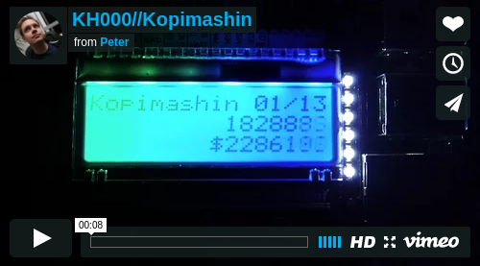
KH000//Kopimashin[9] from Peter[10] on Vimeo[11]. Image rights: unclear / Vimeo.com
The Kopimashin does make real copies of the track, but they are sent to /dev/null, which means that they are not permanently stored.
The most important message, however, is that the millions of dollars in losses the industry claims from him and the other TPB founders are just as fictitious as the number displayed on the Kopimashin.
“The damages in the TPB case are equally ludicrous of course. The idea behind it is of course never to get that money paid, but to scare people into silence and obedience.”
The millions of dollars the industry is said to lose stands in no relation to actual damages according to Peter. On the contrary, he believes that piracy positively affects sales.
“To quote Kenneth Goldsmith, I think the file-sharing trials of this century are going to be our obscenity trials. The claims are never valid, they’re never based on actual damage. If that was the case, we would have been awarded money.”
“The economics work differently in a global networked society. But the industries will not change. That’s why we need to take them down,” he adds.
The Pirate Bay co-founder hopes to finalize 13 Kopimashins for various exhibitions and plans to sell a few as well. In the meantime, he’s continuing to ‘bankrupt’ poor Gnarls Barkley and his label.
“The one running at my home is up to 120 million copies as we speak. That equals $150 million in losses to the recording industry – following their logic,” Peter says.
To get his copying effort recognized Peter contacted the Guinness Book of Records this week, who are currently reviewing[12] his application.
about this article: Author: Ernesto Van der Sar[13]
Contact: ernesto@torrentfreak.com[14]
Shorturl: http://goo.gl/CD6qUV[15]
Hashtag: Piratebay
Fork / improve: on Github[16]
Extras: original article at torrentfreak.com[17]
License of text:

cc-by-sa[18]. Attribute to: Ernesto Van der Sar[19]
Location: 52.3717 / 4.9009[20]

about the author:
Ernesto Van der Sar, Ernesto Van der Sar. News maker and gatherer. Founder and Editor-in-Chief of TorrentFreak[21]. Born and raised near Amsterdam.
Donate to the author: No donation address given.

[0] http://internationalopenmagazine.org/2015-12-21-piratemachine.html
[1] https://torrentfreak.com/pirate-bay-founder-builds-the-ultimate-piracy-machine-151219
[2] https://commons.wikimedia.org/wiki/File:Peter_sunde_close_up.jpg#/media/File:Peter_sunde_close_up.jpg
[3] http://blog.brokep.com/about/
[4] https://torrentfreak.com/pirate-bays-peter-sunde-released-prison-141011/
[5] https://en.wikipedia.org/wiki/Piratbyrån#Kopimism
[6] https://www.youtube.com/watch?v=bd2B6SjMh_w
[7] http://konsthack.se/portfolio/kh000-kopimashin/
[8] https://vimeo.com/148955816
[9] https://vimeo.com/148955816
[10] https://vimeo.com/brokep
[11] https://vimeo.com/
[12] https://torrentfreak.com/images/record1.png
[13] https://torrentfreak.com/author/ernesto/
[14] mailto:ernesto@torrentfreak.com
[15] http://goo.gl/CD6qUV
[16] https://github.com/horstjens/internationalopenmagazine/blob/master/content/blog/2015-12-21-piratemachine.md
[17] https://torrentfreak.com/pirate-bay-founder-builds-the-ultimate-piracy-machine-151219/
[18] https://creativecommons.org/licenses/by-sa/4.0/
[19] https://torrentfreak.com/pirate-bay-founder-builds-the-ultimate-piracy-machine-151219/
[20] http://www.openstreetmap.org/?mlat=52.3716&mlon=4.9009#map=12/52.3717/4.9009
[21] https://torrentfreak.com/

