Can Open Educational Resources (OERs) Bridge The Digital Divide Gap?[0]

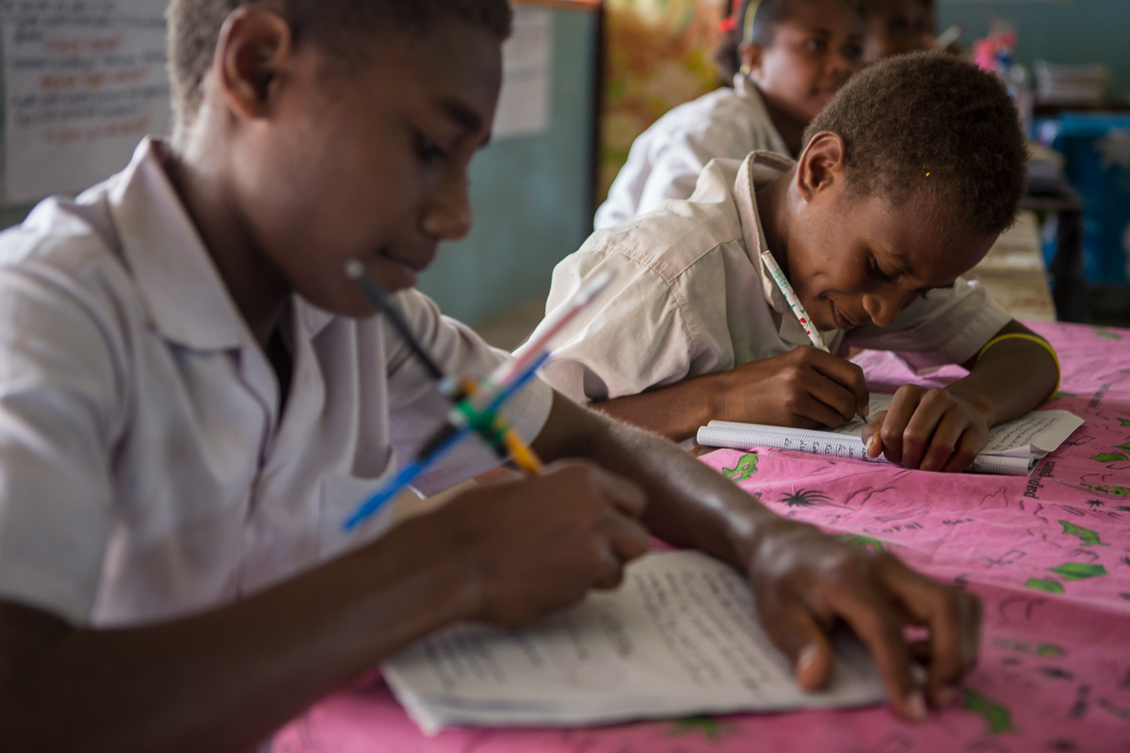
Third grade students during class at Norsup Primary School. Image source: cc-by https://www.flickr.com/photos/dfataustralianaid/10730023883[1]

During the 10th Internet Governance Forum (IGF) in Brazil (2015), I happened to be a panelist on a workshop that I had helped organize. Amongst the panelists were ICT4D experts Dr. Mikhail Komarov[2], Patrick Ryan[3] of Google, Sarah Kiden[4] of the Uganda Christian University, just to mention a few. The workshop sought to answer the question of whether Open Educational Resources (OERs)[5] could bridge the digital divide gap[6], especially in the Global South.

What Are OERs?
OERs are simply teaching, learning or research materials that are in the public domain or released with an intellectual property license that allows for free use, adaptation and distribution.
In an unprecedented move in 2001, the Massachusetts Institute of Technology (MIT), announced the release of almost all its courses on the Internet for free access.
Following this move, several institutions followed suit prompting the number of institutions offering free or open courseware to skyrocket. The turn of events prompted the United Nations Educational, Scientific and Cultural Organization (UNESCO[7]) to organize the first Global OER Forum in 2002 where the term Open Educational Resources (OER) was adopted.
Later, with the partnership of Hewlett Foundation, UNESCO created a global OER Community Wiki in 2005, a move that was geared at sharing information and working collaboratively on issues surrounding the production and use of OERs.

Reality Check
Although a relatively new phenomenon in the African region, the OER meme continues to gain a considerable momentum with increased attention of the accessibility and cost of education in the Sub-Saharan Africa.
According to a UNESCO report, the increased attention on OER can be attributed to the sharp rising demand in education and training.
Ideally, this demand means that traditional methods will not suffice to take Sub-Saharan Africa beyond Universal Primary Education (UPE), into the wider Education for All (EFA) Millennium Development Goals (MDGs) agenda, especially as it applies to gender equity, secondary education, young adults, indigenous peoples, those with disabilities and those living in rural areas.
Similarly, the British Council and IDP Australia Research findings indicate that, by 2025, there will be about 263 million students who will be eligible for higher education.
In order to accommodate this demand, at least 4 universities of 30,000 students will need to open every week for the next 10 years. This is unattainable!
This projection clearly denotes that traditional avenues to quality education are not likely to meet this demand thus the need to adapt OERs.
Generally, higher education in Sub-Saharan countries suffers from unavailability of quality teaching and learning resources due to lack of tradition, competence, and experience to develop such resources. Nevertheless, there are thousands of OERs freely available in the public domain that can potentially improve the quality of existing resources or help to develop new courses.
In Tanzania for instance, The Open University of Tanzania (OUT)[8], the first university in the whole of the East Africa region to offer educational programmes through Open and Distance Learning mode, allows flexible learning environment leading to protracted periods of course completion.
Being an Open Distance Learning (ODL) institution, OUT operates through a network of 30 Regional Centres and more than 70 Study Centres in Tanzania and abroad. Equally, in the quest to circumvent the problem of congestion and sustain academic programmes, University of Dar es Salaam[9] (UDSM), launched three Open Distance eLearning (ODeL) centres across the country to enable off-campus students to take part in the university programmes online.
In Zambia, the Zambian Open University[10] (ZAOU) is committed to increasing access to university education through open and distance learning, a move that was mostly encouraged by a government policy.
As of today, a Commonwealth of Learning (COL) report exhibits that there are about 60 Open Universities established around the world, an indication that effective learning will likely come from using ICTs to broaden educational opportunity, bridge the digital divide gap and in the long run help students develop twenty first century skills.

OER Challenges
There has been increased debate regarding the quality of OERs with some however arguing that these concerns are overstated. Either way, the concerns exist and must be addressed all together.
Scholars suggest that the most obvious way of evaluating OER content is the same as for evaluating restrictively licensed content. A COL document notes that:
“by tradition, the instructor validates the content, and tests its potential pedagogical effectiveness and ease of use. In this respect, it is perceived that the quality of any content varies considerably depending on its purpose and fit with a particular course, its pedagogical framework and lastly its generalisability.”
The other aspect is that of use of Peer Review to validate quality, where a few Subject Matter Experts unanimously certify that the said content meets or exceeds acceptable criteria. This is seen to be one of the best quality indicators.
Similarly, there's the User Ratings concept. Here, user ratings as used on some sites can be useful usually in the form of star ratings or numbers.
OER Instructors can also conduct self-evaluations of resources to ensure that the quality meets their standards. Additionally, the brand or reputation of the course developers or their institutions can be an important indicator of quality. Ideally, OER developers feel that while the above quality indicators can be used to gauge the quality of OERs, they should also be used in evaluating restrictively licensed content too.

Conclusion
OERs are unlikely to replace traditional education; they nevertheless have the potential to obviate demographic, economic, and geographic educational boundaries and to promote life-long learning and personalised learning. The answer to equalizing access to knowledge and educational opportunities thus squarely rests in OERs.
Name: Bonface WITABA[11]
Contact: @bswitaba[12], bswitaba@yahoo.co.uk[13]
Shorturl: http://goo.gl/ibQQM3[14]
Hashtag: #OER
Fork / improve: on Github[15]
Extras:: Author's Blog[16], original article[17]
License for text and photos in this article, unless indicated otherwise (e.g. Image rights notice below pictures): creative commons attribute share-alike 4.0[18]
Location: -7.119496, -34.845012[19]
about the author: ICANN Fellow, and DiploFoundation Internet Governance alumni (Switzerland). He has also been nominated as the 2015 African young scholar and fellow in Communication Policy Research: south (CPRsouth), Yuan Ze University, Taiwan.
Bonface founded Centre for Youth Empowerment and Leadership (CYEL), an initiative that has won several international ICT awards for its concerted efforts to empower youth through digital inclusion.
He works as an e-learning tutor, consultant in technology and Policy areas of Internet Governance.
Donate author: Please use PayPal.com[20] to send donations to the author directly: bswitaba@yahoo.co.uk

[0] http://internationalopenmagazine.org/2016-02-03-oer.html
[1] https://www.flickr.com/photos/dfataustralianaid/10730023883
[2] https://www.linkedin.com/in/mikhail-komarov-57975b39
[3] https://twitter.com/psrlaw
[4] https://www.internetsociety.org/who-we-are/igf-ambassador-non-staff-blogger/sarah-kiden
[5] https://en.wikipedia.org/wiki/Open_educational_resources
[6] https://en.wikipedia.org/wiki/Digital_divide
[7] http://en.unesco.org/
[8] http://www.out.ac.tz/
[9] http://www.udsm.ac.tz/
[10] http://www.zaou.ac.zm/
[11] https://bonfacewitaba.wordpress.com/
[12] https://twitter.com/bswitaba
[13] https://bonfacewitaba.wordpress.com/about/
[14] http://goo.gl/ibQQM3
[15] https://github.com/horstjens/internationalopenmagazine/blob/master/content/blog/2016-02-03-oer.md
[16] https://bonfacewitaba.wordpress.com/
[17] http://www.iafrikan.com/2016/02/03/oers-can-they-bridge-the-digital-divide-gap/
[18] https://creativecommons.org/licenses/by-sa/4.0/
[19] http://www.openstreetmap.org/?mlat=-7.119496&mlon=-34.845012#map=13/-7.1643/-34.8601
[20] http://www.paypal.com/

