**IST107 - Introduction to Internet Programming and Web Applications**

**Quiz #3 Lab**

|  |  |  |
| --- | --- | --- |
| **Name: Harry Ortega** | **Student No.: CT1006148** |  |

You are required to complete the lab and record your answers. Rename the file using your first name and the lab number, e.g., ***washingtonQuiz3Lab.docx***, and submit it through Canvas to receive marks for this lab.

**Quiz #3: Automatic Deployment to Firebase**

**Repo:** [**https://github.com/eduval/Quiz-3-IST107-CCTB**](https://github.com/eduval/Quiz-3-IST107-CCTB)

**Objective:**

To test your ability to clone a repository, solve a code issue, set up GitHub Actions for automated deployment and deploy a project to Firebase

**Instructions:**

1. **Clone the Repository:**
   * Clone the provided GitHub repository containing the source code to your local machine.
   * Create a new GitHub repository in your own GitHub account and push the cloned project to your repository. Make sure to keep the repository **public**.
2. **Solve the Code Issue:**
   * The current game in the source code has an issue where the initial popup continuously shows up, and the player is unable to play the game.
   * Identify and fix this issue locally. Test the solution to ensure that the game can be played without the popup interrupting gameplay.
3. **Set Up Firebase Project:**
   * Create a new Firebase project named **[YourName]_Quiz3**. **(Important: Follow the naming convention exactly. Failure to do so will result in a significant grade reduction.)**
   * Initialize Firebase for your project using the instructions provided during the class:
     + Run firebase init and select "Hosting: Configure files for Firebase Hosting and (optionally) set up GitHub Action deploys."
     + Manually deploy the project to Firebase Hosting first.
4. **Set Up GitHub Actions for Continuous Deployment:**
   * After the manual deployment, set up GitHub Actions for continuous deployment using the option "Hosting: Set up GitHub Action deploys."
   * Ensure the workflow file is correctly configured in your GitHub repository for automatic deployment whenever you push changes to your main branch.
   * Push again your local repository. Make sure to keep the repository **public**.
5. **Verify Deployment:**
   * Verify that the Firebase Hosting URL is correctly updated and accessible. If there are any deployment issues, troubleshoot and resolve them.
   * Ensure the game is functional, and the fixed issue is no longer present.
6. **Submission Requirements:**
   * Submit the following as part of your quiz:
     + **URL of your Firebase deployment**, functional game.

[CCTB - Tic-Tac-Toe (harryortega-quiz3.web.app)](https://harryortega-quiz3.web.app/)

* + - **URL of your public GitHub repository**.

**https://github.com/hortega88/HarryOrtega-Quiz3**

* + - **Screenshot** of your Firebase project.

E.g.

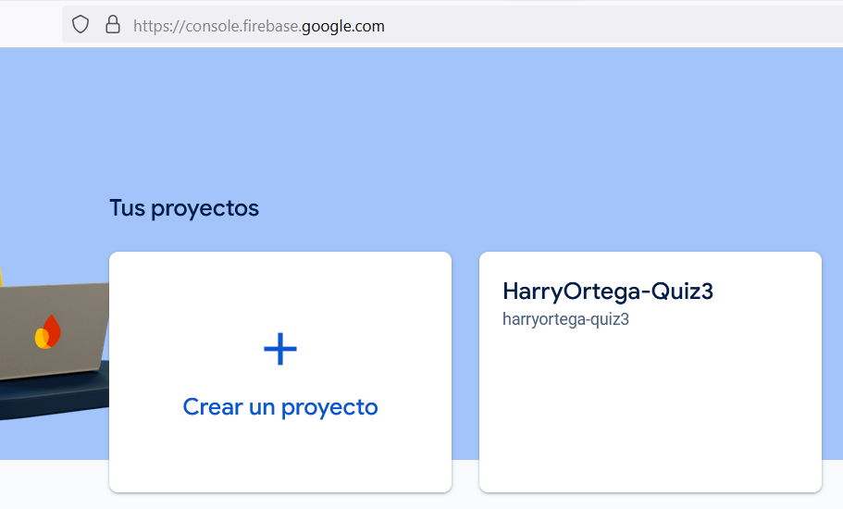

* + - **Screenshot** showing that you have played and won the game after fixing the issue.

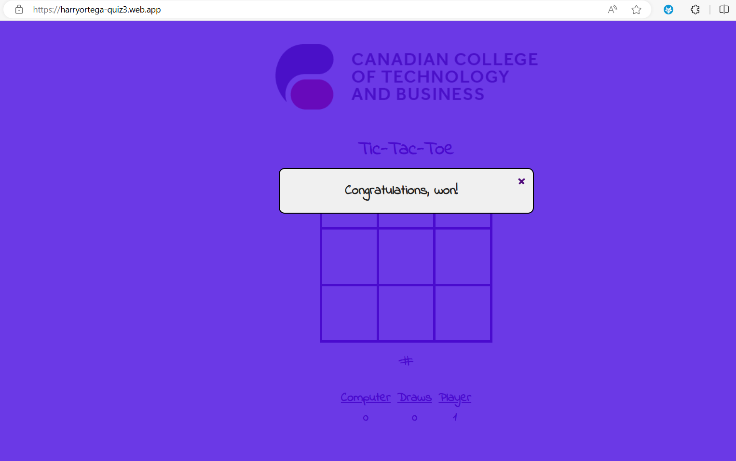

1. **Grading Criteria:**
   * Adherence to naming conventions (Firebase project name): **[YourName]_Quiz3**.
   * Correct setup and configuration of Firebase Hosting and GitHub Actions.
   * Proper resolution of the code issue (popup problem) and verification that the game functions correctly.
   * Submission of both URLs and the required screenshots.
2. **Important Notes:**
   * Ensure all steps are followed carefully. Missing the submission of either URL or failing to follow the naming conventions will result in a grade of zero.

You are required to complete the final exam and record your answers. Rename the file using your first name and the lab number, e.g., ***washingtonQuiz3Lab.docx***, and submit it through Canvas to receive marks for this exam.