Alex Hortin
2/7/2007
Assignment3

1. (7 pts) Complete the Connect Four game using the C language

attached

2. (3 pts) Draw the dependency graph necessary for the Makefile
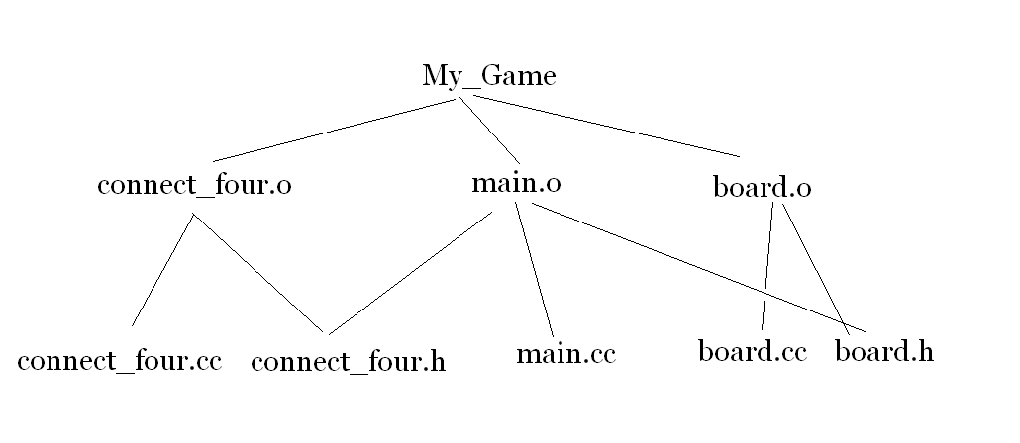
3. (7 pts) Write a Makefile that will compile subparts "main.o", "connect_four.o", and "board.o", and assembly a program called "my_game" from these parts. All dependencies should be correct such that if any of the 5 files is updated, the correct pieces will get rebuilt

attached

4. (2 pts) Explore the usage of the touch command and how it affects the rebuilding of the program

When a file is touched the files above it in the tree with dependencies upon it are rebuilt, for example is connect_four.h is touched than main.o must be rebuilt.

5. (1 pt) What happens if you update "board.h"? Explain!

If board.h is touched than main.cc must be rebuilt

