Alex Hortin
1/24/2007
Assignment 1

1. Briefly describe the system you are using (e.g. "Redhat 7.2 running on my PC" or "wsunix.wsu.edu" or some similar brief description).
I am using ssh-server.eecs.wsu.edu to ssh in and and using putty to interface

2. Describe the purpose of the man command. What does the command list?
The purpose of the man command is to retrieve documentation about a certain program or command. It will also list subcommands like “ls -1” which alters or filters functionality.

3. Describe the finger command. What is the output of finger?
Finger outputs information about the current system users. An example of the output of finger:
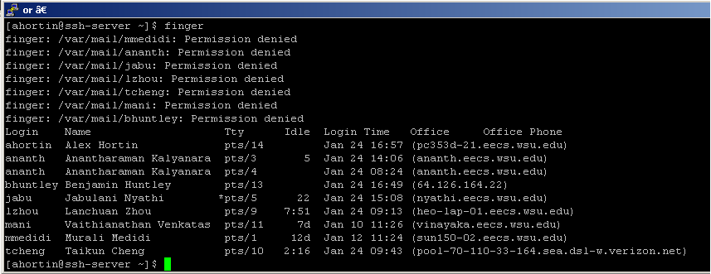

4. How do you copy an entire directory along with its contents? Using just cp will not work! Try it and see!
You must use “cp” as well as the recursive option “cp –r dirname destname”

5. How do you remove an entire directory along with its contents?
“rm –r dirname”

6. How do you move an entire directory along with its contents?
“mv dirname destname”

7. Describe the ps command. List the current output of this command. What does ps ag list?
“ps” lists all of the processes currently running on the machine that you are currently logged into. With no argument is only displays the processes that you own.
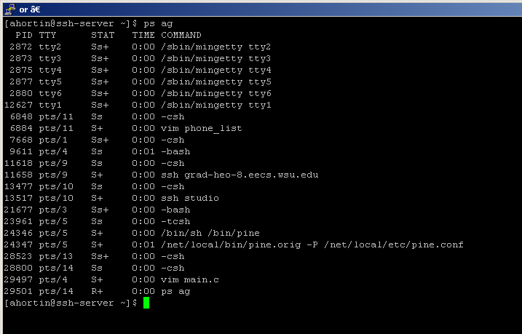

With “ps ag” it will display all processes no matter who owns them.

8. Describe the uname command. What does uname –a list? Show the sample output.
“uname” lists system information. “uname –a” adds more in depth information. The difference is shown below.
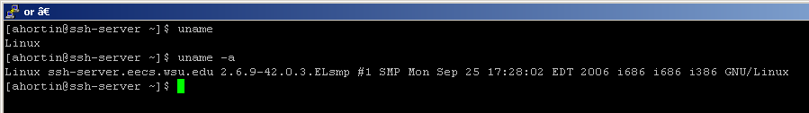

9. Describe the find command.
The “find” command will search for files throughout a directory hierarchy. It will list all files within as well, in a relative path.

10. Which command allows you to change your password?
“passwd”

11. Describe the diff command.
“diff” lists the differences between 2 files. If input was “diff file1 file2”, the lines with < in the front are differences from file one, and the lines preceeded by > are from file2.

12. Which text editor do you prefer to use (i.e. ed, vi, pico, emacs, etc.)? Describe the features and capabilities of your favorite editor. I don't expect all of you to have used an editor before, thus look into some of these editors and see which one you prefer!
I like using vi, because I have seen talented people use it, and it goes really fast. It also made a cameo in a Japanese movie titled Battle Royale, or at least it was similar. I read later that it was called NMAP, but it looks the same. Basically there is no better way to nerd out than fullscreening putty and coding with a 3 way split window of vi.

The next few questions use the man page for ls:
13. How is the ls command described in the "Name" section of the man page?


14. How many options are there to the ls command? Describe 5 of them.
52 different options + 5 SELinux options
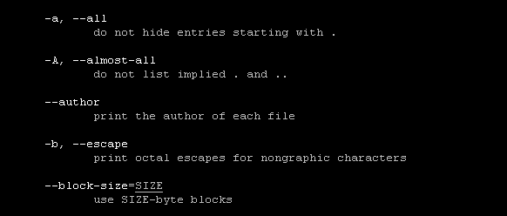

15. How would you invoke ls to get output like the following:
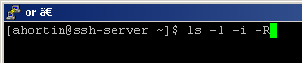
.:
total 12
20199177 -rwxr-xr-x 1 hliu2 grad 0 Feb 25 2004 hugeparms
17312868 -rw-r--r-- 1 hliu2 grad 0 Jul 31 2002 hugeparms.C
20199176 -rwxr-xr-x 1 hliu2 grad 0 Feb 25 2004 hyper
17312873 -rw-r--r-- 1 hliu2 grad 0 Mar 24 1998 hyper.C
17312862 drwxr-xr-x 2 hliu2 grad 4096 Mar 12 1997 independent
20199169 -rwxr-xr-x 1 hliu2 grad 0 Feb 25 2004 md1
20199168 -rwxr-xr-x 1 hliu2 grad 0 Feb 25 2004 mm1
25167961 -rw-r--r-- 1 hliu2 grad 0 Oct 20 1998 mm1.C
17312880 -rwxr-xr-x 1 hliu2 grad 0 Nov 26 1999 mm1_orig
20199175 -rwxr-xr-x 1 hliu2 grad 0 Feb 25 2004 mm1term
17312866 -rw-r--r-- 1 hliu2 grad 0 Feb 26 1997 mm1term.C
25167962 -rw-r--r-- 1 hliu2 grad 0 May 31 1996 multi.C
20199167 -rwxr-xr-x 1 hliu2 grad 0 Feb 25 2004 nonsteady
17312869 -rw-r--r-- 1 hliu2 grad 0 Jul 22 2002 nonsteady.C
20199173 -rwxr-xr-x 1 hliu2 grad 0 Feb 25 2004 norm
17312864 -rw-r--r-- 1 hliu2 grad 0 Feb 4 1997 norm.C
15581517 -rw-r--r-- 1 hliu2 grad 0 Aug 29 10:36 output
17312874 drwxr-xr-x 2 hliu2 grad 4096 Feb 20 2001 pascal
17312870 drwxr-xr-x 2 hliu2 grad 4096 Feb 20 2001 plain_c
17312867 -rw-r--r-- 1 hliu2 grad 0 Mar 7 2001 reg_mm1.C
17312881 -rw-r--r-- 1 hliu2 grad 0 Aug 27 2000 rmm1.mime
25167963 -rw-r--r-- 1 hliu2 grad 26 Mar 6 1995 SA
20199170 -rwxr-xr-x 1 hliu2 grad 0 Feb 25 2004 taks
25167964 -rw-r--r-- 1 hliu2 grad 0 Jul 1 2002 taks.C
25167965 -rwxr-xr-x 1 hliu2 grad 25 Oct 18 1994 test_env
25167966 -rw-r--r-- 1 hliu2 grad 0 Oct 11 1994 test_observation_analyser.C
20199174 -rwxr-xr-x 1 hliu2 grad 0 Feb 25 2004 tmm1
17312865 -rw-r--r-- 1 hliu2 grad 0 Feb 5 1997 tmm1.C
20199171 -rwxr-xr-x 1 hliu2 grad 0 Feb 25 2004 tproc
25167967 -rw-r--r-- 1 hliu2 grad 0 May 28 1996 tproc.C
25167969 -rw-r--r-- 1 hliu2 grad 0 Aug 15 1996 trand.C
25167968 -rw-r--r-- 1 hliu2 grad 0 Aug 15 1996 trand.out
25167970 -rw-r--r-- 1 hliu2 grad 0 Jun 16 1995 trgen.C
20199165 -rwxr-xr-x 1 hliu2 grad 0 Feb 25 2004 uni
20199166 -rwxr-xr-x 1 hliu2 grad 0 Feb 25 2004 uni2
25167971 -rw-r--r-- 1 hliu2 grad 0 Jul 27 1995 uni2.C
25167972 -rw-r--r-- 1 hliu2 grad 0 Jul 22 2002 uni.C
17312882 -rw-r--r-- 1 hliu2 grad 0 Feb 25 2004 uni.o
25167973 -rw-r--r-- 1 hliu2 grad 0 Aug 24 1995 yak.C
20199172 -rwxr-xr-x 1 hliu2 grad 0 Feb 25 2004 zeroes
25167974 -rw-r--r-- 1 hliu2 grad 0 Jul 12 1996 zeroes.C

./independent:
total 0
17312863 -rw-r--r-- 1 hliu2 grad 49 Feb 4 1997 Akaroa

./pascal:
total 0
17312879 -rw-r--r-- 1 hliu2 grad 0 Sep 8 1998 akaroa.h
17312878 -rw-r--r-- 1 hliu2 grad 0 Sep 8 1998 akaroa.pas
17312875 -rw-r--r-- 1 hliu2 grad 0 Sep 8 1998 Makefile
17312877 -rw-r--r-- 1 hliu2 grad 0 Sep 8 1998 temp.c
17312876 -rw-r--r-- 1 hliu2 grad 0 Sep 8 1998 uni.pas

./plain_c:
total 0
17312871 -rw-r--r-- 1 hliu2 grad 0 Sep 8 1998 Makefile
17312872 -rw-r--r-- 1 hliu2 grad 0 Sep 8 1998 uni.c

