Alex Hortin
1/31/2007
Assignment 1

Q1: (5 points) Briefly summarize the organization of the UNIX file system. Make sure you describe the concept of inodes.
The unix file system is structured in a hierarchy beginning with root. The absolute path to any file will always begins with root. Every device is also treated like a file. An inode stores basic information about a regular file, directory, or other file system object. Different types of links to different inodes can be created, further emphasizing the sharing capabilities of the Unix file system.

Q2: (2 points) Explain what commands you used to set all of the above files up.
I created the realfile.txt using a text editor, I created the hardlink with “ln realfile.txt hardlink”, I created the softlink with “ln –s realfile.txt softlink”, and created the copy with “cp realfile.txt filecopy”.

Q3: (1 point) What is the output of ls –l on each file? Make some changes to the text in “realfile”. And then, what is the output of ls –l on each file? How they are different?
Before changes:
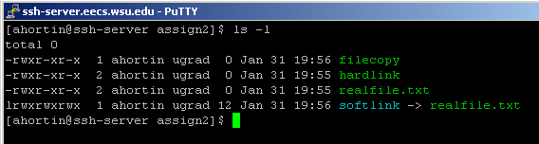
After changes:
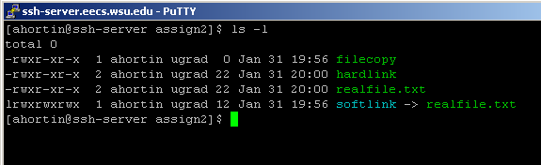
The hardlink and realfile.txt changed modification times. Neither filecopy nor the softlink were affected.

Q4: (1 point) What is the inode number of each file? (You can get the inode number with ls -i )

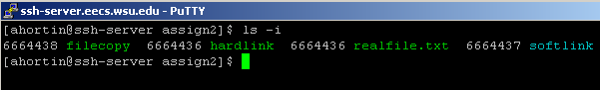

Q5: (1 point) Use the file command and record what type of file each is. Explain any differences.
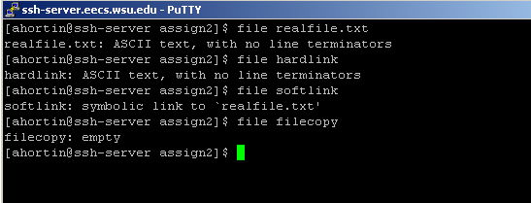
Q6: (1 point) Make “hardlink” readable, writeable, executable by you, but not readable, writeable, executable by anyone else. What command did you use to do this?
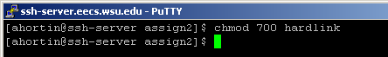

Q7: (1 point) What is the permission of “realfile” before and after you do Q6? How they are different? Why?
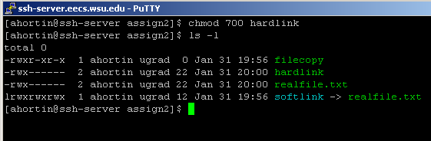
Since it is a hard link it will alter realfile just as if you were altering realfile. It was the same as the filecopy before Q6.

Q8: (1 point) cat each file. Are the results the same for each file?
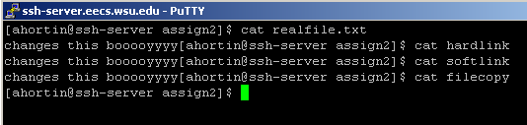
No they are the same for every file except the copy, since the copy is no longer affiliated with the original

Q9: (1 point) Make some changes to the text in "softlink". Explain what happened to the file size of "hardlink", "realfile", and "softlink".
Here is the output after I changed softlink:
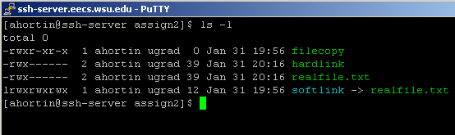
Both the hardlink and the original file was changed, but the softlink remained the same size

Q10: (1 point) Move "realfile" to "realfile1". What is the output of ls -1. Explain what happened to "softlink" and "hardlink" (consider link count and inode number).
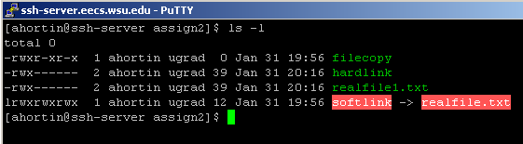
Since hard link points directly to the inode of the real file, it was unaffected. However the softlink points to realfile.txt and now that it is gone, it cannot find the proper file to link to, and when you open it will point to a blank document. Also, hardlink, and realfile will have 1 less link to them.

